11b GCF: Mitigation Denied Tickets
Audience: [LOB: Fraud Support]
- Overview
- Penalty mitigation: Ineligibility criteria
- Ticket handling and workflow
- Standard response Macro

Overview
This article explains how to handle GCF (Guideline Compliance Form) mitigation denied tickets during Fraud Support conversations. It helps you understand the required criteria, follow the proper handling process, use the appropriate responses, and determine when escalation is required.

Penalty mitigation: Ineligibility criteria
Agents are not required to manually verify mitigation eligibility. Properties that meet any of the following criteria are automatically denied penalty mitigation:
Ineligibility criteria | Condition
High suspicious activity | 1 or more Fraud Removals and 30% or more of the remaining reviews removed as Suspicious within the 365 days prior to the GCF submission.
Multiple fraud events | More than one Fraud Removal from different members within the 365 days prior to the GCF submission.
Repeat submissions | Three previous GCF submissions with three different years in the timestamps.
Important: Properties that meet any of the above criteria are automatically denied mitigation and routed for manual review.

Ticket handling and workflow
When a property is denied automated mitigation, a Zendesk ticket is automatically created with Auto-Mitigation: No.
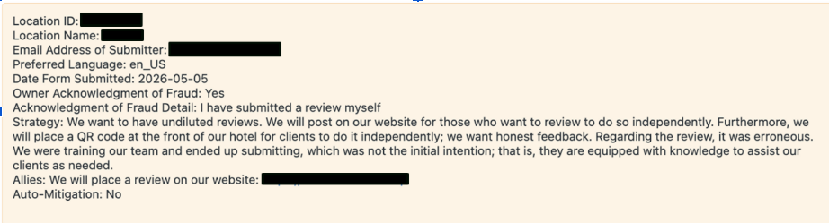
Follow the steps below:
Step | Action
- Review the ticket | Review the ticket details and any information provided by the owner.
- Handle the case | Handle the conversation and determine whether manual mitigation is appropriate by following the existing guidelines in 11c Penalty Mitigation.
- Escalate (when required) | Refer to 11c Penalty Mitigation to determine which cases require escalation to Investigations (refer to the yellow column)
- Tier 2 support | If you have any additional questions, escalate the ticket to Tier 2.

Standard response Macro
If the case does not require escalation, you can generally use the following macro:
Owner::CI::Mitigation::Completed GCF, not eligible for mitigation
Hello {{ticket.requester.first_name}},
Thank you for completing the Guidelines Compliance Form.
While we are unable to make any changes to your listing's ranking at this point, we must ensure that our policies are applied consistently across all listings on Tripadvisor. We can assure you that this penalty will end one year from the date it was imposed (), unless we detect further suspicious activity.
Best regards,
{{ticket.assignee.signature}}
Tripadvisor Content Integrity
Important notes on Macro:
- Not all languages have translated versions of this macro. If a translation is required, use the approved translation tool.
- Do not communicate the reasons behind an auto-mitigation decision, regardless of whether it was granted or not granted.

