05c. URD
- General Overview
- Top Section
- URD commenting Best Practices

General Overview
Housed on the Tonic server and accessible here, The URD is the primary tool for granular, review-level analysis and direct content action.

Top Section:
The search panel on the right allows agents to locate specific review details. A variety of parameters are available within the dropdown menu to help refine your search. You can further refine your search results by selecting specific criteria from the filter dropdown menu.
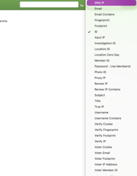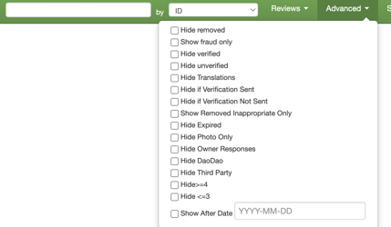

URD Commenting Best Practices
Any time a case involves one or more reviews, or even ORs (Online Responses), agents must leave comments on the URD.
Comments left in the URD should be detailed and thorough. Every comment must clearly explain the following:
- Your actions: Describe exactly what action you took on the review (e.g., removed, kept published) and the specific reason or guideline that supports your decision.
- Connection for peripheral fraud removals: If you are removing a review as peripheral fraud, explain the connection between the review and the fraud case. Detail how you identified the link and what evidence supports it.
- ZD ticket context: Add the Zendesk ID and summarize what is happening in the Zendesk ticket — include the owner's complaint, any evidence provided, and the key points of the investigation.
- Supporting details: Include any relevant review IDs, user IDs, patterns you identified, or cross-references to other cases that informed your decision.
A well-written URD comment should allow any team member reviewing the case later to fully understand what happened and why, without needing to re-investigate from scratch or opening the relevant Zendesk ticket.

