Revenue Forecast Visualization Report
Prepared By: Sandhya Kumari
Role: Data Analyst
Date: 28 May 2026

Abstract
This project focuses on developing a Revenue Forecast Visualization Dashboard using Tableau to improve business forecasting and decision-making. The dataset was downloaded from Kaggle and cleaned using Python to remove missing values, duplicates, and inconsistencies. After preprocessing, the cleaned dataset was imported into Tableau to create an interactive dashboard containing KPI cards, charts, heat maps, filters, and forecast analysis visuals. The dashboard provides insights into sales performance, forecast accuracy, revenue variance, pipeline stages, regional revenue, and growth trends. The system helps organizations monitor business performance efficiently and supports data-driven decisions.

Objectives
- To collect a revenue forecasting dataset from Kaggle.
- To clean and preprocess raw data using Python.
- To identify missing values and remove inconsistencies from the dataset.
- To create interactive visualizations using Tableau.
- To analyze forecast revenue, sales, and business growth.
- To improve decision-making using dashboard analytics.
- To provide easy-to-understand business insights through charts and KPI cards.

Problem Statement
The company, operating across three divisions—Professional Services, Managed Services, and Technology Licensing- Organizations often face difficulties in accurately forecasting revenue due to:
- Manual data handling processes.
- Inconsistent and unclean datasets.
- Lack of centralized visualization systems.
- Difficulty in analyzing large volumes of business data.
- Time-consuming reporting methods.
- Limited visibility into sales trends and forecast accuracy.
These problems reduce business efficiency and may lead to poor decision-making.

Proposed System
The proposed system uses:
- Python for data cleaning and preprocessing.
- Tableau for interactive dashboard creation and visualization.
The system provides:
- KPI Cards for important business metrics.
- Interactive filters and slicers.
- Forecast vs Actual comparison.
- Revenue analysis by region and city.
- Pipeline stage analysis.
- Heat maps and trend visualizations.
This system helps users easily monitor and analyze business performance.

Advantages
- Improved data accuracy after cleaning.
- Faster business analysis using dashboards.
- Interactive and user-friendly interface.
- Better visualization of sales and forecast data.
- Easy identification of business trends.
- Supports data-driven decision-making.
- Reduces manual work and reporting time.
- Helps management monitor forecast performance effectively.

Disadvantages
- Forecast accuracy depends on the quality of input data.
- Requires knowledge of Tableau and Python tools.
- Large datasets may reduce dashboard performance.
- Dashboard maintenance and updates are required regularly.
- Tableau software may involve licensing cost.
- The data cleaning process can be time-consuming.
- Incorrect data preprocessing may affect visualization results.
- Real-time data integration was not included in the current system.
- Advanced forecasting techniques like Machine Learning were not implemented.
- Internet or system performance issues may affect dashboard loading speed.
Existing System
The traditional forecasting system mainly depends on:
- Excel sheets for data storage and analysis.
- Manual calculations and reporting.
- Static charts with limited interaction.
- Separate reports maintained by different departments.

Limitations of Existing System
- High chances of human error.
- Time-consuming report preparation.
- Difficult to identify trends quickly.
- No real-time interactive analysis.
- Poor visualization of business performance.

Methodology
- Data Acquisition: Downloaded raw dataset from Kaggle.
- Data Cleaning: Applied Python (Pandas) for preprocessing—handling missing values, normalizing revenue fields, and restructuring categorical variables.
- Dashboard Development: Built Tableau visualizations integrating cleaned data.
- Validation: Compared forecast vs. actuals to measure accuracy (95.5%).

Result
The developed Tableau dashboard successfully:
- Visualized business revenue forecasting data.
- Improved understanding of sales and forecast performance.
- Displayed interactive insights using charts and filters.
- Simplified complex business data into visual reports.
- Helped compare actual revenue with forecast revenue.
The dashboard provides a clear overview of organizational performance and forecasting trends.

Future Improvement
Future enhancements for this project may include:
- Integration with real-time business databases.
- Use of Machine Learning models for advanced forecasting.
- Automated dashboard refresh functionality.
- Addition of predictive analytics features.
- Mobile-friendly dashboard design.
- Integration with cloud platforms.
- Enhanced security and user access controls.
- More advanced KPI metrics and forecasting models.

Insights from Dashboard
The dashboard provides a clear understanding of:
- Revenue trends
- Regional performance
- Forecast accuracy
- Sales pipeline status
- Business growth opportunities
It helps management make faster and more accurate business decisions using data visualization.
Output
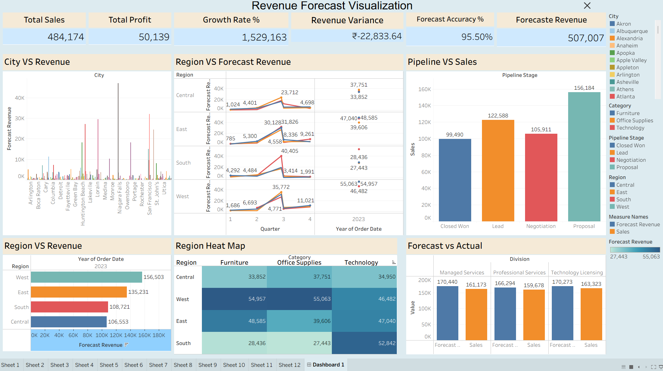
Reference
Title: SampleSuperstore
Author: Ishaan | Kaggle

