Vendor Cost Comparison & Procurement Analysis Report
Prepared By: Sandhya Kumari
Role: Data Analyst
Date: [20/04/2026]

Abstract
This project focuses on analyzes retail sales and procurement data to evaluate vendor performance. While the company's sales volumes are strong across regions and categories, profit margins vary significantly due to discounts, product costs, and inconsistent vendor reliability. This project aims to identify the key reasons behind this issue by analyzing different factors such as discount, product cost, and pricing strategy. The dataset includes important columns like product, category, region, sales, profit, and discount.Using Excel dashboards and Power Query, the data is structured to highlight profitable products, loss-making items, and regional performance gaps. A dashboard is created to visually represent the insights in an easy-to-understand manner. The analysis supports management in making data-driven procurement decisions. It provides meaningful insights that help management make better decisions. Overall, this project helps improve business performance using data-driven analysis.
Objective
The main objective of this project is to analyze product, category, and regional performance. It aims to identify which vendors offer competitive pricing without compromising quality. Another important objective is to study how discounts affect overall profitability. The project Provides actionable insights for procurement optimization. By doing this, the project helps management make better business decisions based on data rather than assumptions. It also aims to improve pricing strategies and control unnecessary discounts. The project enhances negotiation strategies and vendor selection. It ensures better resource allocation and planning. The ultimate goal is to increase overall profitability. Thus, the project serves as a decision-support system for business growth.
Problem Statement
The company is currently facing a major issue of inefficiencies in procurement and sales performance. While overall sales are strong (₹97,095 across products and regions), profit margins are inconsistent. Heavy discounts (average ~24.6%) reduce profitability, and vendor selection is still based on informal relationships rather than structured data. Some products (e.g., batteries, cables) generate high sales but low profit, while premium electronics (MacBook Pro, AirPods) yield higher margins. Without a structured system, management cannot clearly identify which vendors or products deliver the best value. Without proper analysis, decision-making becomes difficult and ineffective. This project addresses these issues by providing detailed and structured analysis.
Proposed System
The proposed system is a Procurement and Sales Analytics Dashboard developed using MS Excel and Power Query. This system provides a complete analysis of sales, profit, and discount data. It includes product-level insights to identify profitable and loss-making products. It also provides category-wise analysis to understand which categories perform best. Region-wise analysis is included to identify geographical performance differences. The system allows users to filter data using slicers for better interaction. Visual charts and KPIs are used to represent data clearly. The dashboard is designed to be user-friendly and easy to understand. It helps management quickly identify problem areas and opportunities. The system supports data-driven decision making. Overall, it improves business efficiency and profitability.
Advantages
The proposed system offers many advantages for the business. It provides clear visibility into vendor and product performance. Management can easily identify profitable vs. loss-making items. The system helps in improving pricing strategies by providing accurate data insights. It also helps in controlling unnecessary discounts that reduce profit margins. The dashboard is interactive and easy to use, which saves time compared to manual analysis. It supports faster and better decision-making. The system Supports faster, data-driven decision-making. It improves overall business efficiency. Finally, it helps in increasing profitability and long-term growth.

Existing System
The existing system used by the company focuses mainly on total sales data and lacks detailed analysis. Vendor decisions are based on past relationships and familiarity. Reporting focuses mainly on total sales, with limited visibility into profit margins. There is no structured vendor evaluation framework. Discounts are applied broadly without analyzing their impact on profitability. Regional and category-level performance differences are not systematically tracked. This leads to higher procurement costs, poor negotiation leverage, and missed opportunities to optimize sourcing. Overall, the existing system is not efficient for modern data-driven business needs.
Disadvantages
The current system has several disadvantages that affect business performance. One major issue is the lack of detailed insights into profitability. Management cannot identify which products are causing losses. Pricing strategies are often incorrect due to lack of data analysis. Discounts are not properly controlled, leading to reduced profit margins. High sales products may still result in low profit, which goes unnoticed. Manual analysis consumes a lot of time and effort. Reports are not user-friendly or interactive. Decision-making becomes difficult and unreliable. Business inefficiencies are not identified properly. Overall, these disadvantages negatively impact the company’s growth and profitability.
Modules Used
· Dataset from Kaggle (Sales data)
· Columns: Product, Category, Region, Sales, Profit, Discount
· Tool used: MS Excel 2024
· Data cleaning: Power Query
· Data processing: Error removal & transformation
· Analysis: Pivot Tables
· Visualization: Charts & Graphs
Methodology
The project follows a structured methodology to ensure accurate results. First, the dataset is collected from Kaggle. Then, the data is imported into Excel for processing. Data cleaning is performed using Power Query to handle missing and incorrect values. Data transformation is applied to prepare the dataset for analysis. Key performance indicators such as vendor sales, cost, discount, and profit records created. Pivot tables for product, category, and region performance are used to summarize and analyze the data. Excel dashboard with KPIs, charts, and slicers and visualizations are created for better understanding. A dashboard is designed to display all insights in one place. Filters and slicers are added for user interaction. Finally, the dashboard is tested and finalized for use.
The project includes multiple levels of analysis to gain meaningful insights. Product-level analysis is performed to identify high-profit and low-profit products. Category-wise analysis helps in understanding which product categories perform best. Region-wise analysis is done to compare performance across different locations. Discount analysis is conducted to study its impact on profitability. It is observed that higher discounts often lead to lower profits. Some products with high sales volume generate very low profit. Certain categories contribute more to profit despite lower sales. Some regions have strong sales but weak profit margins. Vendor evaluation using weighted scoring system applied to cost, delivery, quality, and reliability. These insights help management make better decisions. Overall, the analysis provides a clear understanding of business performance.
Conclusion
The project successfully identifies the gap between sales and profit in the business. It highlights the importance of analyzing profit rather than just focusing on sales. The analysis confirms that while sales are strong, profitability is uneven due to discounts and vendor inefficiencies. Some products require pricing adjustments to improve margins. High-performing categories should be given more focus. Weak regions need better strategies for improvement. The dashboard provides clear and actionable insights. It helps management make informed and data-driven decisions. A structured vendor evaluation system combined with a sales dashboard ensures better procurement decisions, cost savings, and improved business performance. In conclusion, this analysis supports sustainable business growth and profitability.
Result
The project achieves its objectives by providing detailed insights into business performance. The high sales, low profit products are batteries and cables show strong sales but reduced margins due to discounts. It clearly identifies profitable and loss-making products. The high profit products are premium electronics (MacBook Pro, AirPods) generate higher profit percentages. The analysis helps in improving pricing strategies. Regional insights of San Francisco and Los Angeles lead in sales and profit, while Portland and Atlanta lag. Category and region performance are clearly understood. Balanced vendors provide the best overall value compared to low-cost but unreliable suppliers. The dashboard provides a user-friendly interface for analysis. Management can make quick and effective decisions using this tool. The project reduces business inefficiencies. It supports better planning and execution. Overall, the project contributes to improving profitability and business growth.
Future Improvement
The project can be further improved by adding advanced features. It can be integrated with Power BI for better visualization. Real-time data updates can be implemented. Machine learning models can be added for prediction. Sales forecasting can help in future planning. Automation can reduce manual work. Advanced filters and drill-down features can be included. Mobile-friendly dashboards can be developed for real-time monitoring. More datasets can be integrated for deeper analysis. Predictive analytics can improve accuracy for vendor risk and sales forecasting. These improvements will make the system more powerful and efficient.
Output
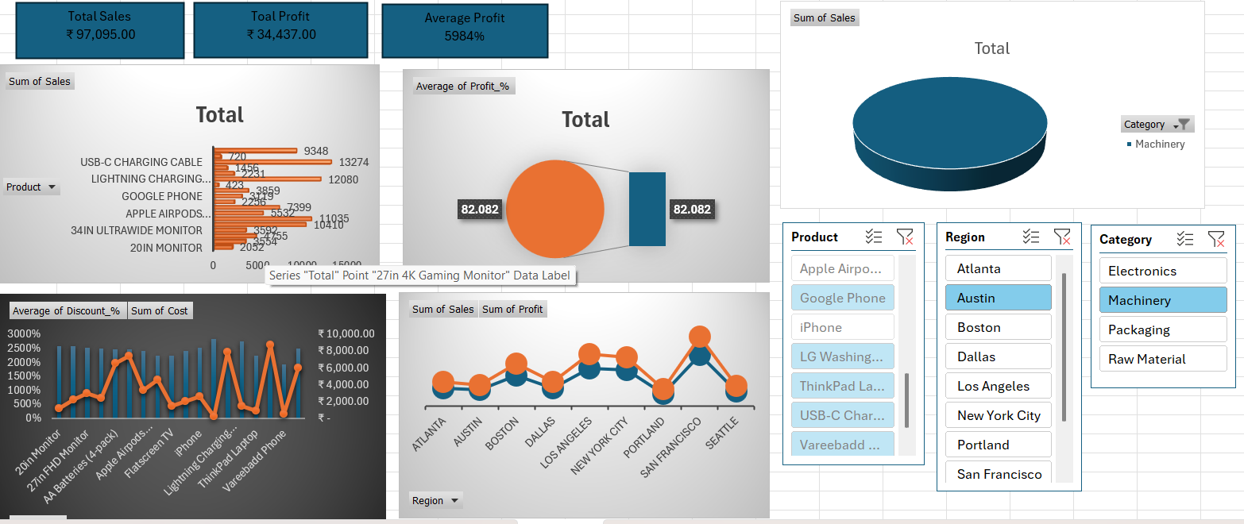

Reference

Title: Sales Data Analysis

Author: BeeKiran | Kaggle

