Heart Disease Prediction MLOps Project Report
Student: Sandhya Sharma
Repository: https://github.com/SandhyaSharma1512/2025ae05678-mlops-assignment1

Project Overview
This project implements an end-to-end MLOps workflow for heart disease prediction. The solution includes exploratory data analysis, preprocessing, model training, testing, FastAPI serving, Docker containerization, Kubernetes deployment, monitoring, logging and CI/CD automation.

Setup and Installation
Clone the repository, create a Python environment, install dependencies from requirements.txt, execute unit tests and launch the FastAPI application using Uvicorn. The Swagger interface is available through the /docs endpoint.

Exploratory Data Analysis (EDA)
EDA was performed to understand data quality, distributions, correlations and target balance. Activities included missing value analysis, summary statistics, feature distribution analysis, correlation heatmaps and outlier inspection. Screenshots of key visualizations should be included in this section.

Modelling Choices
The problem was formulated as a binary classification task. A preprocessing pipeline was implemented to handle transformations consistently. Multiple modelling approaches were evaluated using Accuracy, Precision, Recall and F1-Score before selecting the final model for deployment.

Experiment Tracking Summary
Several experiments were conducted to compare model performance. Parameters, evaluation metrics and model configurations were tracked and compared. The best-performing model was selected and stored as the production artifact.

Architecture Diagram
Data Source -> EDA & Preprocessing -> Model Training -> Saved Model Artifacts -> FastAPI Service -> Docker Container -> Kubernetes Deployment -> Monitoring & Logging.
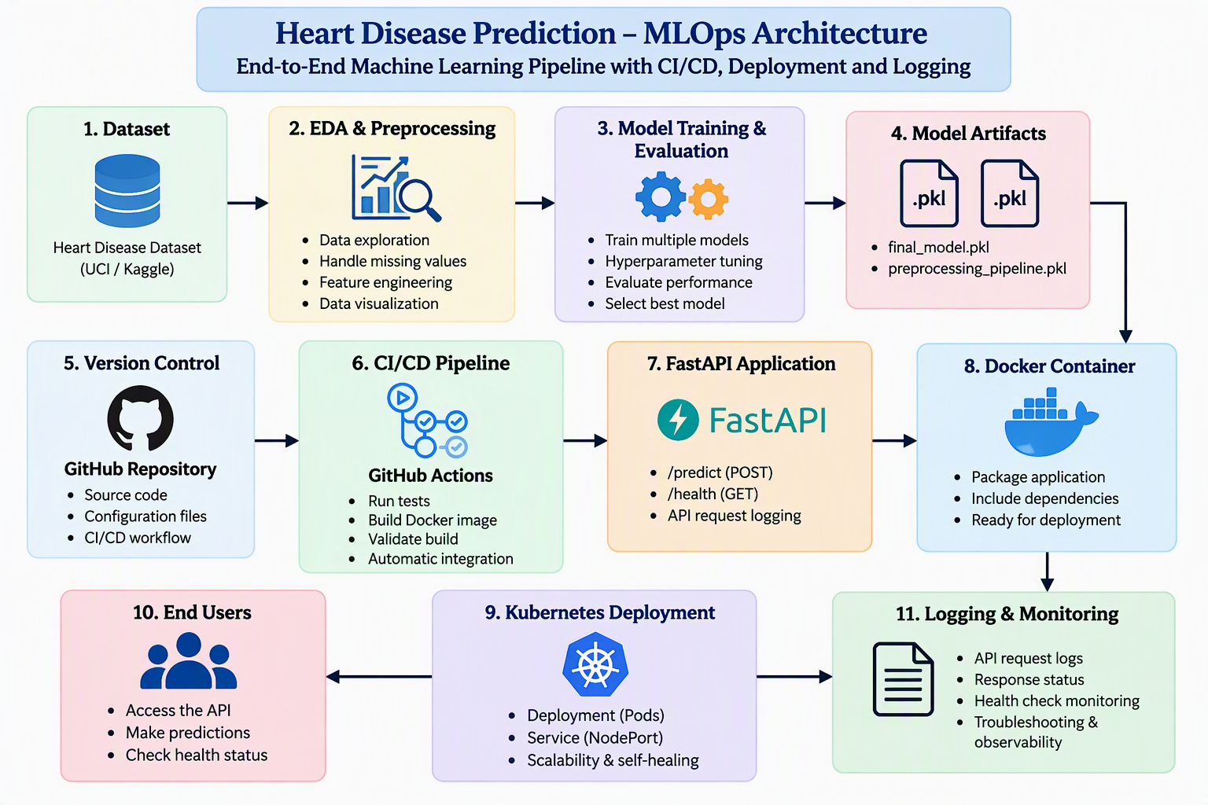

CI/CD Workflow
GitHub Actions was configured to automate repository checkout, dependency installation, test execution and build validation. This ensures code quality and reduces manual verification effort.

Docker Containerization
The application was packaged into a Docker image containing all dependencies and model artifacts. This ensures consistent execution across different environments and simplifies deployment.

Kubernetes Deployment
The Dockerized application was deployed using Kubernetes Deployment and Service manifests. Kubernetes manages application availability while the service exposes the API endpoints externally.

Monitoring and Logging
FastAPI middleware records incoming requests, response codes, predictions and confidence scores. Monitoring is provided through application metrics exposed at the /metrics endpoint using Prometheus-compatible instrumentation.

API Endpoints
GET /health verifies service availability. POST /predict accepts patient information and returns a prediction along with a confidence score.

Conclusion
This project demonstrates practical MLOps concepts including experimentation, model deployment, automation, monitoring and container orchestration in a production-oriented workflow.

Screenshots to Include
- EDA visualizations
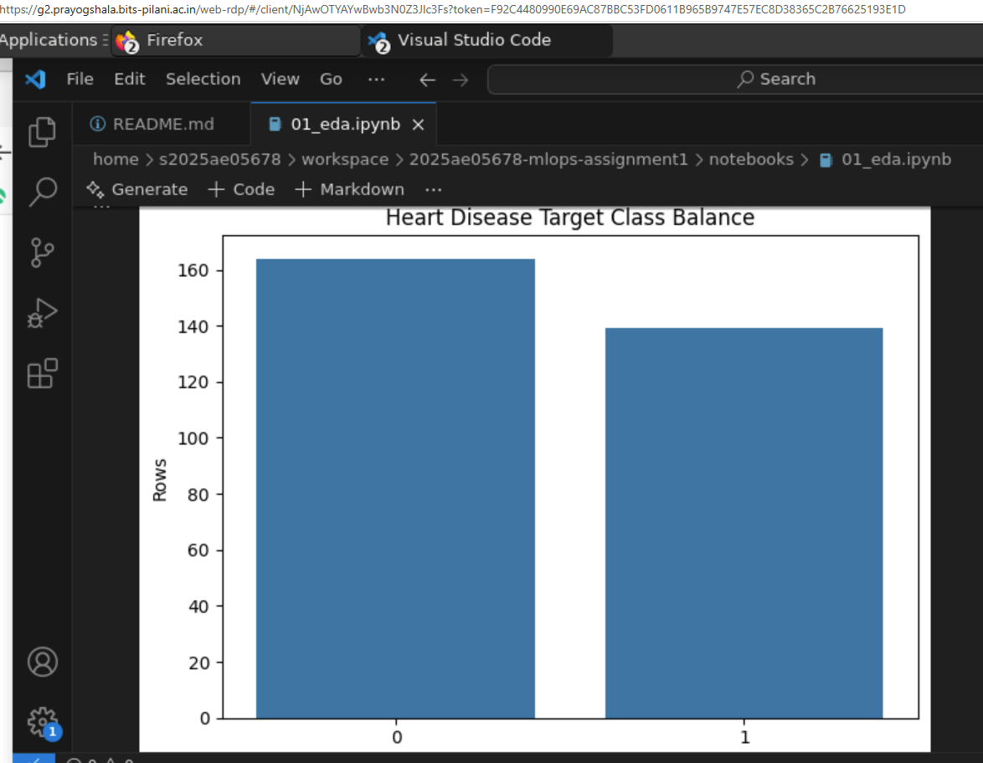
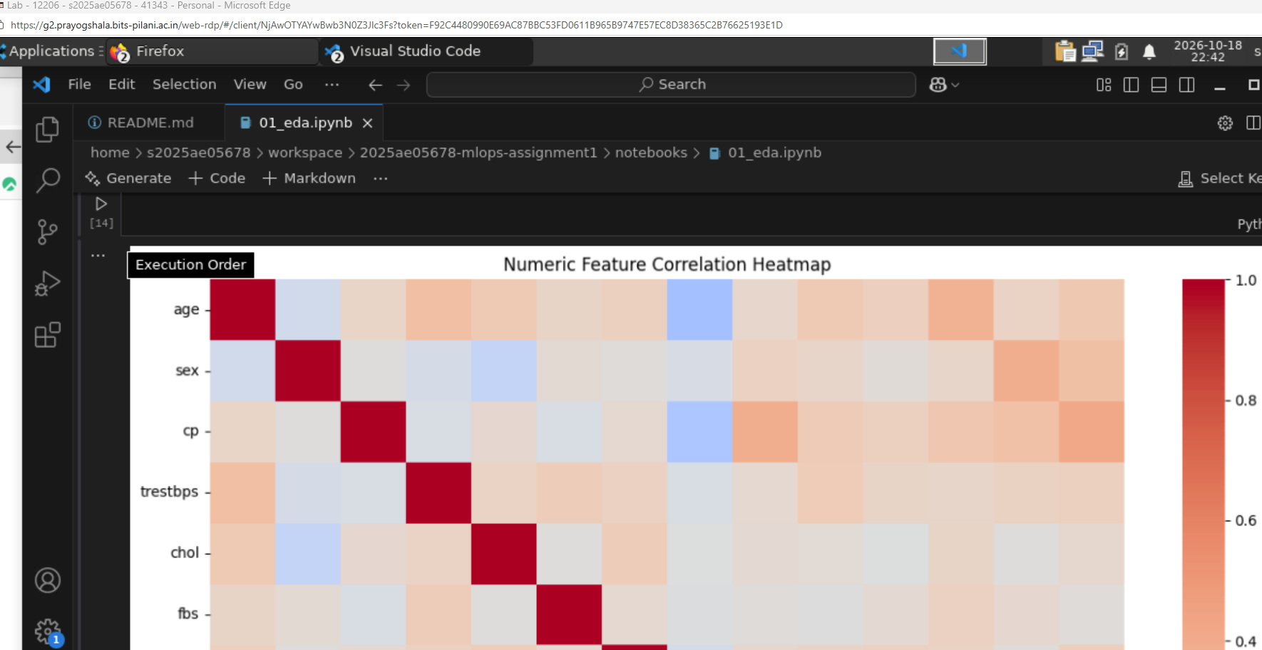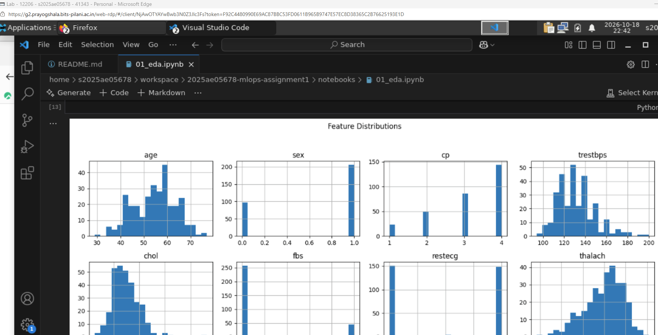

- Experiment tracking results
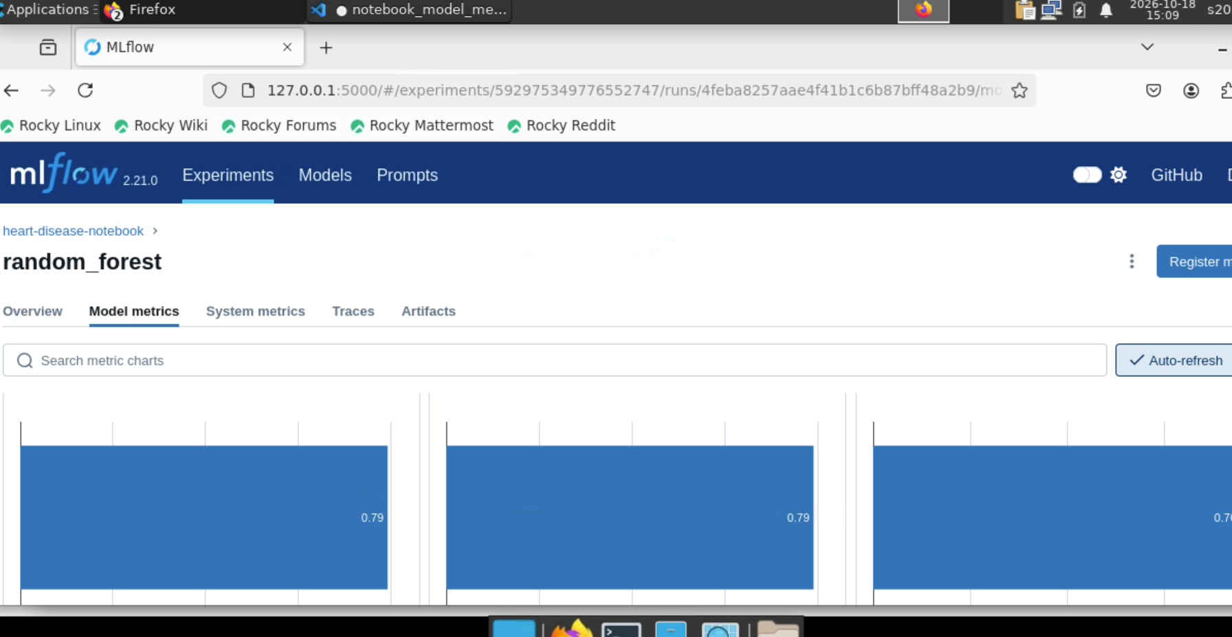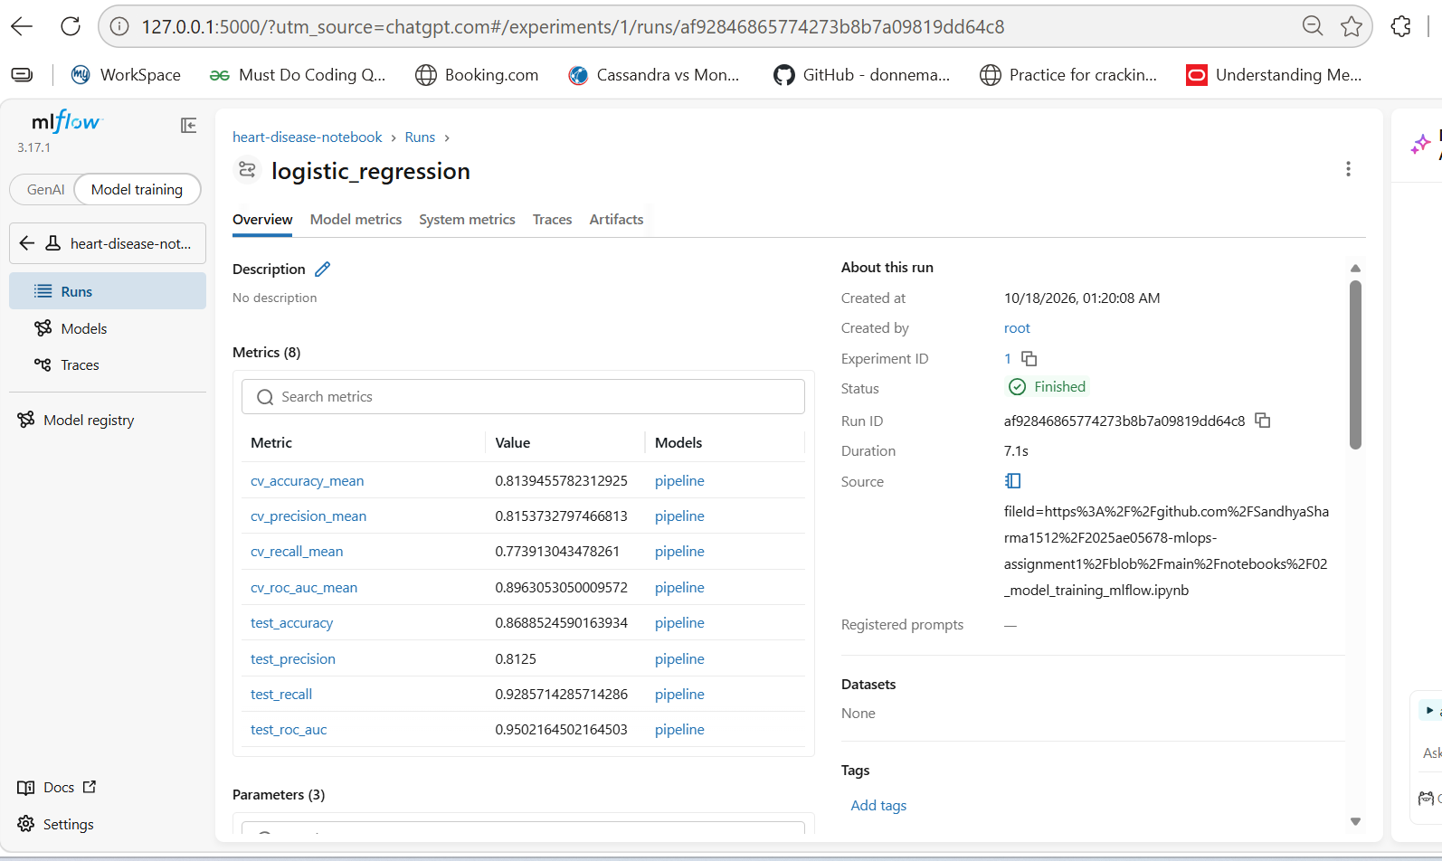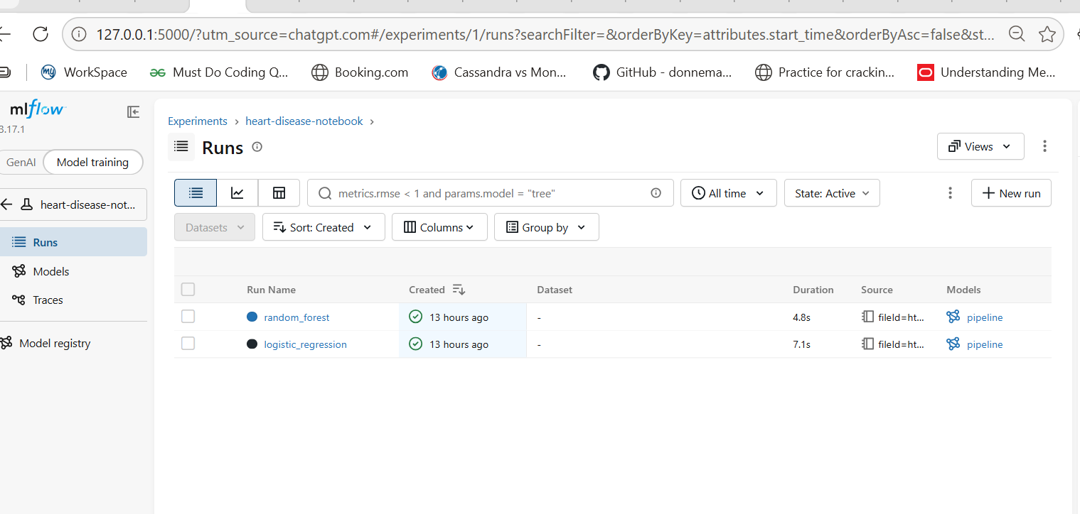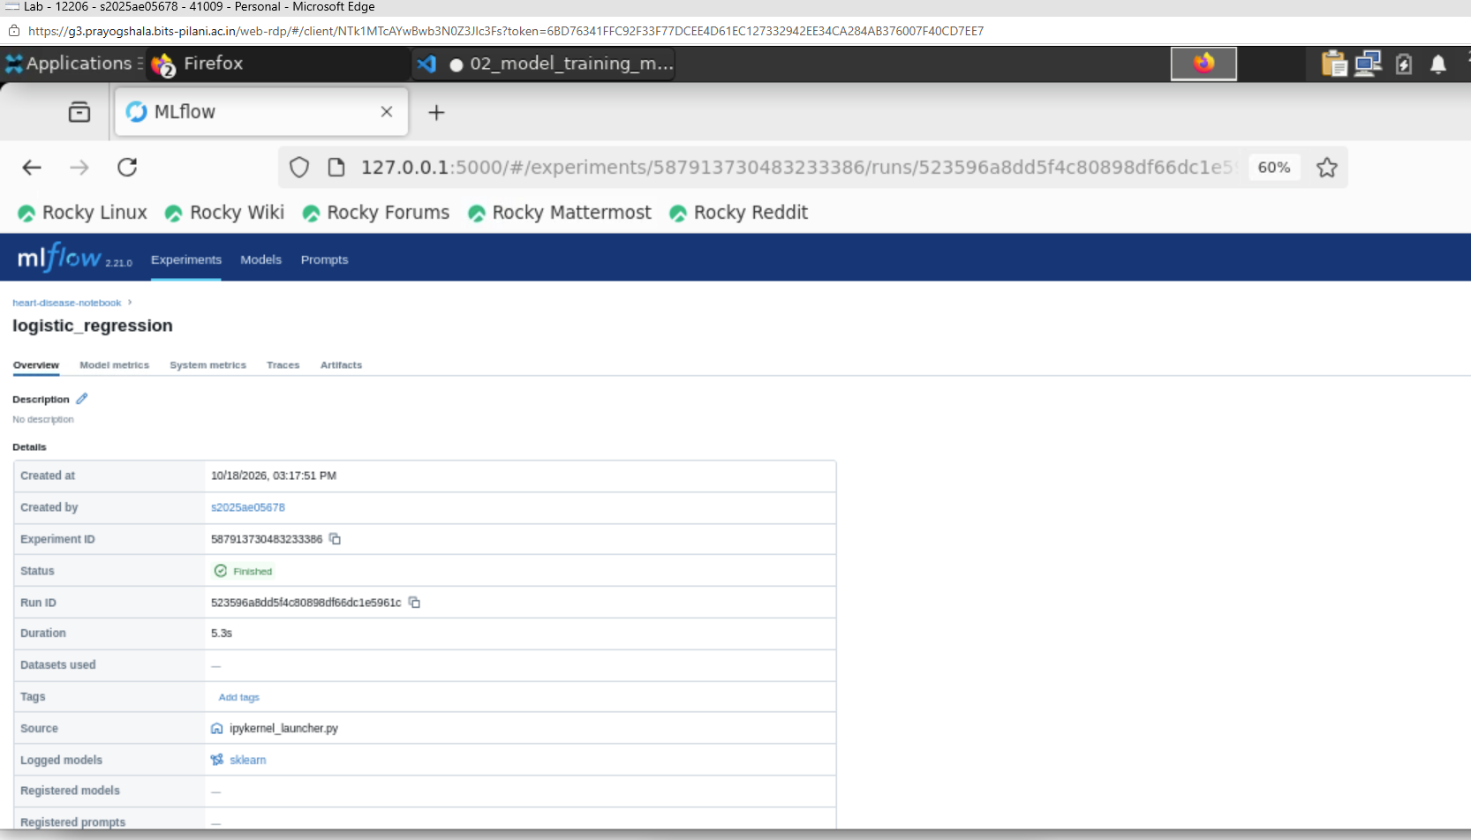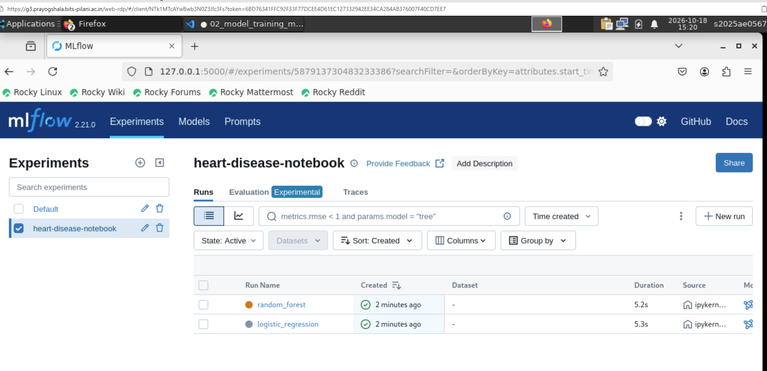

- GitHub Actions successful run
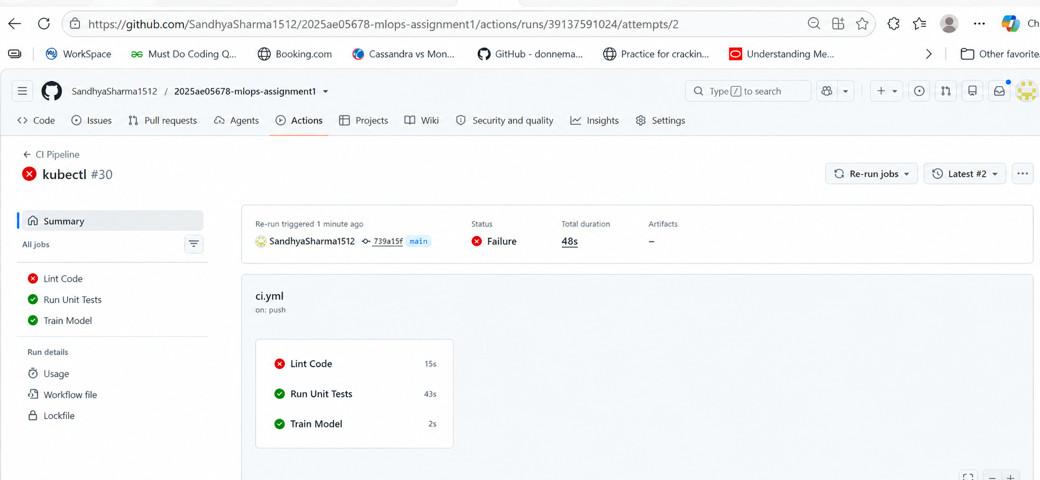
- Docker build output
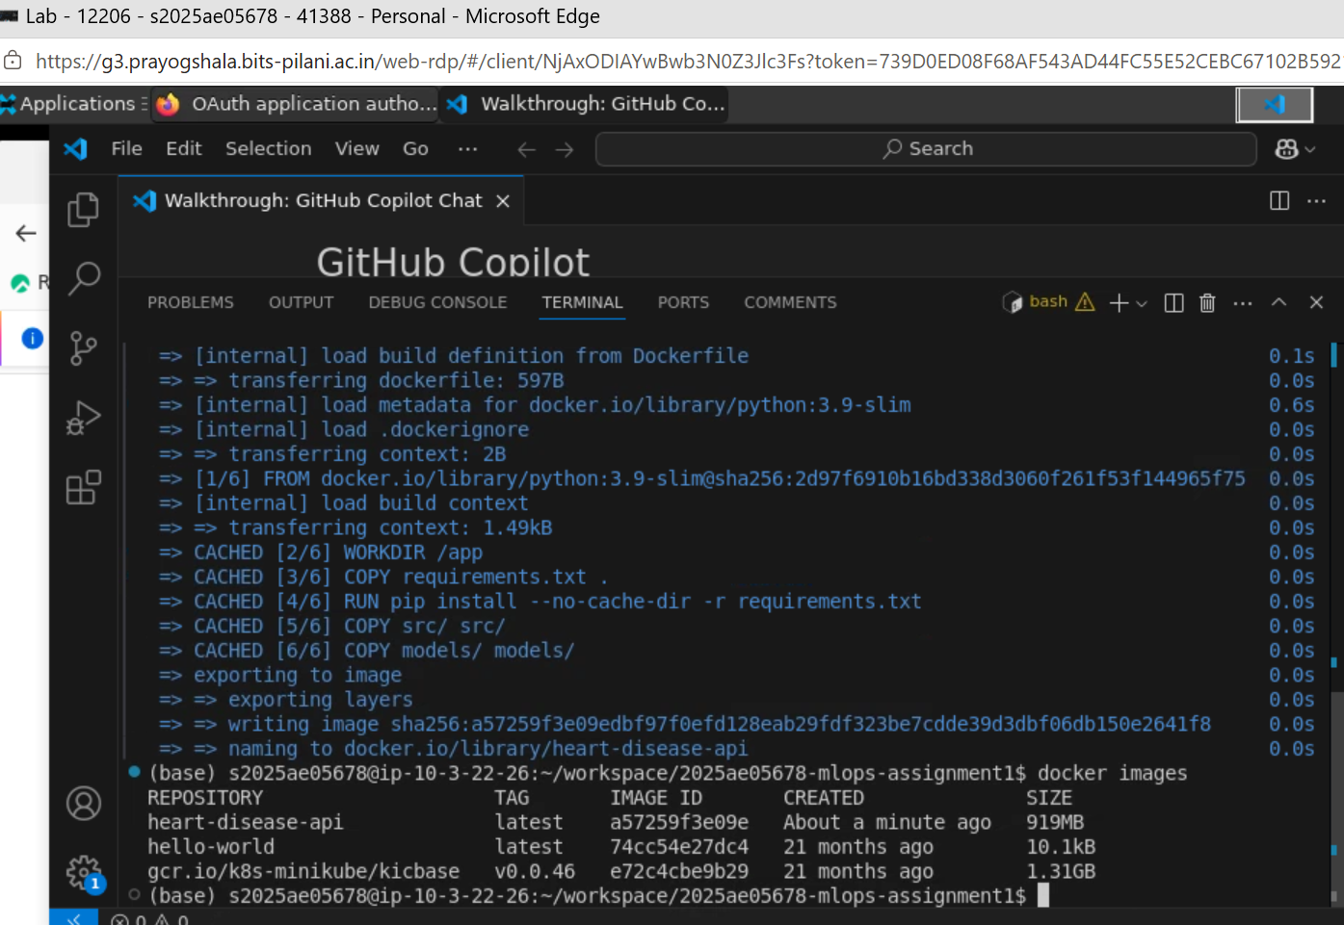

- Kubernetes deployment and services
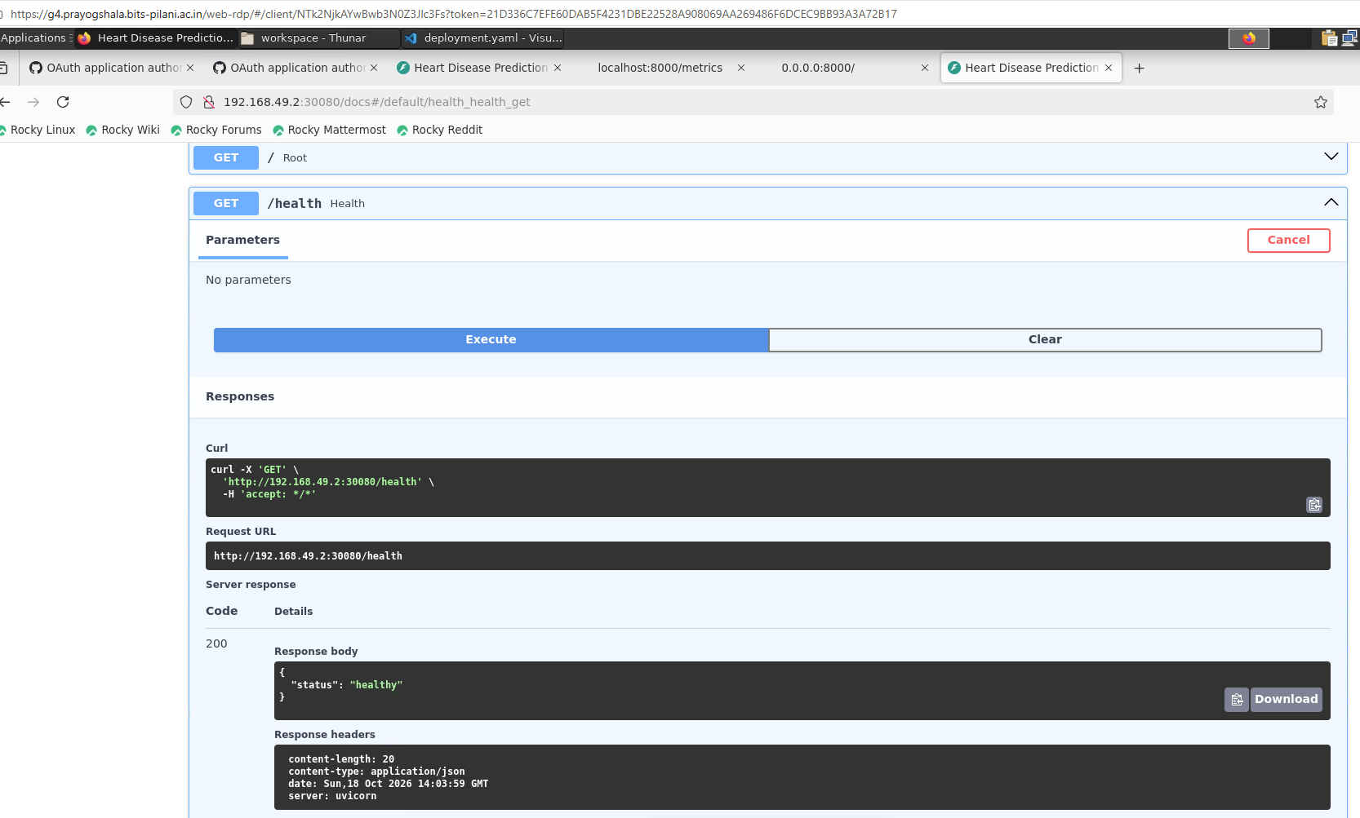
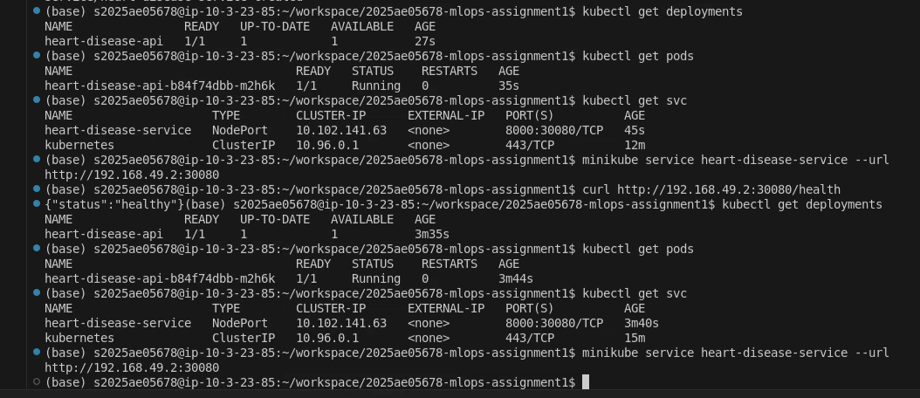

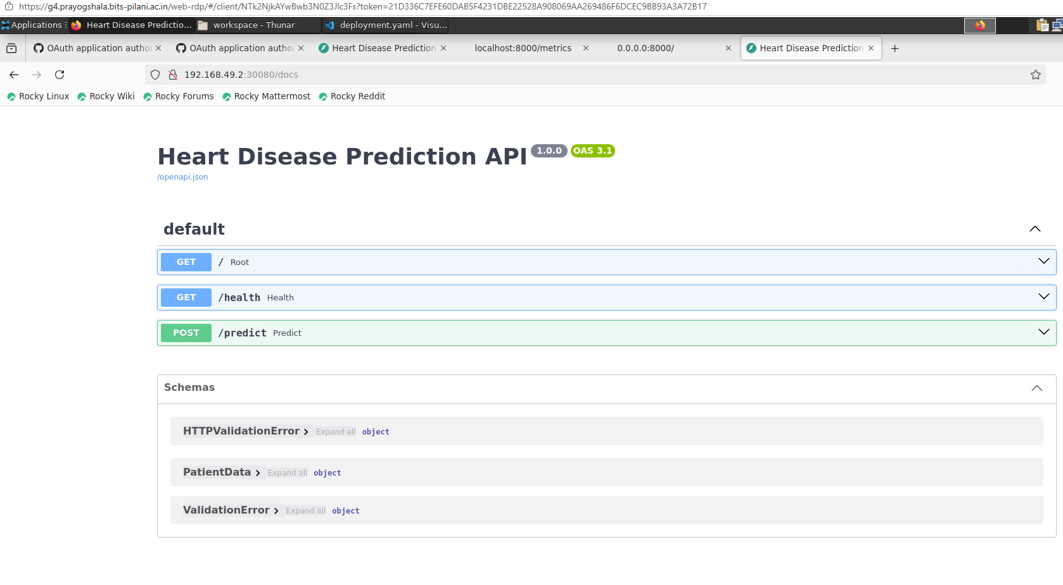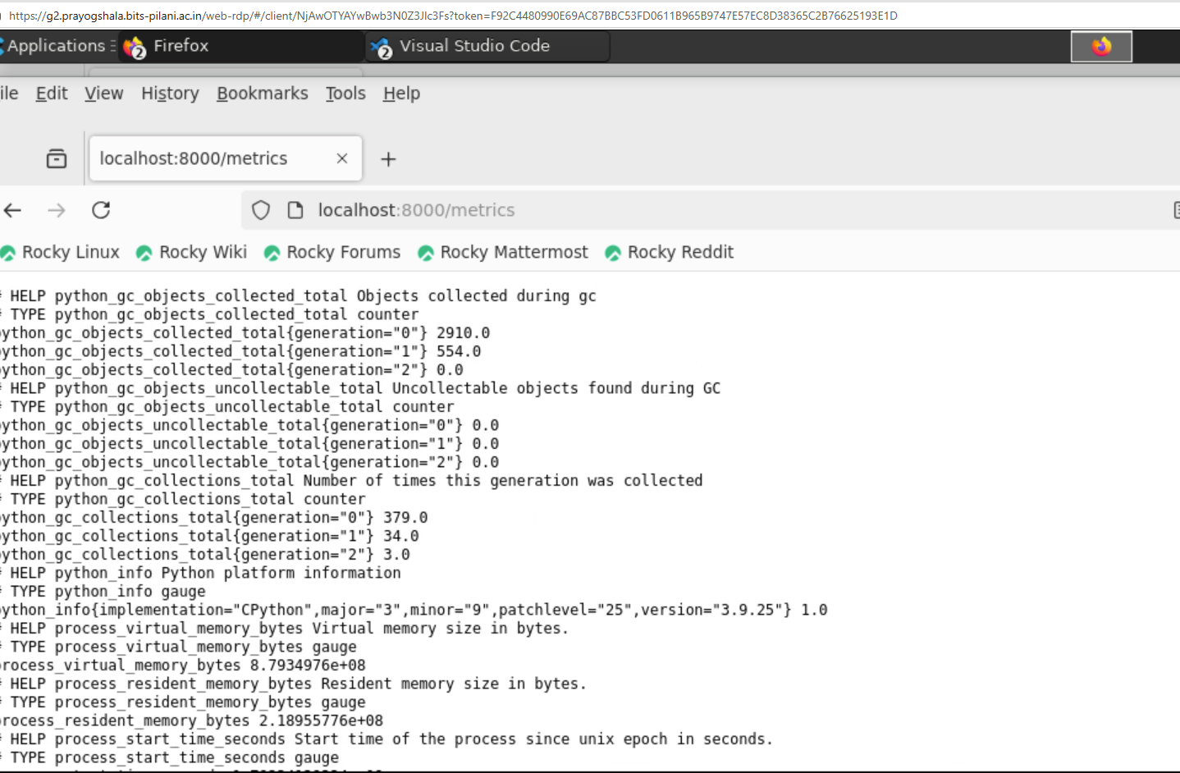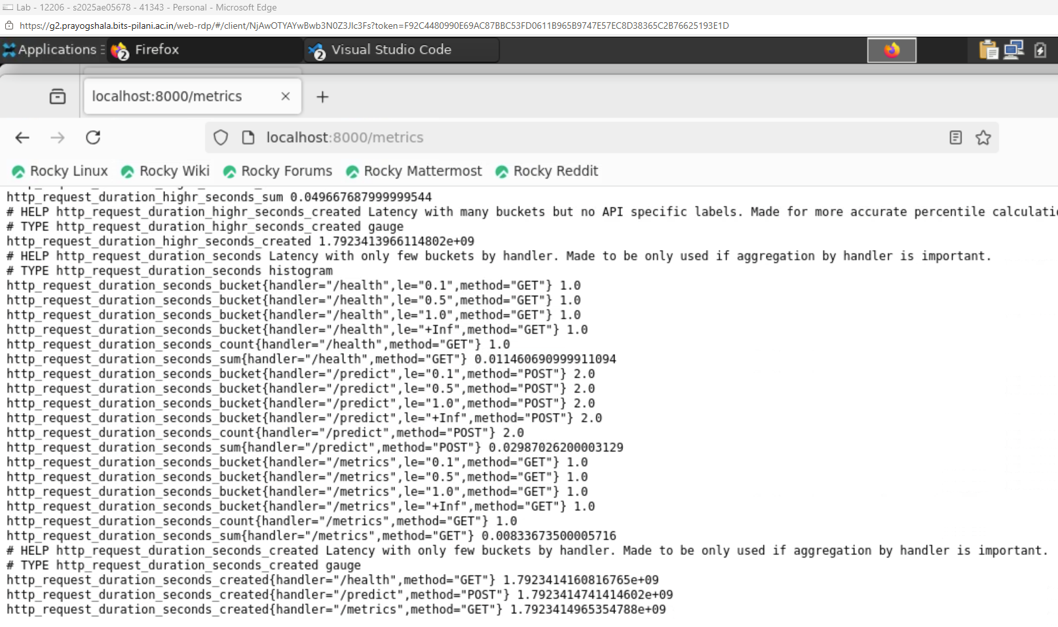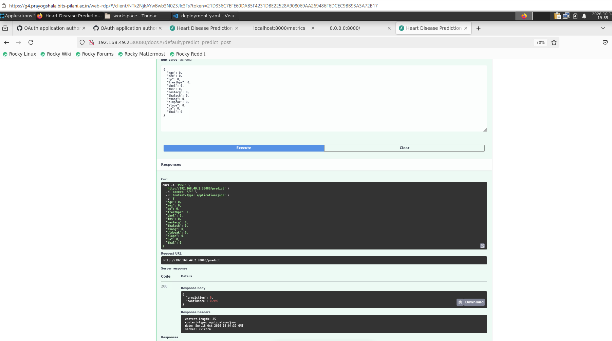

- Swagger UI
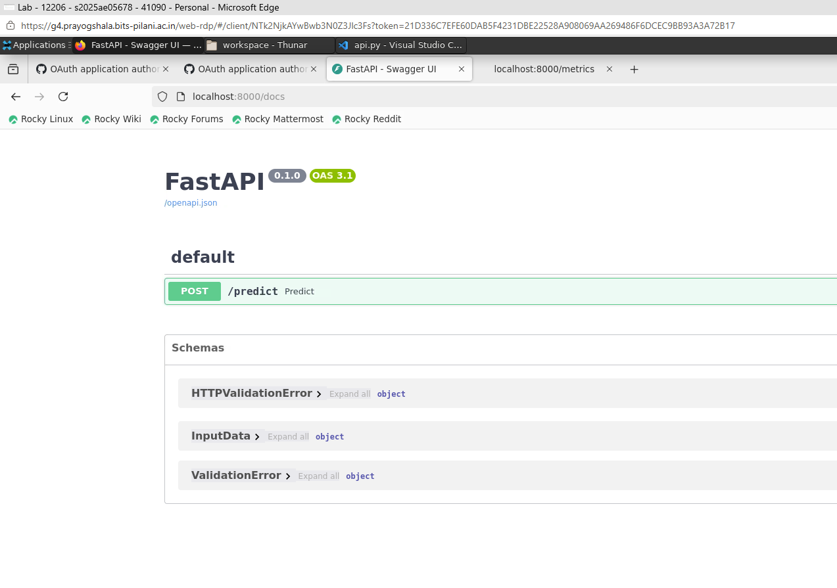

- Health endpoint response

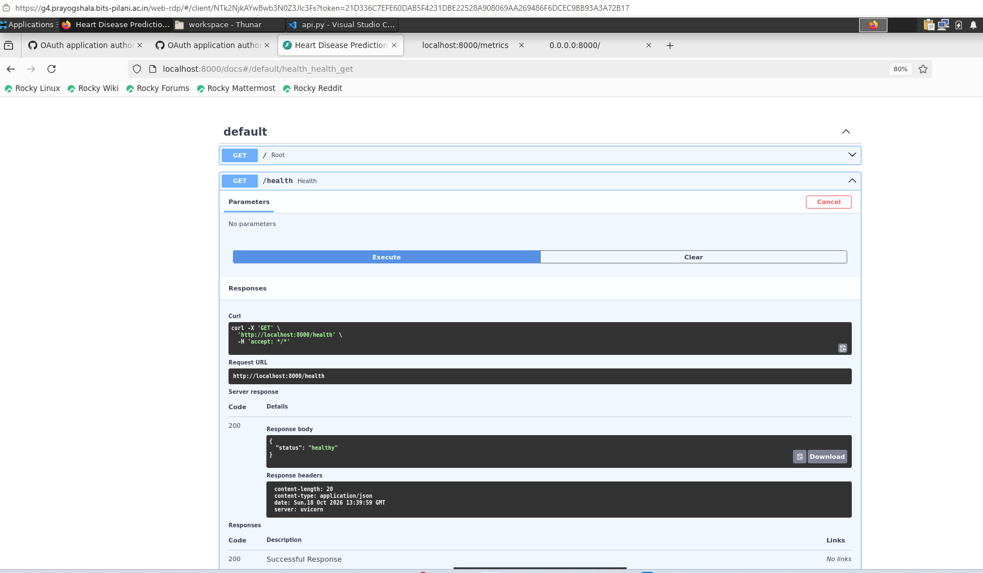
- Prediction endpoint response

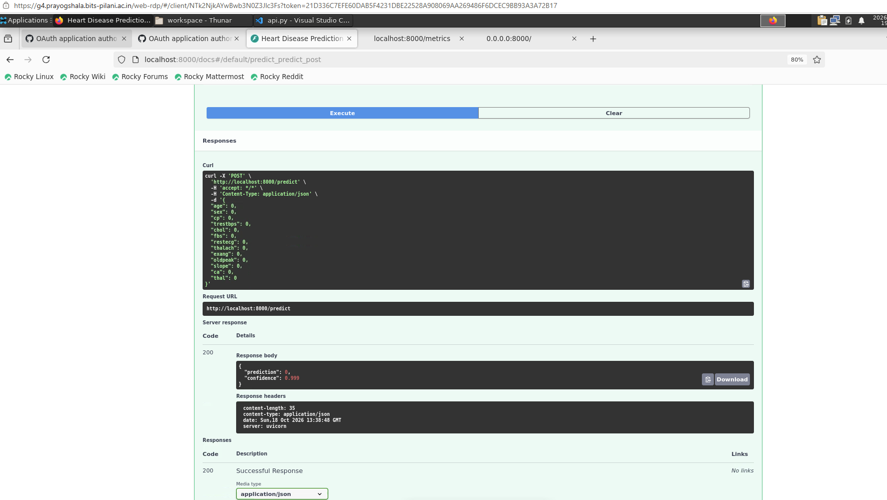

- Logs output

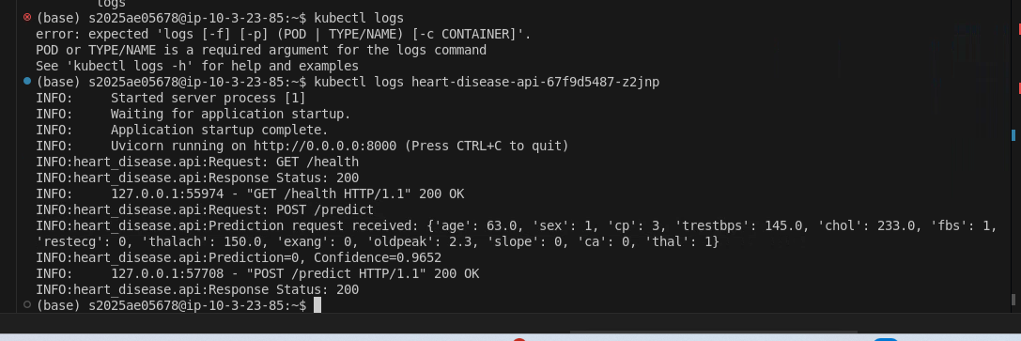

Metrics endpoint output

