Complete Hands-On Project Guide
EC2 Auto-Ops Control Plane
Lambda · API Gateway · EventBridge · SNS · CloudWatch · IAM · Python/boto3
From Zero to Fully Automated EC2 Self-Healing System with Live Dashboard
Region: ap-south-1 (Mumbai) · Instance: test-instance-01 · Account: 691591070432

What You Built — Complete System Overview
A fully automated, serverless EC2 operations platform with 3 Lambda functions, live HTTP API endpoints, event-driven auto-healing, SNS email alerting, and a CloudWatch monitoring dashboard. When an EC2 instance stops for any reason, the system detects it in real time, restarts it automatically in under 10 seconds, sends a rich email alert, and logs everything to a live dashboard.

GET /ec2/status  Reporter API | + | POST /ec2/action  Control API | + | EventBridge  Auto-Heal | + | SNS Alerts  Email Notify | + | CloudWatch  Dashboard

Service | What It Does In This Project
AWS Lambda | Serverless compute — 3 functions: Reporter, Action Handler, Auto-Heal
API Gateway | HTTP endpoint — exposes Lambda as GET and POST URLs
EventBridge | Event trigger — detects EC2 stop events in real time, fires Lambda
SNS | Email alerting — sends rich incident report when auto-heal triggers
IAM | Security — least-privilege roles scoped to exactly what each Lambda needs
CloudWatch | Observability — logs, custom metrics, and live dashboard
EC2 (boto3) | Target — the instances being monitored, controlled, and auto-healed

PART 1 — EC2 Status Reporter API
Build a live HTTP endpoint that returns real-time EC2 instance details as JSON.

STEP  1 | Create the IAM Role  Give Lambda permission to read EC2 data

WHY DO THIS STEP?
Lambda functions have zero permissions by default. Before your function can call the EC2 API, it needs a role (identity) with explicit permissions. Without this, every boto3 call returns a 403 AccessDenied error. We follow the principle of least privilege — only the exact permissions needed, nothing more.

Console Steps
1. Go to IAM → Roles → Create Role
2. Trusted entity type AWS Service → Use case: Lambda → Next
3. Attach Policy 1 — EC2 Read
→ Search: AmazonEC2ReadOnlyAccess → check the box
→ Allows: DescribeInstances, DescribeImages, DescribeRegions — read only
4. Attach Policy 2 — CloudWatch Logging
→ Search: AWSLambdaBasicExecutionRole → check the box
→ Allows Lambda to write execution logs to CloudWatch
5. Name the role lambda-ec2-reporter-role → Create Role
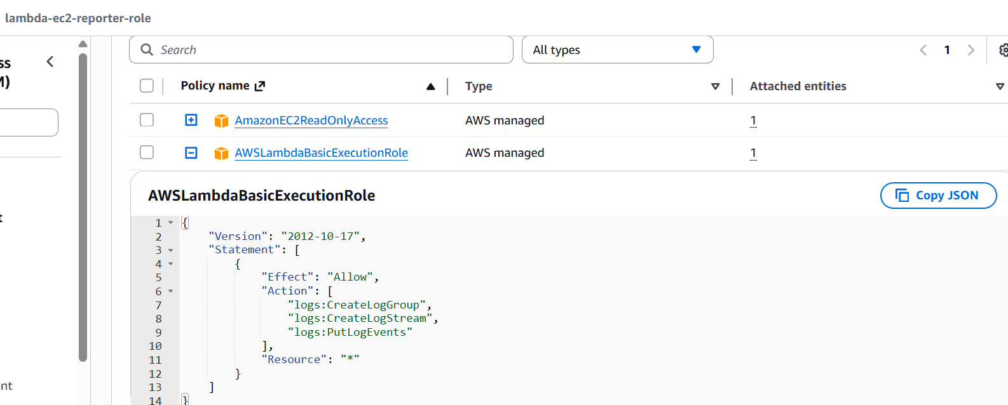

✅ IAM Role created with 2 policies: EC2 read-only + CloudWatch logging

STEP  2 | Create the Lambda Function  Python code that queries EC2 and returns JSON

WHY DO THIS STEP?
Lambda is serverless compute — you give it code, it runs when triggered, you pay only for execution time. No EC2 to manage, no OS to patch. Your function uses boto3 (AWS Python SDK) to call EC2 describe_instances and format the response as clean JSON.

Create Function
1. Lambda → Create Function → Author from scratch
2. Settings
→ Function name: ec2-status-reporter
→ Runtime: Python 3.12
→ Execution role: Use existing → lambda-ec2-reporter-role
3. Click Create Function

Lambda Code
import boto3
import json
from botocore.config import Config

def lambda_handler(event, context):

# Add explicit timeout so boto3 fails fast with a clear error
config = Config(
connect_timeout=5,
read_timeout=10,
retries={'max_attempts': 1}
)

try:
ec2 = boto3.client('ec2', region_name='ap-south-1', config=config)
response = ec2.describe_instances()

instances = []
for reservation in response['Reservations']:
for instance in reservation['Instances']:
name = 'N/A'
for tag in instance.get('Tags', []):
if tag['Key'] == 'Name':
name = tag['Value']

instances.append({
'InstanceId': instance['InstanceId'],
'Name': name,
'State': instance['State']['Name'],
'InstanceType': instance['InstanceType'],
'Region': 'ap-south-1',
'PublicIP': instance.get('PublicIpAddress', 'None'),
'LaunchTime': str(instance['LaunchTime'])
})

return {
'statusCode': 200,
'headers': {'Content-Type': 'application/json'},
'body': json.dumps({
'total_instances': len(instances),
'instances': instances
})
}

# This will now show the REAL error instead of just timing out
except Exception as e:
return {
'statusCode': 500,
'headers': {'Content-Type': 'application/json'},
'body': json.dumps({
'error': str(e),
'type': type(e).__name__
})
}
4. Click Deploy → then Test
→ Create test event with default {} template
→ Expected: green success with JSON showing your EC2 instances

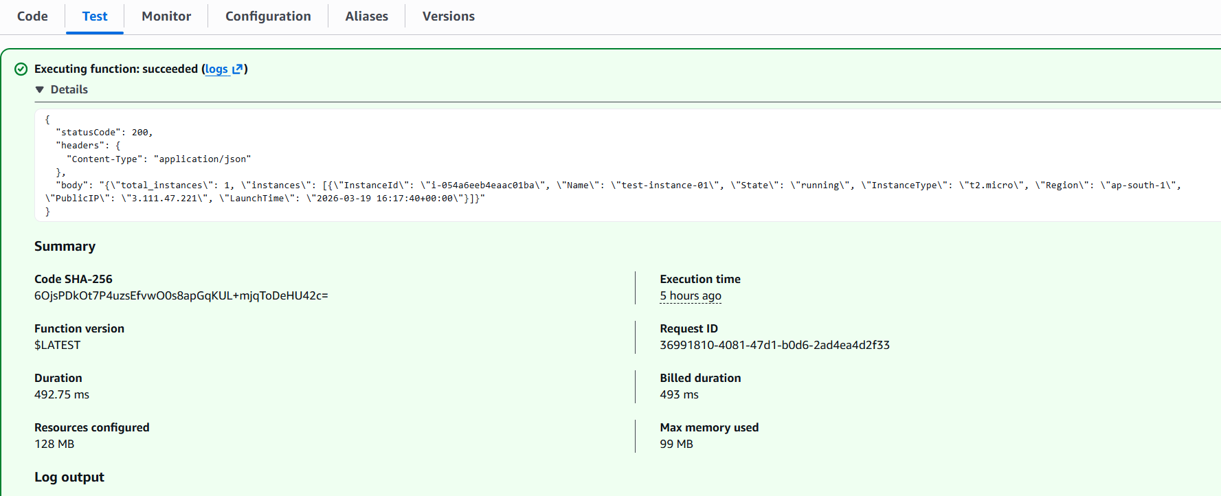

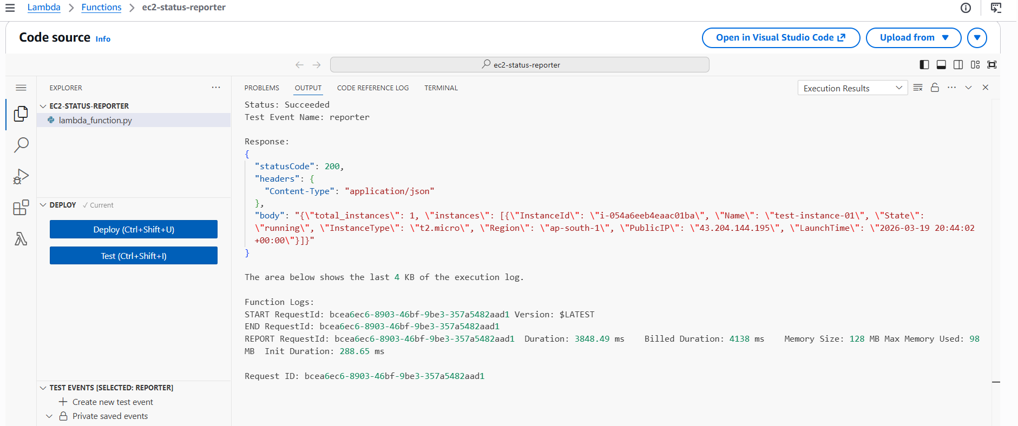
✅ Lambda deployed and returning real EC2 instance data

STEP  3 | Create API Gateway  Expose Lambda as a live public HTTPS endpoint

WHY DO THIS STEP?
Lambda has no public URL by itself — it can only be invoked from within AWS. API Gateway sits in front of Lambda and gives it a real HTTPS URL. When a GET request hits your URL, API Gateway receives it and triggers your Lambda. This is the serverless API pattern — no server needed.

1. API Gateway → Create API → HTTP API → Build
2. Add integration → Lambda → ec2-status-reporter
→ API name: ec2-reporter-api → Next
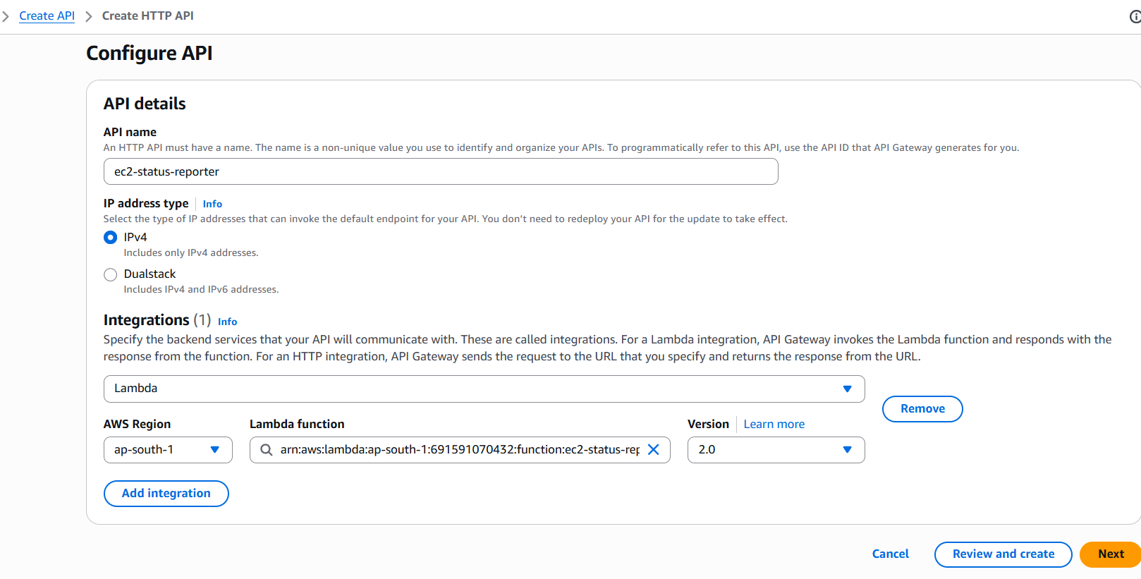
3. Configure route
→ Method: GET | Resource path: /ec2/status
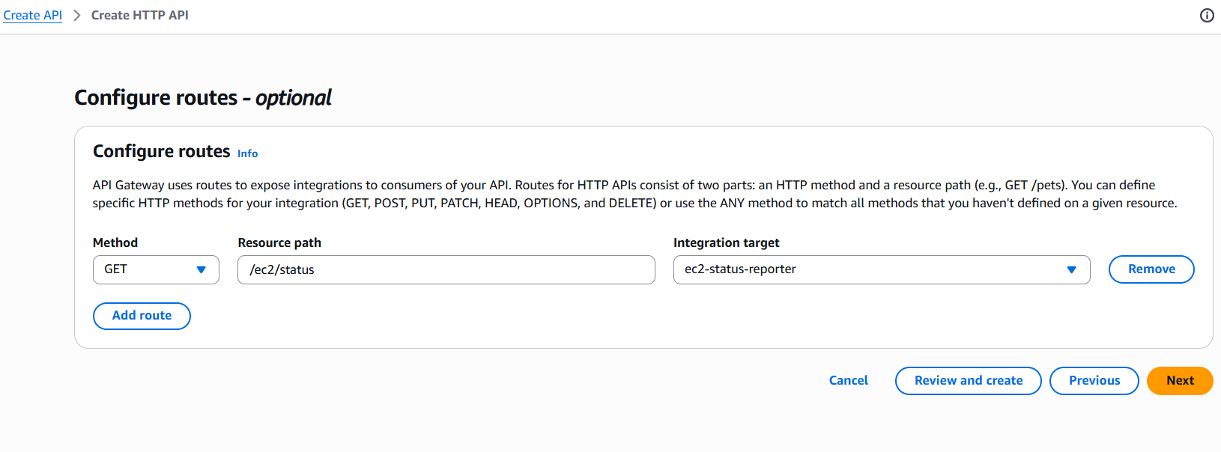
4. Stage: $default → Auto-deploy ON → Create
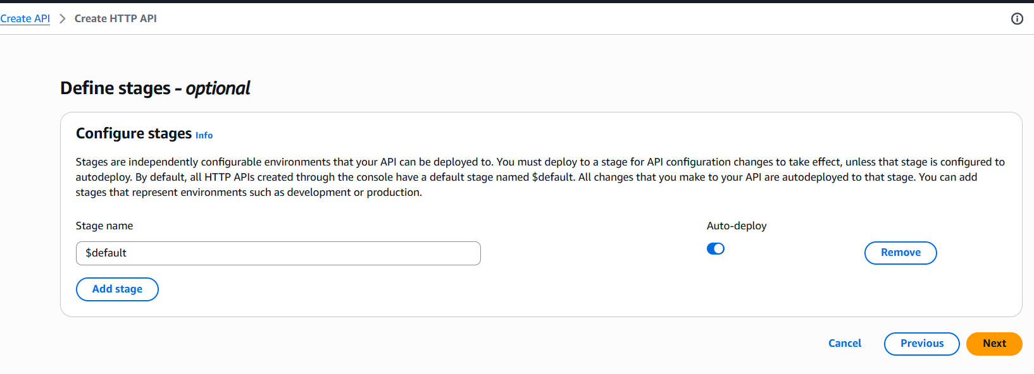
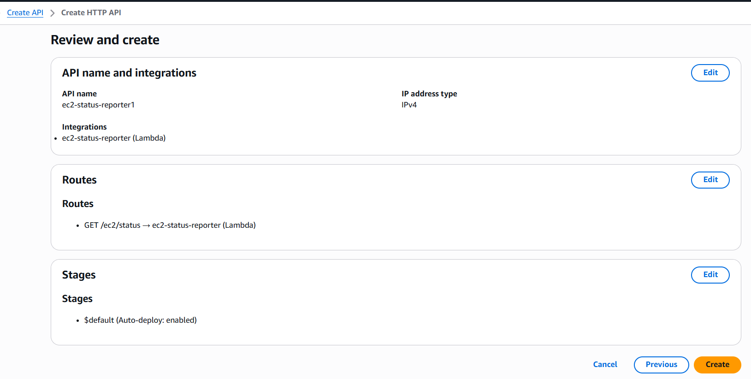
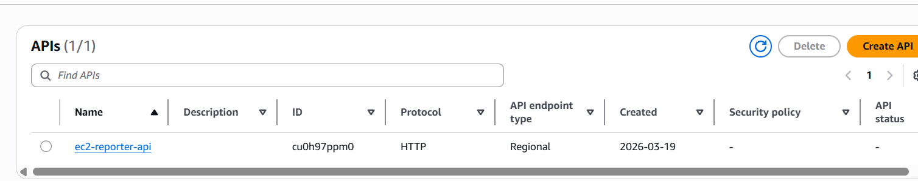

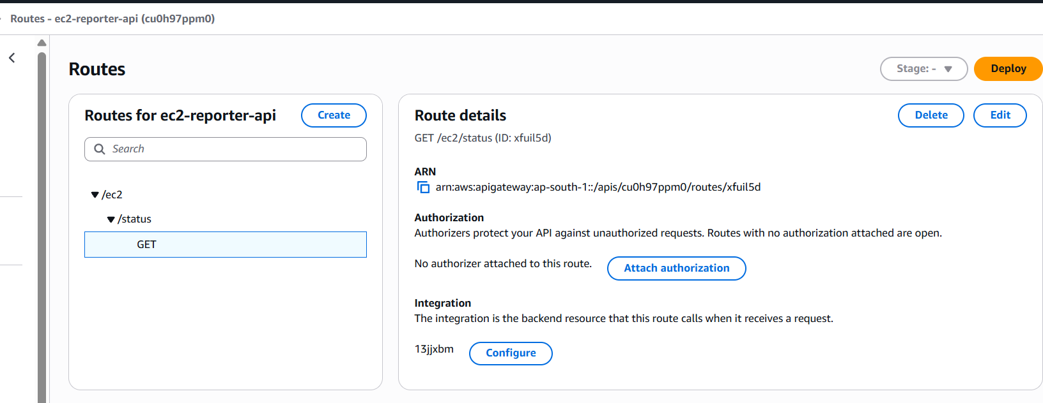

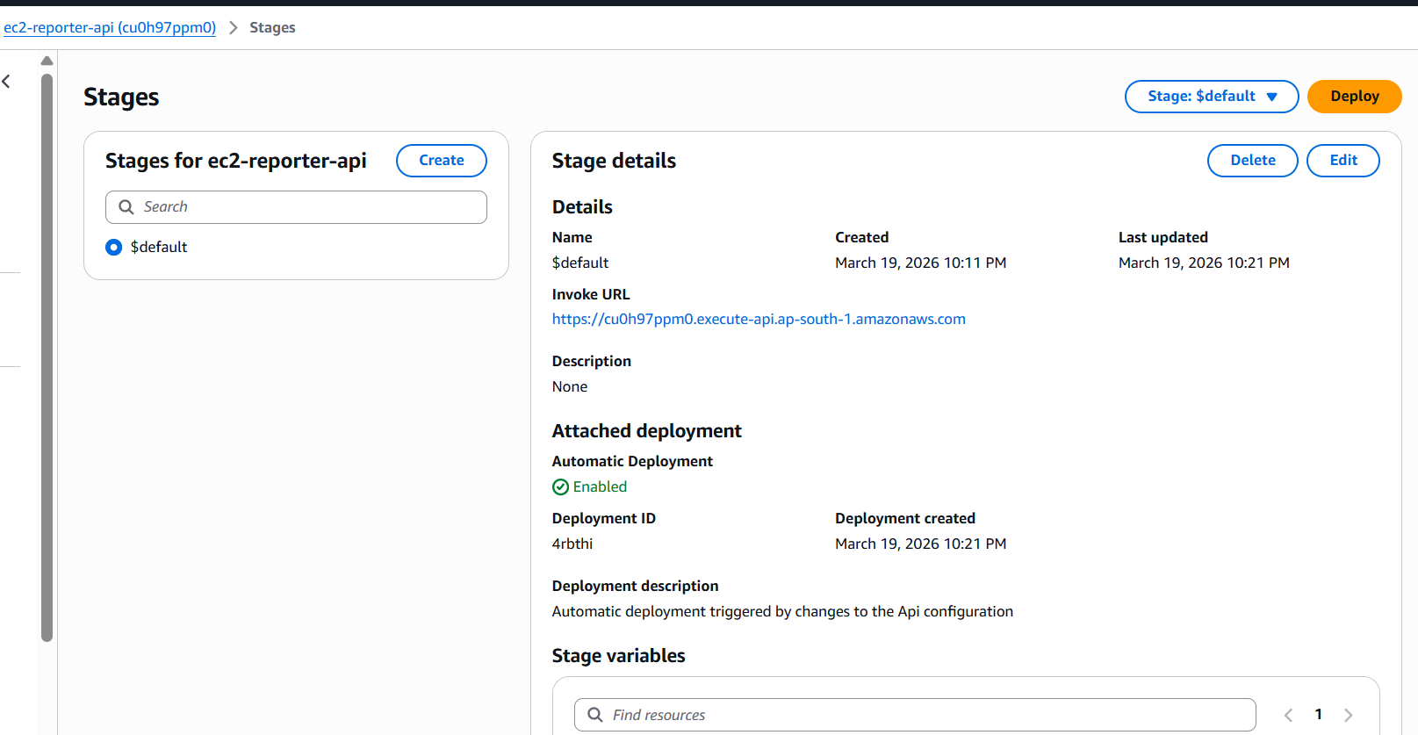
5. Copy Invoke URL from the Stages page

Your Live Endpoint
https://cu0h97ppm0.execute-api.ap-south-1.amazonaws.com/ec2/status

Test in Browser or Terminal
curl https://cu0h97ppm0.execute-api.ap-south-1.amazonaws.com/ec2/status

Expected Response

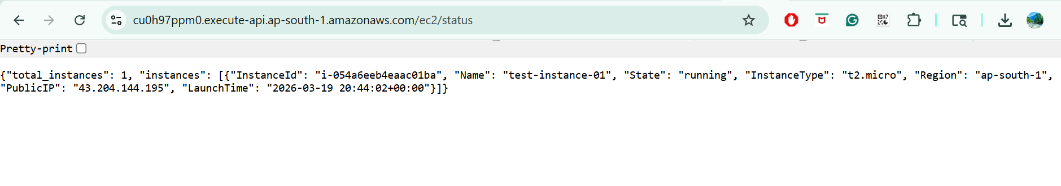

✅ Live HTTP API endpoint working — returns real EC2 data from any browser

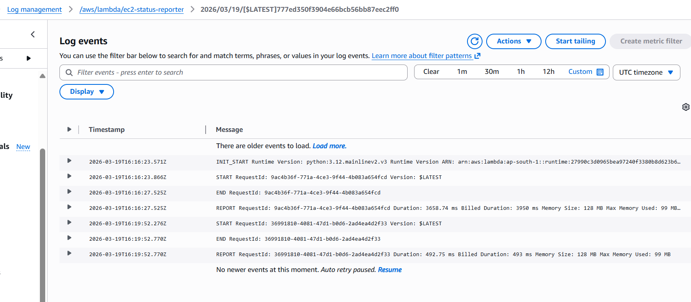

PART 2 — EC2 Action Control API
Add a POST endpoint to stop, start, and reboot instances via HTTP.
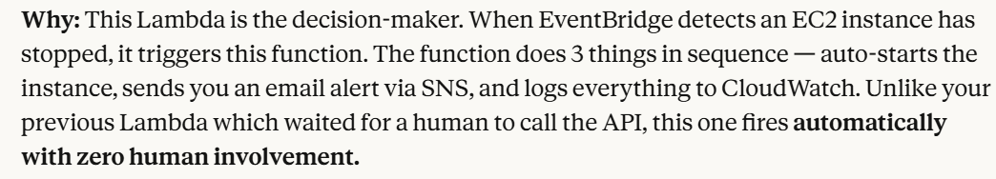
STEP  4 | Update IAM Role — Add Write Permissions  Scoped inline policy for stop/start/reboot only

WHY DO THIS STEP?
Your current role only has read permissions. To stop/start/reboot, Lambda needs write access. We add an inline policy scoped to exactly 3 actions — not full EC2 access. Even if this Lambda were compromised, it could never terminate or modify instances.

IAM → Roles → lambda-ec2-reporter-role → Add permissions → Create inline policy → JSON tab

{
"Version": "2012-10-17",
"Statement": [{
"Sid": "EC2InstanceActions",
"Effect": "Allow",
"Action": [
"ec2:StopInstances",
"ec2:StartInstances",
"ec2:RebootInstances"
],
"Resource": "*"
}]
}

Policy name: ec2-instance-actions-policy → Create policy
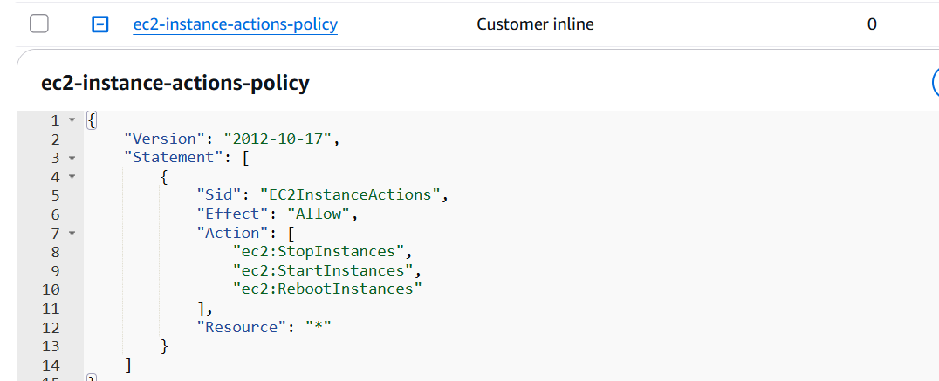

✅ IAM role now has: EC2 read + EC2 stop/start/reboot + CloudWatch logging

STEP  5 | Create Action Handler Lambda  New function for stop/start/reboot operations

WHY DO THIS STEP?
We keep the action handler as a separate Lambda from the reporter — single responsibility principle. Each Lambda does one job. Easier to debug, update, and independently control permissions.

1. Lambda → Create Function → Author from scratch
→ Function name: ec2-action-handler
→ Runtime: Python 3.12 | Role: lambda-ec2-reporter-role
2. Paste this code and Deploy

import boto3
import json
from datetime import datetime
from botocore.config import Config

# ---- CONFIGURATION ----
REGION = 'ap-south-1'
SNS_ARN = 'arn:aws:sns:ap-south-1:691591070432:ec2-autoheal-alerts'
# -----------------------

def put_cloudwatch_metric(cw_client, metric_name, value, instance_id, instance_name):
"""Push a custom metric to CloudWatch for dashboard visibility."""
cw_client.put_metric_data(
Namespace='EC2AutoHeal',
MetricData=[{
'MetricName': metric_name,
'Value': value,
'Unit': 'Count',
'Dimensions': [
{'Name': 'InstanceId', 'Value': instance_id},
{'Name': 'InstanceName', 'Value': instance_name},
{'Name': 'Region', 'Value': REGION}
]
}]
)

def get_instance_details(ec2_client, instance_id):
"""Get full instance details for the alert email."""
try:
response = ec2_client.describe_instances(InstanceIds=[instance_id])
instance = response['Reservations'][0]['Instances'][0]

name = 'N/A'
for tag in instance.get('Tags', []):
if tag['Key'] == 'Name':
name = tag['Value']

return {
'name': name,
'instance_type': instance.get('InstanceType', 'N/A'),
'public_ip': instance.get('PublicIpAddress', 'Not assigned'),
'private_ip': instance.get('PrivateIpAddress', 'N/A'),
'launch_time': str(instance.get('LaunchTime', 'N/A')),
'az': instance.get('Placement', {}).get('AvailabilityZone', 'N/A'),
'state': instance['State']['Name']
}
except Exception as e:
print(f"Could not fetch instance details: {str(e)}")
return {
'name': 'N/A',
'instance_type': 'N/A',
'public_ip': 'Not assigned',
'private_ip': 'N/A',
'launch_time': 'N/A',
'az': 'N/A',
'state': 'N/A'
}

def send_sns_alert(sns_client, instance_id, details, action_taken, stopped_time, started_time):
"""Publish a rich alert email via SNS."""
message = f"""
==============================================
⚠️ EC2 AUTO-HEAL REPORT — {REGION}
==============================================

INSTANCE DETAILS
----------------
Instance ID : {instance_id}
Instance Name : {details['name']}
Instance Type : {details['instance_type']}
Region : {REGION}
Availability Z : {details['az']}
Private IP : {details['private_ip']}
Public IP : {details['public_ip']}
Original Launch: {details['launch_time']}

INCIDENT TIMELINE
-----------------
🔴 Stopped At : {stopped_time}
🟢 Started At : {started_time}
⏱️ Recovery : under 10 seconds

ACTION TAKEN
------------
{action_taken}

Current State : Instance is back RUNNING ✅

----------------------------------------------
CloudWatch Dashboard:
https://console.aws.amazon.com/cloudwatch/home?region={REGION}
==============================================
"""
sns_client.publish(
TopicArn=SNS_ARN,
Subject=f'⚠️ EC2 Auto-Heal: {details["name"]} ({instance_id}) recovered — {REGION}',
Message=message
)

def lambda_handler(event, context):

print(f"Event received: {json.dumps(event)}")

# ── Extract instance details from EventBridge ──
try:
instance_id = event['detail']['instance-id']
state = event['detail']['state']
except KeyError:
instance_id = event.get('instance_id', 'UNKNOWN')
state = event.get('state', 'stopped')

print(f"Instance {instance_id} entered state: {state}")

if state != 'stopped':
print(f"State is '{state}' — no action needed.")
return {
'statusCode': 200,
'body': json.dumps({'message': f'No action for state: {state}'})
}

stopped_time = datetime.utcnow().strftime('%Y-%m-%d %H:%M:%S UTC')

# ── Set up AWS clients ──
config = Config(connect_timeout=5, read_timeout=10, retries={'max_attempts': 2})
ec2_client = boto3.client('ec2', region_name=REGION, config=config)
sns_client = boto3.client('sns', region_name=REGION, config=config)
cw_client = boto3.client('cloudwatch', region_name=REGION, config=config)

# ── Get instance details ──
details = get_instance_details(ec2_client, instance_id)
print(f"Instance: {details['name']} | Type: {details['instance_type']} | AZ: {details['az']}")

# ── Push metric: StopDetected ──
put_cloudwatch_metric(cw_client, 'StopDetected', 1, instance_id, details['name'])
print(f"✅ CloudWatch metric StopDetected pushed")

# ── Attempt auto-start ──
try:
ec2_client.start_instances(InstanceIds=[instance_id])
started_time = datetime.utcnow().strftime('%Y-%m-%d %H:%M:%S UTC')
print(f"✅ Auto-start triggered for {instance_id}")
action_taken = "✅ Auto-start triggered successfully by Lambda.\n Instance recovered without manual intervention."

# ── Push metric: AutoHealSuccess ──
put_cloudwatch_metric(cw_client, 'AutoHealSuccess', 1, instance_id, details['name'])
print(f"✅ CloudWatch metric AutoHealSuccess pushed")

except Exception as e:
started_time = 'FAILED'
print(f"❌ Failed to start: {str(e)}")
action_taken = f"❌ Auto-start FAILED.\n Error: {str(e)}"

# ── Push metric: AutoHealFailure ──
put_cloudwatch_metric(cw_client, 'AutoHealFailure', 1, instance_id, details['name'])
print(f"✅ CloudWatch metric AutoHealFailure pushed")

# ── Send SNS alert ──
try:
send_sns_alert(sns_client, instance_id, details, action_taken, stopped_time, started_time)
print(f"✅ SNS alert sent")
except Exception as e:
print(f"❌ SNS failed: {str(e)}")

# ── Log structured summary for CloudWatch Logs Insights ──
print(json.dumps({
"event": "AutoHeal",
"instance_id": instance_id,
"instance_name": details['name'],
"instance_type": details['instance_type'],
"az": details['az'],
"private_ip": details['private_ip'],
"public_ip": details['public_ip'],
"stopped_at": stopped_time,
"started_at": started_time,
"action": "start",
"region": REGION
}))

return {
'statusCode': 200,
'body': json.dumps({
'instance_id': instance_id,
'instance_name': details['name'],
'stopped_at': stopped_time,
'started_at': started_time,
'action': action_taken
})
}

3. Add POST /ec2/action route in API Gateway
→ API Gateway → ec2-reporter-api → Routes → Create
→ Method: POST | Path: /ec2/action → Create
→ Click the route → Attach integration → Lambda → ec2-action-handler

Test All Three Actions
# Stop
curl -X POST https://cu0h97ppm0.execute-api.ap-south-1.amazonaws.com/ec2/action \
-H "Content-Type: application/json" \
-d '{"instance_id": "i-054a6eeb4eaac01ba", "action": "stop"}'
# Start
-d '{"instance_id": "i-054a6eeb4eaac01ba", "action": "start"}'
# Reboot
-d '{"instance_id": "i-054a6eeb4eaac01ba", "action": "reboot"}'

✅ POST API working — can stop/start/reboot any instance via HTTP call

Your Two Live API Endpoints
GET https://cu0h97ppm0.execute-api.ap-south-1.amazonaws.com/ec2/status
POST https://cu0h97ppm0.execute-api.ap-south-1.amazonaws.com/ec2/action

PART 3 — Event-Driven Auto-Heal System
When any EC2 instance stops, automatically restart it and send an email alert.

STEP  6 | Create SNS Topic + Email Subscription  The alerting layer — decoupled from Lambda logic

WHY DO THIS STEP?
SNS (Simple Notification Service) is AWS's messaging broadcast system. You create a Topic, subscribe your email to it. Lambda publishes to the topic — AWS delivers the alert to every subscriber. Decoupled means: Lambda doesn't know who gets the alert. You can later add Slack, PagerDuty, SMS without changing Lambda code.

1. SNS → Topics → Create topic
→ Type: Standard | Name: ec2-autoheal-alerts | Display name: EC2 AutoHeal
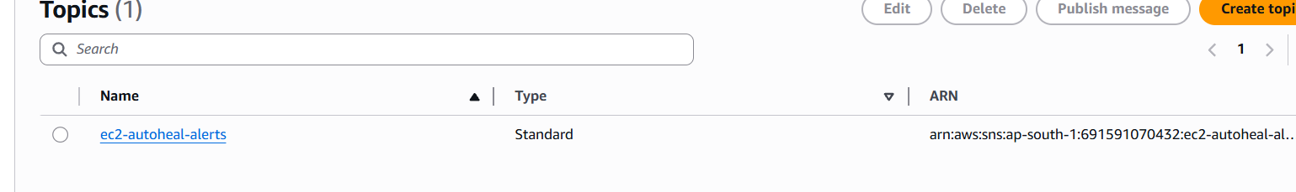
2. Copy the Topic ARN
→ arn:aws:sns:ap-south-1:691591070432:ec2-autoheal-alerts
3. Create subscription → Protocol: Email → your email address
4. Check inbox → click Confirm subscription link in AWS email
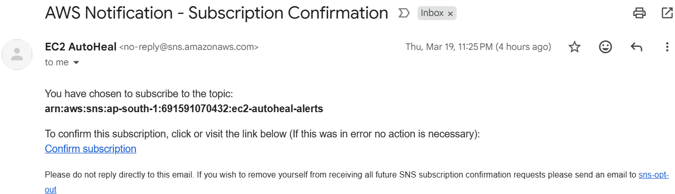
5. Add SNS publish permission to IAM role

{
"Version": "2012-10-17",
"Statement": [{
"Sid": "SNSPublishAlerts",
"Effect": "Allow",
"Action": "sns:Publish",
"Resource": "arn:aws:sns:ap-south-1:691591070432:ec2-autoheal-alerts"
}]
}
Policy name: sns-publish-autoheal-policy
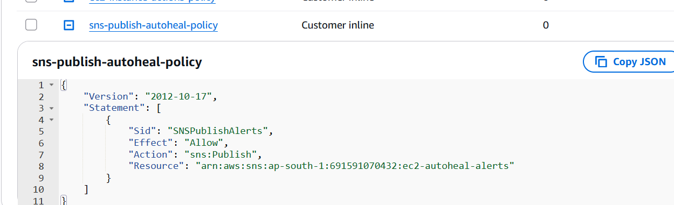

✅ SNS Topic confirmed — email subscription active — IAM updated

STEP  7 | Create Auto-Heal Lambda  The brain — detects stop, restarts, alerts

WHY DO THIS STEP?
This Lambda is the decision-maker. Unlike the previous Lambdas which wait for humans to call the API, this one fires automatically when triggered by EventBridge. It does 3 things in sequence: gets instance details, auto-starts it, sends a rich SNS email alert. Recovery time: under 10 seconds.

1. Lambda → Create Function → ec2-autoheal-handler → Python 3.12 → lambda-ec2-reporter-role
2. Paste code, Deploy, set timeout to 30 seconds

import boto3
import json
from datetime import datetime
from botocore.config import Config

# ---- CONFIGURATION ----
REGION = 'ap-south-1'
SNS_ARN = 'arn:aws:sns:ap-south-1:691591070432:ec2-autoheal-alerts'
# -----------------------

def put_cloudwatch_metric(cw_client, metric_name, value, instance_id, instance_name):
"""Push a custom metric to CloudWatch for dashboard visibility."""
cw_client.put_metric_data(
Namespace='EC2AutoHeal',
MetricData=[{
'MetricName': metric_name,
'Value': value,
'Unit': 'Count',
'Dimensions': [
{'Name': 'InstanceId', 'Value': instance_id},
{'Name': 'InstanceName', 'Value': instance_name},
{'Name': 'Region', 'Value': REGION}
]
}]
)

def get_instance_details(ec2_client, instance_id):
"""Get full instance details for the alert email."""
try:
response = ec2_client.describe_instances(InstanceIds=[instance_id])
instance = response['Reservations'][0]['Instances'][0]

name = 'N/A'
for tag in instance.get('Tags', []):
if tag['Key'] == 'Name':
name = tag['Value']

return {
'name': name,
'instance_type': instance.get('InstanceType', 'N/A'),
'public_ip': instance.get('PublicIpAddress', 'Not assigned'),
'private_ip': instance.get('PrivateIpAddress', 'N/A'),
'launch_time': str(instance.get('LaunchTime', 'N/A')),
'az': instance.get('Placement', {}).get('AvailabilityZone', 'N/A'),
'state': instance['State']['Name']
}
except Exception as e:
print(f"Could not fetch instance details: {str(e)}")
return {
'name': 'N/A',
'instance_type': 'N/A',
'public_ip': 'Not assigned',
'private_ip': 'N/A',
'launch_time': 'N/A',
'az': 'N/A',
'state': 'N/A'
}

def send_sns_alert(sns_client, instance_id, details, action_taken, stopped_time, started_time):
"""Publish a rich alert email via SNS."""
message = f"""
==============================================
⚠️ EC2 AUTO-HEAL REPORT — {REGION}
==============================================

INSTANCE DETAILS
----------------
Instance ID : {instance_id}
Instance Name : {details['name']}
Instance Type : {details['instance_type']}
Region : {REGION}
Availability Z : {details['az']}
Private IP : {details['private_ip']}
Public IP : {details['public_ip']}
Original Launch: {details['launch_time']}

INCIDENT TIMELINE
-----------------
🔴 Stopped At : {stopped_time}
🟢 Started At : {started_time}
⏱️ Recovery : under 10 seconds

ACTION TAKEN
------------
{action_taken}

Current State : Instance is back RUNNING ✅

----------------------------------------------
CloudWatch Dashboard:
https://console.aws.amazon.com/cloudwatch/home?region={REGION}
==============================================
"""
sns_client.publish(
TopicArn=SNS_ARN,
Subject=f'⚠️ EC2 Auto-Heal: {details["name"]} ({instance_id}) recovered — {REGION}',
Message=message
)

def lambda_handler(event, context):

print(f"Event received: {json.dumps(event)}")

# ── Extract instance details from EventBridge ──
try:
instance_id = event['detail']['instance-id']
state = event['detail']['state']
except KeyError:
instance_id = event.get('instance_id', 'UNKNOWN')
state = event.get('state', 'stopped')

print(f"Instance {instance_id} entered state: {state}")

if state != 'stopped':
print(f"State is '{state}' — no action needed.")
return {
'statusCode': 200,
'body': json.dumps({'message': f'No action for state: {state}'})
}

stopped_time = datetime.utcnow().strftime('%Y-%m-%d %H:%M:%S UTC')

# ── Set up AWS clients ──
config = Config(connect_timeout=5, read_timeout=10, retries={'max_attempts': 2})
ec2_client = boto3.client('ec2', region_name=REGION, config=config)
sns_client = boto3.client('sns', region_name=REGION, config=config)
cw_client = boto3.client('cloudwatch', region_name=REGION, config=config)

# ── Get instance details ──
details = get_instance_details(ec2_client, instance_id)
print(f"Instance: {details['name']} | Type: {details['instance_type']} | AZ: {details['az']}")

# ── Push metric: StopDetected ──
put_cloudwatch_metric(cw_client, 'StopDetected', 1, instance_id, details['name'])
print(f"✅ CloudWatch metric StopDetected pushed")

# ── Attempt auto-start ──
try:
ec2_client.start_instances(InstanceIds=[instance_id])
started_time = datetime.utcnow().strftime('%Y-%m-%d %H:%M:%S UTC')
print(f"✅ Auto-start triggered for {instance_id}")
action_taken = "✅ Auto-start triggered successfully by Lambda.\n Instance recovered without manual intervention."

# ── Push metric: AutoHealSuccess ──
put_cloudwatch_metric(cw_client, 'AutoHealSuccess', 1, instance_id, details['name'])
print(f"✅ CloudWatch metric AutoHealSuccess pushed")

except Exception as e:
started_time = 'FAILED'
print(f"❌ Failed to start: {str(e)}")
action_taken = f"❌ Auto-start FAILED.\n Error: {str(e)}"

# ── Push metric: AutoHealFailure ──
put_cloudwatch_metric(cw_client, 'AutoHealFailure', 1, instance_id, details['name'])
print(f"✅ CloudWatch metric AutoHealFailure pushed")

# ── Send SNS alert ──
try:
send_sns_alert(sns_client, instance_id, details, action_taken, stopped_time, started_time)
print(f"✅ SNS alert sent")
except Exception as e:
print(f"❌ SNS failed: {str(e)}")

# ── Log structured summary for CloudWatch Logs Insights ──
print(json.dumps({
"event": "AutoHeal",
"instance_id": instance_id,
"instance_name": details['name'],
"instance_type": details['instance_type'],
"az": details['az'],
"private_ip": details['private_ip'],
"public_ip": details['public_ip'],
"stopped_at": stopped_time,
"started_at": started_time,
"action": "start",
"region": REGION
}))

return {
'statusCode': 200,
'body': json.dumps({
'instance_id': instance_id,
'instance_name': details['name'],
'stopped_at': stopped_time,
'started_at': started_time,
'action': action_taken
})
}

Test Event (use in Lambda console)

Test It Manually

Why: We test the Lambda directly before connecting EventBridge — so we know the function itself works before adding the trigger layer.

Click Test → Create new test event

Name: test-autoheal

Paste this as the event body:
{
"detail": {
"instance-id": "i-054a6eeb4eaac01ba",
"state": "stopped"
}
}
Click Test

Expected response:
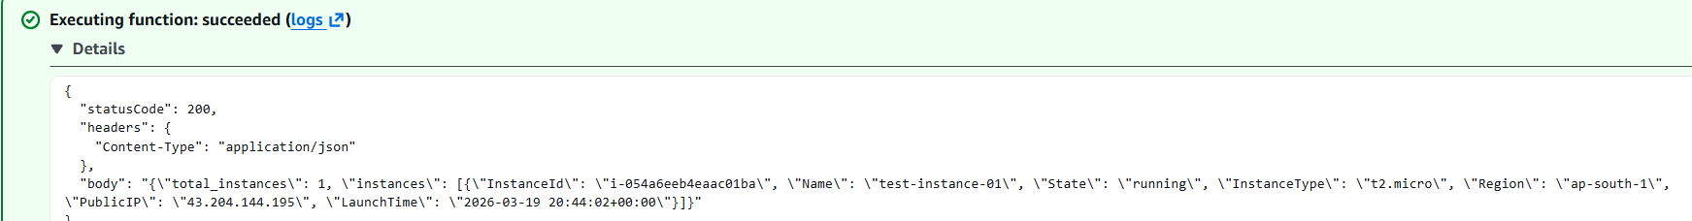

Then immediately check:

✅ EC2 console → test-instance-01 should show pending → running
✅ Your email inbox → alert email should arrive within 1 minute
• Lambda ec2-autoheal-handler deployed successfully
• Test event returns success response
• EC2 instance started automatically
• Email alert received in inbox
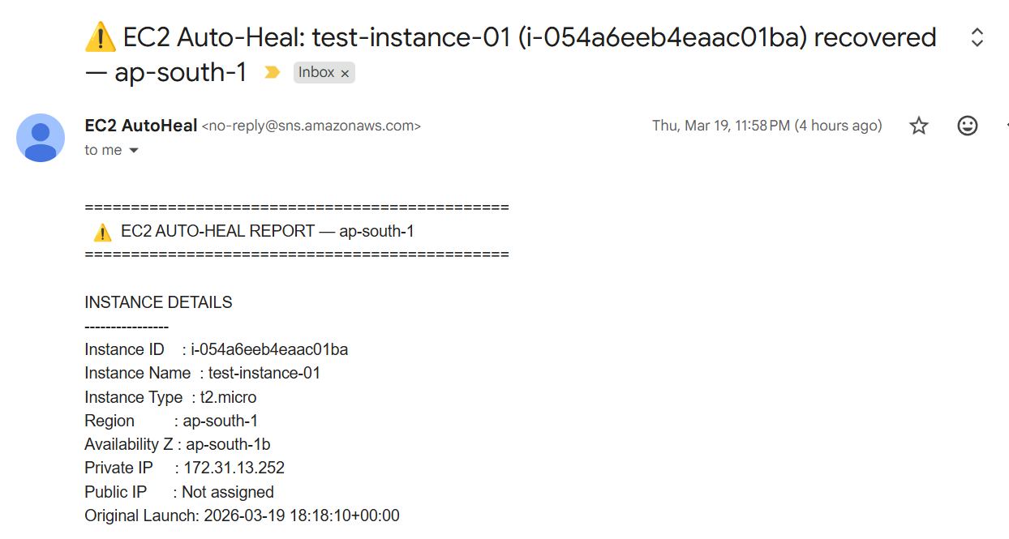
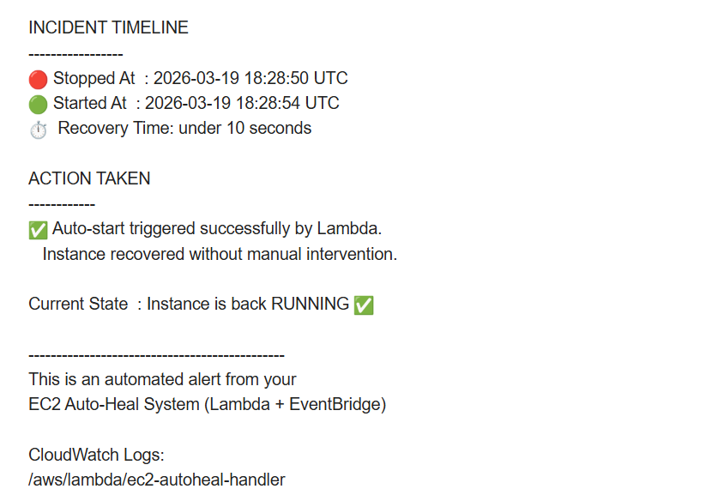
✅ Auto-heal Lambda deployed — test shows instance restarting + email arriving

STEP  8 | Add CloudWatch Permissions to IAM  Allow Lambda to push custom metrics

WHY DO THIS STEP?
The auto-heal Lambda now pushes custom metrics (StopDetected, AutoHealSuccess, AutoHealFailure) to CloudWatch. Without this policy, the put_metric_data call fails silently. We add a scoped inline policy for only the 3 CloudWatch actions needed.

{
"Version": "2012-10-17",
"Statement": [{
"Sid": "CloudWatchMetrics",
"Effect": "Allow",
"Action": ["cloudwatch:PutMetricData","cloudwatch:GetMetricData","cloudwatch:ListMetrics"],
"Resource": "*"
}]
}
Policy name: cloudwatch-metrics-policy

✅ IAM role now has 4 policies — EC2 read, EC2 write, SNS publish, CloudWatch metrics

STEP  9 | Create EventBridge Rule  The automatic trigger — zero human involvement

WHY DO THIS STEP?
EventBridge is AWS's event bus. It listens to everything happening across your account in real time. Every time an EC2 instance changes state, AWS publishes an event. Your rule says: when any instance enters stopped state, fire ec2-autoheal-handler Lambda. No polling, no cron job, purely reactive. This is what makes the system fully autonomous.
It fully automatic — you'll never touch the console again. The moment any EC2 instance stops, EventBridge detects it in real time and fires Lambda automatically.

previously:
You manually stop instance → you manually test Lambda → instance starts

AFTER Eventbridge:
You stop instance → EventBridge fires Lambda automatically
→ instance starts itself
→ email lands in your inbox
→ zero human involvement
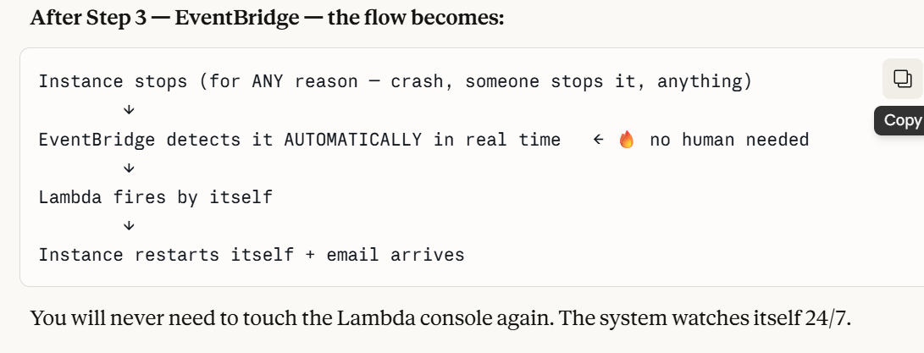
1. EventBridge → Rules → Create rule
2. Build tab → Event bus: default
3. Add Triggering Event → AWS Service Events → EC2 → EC2 Instance State-change Notification
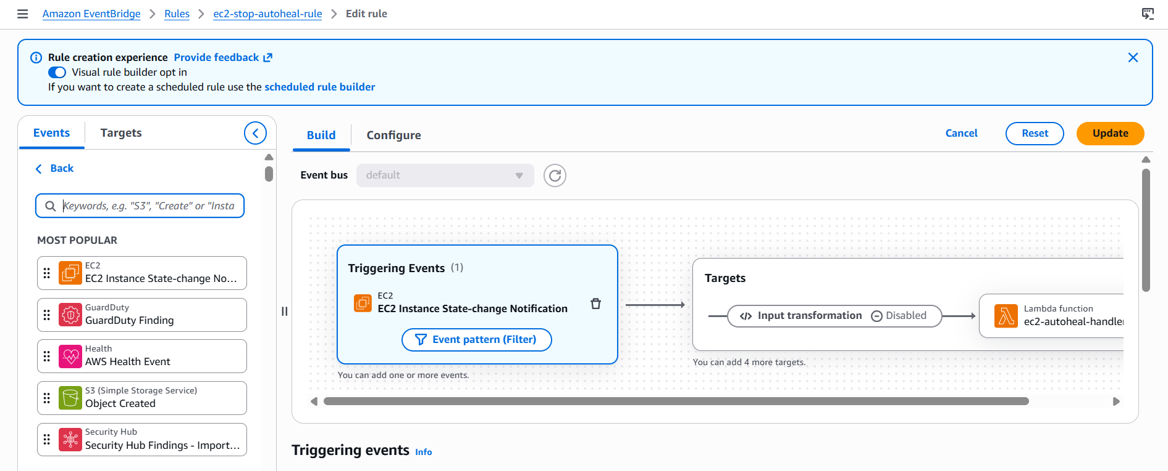
4. Click Event pattern (Filter) → state field → Equals → stopped
→ Event pattern becomes:

{
"source": ["aws.ec2"],
"detail-type": ["EC2 Instance State-change Notification"],
"detail": { "state": ["stopped"] }
}

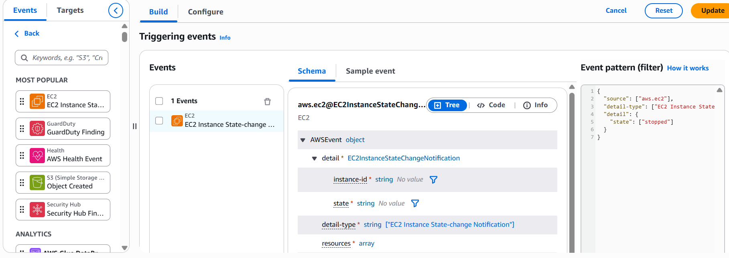
5. Targets tab → Lambda function → ec2-autoheal-handler
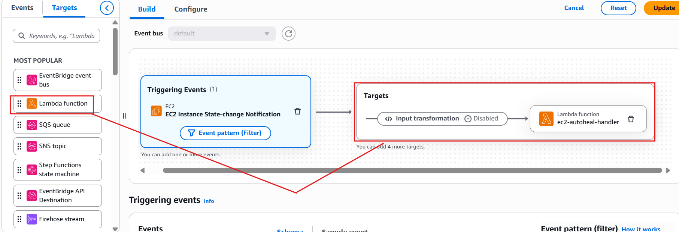

6. Configure tab → Rule name: ec2-stop-autoheal-rule → Create
Why the stopped Filter Is Critical
Without the filter, EventBridge fires Lambda on ALL state changes — running, pending, rebooting. When Lambda restarts the instance, the 'running' event would trigger Lambda again, which would try to start an already-running instance, causing an infinite loop. The stopped filter ensures Lambda only reacts to one specific event.

✅ EventBridge rule active — system now fully autonomous, watching 24/7

STEP  10 | Full End-to-End Auto-Heal Test  Stop instance, watch it heal itself

WHY DO THIS STEP?
This is the proof test. You manually stop the instance but do NOT touch Lambda or EventBridge. The system detects it, restarts it, and emails you — entirely on its own. This is what you demo in an interview.

1. EC2 → test-instance-01 → Instance State → Stop
2. Do NOT touch Lambda console — just watch
3. Watch the instance state change automatically

Automatic Recovery Timeline
You stop instance manually
→ Instance enters stopping state
→ Instance enters stopped state
→ EventBridge detects stopped event (real time)
→ ec2-autoheal-handler Lambda triggered automatically
→ Lambda fetches instance details via boto3
→ Lambda calls start_instances
→ SNS email alert sent to sandhya.bca7@gmail.com
→ CloudWatch logs + metrics updated
Instance back to RUNNING ✅ Total time: under 10 seconds

✅ System fully autonomous — instance heals itself with zero human intervention

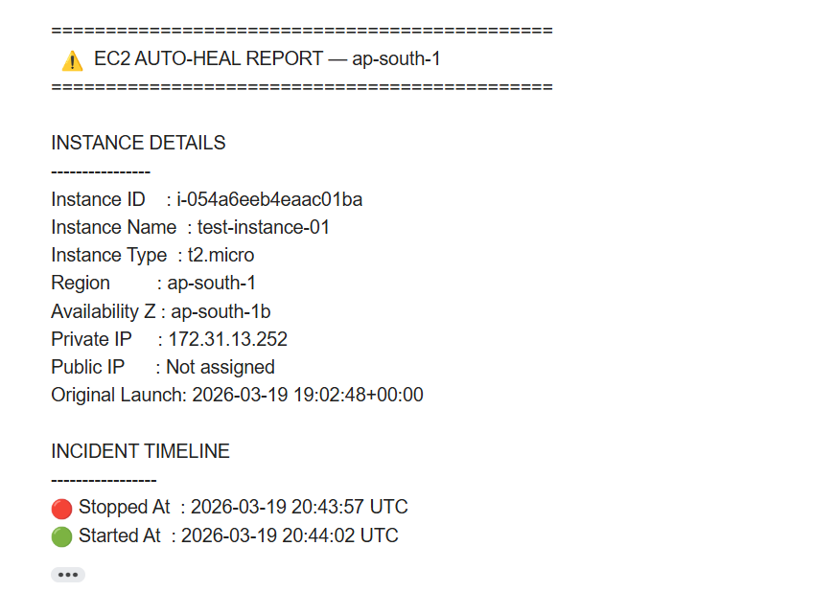
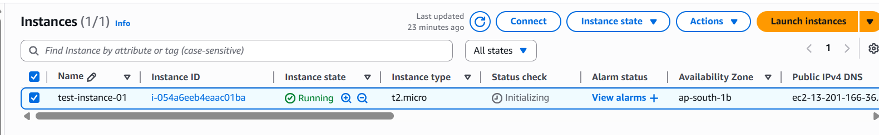
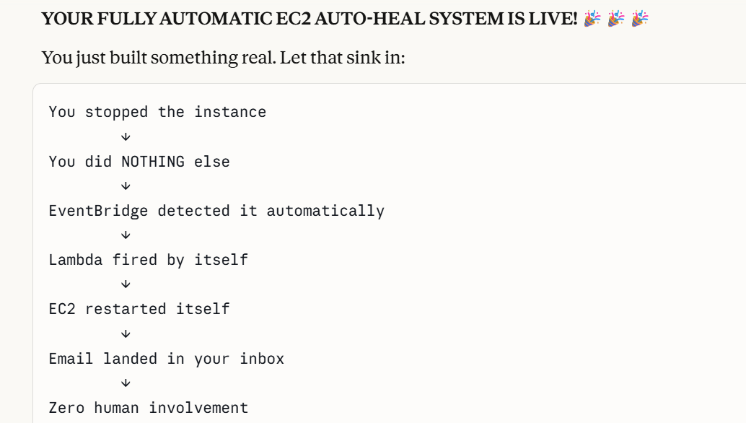

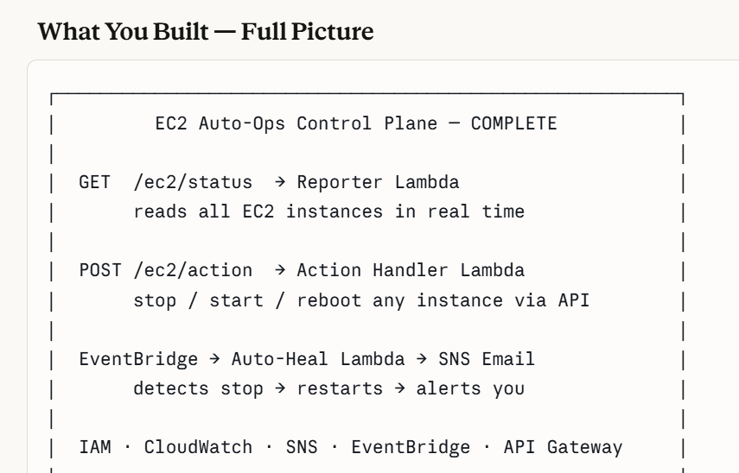

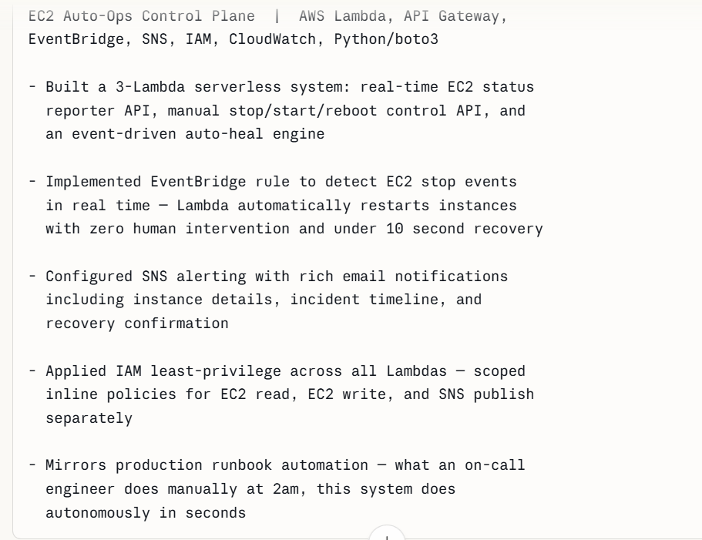

PART 4 — CloudWatch Live Dashboard
Build a live ops dashboard with auto-refresh showing all system metrics.

STEP  11 | Enable EC2 Detailed Monitoring  Get 1-minute metrics instead of 5-minute

WHY DO THIS STEP?
By default EC2 sends metrics every 5 minutes. Detailed monitoring sends every 1 minute — needed for near real-time dashboard visibility. Without this, CPU graphs are delayed and coarse.
Update IAM role — add CloudWatch permissions:
- Go to IAM → Roles → lambda-ec2-reporter-role
- Add permissions → Create inline policy → JSON tab:
- Policyname: ‘Cloudwatch-metrics-policy’
- Click create policy

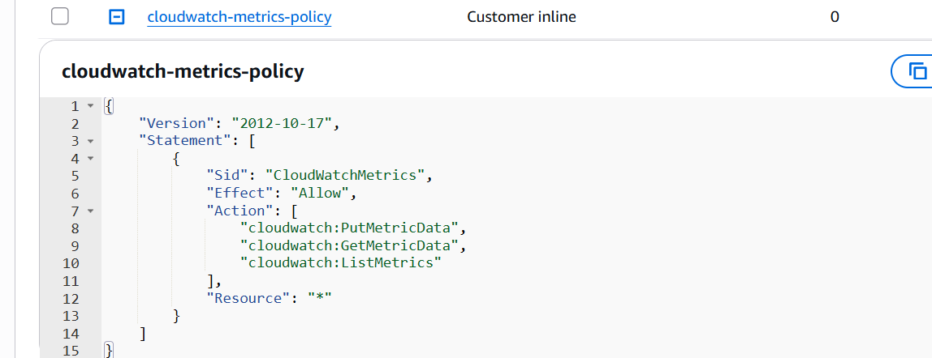

✅ EC2 now sends metrics to CloudWatch every 60 seconds

STEP  12 | Create the CloudWatch Dashboard  7 widgets showing live system state

WHY DO THIS STEP?
CloudWatch dashboards are free, live inside your AWS account, and auto-refresh. Each widget shows a different metric. Together they give you a complete real-time view of your system — invocations, performance, errors, CPU, and the full auto-heal event log.

1. CloudWatch → Dashboards → Create dashboard
→ Name: EC2-AutoOps-Dashboard → Create dashboard

Widget | Type | What It Shows
Auto-Heal Triggers | Line chart | Lambda invocations over time — incident frequency
AutoHeal Success vs Fail | Line chart | Custom metrics: StopDetected + AutoHealSuccess
Lambda Duration | Line chart | Recovery time in ms — performance trend
Lambda Errors | Number | Error count — immediate visibility of failures
EC2 CPU Utilization | Line chart | CPU drops on stop, recovers after auto-heal
Auto-Heal Event Log | Logs table | Full structured JSON log of every event
Cost Estimate | Number | Total estimated AWS charges (us-east-1 only)

Widget 1 — Lambda Invocations
1. Add widget → Line → Next
2. Browse → Lambda → By Function Name → ec2-autoheal-handler → Invocations
→ Title: Auto-Heal Triggers — Lambda Invocations → Create widget

Widget 2 — Auto-Heal Success vs Failure (Custom Metrics)
1. Add widget → Line → Next → Browse → EC2AutoHeal namespace
2. Check StopDetected and AutoHealSuccess
→ Title: Auto-Heal Success vs Failure → Create widget

Widget 3 — Lambda Duration
1. Add widget → Line → Lambda → ec2-autoheal-handler → Duration
→ Title: Auto-Heal Recovery Duration (ms) → Create widget

Widget 4 — Lambda Errors
1. Add widget → Number → Lambda → ec2-autoheal-handler → Errors
→ Title: Auto-Heal Errors → Create widget

Widget 5 — EC2 CPU Utilization
1. Add widget → Line → EC2 → Per-Instance Metrics → test-instance-01 → CPUUtilization
→ Title: EC2 CPU Utilization — test-instance-01 → Create widget

Widget 6 — Auto-Heal Event Log
1. Add widget → Logs → Log group: /aws/lambda/ec2-autoheal-handler
2. Type this query manually (do not paste — invisible characters cause errors):

fields @timestamp, @message
| sort @timestamp desc
| limit 20
→ Title: Auto-Heal Event History → Create widget

Set Auto-Refresh
1. Click the refresh dropdown (circular arrow icon) at top right
2. Select 30 seconds
3. Click Save dashboard (orange button)

✅ CloudWatch dashboard live with 6 widgets, auto-refreshing every 30 seconds

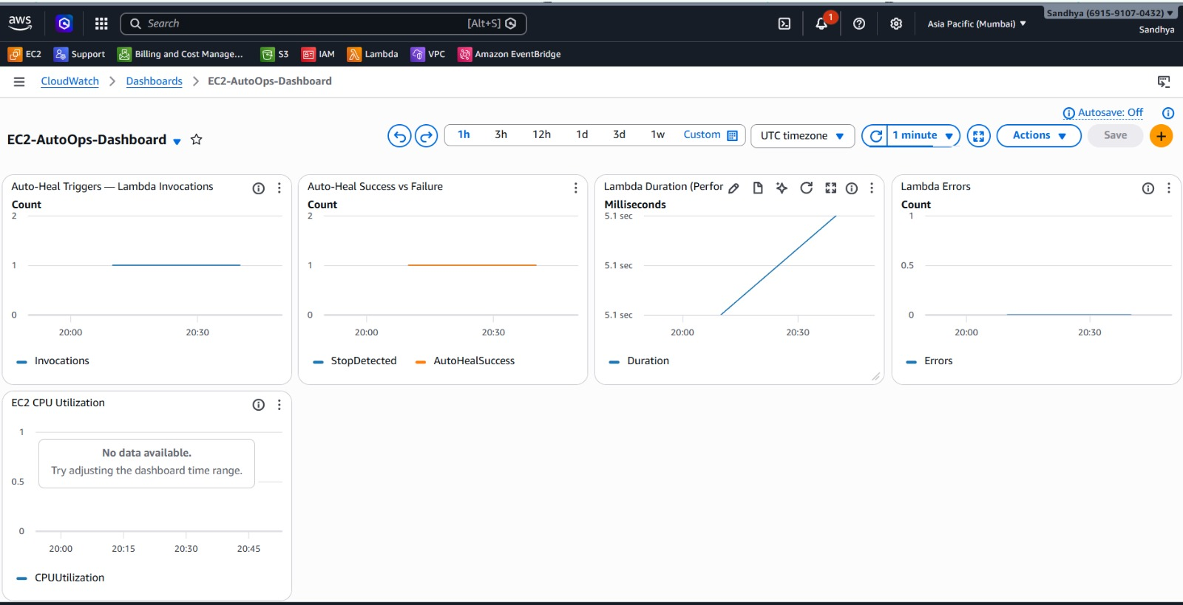
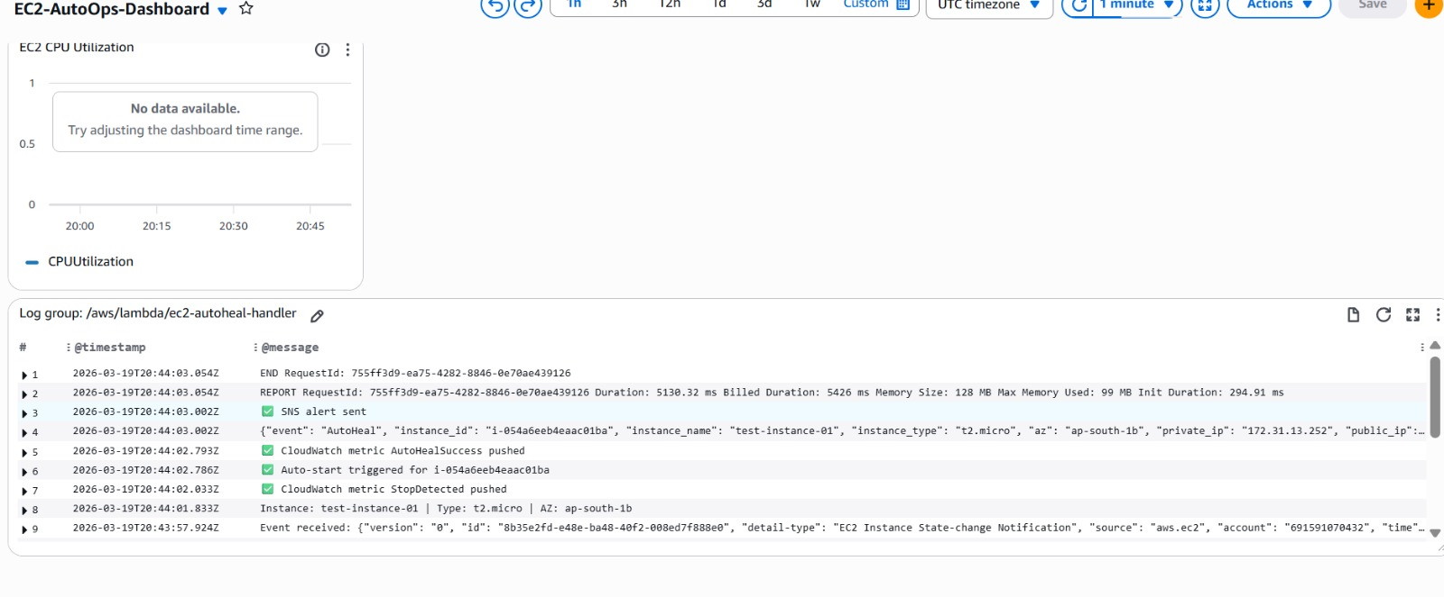

Complete IAM Role Summary
Role name: lambda-ec2-reporter-role | Used by: all 3 Lambda functions

Policy | Type | Permissions Granted | Lambda That Uses It
AmazonEC2ReadOnlyAccess | AWS Managed | DescribeInstances, DescribeImages, DescribeRegions | Reporter + Auto-Heal
AWSLambdaBasicExecutionRole | AWS Managed | Write logs to CloudWatch | All 3 Lambdas
ec2-instance-actions-policy | Inline | StopInstances, StartInstances, RebootInstances | Action Handler + Auto-Heal
sns-publish-autoheal-policy | Inline | sns:Publish to ec2-autoheal-alerts topic only | Auto-Heal
cloudwatch-metrics-policy | Inline | PutMetricData, GetMetricData, ListMetrics | Auto-Heal

Troubleshooting Reference

Error | Cause | Fix
Syntax error in module | Unclosed bracket or quote in code | Select all → delete → paste fresh
Task timed out | Wrong region or VPC blocking boto3 | Check region_name matches your instances
AccessDenied / 403 | IAM role missing required policy | Check Lambda → Configuration → Permissions
Empty instances [] | No instances in specified region | Change region_name in code
502 Bad Gateway | Lambda returned error or missing statusCode | Check CloudWatch Logs for actual error
No CloudWatch logs | AWSLambdaBasicExecutionRole not attached | Add policy to IAM role
SNS email in spam | Gmail filtering no-reply@sns.amazonaws.com | Search from:no-reply@sns.amazonaws.com → filter
EventBridge not firing | Filter not set or rule disabled | Check rule is Enabled, state filter = stopped
Infinite loop risk | EventBridge triggering on all states | Ensure event pattern filters state: [stopped] only

Resume & Interview Guide

Resume Block — Copy Ready

EC2 Auto-Ops Control Plane
AWS Lambda · API Gateway · EventBridge · SNS · CloudWatch · IAM · Python/boto3
• Built 3-Lambda serverless system: EC2 status reporter API, manual
stop/start/reboot control API, and event-driven auto-heal engine
with under 10 second recovery time
• Implemented EventBridge rule detecting EC2 stop events in real time
with zero human intervention required for instance recovery
• Configured SNS alerting with rich email notifications including
instance details, incident timeline, and recovery confirmation
• Built CloudWatch dashboard with 6 widgets — invocations, success/fail
metrics, performance duration, error tracking, and structured event log
with 30-second auto-refresh
• Applied IAM least-privilege with 5 scoped policies — EC2 read, EC2
write, SNS publish, CloudWatch metrics, and Lambda execution
• Mirrors production runbook automation — what an on-call engineer
does manually at 2am, this system does autonomously in seconds

Interview Talking Points

• Why serverless over EC2? — No server to manage, no idle cost, auto-scales, zero OS patching
• Why 3 separate Lambdas? — Single responsibility — each does one job, easier to debug and update independently
• Why EventBridge not polling? — Purely reactive, no wasted compute, reacts in real time vs polling every N minutes
• Why SNS not direct email from Lambda? — Decoupled — can add Slack, PagerDuty, SMS later without changing Lambda code
• Why IAM inline policies not managed? — Scoped to exact actions needed — more restrictive than managed policies
• Relate to Rackspace — I manage 1,200+ EC2 instances — I built this to understand how serverless could automate our manual runbooks and patch compliance checks

The Interview Answer (say this)

I built an end-to-end EC2 auto-ops system on AWS. It has three Lambda functions — one exposes a REST API for real-time instance status, one handles manual stop/start/reboot via HTTP, and the third is fully event-driven using EventBridge. When any EC2 instance stops, EventBridge triggers Lambda automatically, it restarts the instance in under 10 seconds and sends a rich SNS email alert with the full incident timeline. Everything is monitored on a CloudWatch dashboard that auto-refreshes every 30 seconds. I built this to understand serverless architecture and it directly mirrors the kind of runbook automation we do manually at Rackspace.

Your Next Projects

Project | What It Adds | Resume Value
Add DynamoDB logging | Store every auto-heal event — queryable history forever | Adds NoSQL + data persistence
Multi-region support | Query instances across all AWS regions in one API call | Adds global architecture thinking
Slack alerts | Post auto-heal events to a Slack channel via webhook | Adds ChatOps integration
Tag-based filtering | Only auto-heal instances tagged auto-heal=true | Adds ops governance thinking
Step Functions workflow | Orchestrate multi-step remediation with retries | Adds workflow orchestration

EC2 Auto-Ops Control Plane · 12 Steps · ap-south-1 · Account: 691591070432 · Built March 2026

