<Customer Name>
<Project Name>
High Level Design and Architecture Document
<Version No.>

 | Prepared By / Last Updated By | Reviewed By | Approved By
Name
Role
Signature
Date

.>

Table of Contents
1.0 Introduction 3
1.1 Purpose of this document 3
1.2 Scope 3
1.3 Out of scope 3
1.4 Intended Audience 3
1.5 Acronyms 3
2.0 System Architecture 3
2.1 Architectural Views 3
2.1.1 Functional View 4
2.1.2 Conceptual View 6
2.1.3 Logical View 7
2.1.4 Functional Architecture View 9
2.1.5 Technology View 11
2.1.6 Integration View 14
2.1.7 Implementation View 15
2.1.8 Data View 17
2.1.9 Deployment View 17
2.1.10 Security View 22
2.1.11 Process View 24
2.2 System Interfaces 24
2.3 Reporting 25
3.0 Prototype Design 25
3.1.1 Wireframe/ Visual Design 25
4.0 Technology, Tools and Frameworks 26
5.0 Solution Recommendations 26
5.1 Technical recommendations 26
5.2 Infrastructure recommendations 26
6.0 Reference 26
7.0 Change Log 27

- Introduction
  - Purpose of this document
Document High level Design and Architecture for <App Name>.
  - Scope
[This HLD & Architecture Document is designed for green field applications, This document is technical in nature and includes
- System/App architecture views depicting component layers, technology involved, integration, deployment, security, recoverability views for <App Name>.
- UI/Wireframe design if not covered by the BRD.
  - Out of scope
  - Intended Audience
Internal Technical teams, Architects, Developers, IT Security, DelEx.
  - Acronyms
S. No | Acronym | Expansion
1 | BRD | Business Requirements Document
2 | DelEx | Delivery Excellence
3 | RBAC | Role Based Access Control
- System Architecture
  - Architectural Views
The architecture of a system can be depicted in multiple views that makes it easy to understand from a specific perspective. Design team is free to decide and merge views as applicable to simplify diagram creation. For vendor/3rd party products some of the views may be available as part of vendor provided docs and must be explored for reuse/reference here.
Additional Guidance:
Architecture and design standard shall be found in
https://corporatesecurity.cognizant.com/Policies/Corporate_Security_Policies/Standards/QSIS-APPARCDES.pdf

Sample Architecture can be referenced from https://www.us-cert.gov/ics/Secure-Architecture-Design

Ideal System Architecture should outline the below properties (at a minimum) on each components of application
- Confidentiality
- Integrity
- Availability
- Authentication
- Authorization
- Accounting
- Non-Repudiation
- Replication
- Failover
- Scalability
- Design Pattern used

It is highly advisable to decide on the Cryptographic algorithms (Encryption, Hashing for data at rest and transit) & Key management strategy defined during the Architecture & Design stage to avoid re-work

Note: This guidance table must be removed from the final version of the HLD
    - Functional View
      - Key Business Processes
[This section should document the key business processes and rationalize why the documented processes are considered key. The documentation of the business process should conform to standard representation agreed upon by all the stake holders. It should cover the business actors, activities, policies, roles and SLAs]
      - Architecturally Significant Use Cases/Functional Requirements
[This section should cover Architecturally Significant Use Cases/Functional Requirements and capture the functional scenarios and non-functional requirements that will impact architectural decision. The rationalization should justify that the Business Processes and Use Cases/Functional Requirements chosen are sufficient for Architecture Definition.]
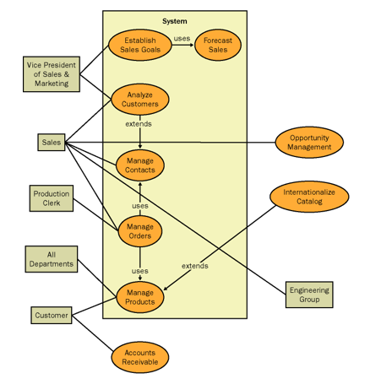
      - Functional Modules
[This section should provide a Block diagram view of Functional Modules, Business Processes and Use Cases/Functional Requirements.]
The functional modules of the system shall be decomposed into several levels to understand the system functionalities. Each level and its purpose are explained below:-
Level 0 -
[The level 0 of the system should define the overall context of the business and the primary services. It should also highlight the highest level view of a system, showing a system as a whole and its inputs and outputs from/to external factors.]
Level 1 -
[In level 1, the architecture document should highlight the major functional modules available in the system. It shall be a functional drill down from the system context diagram which is depicted in level 0]
Level 2 -
[The level 2 should highlight the Sub modules available in the system. Level 2 diagrams are functional drill downs from their parent component on the Level 1 diagram. Each diagram should depict the functionality making up each Level 1 entity. Each diagram should be accompanied by text describing each Level 2 function]
Level 3 -
[The level 3 shall be a set of diagrams for each Level 2 functions decomposed into Level 3 functions. In this case, each Level 3 function should be documented in the same manner as the Level 2 diagrams.]
Note: [Based on the complexity of the application/system, the number of functional levels shall vary from system to system. It may not be possible to describe the lower level of the functionality at the architecture stage, generally the levels are restrict to level 1 and 2 only]
    - Conceptual View
      - Actors
List the primary actors in the system. A brief description of the actor, their role as it relates to the system, any utility they will derive or consume (consumers or suppliers of functionality). External systems should also be treated as actors.
      - System Components
More of an overview section this should diagram and list all the major components of the system (applications, other systems, key processing elements etc.). This should be at a conceptual level so as to be able to communicate to a non-technical audience the approach to providing required functionality as part of the overall design.

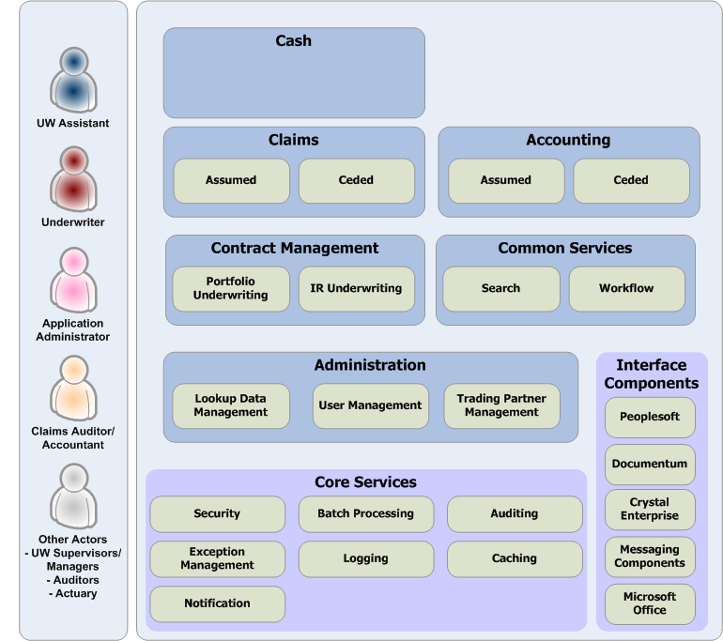
    - Logical View
This view must depict the following at a generic level:
- All layers applicable like Actors/Roles (User), Devices/End Points (Client), Presentation, Services, Persistence, Integrations (including external).
- Depict common/cross-cutting/infrastructural elements such as Security, Logging, Monitoring, Availability, Scalability, Caching as vertical layers

Sample 1
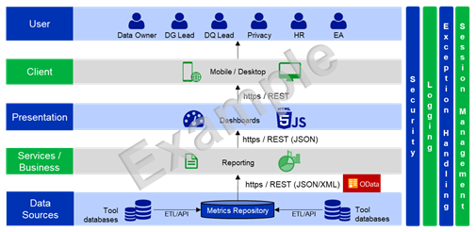
Sample 2
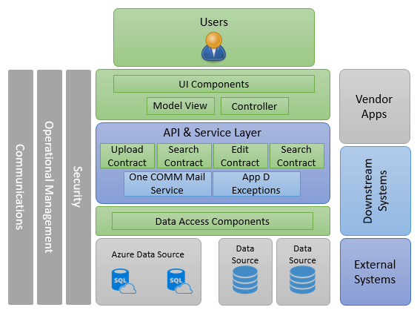
Download Sample Diagram

    - Functional Architecture View
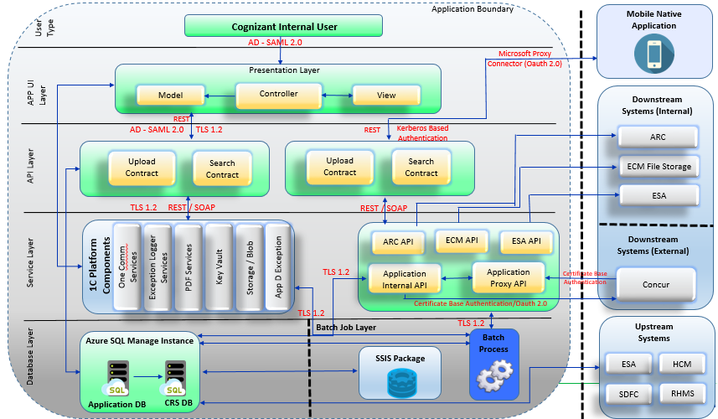
Download Sample Diagram
Additional Guidance:
Component’s environment segregation & grouping (Azure/ AWS/ On-Prem/ Vendor SaaS/ Vendor On-Premise) (within application scope / outside)

Each connection should have Protocol & Port

Tier & Conceptual Firewall & N/W segregation (Firewall, LB, etc.,). Eg., when app sends data to external entities it goes via Proxy and data from external entities need to come crossing Firewall, RP, etc., same goes for connection within corporate network across DC & VPC (cloud/internal)

Network Segregation between tiers & amongst applications – to depict the horizontal propagation of exploit.

Note: This guidance table must be removed from the final version of the HLD

System Flow (In detail):
Tier 1 - User Type (User Interaction)
Web Application
- User Invoking One Cognizant application from browser
- Request get serve by one of the node available in Load Balancer.
- User will get verified in Active Directory by using SAML
Mobile Native App
- Open Onec Mobile Native App from Mobile(Downloaded from Cognizant Native store)
- Authenticate using Oauth 2.0 get access the Application API layer to get data display on card or perform any action by card
Tier 2 - Presentation Layer (App UI Layer)
Web Application
- Web Application (MVC app) get accessed by different type of user & specific screens & report get available to user as per user roles.
Tier 3- API Façade (API layer)
Web Application (API)
- Web Application call its internal API through SAML(TLS 1.2).
- Application API hosted on same URL where the web application URL hosted i.e. under same SAML domain group, API hosted under different SAML group cannot accessible from client/server side code
Mobile Native App (API)
- Mobile API get calls from Native app through token based Authentication from mobile specific URL (Kerberos base authentication) using Microsoft proxy connector
Tier 4- Services Façade (Service layer)
- 1C Platform Component Communication
Only accessible within cognizant without any authentication, internal all components keep track on the application detail that access same
Component Name | Description | Access Type
One Communicator Service | Unified platform for sending mails & SMS | Anonymous
Azure Blob Storage | Blob storage is optimized for storing massive amounts of unstructured data, such as text or binary data. | MSI
Exception Logger | Unified platform for logging application exceptions | Anonymous
PDF Services | Unified platform for generating PDF. | Anonymous
Azure Key Vault | Azure Key Vault is a cloud service that provides a secure store for secrets | MSI
AWS S3 Storage | AWS s3 storage is optimized for storing massive amounts of unstructured data, such as text or binary data. | Key base

Tier 4.1 Services Façade (Upstream & Downstream External Applications)
- External system pull or push data to cognizant system : Application communicate with Downstream/downstream external applications using certificate authentication along with IP base restriction and message encryption using CS approved algorithm and key length
- Cognizant system pull or push data to External system : Application communicate with Downstream/downstream external applications using either certificate or oauth base authentication along with IP base restriction and message encryption using CS approved algorithm and key length
Tier 5 Database Layer
- Application DB (Portfolio DB) will be accessed by Web Application, API, Web Services, Batch Job, SSIS Package through Azure MSI connection.
- CRS specific views can be accessed from Application DB as per permission given by CRS team
Tier 5.1 Batch Layer
<<Details on any bulk data operation using .net console job (along with integration with different services) >>
<<Details on different integration with other application using SSIS package >>
External Tools/Service Used
<<Details External Tool used specific for this application>>
Reports
<<Details Reporting Tool Platform (OneCaap) used specific for this application >
    - Technology View
[For each layer depicted in logical view, specify the technology platform/ framework for each component. For vendor supplied components, either provide the technology if known or provide link to vendor’s documentation url. For common/cross-cutting/infrastructural elements reuse/refer to as much of existing content as available/maintained by the organization (customer/internal). Internal systems can refer to relevant views documented by the IT/Enterprise Architect team (see references section)]

Component Name | Technology | Version/Comments
Presentation Layer | MVC/Web Application (JSON) | .net Core 3.2
API layer(<<Protocol REST/AMQP>> | MVC API ((JSON) | .net framework 4.5
Batch layer(<<Protocol REST/AMQP>> | Console | .net framework 4.5
Database Layer | SQL MI | 2014
SSIS Package | <<Authentication Type>>
Mobile Native App | Xamrin | Android – 7.4.5.1  IOS -
Azure Storage |  | MSI
ECM Storage |  | Token base authentication
1c Platform Services  (Onecom, Exception Logger, PDF Creation) | .net 4.5 + /Net core 3.2 | SOAP
Azure Keyvault |  | MSI
AWS S3 |  | Key & Token base authentication
AppDynamics Monitoring (Application Monitoring) |  | Refer Monitoring section below
SCOM Monitoring (Server side) |  | Refer Monitoring section below

Additional Guidance:
Highlight application specific - 3rd party licensed or open source software used with its version would be appropriate.
Include any 3rd party solutions – like Hard Tokens, Signature Devices etc.,

Note: This guidance table must be removed from the final version of the HLD

Security
This application relies on the security services provided by the platform [Refer the appropriate platform architecture document from references depicting the security controls used. Provide details of any specific/custom security controls required to be implemented.]
Refer to the document in the below link: Section 1, 2, 3 for (Azure) & 5 for (AWS)
https://cognizantonline.sharepoint.com/:w:/r/sites/ITEA/Documents/Standards/Onecognizant-%20HLD.doc?d=wb1a21b5b8a2b48dba7ab3ab0a3a26f30&csf=1&web=1&e=5Pvc7s

Note: If the application is deployed in the One Cognizant Shared Infrastructure, then this section can stay as is; No need to Update/Change

Logging
<<Provide/refer existing details about this layers technology and components>>
[Refer the appropriate platform services document from references depicting the logging mechanism/service used. Provide details of any specific/custom logging required to be implemented. For example, for 1C Apps logging is enabled by integration with an exception logging service. Azure hosted Apps rely on the QRadar log collector for logging security events and the on-premise SIEM for log analysis. These are components of Azure Security Controls documented in Page 13 of Azure Architecture]
Monitoring
- AppDynamics – AppDynamics tool is recommended tool to monitor all the client & server side Application transactions
- Application Browser side Transaction Monitoring(Anonymous End user monitoring) – All the applications on 1c infra get accessed via IIS server, App team created a rule to inject JavaScript dynamically in all the pages to tract all the browser related transactions
- Application Server side Transaction Monitoring(AD End user monitoring) – All the servers of 1c infra are having Appd Agent installed that monitor application transaction real time & have specific interface for developer to view same
- Server Side Monitoring- SCOM is default monitoring tool recommend for Windows operating system, SCOM agent get installed & configured during VM creation.
Availability
<<Provide/refer existing details about this layers technology and components>>
[Refer the appropriate platform services document from references depicting the availability configuration/mechanism/service used. Provide details of any specific/custom availability configurations required to be implemented.]
Scalability
<<Provide/refer existing details about this layers technology and components>>
[Refer the appropriate platform services document from references depicting the scalability mechanism/service used. Provide details of any specific/custom scalability required to be implemented.]
Caching
<<Provide/refer existing details about this layers technology and components>>
[Refer the appropriate platform services document from references depicting the caching mechanism/service used. Provide details of any specific/custom caching required to be implemented. For example, 1C on-premise Apps rely on Redis cache as depicted by 1C on-premise logical and physical deployment architectures]
    - Integration View
[Provide details on all the interfaces of this application with other source/target systems including data content, modes like Web Service, ETL, Custom/3rd party API/Adapter, protocols and ports, in the attached spreadsheet template. Team is free to store the filled spreadsheet and related visualizations in an online repository (example, SharePoint) and include a link to it here. Call out any specific differences between environments. Consider only the direct or first-level dependencies. Dependencies on infrastructural elements/common platform services can be referred from existing content as available/maintained by the organization (customer/internal)]
This section should cover integration mechanisms like:
- Internal Integration - Describe the integration mechanisms of the systems that reside within the enterprise such as database, ESB, etc.,
- External Integration - Elaborate the integration mechanisms of the external systems such as SAP, CRM etc.,
- Integration matrix - It should provide details on various inbound and outbound interfaces between the system and the external systems
App ID | App Name | Integration Type (Upstream/Downstream) |  | Data elements transferred/ received  (eg., personal details, cognizant revenue, compensation details, etc.,) | Authentication Type  (eg., SSO/ Impersonation, Service Account, MSI Group, Username Password, API Key, Token, Certificate, etc.,) | Mode of Integration(API/  Views/others if any)  (eg., API – GET/ POST/PUT/DELETE, Views – Dedicated/ Shared, Tables, etc.,) | Intermediate Systems (ETL)  (Eg., SSIS packages, Pentaho, Informatics, Azure Data Factory, Batch Processes, etc.,) | Frequency  (Eg., Real time, once an Hour/ Day/Week/Fortnight/Month/Quarter/Year, etc.,)
    - Implementation View
This view needs to capture following
- What integration adapters will be used to interface with external systems
- Information about all layers with details about what components will be used and what will be technology. Detailed explanation about each layer or logically separated boundary should follow after the diagram
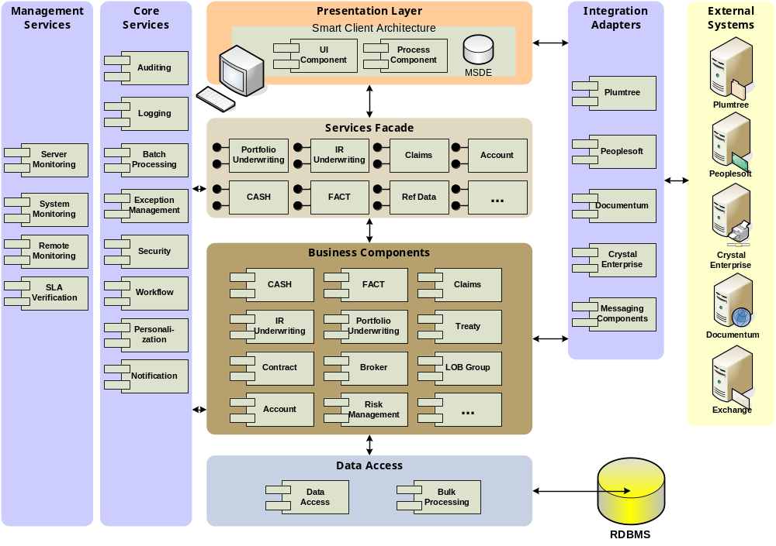
Each of the layers of the above architecture is explained in more detail:
Presentation Layer
<<Please provide details about this layers technology and components>>
Services Façade
<<Please provide details about this layers technology and components>>
Business Components
<<Please provide details about this layers technology and components>>
Data Access
<<Please provide details about this layers technology and components>>
Management Services
<<Please provide details about this layers technology and components>>
Core Services
<<Please provide details about this layers technology and components>>
Integration Adapters
<<Please provide details about this layers technology and components>>
<<Depending upon the client requirements and complexity involved, you might want to add another diagram providing more details about the implementation. Take a look at the sample below. You may need to provide subset of this diagram. Few other UML diagrams like Sequence diagram can also be provided to give more clarity regarding implementation view>
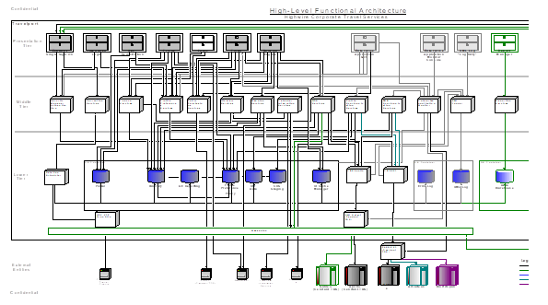
    - Data View
<<Please add information about database architecture as to what and how many databases will be needed for the application >>
<<Insert logical data model and provide explanation that goes with this. All important decisions like relationship need to be explained here>>

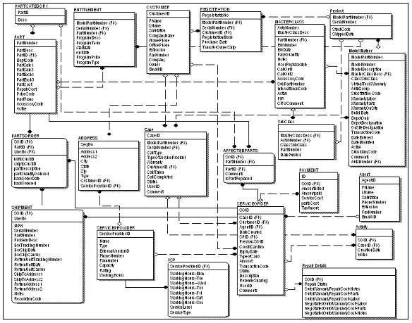
    - Deployment View
Show the split up of on premise and cloud hosted components, highlighting cloud vendor names, where applicable. For each environment, include details like FQDN of servers (web, database, file, load balancers, clusters etc.), their IP addresses, OS/software versions, vanity/zip urls, geo-location etc. Call out any specific differences between environments. H/W specifications can be listed in a separate table. Dependencies on infrastructural elements/common platform services can be referred from existing content as available/maintained by the organization (customer/internal)
Refer to the document in the below link: Section 4 & 5 (Cover Onprem, Azure & AWS)
https://cognizantonline.sharepoint.com/:w:/r/sites/ITEA/Documents/Standards/Onecognizant-%20HLD.doc?d=wb1a21b5b8a2b48dba7ab3ab0a3a26f30&csf=1&web=1&e=5Pvc7s

Note: If the application is deployed in the OneCognizant Shared Infrastructure, then this section can stay as is; No need to Update/Change

S No | IP Address/ Host Name | Location (On-Prem/ AZ/ AWS/ Vendor) | Type  (Web Server/ App Server/ DB Server/ Middleware/ Container) | Primary/ DR server?

Additional Guidance:
App team to fill the table, calling out the IP Addresses and its environment

Note: This guidance table must be removed from the final version of the HLD
      - Tiers
[This subsection should describe the various tiers along with the identified application and hardware infrastructure components in each tier. This section should also provide appropriate rationalization for each tier and for the placement of an infrastructure component in that tier.]
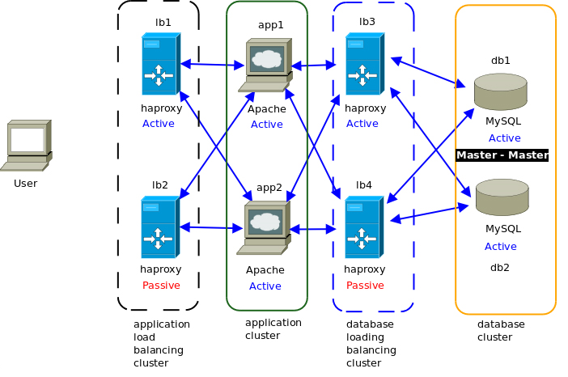
      - Logical Infrastructure
[This subsection should describe the logical model of the hardware infrastructure that is devoid of the number of nodes, clustering requirements, bandwidth, hardware infrastructure components etc.]
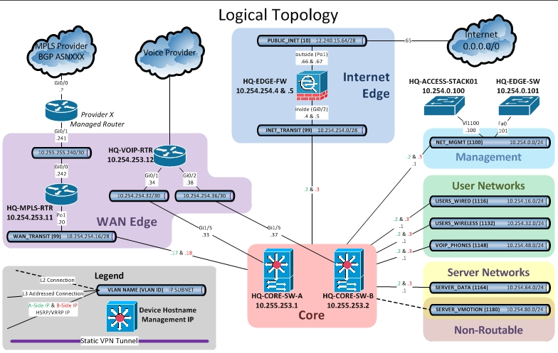
Sample Logical Infrastructure Diagram
      - Physical Infrastructure
[In this section extend the logical infrastructure model described in the previous section to a representational physical infrastructural model. This section should highlight the physical infrastructures in each tier. The infrastructure could be load balancer, proxy server, application server, clustered environment, database cluster, etc. Firewalls between each tier will also be highlighted here.]

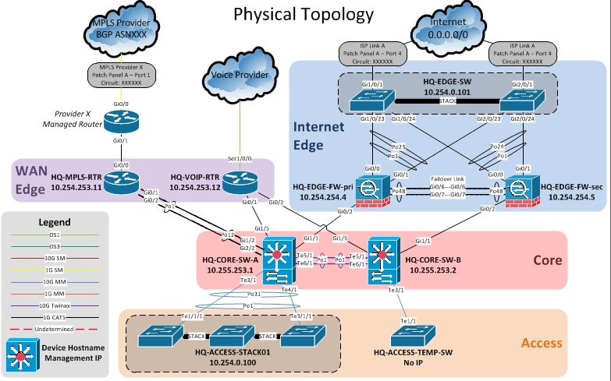
Sample Physical Infrastructure Diagram
      - Product Deployment Model
[This subsection should describe the how the application will be deployed onto the application and hardware infrastructure along with its deployable unit organization etc]
Detailed explanation should follow the diagram about each block
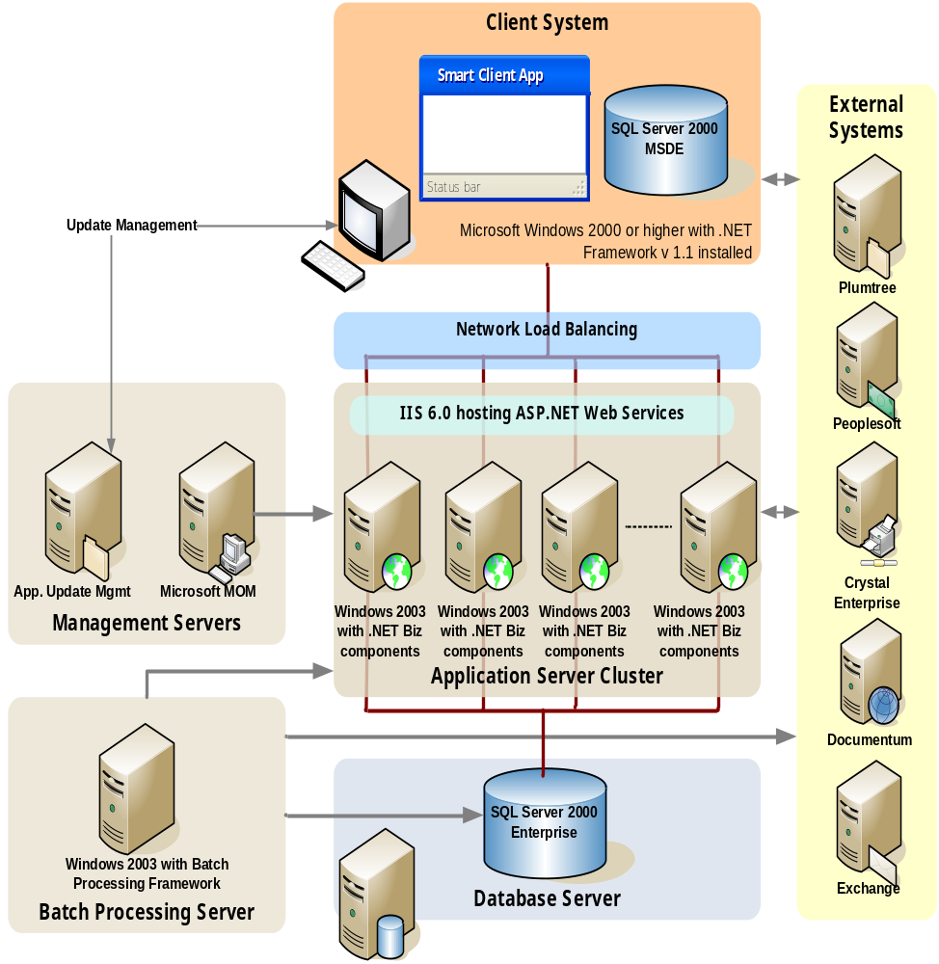
Sample Product Deployment Diagram
    - Security View
[Use this section to depict how security control(s) objectives are incorporated into the application conceptual design to demonstrate security is not an ‘after-thought’ but built into the application design and securely developed/deployed in the later stages of the application development process. Dependencies on infrastructural elements/common platform services can be referred from existing common platform components.]

Additional Guidance:
To be filled by app teams, specific to each application.
Few of the sections are called out in LLD, these should be spoken at the Design level. Then at each component
Note: This guidance table must be removed from the final version of the HLD

Refer to the ‘Application Architecture and Design Security’ standard as you attempt to respond to the ‘Secure Design Considerations’ section below.
      - Secure Design Considerations
Authentication Design
Specify the design considerations for the application to implement and/or enforce authentication in a manner it is strong (e.g. multi-factor authentication for privileged users/internet admins, etc.).
Access Privilege and Authorization Design
Specify the design considerations specific to access control based on a granular role-based access (RBAC) which primarily implements the design principle of segregation of duties (SOD) and the principle of Least Privilege (i.e. a user should have the minimum set of privileges required to perform a specific task).
Also, substantiate how conceptual design protects ‘role and permission metadata’ from replay or tampering (if maintained within the confines of the application/database).
Input / Data Validation
Specify the design considerations with respect to the application having to validate ALL input prior to taking it for further processing.
Does your application design?
- validate all input to be correct and fit for the intended purpose
- encode all output in a manner it is safe to relay back to the end-user/browser

Data Protection
Specify the design considerations specific to protection of sensitive information (such as privacy/PII/etc) used by the application at all data states (i.e. data-at-rest, data-in-transit, data-in-use) and throughout the data lifecycle (e.g. creation, store, use, share, archive, destroy).

Cryptography and Key Management
Specify the design considerations specific to secure cryptographic implementations and related key management activities to protect the confidentiality and integrity of sensitive data processed by the application.
Key Management Standard
Accountability Design
Specify the design considerations taken to establish accountability of actions by the users of the system using the means of enabling and maintaining detailed audit trails at all levels possible and centrally monitoring the logs for suspicious activities.
Log Management Standard
Secure Integrations & Communication
Specify the design considerations with respect to securing the integrations and communications with all upstream and downstream systems (using viable mechanism, such as but not limited to, REST/ API, XML, Web Services, Secure FTP, Batch jobs, DB to DB direction connections, etc.)
Error Handling and Exception Design
Specify the design considerations put in place to provide assurance that the application implements the ‘Fail Securely’ design principle under all possible error conditions, expected and unexpected and prevent information leakage in any manner.
Session Management Design
Specify the design considerations specific to managing session state of the application/user(s) in a manner it does not allow session state to be hijacked or overridden which may lead to unauthorized exposure.
Security by Design
The scope of ‘security by design/ default’ considers the following minimum parameters. Please substantiate how the following security considerations are conceptualized as part of your design:

- Securing the Database
- Securing the Configurations
- Securing the Web/App Server
- Securing the Network

Privacy by Design
The scope of ‘privacy by design’ primarily considers the protection of sensitive privacy data through technology design. Please substantiate how your design satisfies any applicable regulatory and/or statutory requirements that mandate privacy objectives.

      - Infrastructure Design

Refer to the document in the below link: Section 1, 2, 3 for (Azure) & 5 for (AWS)
https://cognizantonline.sharepoint.com/:w:/r/sites/ITEA/Documents/Standards/Onecognizant-%20HLD.doc?d=wb1a21b5b8a2b48dba7ab3ab0a3a26f30&csf=1&web=1&e=5Pvc7s

Additional Guidance:
App teams to specify where the application is hosted (On Premise/ Azure/ AWS, etc.,).

Note: This guidance table must be removed from the final version of the HLD

Note: If the application is deployed in the OneCognizant Shared Infrastructure, then this section can stay as is; No need to Update/Change
    - Process View
[This section should highlight the process view of the system and maps the logical view into the process view. It describes the system’s decomposition into executing tasks and processes by assigning logical structural elements to threads of control, and grouping threads and processes.]
[Additionally is should also provide details on the various processes in the system along with the nature of their interactions.]
[For Example, A process could be a part of the following categories:-
- Management processes - These should provide the direction and governance of an enterprise to setup organizational goals like IT management, Cost management, CRM, Strategic planning etc
- Business processes - It should describe the mission critical business processes like Business Continuity Planning, Purchasing, Marketing, Sales, etc.
- Support processes - It should describe the support processes which are required to keep the applications running and stable like Monitoring, Security, Logging, Tracking, Training, etc ]
Information View
[This section should provide information on the various subject areas relevant to the solution along with their existing repositories of residence. In a data oriented application (migration or data warehousing application), this view should identify the relevant repositories of information and interactions among them.]
  - System Interfaces
<<Provide details about the technologies/methods that will be used to satisfy the requirements related to external interfaces.
  - Reporting
<<Please provide details as to how reporting requirements will be addressed using the proposed architecture. Also need to mention all details as to how data for reporting will be extracted and maintained in reporting database. Whether there will be separate reporting database or same online database will be used. All critical decisions need to be mentioned here and provide explanation for the same>>
- Prototype Design
This section is applicable only if the design is identified as one of the process elements. Design Document for the prototype shall be developed containing:
- Wireframe/ Visual Design
- Program Specification
- Data Entity Model

INCLUDEPICTURE "https://dzone.com/storage/temp/2037365-figure-07.jpg" \* MERGEFORMATINET INCLUDEPICTURE "https://dzone.com/storage/temp/2037365-figure-07.jpg" \* MERGEFORMATINET 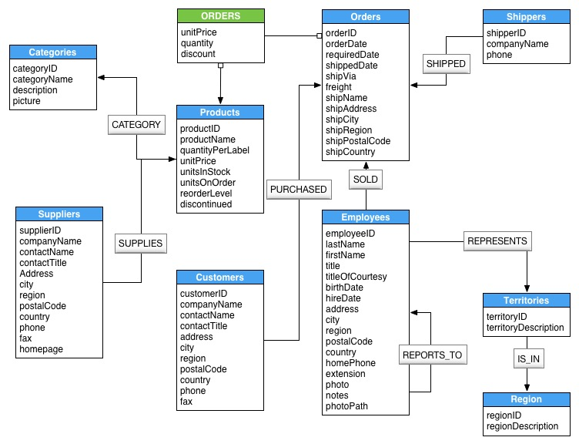
    - Wireframe/ Visual Design
<Provide url/share path of the prototype / wireframe / deployed application as available. If already covered in BRD, simply provide a reference here>
- Technology, Tools and Frameworks
<Provide list of technology, tools and frameworks followed in project.>
- Solution Recommendations
  - Technical recommendations
<Include technical recommendations.>
  - Infrastructure recommendations
<Include infrastructure recommendations.>
- Reference
< In this section references can be provided w.r.t. the requirements and scope documents>
Corporate Security Policy
Enterprise/Corporate Infrastructure/Deployment Architecture
1C Exception Logging Service

- Change Log
Version Number | Changes Made
V1.0.0 | Initial baseline created on <dd-Mmm-yyyy> by <Name of Author>
V X.Y.Z | <Please refer the configuration control tool / change item status form if the details of changes are maintained separately. If not, the template given below needs to be followed>
V X.Y.Z | Section No. | Changed By | Effective Date | Changes Effected
V X.Y.Z | NA | NA | NA | NA

