Unified Rewards Platform
API Design Document — Microservices (as built)
Gateway + 7 backend microservices. Contracts, authentication, routing, and cross-service flows of the implemented system, with the production (Azure) mapping noted throughout.

Source of truth: docs/Requirement_Document. Cognizant — Upgrade to Architect, Phase 3.

1. Purpose & scope
This document specifies the HTTP API of the Unified Rewards microservices platform exactly as implemented and verified: one API gateway and seven backend services, each owning its data. All endpoints are reached through the gateway. Where the local implementation differs from the intended production deployment, the Azure mapping is called out.

2. Architecture overview
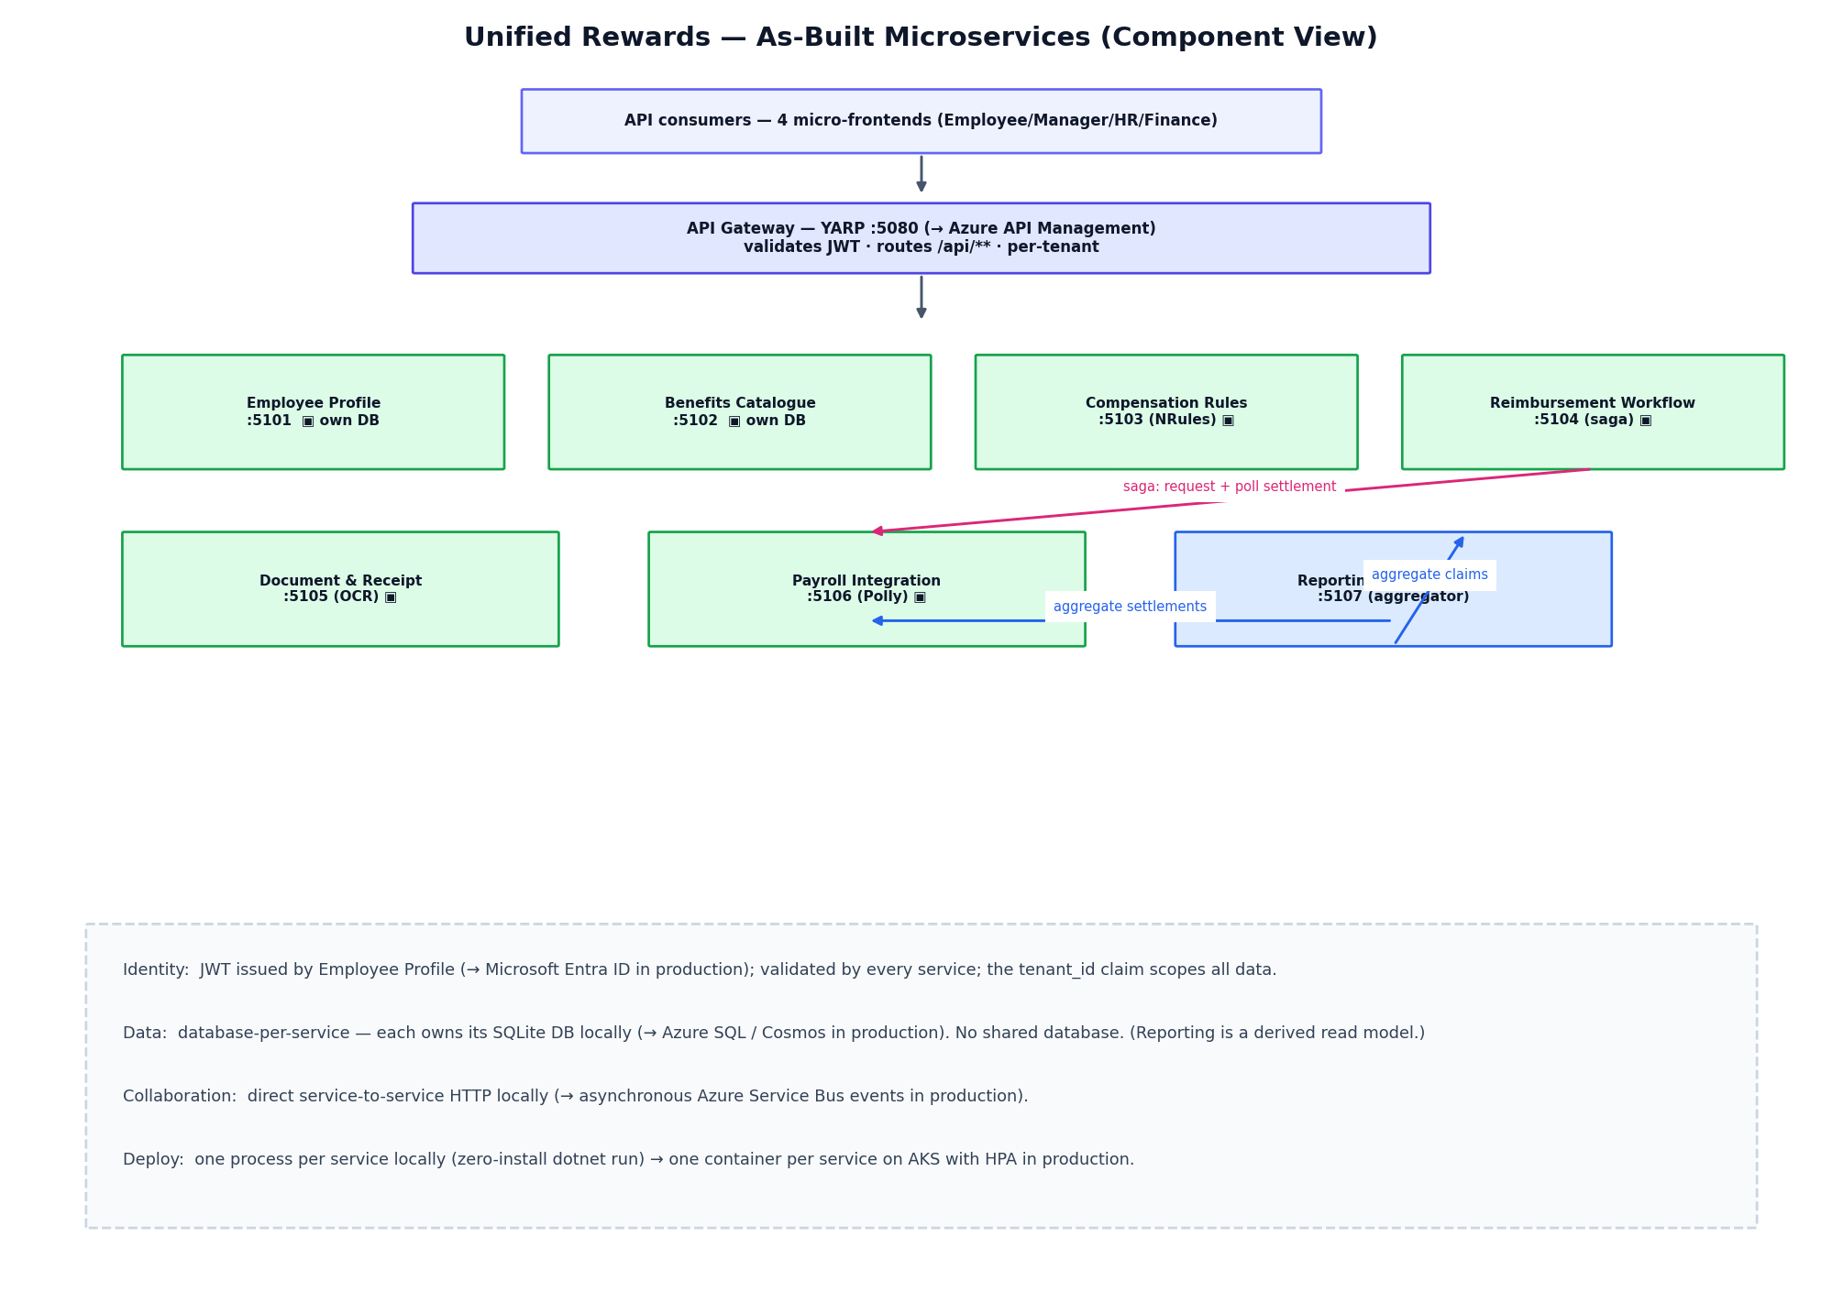
Figure 1 — As-built component view: the gateway routes to seven services, each owning its database; services collaborate over HTTP (the local stand-in for Azure Service Bus).

3. API conventions
- Single entry point. All client traffic goes through the gateway (local http://localhost:5080 → Azure API Management in production). Service ports (5101–5107) are internal.
- Authentication. Bearer JWT in the Authorization header. The token is issued by the Employee Profile service’s /api/auth/login (→ Microsoft Entra ID in production) and validated by every service.
- Multi-tenancy. The token carries a tenant_id claim; every service scopes all reads/writes to that tenant automatically.
- Authorisation. Role-based (Employee, Manager, HrAdmin, Finance) via the token’s role claim; unauthorised → 401, forbidden → 403.
- Pagination. List endpoints accept page & pageSize (default 25, max 200) and return { items, page, pageSize, totalCount }. No endpoint returns an unbounded set.
- Errors. JSON problem objects; standard status codes (400 invalid, 401 unauthenticated, 403 forbidden, 404 not found, 409 conflict, 502 upstream).
- Content type. application/json, except receipt upload (multipart/form-data) and report export (.xlsx).

4. Gateway routing
Path prefix | Service | Local port
/api/auth, /api/employees | Employee Profile | 5101
/api/benefit-plans, /api/enrollments | Benefits Catalogue | 5102
/api/compensation | Compensation Rules | 5103
/api/claims | Reimbursement Workflow | 5104
/api/documents | Document & Receipt Processing | 5105
/api/settlements, /api/payslips | Payroll Integration | 5106
/api/reports | Reporting & Compliance | 5107

5. Endpoint catalogue

5.1 Employee Profile (identity, users)
Method | Path (via gateway) | Auth / Role | Request body | Success response
POST | /api/auth/login | Anonymous | { email, password } | 200 { token, expiresAtUtc, user }
POST | /api/employees | HrAdmin | { fullName, email, password, grade, dateOfJoining, managerId? } | 201 UserDto
GET | /api/employees?role=&page=&pageSize= | Authenticated | — | 200 Paged<UserDto>
GET | /api/employees/{id} | Authenticated | — | 200 UserDto / 404

5.2 Benefits Catalogue (plans, enrolments)
Method | Path (via gateway) | Auth / Role | Request body | Success response
GET | /api/benefit-plans?category=&activeOnly=&page=&pageSize= | Authenticated | — | 200 Paged<BenefitPlanDto>
POST | /api/benefit-plans | HrAdmin | { name, description, category, monthlyCost } | 201 / 409 (dup name)
POST | /api/enrollments | Employee, Manager | { benefitPlanId, coverageStartDate } | 201 / 400 / 409 (dup)
DELETE | /api/enrollments/{id} | Employee, Manager (owner) | — | 204 / 404
GET | /api/enrollments/me | Authenticated | — | 200 [BenefitEnrollmentDto]

5.3 Compensation Rules (rule-engine output)
Method | Path (via gateway) | Auth / Role | Request body | Success response
POST | /api/compensation | HrAdmin | { employeeId, grade, annualBasic, effectiveFrom } | 201 CompensationStructureDto (NRules)
POST | /api/compensation/{id}/approve | HrAdmin, Finance | — | 200 / 404
GET | /api/compensation?employeeId= | Authenticated | — | 200 [CompensationStructureDto]
GET | /api/compensation/me | Authenticated | — | 200 [CompensationStructureDto]
GET | /api/compensation/{id} | Authenticated | — | 200 / 404

5.4 Reimbursement Workflow (claims state machine + saga)
Method | Path (via gateway) | Auth / Role | Request body | Success response
POST | /api/claims | Employee, Manager | { type, amount, description } | 201 ClaimDto (Submitted)
POST | /api/claims/{id}/approve | Manager, Finance, HrAdmin | { notes? } | 200 / 409 (illegal transition)
POST | /api/claims/{id}/reject | Manager, Finance, HrAdmin | { notes? } | 200 / 409
POST | /api/claims/{id}/settle | Finance | — | 200 Settled (orchestrates Payroll) / 409 / 502
GET | /api/claims?status=&page=&pageSize= | Manager, Finance, HrAdmin | — | 200 Paged<ClaimDto>
GET | /api/claims/me | Authenticated | — | 200 [ClaimDto]
GET | /api/claims/{id} | Manager, Finance, HrAdmin | — | 200 / 404

5.5 Document & Receipt Processing (storage + OCR)
Method | Path (via gateway) | Auth / Role | Request body | Success response
POST | /api/documents | Authenticated | multipart: ClaimId, File | 201 DocumentDto (stored + OCR-scanned)
GET | /api/documents?claimId=&page=&pageSize= | Authenticated | — | 200 Paged<DocumentDto>
GET | /api/documents/{id} | Authenticated | — | 200 / 404
GET | /api/documents/{id}/file | Authenticated | — | 200 (binary file)

5.6 Payroll Integration (settlements, payslips)
Method | Path (via gateway) | Auth / Role | Request body | Success response
POST | /api/settlements | Finance | { employeeId, amount } | 202 SettlementDto (async, Polly-resilient)
GET | /api/settlements/{id} | Authenticated | — | 200 SettlementDto (poll for status)
GET | /api/settlements?page=&pageSize= | Authenticated | — | 200 Paged<SettlementDto>
POST | /api/payslips | Finance, HrAdmin | { employeeId, year, month, grossMonthly, totalDeductionsMonthly, netMonthly } | 201 (idempotent per period)
GET | /api/payslips?employeeId=&page=&pageSize= | Authenticated | — | 200 Paged<PayslipDto>

5.7 Reporting & Compliance (read model)
Method | Path (via gateway) | Auth / Role | Request body | Success response
GET | /api/reports/dashboard | HrAdmin, Finance | — | 200 DashboardDto (aggregated)
GET | /api/reports/claims/export | HrAdmin, Finance | — | 200 .xlsx workbook

6. Cross-service flows
The reimbursement saga shows how services collaborate. Locally this is direct service-to-service HTTP (orchestration); in production the settle step publishes an event to Azure Service Bus (choreography). Reporting & Compliance aggregates live from Reimbursement and Payroll (a derived read model that consumes Service Bus events in production).
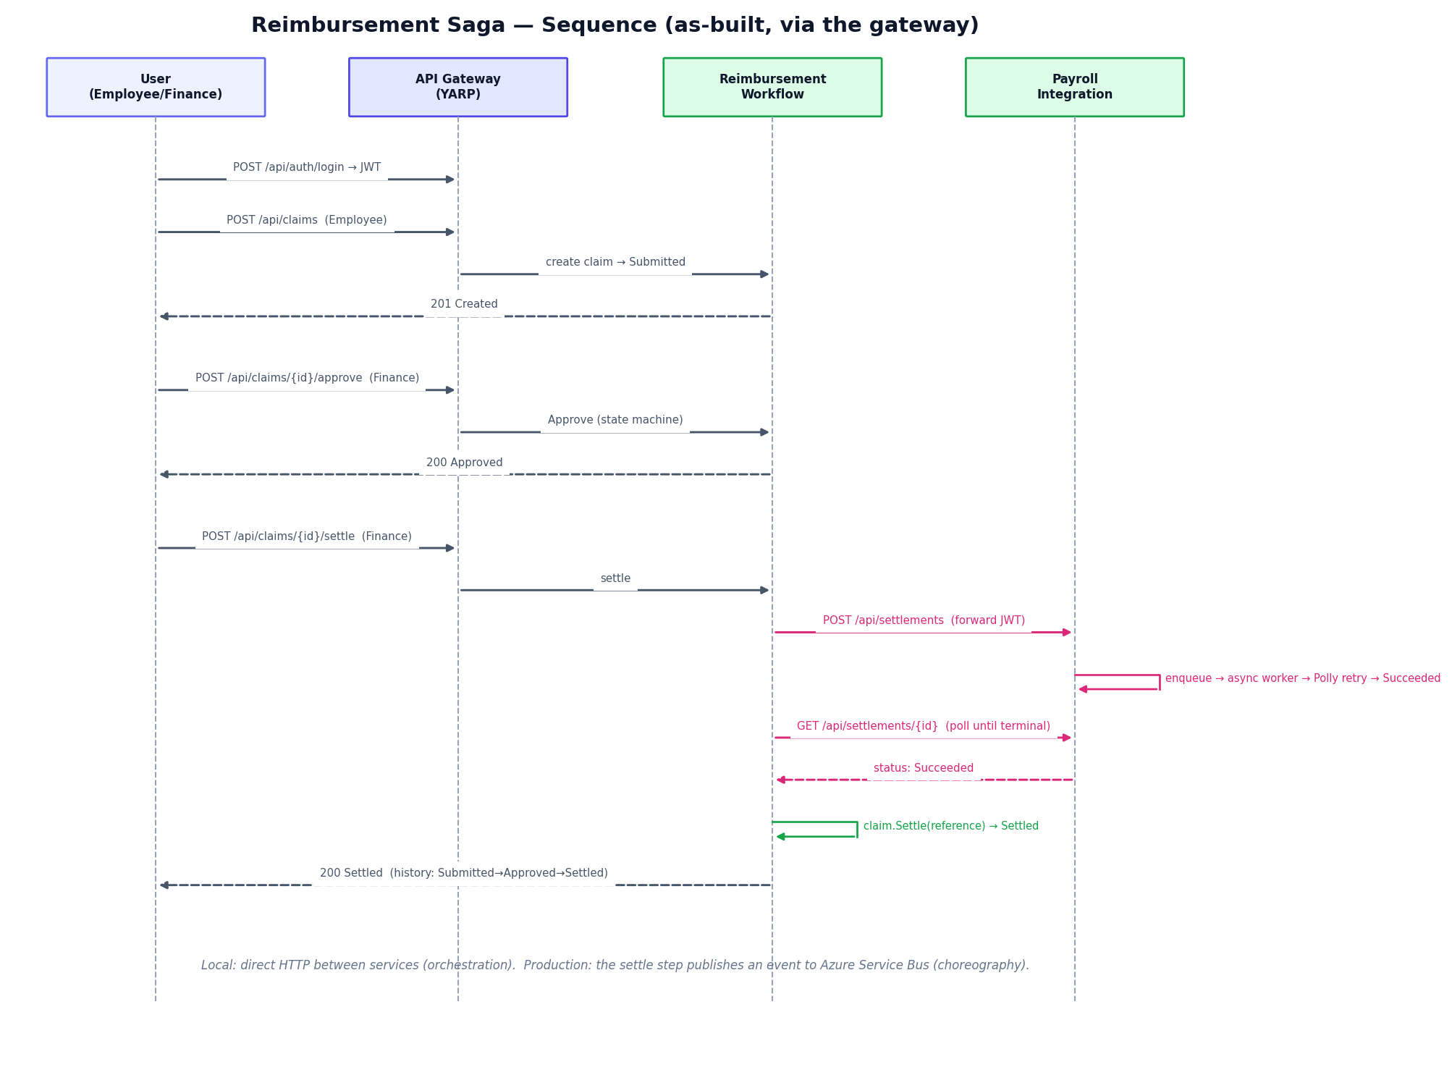
Figure 2 — Reimbursement saga: submit → approve → settle, where ‘settle’ orchestrates the Payroll service (request, asynchronous Polly-resilient processing, poll), then closes the claim.

7. Data ownership (database-per-service)
Each service is the only owner/writer of its data; others access it through the API or via events. No shared database.
Service | Owns (entities / tables) | Store (local → prod)
Employee Profile | Users (TPH: Employee/Manager/HrAdmin/Finance) | SQLite → Azure SQL
Benefits Catalogue | BenefitPlans, BenefitEnrollments | SQLite → Azure SQL
Compensation Rules | CompensationStructures, CompensationComponents | SQLite → Azure SQL
Reimbursement Workflow | Claims, ClaimTransitions (history) | SQLite → Azure SQL
Document & Receipt | Documents (+ files via storage seam) | SQLite + filesystem → Azure SQL + Blob
Payroll Integration | Settlements, Payslips | SQLite → Azure SQL
Reporting & Compliance | (derived read model — no transactional store) | in-memory → event-sourced store

8. Production (Azure) mapping
Concern | Local (as built) | Production (Azure)
Gateway | YARP reverse proxy | Azure API Management
Identity | JWT issued by Employee Profile (shared key) | Microsoft Entra ID (OIDC); managed identity for service-to-service
Service-to-service | Direct HTTP (orchestration) | Azure Service Bus events (choreography) + outbox
Datastores | SQLite per service | Azure SQL / Cosmos DB per service
Documents | Local filesystem | Azure Blob Storage
OCR | Stub (reads text receipts) | Azure AI Document Intelligence
Hosting | dotnet run processes | Containers on AKS (HPA per service)
Secrets / observability | config files / console | Key Vault / Application Insights

