Unified Rewards Platform
Microservices Migration & Decomposition Plan
Evolving the modular monolith into the requirement-mandated 7-service architecture on Azure — multi-tenant, multi-country, AKS-hosted.

Source of truth: docs/Requirement_Document. Cognizant — Upgrade to Architect, Phase 3.

1. Purpose & scope
The Requirement_Document mandates a Backend-Microservices architecture (seven named services) plus micro-frontends, for a Large, multi-tenant HR-Tech Enterprise SaaS on Azure. The platform today is a modular monolith (functionally complete; micro-frontends already delivered). This plan defines the target service decomposition, data ownership, communication, API gateway, multi-tenancy, multi-country compliance, AKS deployment, and a safe, incremental migration path.
Key principle: the monolith was deliberately built with Clean Architecture and clear module seams, so each module maps almost 1:1 to a target service and can be carved out using the strangler pattern — an evolution, not a rewrite.

2. Service decomposition — mapping the 7 modules to the 7 services
The requirement names seven services. The mapping below shows two decomposition decisions: the monolith’s combined Claims & Documents module splits into two services (as the requirement separates them), and Promotions — which the requirement does not list as a standalone service — folds into the Employee Profile / Compensation domains as a capability that emits events.
Current monolith module | Target microservice (per requirement) | Decomposition note
User Management | Employee Profile Service | AuthN/AuthZ moves to Entra ID; service owns profile, org, grade, promotion history
Benefits | Benefits Catalogue Service | Plans + enrolments; mostly catalogue/CRUD
Compensation (NRules) | Compensation Rules Engine | Comp structures + country-specific rule sets
Claims & Documents | Reimbursement Workflow Service | Owns the claim state machine & approvals
Claims & Documents | Document & Receipt Processing Service | SPLIT OUT: receipt storage + OCR (different scaling profile)
Payroll | Payroll Integration Service | External payroll integration + settlements (Polly resilience)
Promotions | → Employee Profile / Compensation | No standalone service in the requirement; modelled as a capability + events
Reporting & Audit | Reporting & Compliance Service | Event-sourced read store; compliance reporting + audit

Per-service responsibilities & dependencies
Service | Owns (data) | Sync calls (via APIM) | Async events (Service Bus)
Employee Profile | Employees, org, grade | — | publishes EmployeeOnboarded, GradeChanged
Benefits Catalogue | Plans, enrolments | Employee Profile (validate) | publishes EnrolmentChanged
Compensation Rules | Comp structures, rules | Employee Profile | publishes CompensationApproved; consumes GradeChanged
Reimbursement Workflow | Claims, approvals | Employee Profile | publishes ClaimSubmitted/Approved/Settled; consumes DocProcessed, SettlementCompleted
Document & Receipt | Receipts (Blob), OCR results | — | consumes ClaimSubmitted; publishes DocProcessed
Payroll Integration | Settlements, payslips | — | consumes ClaimApproved; publishes SettlementCompleted
Reporting & Compliance | Read models, audit | (reads replicas) | consumes ALL events

3. Data ownership — database-per-service
- No shared database. Each service owns its data and is the only writer; others get data via its API or via events. This is what enables independent deployment and scaling.
- Provider per fit. Relational, transactional services (Reimbursement, Compensation, Payroll, Employee) use Azure SQL; catalogue/读-heavy or document-metadata services may use Azure Cosmos DB; documents in Blob; hot reads in Redis.
- Splitting the current schema. The monolith’s single schema is partitioned along module boundaries; foreign keys that cross a boundary become API/event references (e.g., a claim stores EmployeeId, not a FK to a Users table it no longer owns).
- Consistency across services. Use the Saga pattern (orchestrated by Reimbursement Workflow) with the Transactional Outbox so events are never lost; accept eventual consistency between services; compensating actions on failure.
- Reporting. Reporting & Compliance builds its own read store by subscribing to events (event-sourced/CQRS read model) — it never queries other services’ databases directly.

4. Inter-service communication
- Synchronous (request/response). REST over HTTPS through API Management for queries that need an immediate answer (e.g., validate an employee). Kept to a minimum to avoid coupling and latency chains.
- Asynchronous (events). Azure Service Bus topics/queues for state changes — the default. Services react to events rather than calling each other, which decouples them and absorbs load spikes.
- The reimbursement saga. Submit → (event) Document & Receipt OCRs the receipt → Reimbursement Workflow advances on DocProcessed → on approval, (event) Payroll settles → SettlementCompleted closes the claim. Each step is independently retriable and idempotent.
Event backbone (illustrative): EmployeeOnboarded, GradeChanged, EnrolmentChanged, CompensationApproved, ClaimSubmitted, ClaimApproved, ClaimRejected, DocProcessed, SettlementRequested, SettlementCompleted, plus audit/compliance events consumed by Reporting & Compliance.

5. API Management (APIM) — the gateway
- Single entry point for all micro-frontends and external integrations; routes to the right service.
- Security — validates the Entra ID JWT (incl. the tenant claim), enforces scopes/roles, terminates TLS.
- Protection — per-tenant rate limiting/throttling and quotas; protects services from spikes and noisy tenants.
- Versioning & lifecycle — API versions, revisions, and a developer portal for enterprise integration partners.
- Aggregation (BFF) — optional backend-for-frontend composition so a portal screen needs one call, not many.

6. Multi-tenancy (the SaaS dimension)
Each customer enterprise is a tenant. Tenant identity flows from Entra ID as a tenant claim in the JWT, is validated at APIM, and is propagated to every service and onto every data operation.
Isolation model | What it means | Use for
Pooled (shared DB + TenantId) | One database, every row tagged with TenantId, enforced by a global query filter / row-level security | Default — most tenants; best density & cost
Bridge (schema-per-tenant) | Shared server, separate schema per tenant | Mid-size tenants needing logical separation
Siloed (DB-per-tenant) | Dedicated database (and region) per tenant | Large or regulated tenants; data-residency needs

- Recommended: a hybrid ‘pool + silo’. Pooled by default; promote specific tenants to siloed/regional databases when contracts or compliance demand it — without code changes (tenant-to-store routing is configuration).
- Tenant context everywhere. EF Core global query filters guarantee no query can cross tenant boundaries; APIM rejects tokens without a valid tenant; audit records the tenant.
- Tenant onboarding. A provisioning process creates the tenant, its store/route, default catalogue, and admin user.

7. Multi-country compliance
- Data residency. Deploy per-region (AKS cluster + data stores per geography); route each tenant to its home region via Front Door/APIM so data stays in-country.
- Country-specific business rules. The Compensation Rules Engine and Reimbursement Workflow load country rule sets (tax, statutory allowances, claim limits) — a natural fit for the existing NRules engine, with one rule set per country/tenant.
- Privacy (GDPR & local laws). Consent capture, data-minimisation, right-to-erasure/portability workflows, and field-level encryption for sensitive pay/PII.
- Auditability. Reporting & Compliance maintains an immutable audit/compliance trail (from events) with per-country retention policies.
- Localisation. Currency, number/date formats, language (i18n) per country in the micro-frontends.

8. Deployment on AKS
- One deployment + HPA per service — each service scales independently on CPU/memory or queue length; no more scaling the whole app to scale one part.
- Namespaces per environment (dev/test/prod); ingress controller behind APIM/Front Door.
- Service mesh (optional, e.g. Istio/Linkerd) for mutual-TLS between services, traffic shifting (canary), and uniform telemetry.
- Secrets via Key Vault CSI driver + Workload Identity — no secrets in images or config; pods get managed-identity access.
- Images in Azure Container Registry ; GitHub Actions pipeline per service builds, scans, and deploys (Helm/Kustomize) with blue-green/canary.
- Per-region clusters for residency and lower latency; geo-failover for DR.
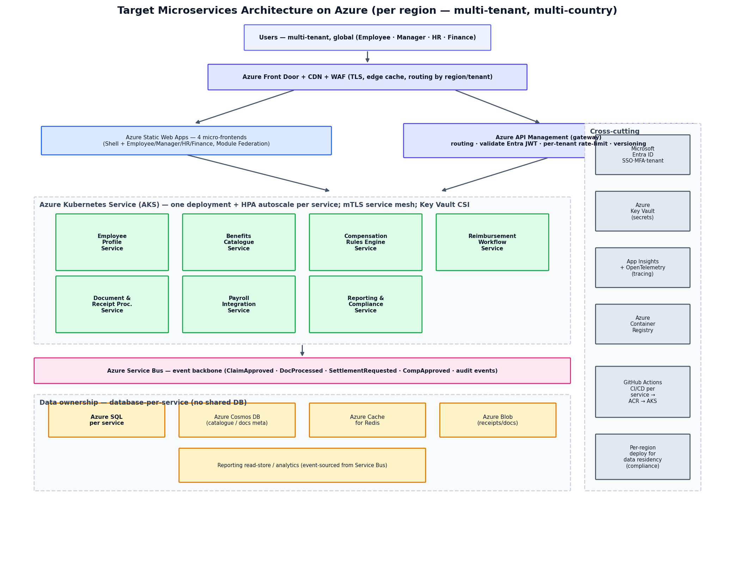
Figure 1 — Target microservices architecture on Azure (per region). Stateless services on AKS behind APIM, communicating via Service Bus events, each owning its data, with Entra ID, Key Vault and Application Insights as cross-cutting platform services.

9. Cross-cutting concerns
- Identity — Microsoft Entra ID (OIDC/OAuth2, RS256, MFA, SSO) issues tenant- and role-aware tokens; services trust the gateway-validated token.
- Observability — Application Insights + OpenTelemetry distributed tracing with a correlation id propagated across sync calls and async events; per-service dashboards and SLO alerts.
- Resilience — Polly retries/circuit-breakers/timeouts on every external and inter-service call (already proven on Payroll); idempotent consumers.
- Shared contracts — event and DTO contracts versioned in a shared package; consumer-driven contract tests prevent breaking changes.
- Config & secrets — Azure App Configuration + Key Vault; feature flags for safe rollout.

10. Migration strategy & sequencing (Strangler pattern)
The monolith keeps running and serving traffic while services are carved out one at a time behind APIM; each extracted capability is routed to its new service and the old code path retired. No big-bang cutover.
Phase | Focus | Key work
0. Foundations | Platform | Entra ID, APIM, Service Bus, AKS, ACR, observability, shared-contracts lib, CI/CD, tenant context + multi-tenant data filter
1. Front the monolith | Gateway | Put APIM in front of the existing monolith (no behaviour change); switch auth to Entra ID; add tenant claim end-to-end
2. Extract leaf services | Low-coupling first | Document & Receipt Processing, then Payroll Integration (already behind seams, async) — own data store + events; route via APIM
3. Extract domain services | Workflow & catalogue | Benefits Catalogue, Compensation Rules Engine, Reimbursement Workflow (saga over Document + Payroll)
4. Extract core + reporting | Core & read-side | Employee Profile Service; Reporting & Compliance built as an event-sourced read store consuming all events
5. Retire monolith | Cutover & harden | Remove residual monolith code; full multi-region + compliance + DR; load/chaos/security testing

Extraction order rationale: start with the most independent, differently-scaling capability (Document/OCR), then the already-seamed async Payroll, building the event backbone early; tackle the highly-referenced Employee Profile later when the event patterns are proven; Reporting consumes events throughout.

11. Risks & mitigations
Risk | Mitigation
Distributed data consistency | Saga + Transactional Outbox; idempotency; design for eventual consistency
Operational complexity (many services) | IaC, service mesh, strong observability, platform team & golden paths
Latency from chatty sync calls | Prefer events; cache; BFF aggregation; keep sync calls shallow
Harder testing | Consumer-driven contract tests; per-service test suites; staging with prod-like data
Cost of AKS + per-service stores | Right-size, autoscale to zero where possible, pooled multi-tenancy by default
Migration regressions | Strangler (incremental), feature flags, canary, parallel-run & compare

12. How this satisfies the Requirement_Document
- Backend Microservices (7): delivered exactly as named (with Claims/Documents split and Promotions folded).
- Micro Frontends (4): already delivered via React Module Federation; retained as-is.
- Rule engines vs hard-coded: Compensation Rules Engine (NRules) + country rule sets.
- Multi-country compliance: per-region residency, country rule sets, GDPR workflows, audit.
- Enterprise integrations: APIM developer portal + Payroll Integration Service + event backbone.
- Data privacy & access segregation: Entra ID + RBAC + per-tenant isolation + field-level encryption.
- Scalable workflow design: event-driven saga on Service Bus, each service autoscaled on AKS.

