Cognizant / Unified Rewards Platform
High Level Design and Architecture Document
Version: 1.0

 | Prepared By / Last Updated By | Reviewed By | Approved By
Name | Sandhya S
Role | Architect
Signature
Date | 23/05/2026

Table of Contents
1.0 Introduction 4
1.1 Purpose of this document 4
1.2 Scope 4
1.3 Out of scope 4
1.4 Intended Audience 4
1.5 Acronyms 4
2.0 System Architecture 6
2.1 Architectural Views 6
2.1.1 Functional View 6
2.1.2 Conceptual View 8
2.1.3 Logical View 9
2.1.4 Functional Architecture View 11
2.1.5 Technology View 12
2.1.6 Integration View 14
2.1.7 Implementation View 15
2.1.8 Data View 16
2.1.9 Deployment View 17
2.1.10 Security View 19
2.1.11 Process View 21
2.2 System Interfaces 24
2.3 Reporting 24
3.0 Prototype Design 26
3.1.1 Wireframe / Visual Design 26
4.0 Technology, Tools and Frameworks 27
5.0 Solution Recommendations 29
5.1 Technical recommendations 29
5.2 Infrastructure recommendations 29
6.0 Reference 31
7.0 Change Log 31

1.0 Introduction

1.1 Purpose of this document
This document provides the High-Level Design and Architecture for the Unified Rewards Platform (URP) — an enterprise HR Technology solution built on Microsoft Azure. The platform centralizes employee benefits management, compensation structuring, expense claim processing, payroll integration, promotion management, and compliance reporting into a single unified digital experience. This document serves as the primary technical reference for architecture decisions, component design, integration patterns, deployment topology, and security controls for all engineering, operations, and security teams involved in the delivery of the platform.

1.2 Scope
This HLD & Architecture Document is designed for a greenfield application. It is technical in nature and covers the following System/Application Architecture views:
- 7 independent backend microservices (ASP.NET Core 8) deployed on Azure Kubernetes Service (AKS) — Employee, Benefits, Compensation, Claims, Documents, Payroll, and Reporting Service.
- 4 independently deployed micro-frontend portals (React 18 + Webpack 5 Module Federation) — Employee Self-Service Portal, Manager Approval Portal, HR Admin Portal, and Finance & Audit Portal.
- Azure cloud infrastructure: APIM, AKS, Azure SQL, Azure Cosmos DB, Azure Redis Cache, Azure Blob Storage, Azure Service Bus, Azure Event Hub, Azure Functions, Azure Key Vault, Azure Front Door.
- Security architecture: Azure AD / Entra ID for SSO + MFA, JWT RBAC, TLS 1.3, Private VNet, Transparent Data Encryption.
- Event-driven integration using Azure Service Bus (claim lifecycle events) and Azure Event Hub (audit stream).
- External integration with Payroll Systems (SAP / ADP / Workday) via REST with Polly resilience policy.
- CI/CD pipeline via GitHub Actions with independent deployment pipelines per service.

1.3 Out of scope
- Internal configuration and administration of external payroll systems (SAP / ADP / Workday).
- Mobile native applications — not in scope for Release 1.0.
- Legacy HR system data migration — migration strategy to be covered in a separate Migration HLD.
- Low-Level Design (LLD) details of individual microservice business logic.
- Third-party vendor SLA guarantees beyond the Azure SLA.

1.4 Intended Audience
Internal Technical teams, Solution Architects, Backend and Frontend Developers, DevOps / Platform Engineers, IT Security Team, Delivery Excellence (DelEx), and Project Managers.

1.5 Acronyms
S. No | Acronym | Expansion
1 | HLD | High Level Design
2 | AKS | Azure Kubernetes Service
3 | APIM | Azure API Management
4 | RBAC | Role-Based Access Control
5 | MFA | Multi-Factor Authentication
6 | JWT | JSON Web Token
7 | CQRS | Command Query Responsibility Segregation
8 | CTC | Cost to Company
9 | OCR | Optical Character Recognition
10 | MFE | Micro Frontend
11 | SLA | Service Level Agreement
12 | BRD | Business Requirements Document
13 | VNet | Azure Virtual Network
14 | GRS | Geo-Redundant Storage
15 | TDE | Transparent Data Encryption
16 | HPA | Horizontal Pod Autoscaler
17 | WAF | Web Application Firewall
18 | MSI | Managed Service Identity
19 | PF | Provident Fund
20 | HRA | House Rent Allowance
21 | LTA | Leave Travel Allowance
22 | DelEx | Delivery Excellence

2.0 System Architecture

2.1 Architectural Views
The architecture of the Unified Rewards Platform is depicted across multiple views to ensure clarity from different stakeholder perspectives. Each view addresses specific concerns of the system and its stakeholders, following the 4+1 architectural view model extended with security and deployment views.
The architecture is designed to address the following quality attributes for each component:
- Confidentiality — Data isolation per employee; role-based data access; encrypted storage and transit.
- Integrity — Immutable audit entries; append-only Event Hub stream; JWT signature validation.
- Availability — AKS HPA (2–10 pods per service); geo-replicated Azure SQL; multi-region Cosmos DB.
- Authentication — Azure AD OIDC/OAuth 2.0; MFA enforcement; JWT Bearer with RS256 signing.
- Authorization — RBAC (EMPLOYEE, MANAGER, HR_ADMIN, FINANCE_USER); [Authorize] ASP.NET Core Middleware.
- Accounting — Full audit trail via Azure Event Hub; AuditEntry records in Azure SQL.
- Non-Repudiation — Immutable ClaimStatusHistory; signed JWT with user identity claims.
- Replication — Azure SQL Geo-replication; Cosmos DB multi-region write; Blob GRS.
- Failover — AKS pod restart policies; Azure SQL auto-failover group; Polly circuit breaker.
- Scalability — AKS HPA per service; Cosmos DB auto-scale throughput; Azure Redis Cache Premium.
- Design Pattern — CQRS (MediatR), Rules Engine (NRules), Event-Driven (Service Bus), Module Federation (MFE).
- Cryptographic Strategy — RS256 for JWT signing; AES-256 for data at rest; TLS 1.3 for data in transit; RSA 2048 for key management via Azure Key Vault.

2.1.1 Functional View

2.1.1.1 Key Business Processes
The following key business processes are identified as architecturally significant and drive the core functional design of the Unified Rewards Platform:
# | Business Process | Description | Key Actors | SLA / Policy
1 | Employee Benefits Enrollment | Employee views eligible benefit plans, evaluates coverage, and enrolls. Eligibility is enforced by grade, tenure, employment type, and location. | Employee, HR Admin | Enrollment effective from next payroll cycle
2 | Expense Claim Submission & Approval | Employee submits expense claim with OCR-scanned receipts. Manager reviews and approves or rejects within SLA. Approved claims settle in next payroll run. | Employee, Manager | 7 business days SLA for manager action
3 | Compensation Management (CTC) | HR Admin configures grade-based compensation rules using NRules Engine. Rules compute BasicPay, HRA, Bonus, PF per employee. | HR Admin, Employee | CTC updated annually or on grade change
4 | Payroll Settlement Processing | Approved claims trigger Settlement records in the Payroll Service. Finalized payroll pushed to external SAP/ADP/Workday system via REST with Polly retry. | Payroll Service, External Payroll System | Processed monthly; 3 retry attempts
5 | Promotion Cycle Management | HR Admin creates promotion cycle, defines eligibility criteria, and opens nominations. Managers nominate team members. HR Admin records outcomes and closes cycle. | HR Admin, Manager, Employee | Quarterly promotion cycles
6 | Compliance Reporting & Audit Trail | Finance User generates Claim Summary, Compensation, and Audit reports. All platform actions streamed to Event Hub as immutable audit entries. | Finance User | Reports on demand; audit entries in real-time

2.1.1.2 Architecturally Significant Use Cases / Functional Requirements
- UC-01: User Management & Authentication — Azure AD SSO (OIDC/MFA) with JWT RBAC across 4 distinct roles (Employee, Manager, HR Admin, Finance User) manages identity and access control via the User Management module across all portals.
- UC-02: Claim Workflow State Machine — Claim transitions (DRAFT → SUBMITTED → UNDER_REVIEW → APPROVED/REJECTED → SETTLED) require a robust state machine with audit trail at each transition.
- UC-03: OCR-based Receipt Processing — Async OCR via Azure Function Blob Trigger requires Document → Receipt → OCRResult pipeline with confidence scoring and manual review fallback for low-confidence results.
- UC-04: Rules Engine-driven CTC Calculation — Compensation rules must be configurable at runtime without code deployment; NRules Engine evaluates grade-based formulas dynamically with Redis caching of compiled rules.
- UC-05: Event-Driven Payroll Settlement — Claim approval triggers asynchronous Settlement via Azure Service Bus, decoupling Claims & Documents Service from Payroll Service; Finance User can trigger and monitor settlement status.
- UC-06: Real-time Audit Logging — All domain events must be captured as immutable audit entries via Azure Event Hub, persisted for 7 years in SQL, for regulatory compliance.
- UC-07: Independent Micro Frontend Deployment — Each portal (Employee, Manager, HR Admin, Finance User) must be deployable independently without impacting other portals.
- UC-08: External Payroll Integration Resilience — Payroll data push to SAP/ADP/Workday must tolerate transient failures via Polly retry with Dead Letter Queue fallback.
Functional Use Case Coverage by Module (refer diagrams uc_00_system_overview through uc_07_reporting_audit):
Module | Actors | Key Use Cases
User Management | Employee, HR Admin, Azure AD (System) | Login via SSO (OIDC/MFA); View own profile; Update contact details; View role & permissions; Manage user accounts; Assign roles (Employee / Manager / HR Admin / Finance User); Set grade & department; Deactivate / Reactivate user; Validate JWT & Enforce RBAC
Benefits Management | Employee, HR Admin, Payroll Service (System) | Enroll in benefit plan; Check eligibility criteria; Opt-out of benefit plan; Browse benefits catalog; View plan details & coverage; View enrollment status; Configure benefit plans; Set eligibility criteria; Activate / Deactivate plan; View enrollment summary report; Trigger benefit deduction in payroll
Claims & Documents | Employee, Manager, OCR Engine (System) | Submit expense claim; Upload receipt / document; Track claim status in real time (DRAFT → SUBMITTED → UNDER_REVIEW → APPROVED / REJECTED → SETTLED); View claim history; Withdraw pending claim; Review claim details & receipt; Approve claim (within 7-day SLA); Reject claim with reason; View pending approvals queue; Process receipt via OCR; Validate OCR confidence score; Route to manual review (low OCR)
Compensation Management | Employee, HR Admin, NRules Engine (System) | View CTC breakdown; View compensation history; Download compensation statement; Create compensation rule; Modify / Deactivate rule; Invalidate rule cache on update; Assign rule to employee grade; Preview rule impact; Calculate CTC (NRules Engine); Cache compiled rules (Redis)
Payroll Management | Employee, Finance User, External Payroll System (SAP/ADP/Workday), Payroll Service (System) | Download payslip (PDF); View payslip list; Trigger payroll settlement; Monitor settlement status; View settlement history; Process settlement via external API; Retry failed settlement (Polly); Route to Dead Letter Queue; Generate payslip (ClosedXML → PDF); Store payslip in Azure Blob
Promotions Management | Employee, Manager, HR Admin | View promotion eligibility; View promotion status & history; Nominate employee for promotion; View team nominations; Configure promotion cycle; Set eligibility bands & criteria; Set bonus multipliers; Approve promotion; Trigger CTC update on approval; Reject nomination; Notify employee of decision; Review pending nominations
Reporting & Audit | Finance User, HR Admin, Reporting Service (System) | Generate compliance report (PDF / XLSX); Export report as PDF; Export report as XLSX; Apply report filters (date / grade / dept); View audit trail entries; Search & filter audit events; Export audit trail (XLSX / PDF); Schedule nightly report; View analytics dashboard; View HR summary reports; Ingest audit events from Event Hub; Persist audit entries (7-year SQL)

- Figure: Architecturally Significant Use Cases — UML Use Case Diagram (UC-01 to UC-08). Refer module-level use case diagrams: Use_Case_Diagrams
Figure: Architecturally Significant Use Cases — UML Use Case Diagram (UC-01 to UC-08)

2.1.1.3 Functional Modules
Level 0 — System Context

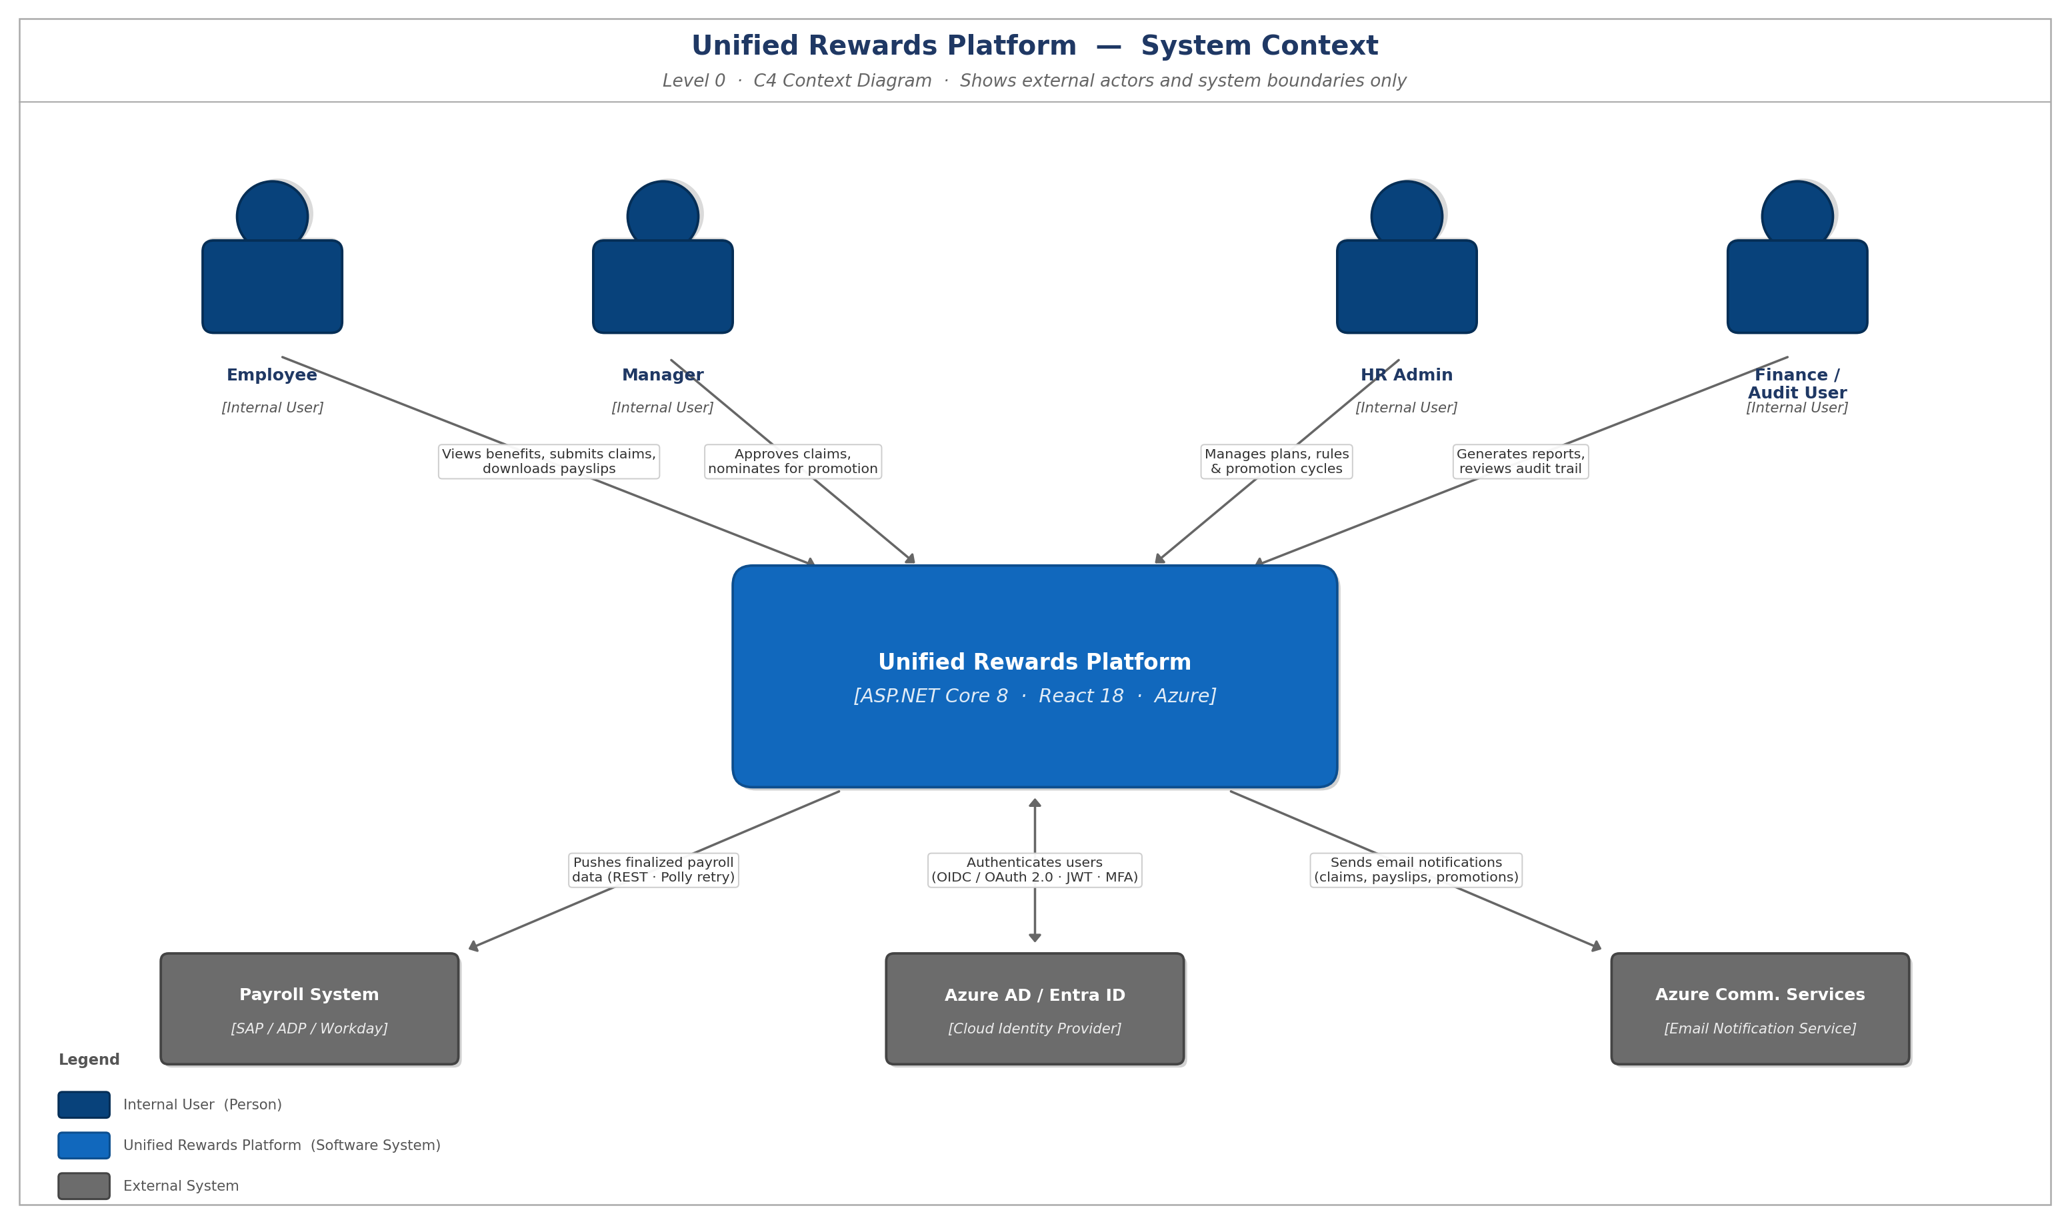
Figure: Level 0 — System Context Diagram

Level 1 — Major Functional Modules
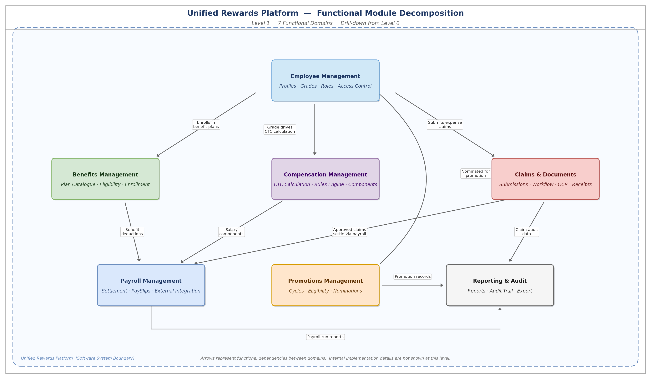
Figure: Level 1 — Functional Module Decomposition (7 Domains)

Level 2 — Sub-Module Breakdown (per service)
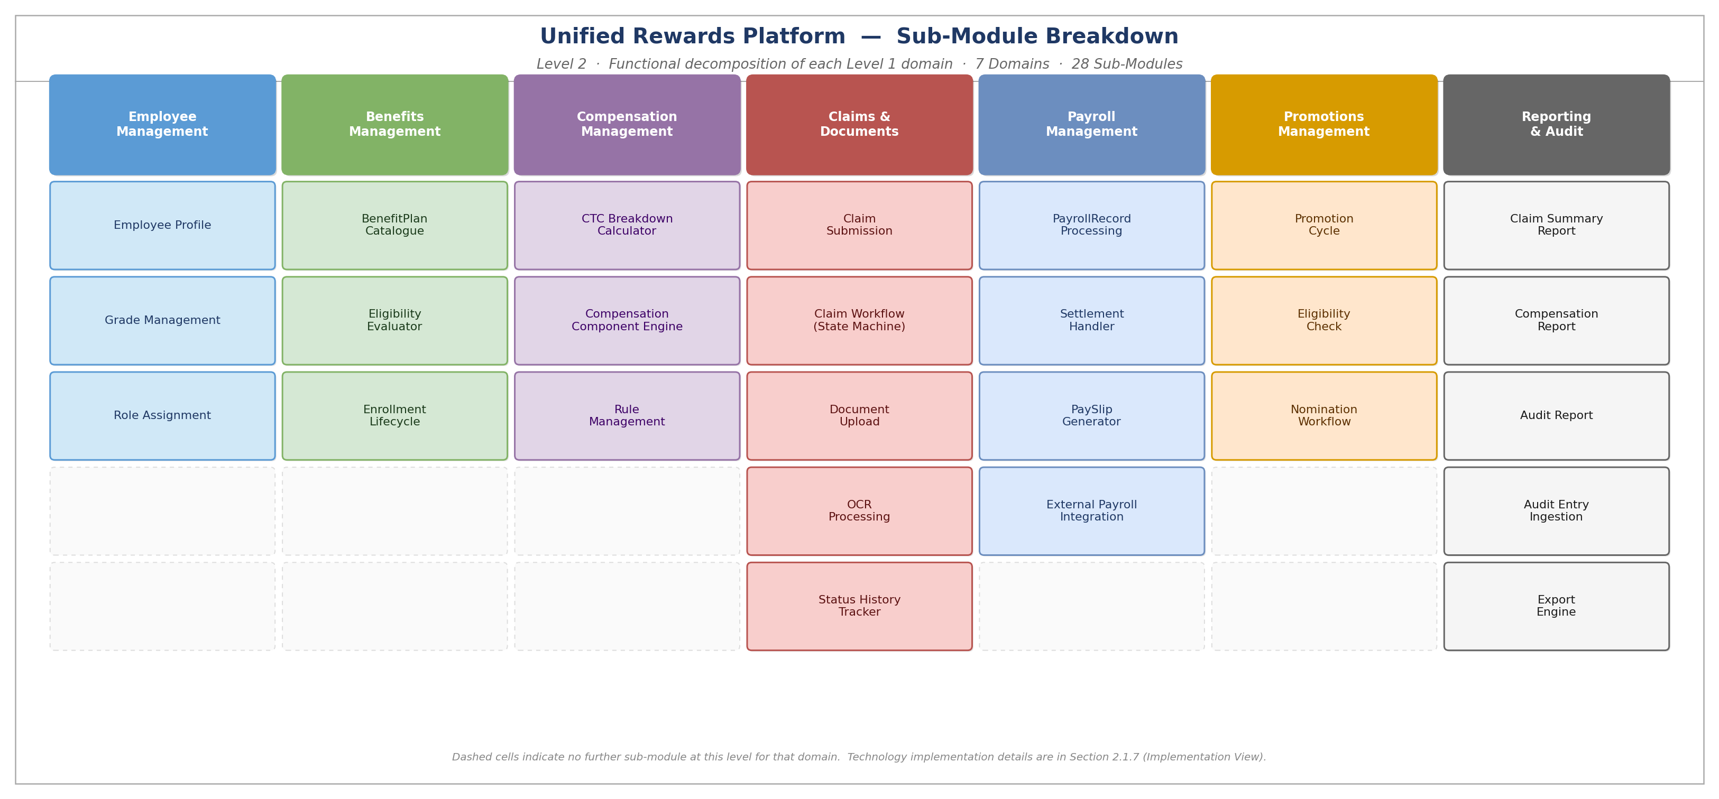
Figure: Level 2 — Sub-Module Breakdown (7 Functional Domains · 28 Sub-Modules)
Module | Sub-Modules
Employee Management | Employee Profile, Grade Management, Role Assignment
Benefits Management | BenefitPlan Catalogue, EligibilityCriteria Evaluator, BenefitEnrollment Lifecycle
Compensation Management | CTCBreakdown Calculator, CompensationComponent Engine (NRules), Rule Management
Claims & Documents Management | Claim Submission, ClaimWorkflow State Machine, StatusHistory Tracker, Document Upload, OCR Processing (Tesseract.Net)
Payroll Management | PayrollRecord Processing, Settlement Handler, PaySlip Generator (ClosedXML), External Payroll Integration (Polly)
Promotions Management | Promotion Cycle, EligibilityCheck, Nomination Workflow
Reporting & Audit | ClaimSummaryReport, CompensationReport, AuditReport, AuditEntry Ingestion, Export Engine (ClosedXML)

2.1.2 Conceptual View

2.1.2.1 Actors
Actor | Type | Role Description | Utility (Consumer / Supplier)
Employee | Human – Internal | Submits expense claims, enrolls in benefit plans, views CTC breakdown, downloads payslips. | Consumer
Manager | Human – Internal | Reviews and approves/rejects claims for own team members, submits promotion nominations. | Consumer + Supplier (approval decisions)
HR Admin | Human – Internal | Configures benefit plans, compensation rules (NRules), and manages promotion cycles. | Supplier (platform configuration)
Finance / Audit User | Human – Internal | Generates Claim Summary, Compensation, and Audit reports; views full audit trail. | Consumer (read-only analytics)
External Payroll System | System – External | SAP / ADP / Workday — receives finalized payroll data from Payroll Service via REST API. | Consumer (downstream)
Azure AD / Entra ID | System – Cloud | Issues JWT Bearer tokens post SSO + MFA authentication; provides Managed Identity for service-to-service. | Supplier (identity)
Azure Communication Svc | System – Cloud | Sends email notifications for claim status changes, enrollment confirmations, payslip readiness, promotions. | Consumer (triggered by events)
Azure Service Bus | System – Cloud | Routes event notifications between internal services (e.g. claim approval triggers payroll settlement; status changes trigger email notifications). | Infrastructure (internal event bus)
Azure Functions | System – Cloud | Executes automated background tasks: receipt document scanning (OCR), scheduled report generation, and payroll batch processing. | Infrastructure (automated processing)

2.1.2.2 System Components
The following high-level components form the Unified Rewards Platform. This view is designed to communicate architecture to a non-technical audience.
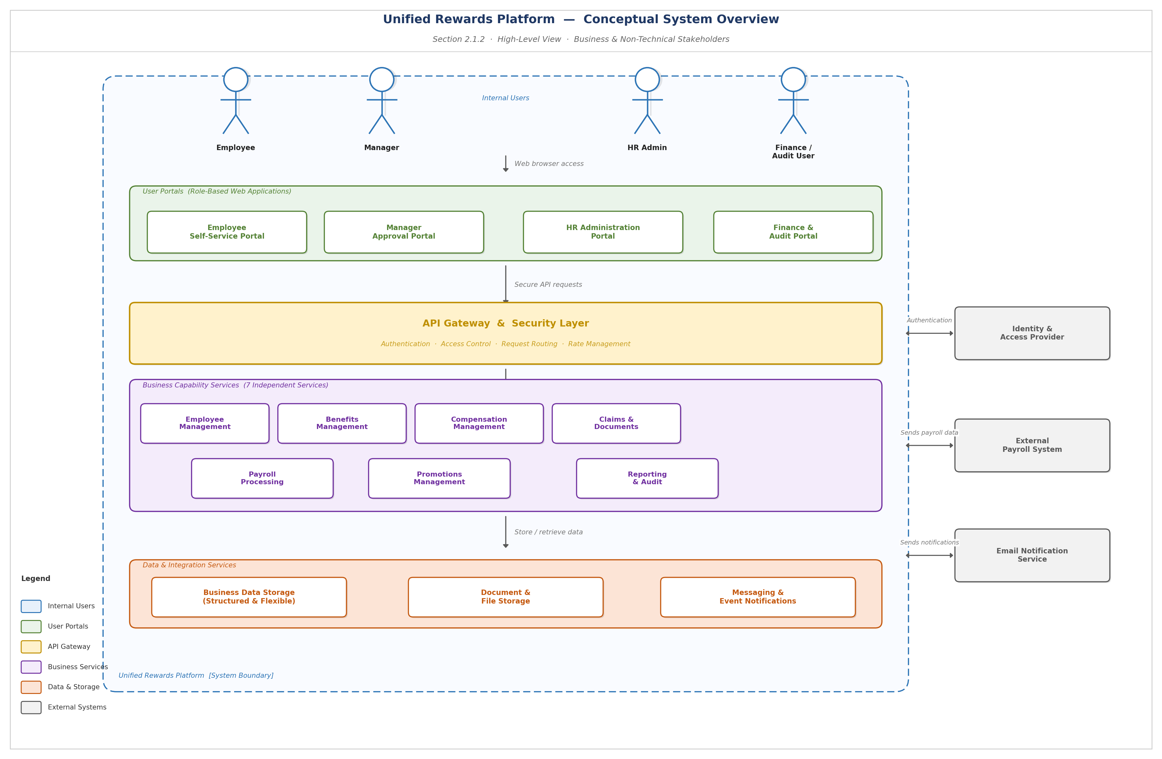
Figure: Conceptual Architecture Diagram

Component | Description
Shell Host App (React) | Module Federation host — loads role-specific remote portals lazily based on JWT claims.
Employee Remote Portal | React micro-frontend for employees: benefit catalogue, claim form, CTC view, payslip download.
Manager Remote Portal | React micro-frontend for managers: pending approvals queue, claim review, nomination form.
HR Admin Remote Portal | React micro-frontend for HR Admins: benefit plan config, compensation rule builder, promotion cycle manager.
Finance Remote Portal | React micro-frontend for Finance: report dashboard, audit trail viewer, export engine.
Azure APIM (API Gateway) | Single, secure entry point for all application API traffic. Handles user authentication, access control, and request routing to the appropriate service.
7 Microservices (AKS) | Seven independently deployable business capability services covering Employee, Benefits, Compensation, Claims & Documents, Payroll, Promotions, and Reporting & Audit functions.
Azure Service Bus | Cloud messaging service that reliably routes event notifications between internal services — for example, a claim approval automatically triggers payroll processing.
Azure Event Hub | High-throughput event streaming service that captures all platform activities in an immutable audit trail for compliance and reporting purposes.
Azure Functions | Serverless compute service that executes automated background tasks such as receipt scanning (OCR), scheduled report generation, and payroll batch jobs.
Azure SQL Database | Relational store for Claims, Employees, Payroll, Reports, AuditEntries.
Azure Cosmos DB | Cloud database service for storing benefit plan configurations and compensation rule sets with high availability and flexible data structures.
Azure Redis Cache | High-speed in-memory data store that improves application response times by caching frequently accessed information.
Azure Blob Storage | Object store for receipts, PaySlip PDFs, and exported reports.
Azure Key Vault | Secure cloud service that safely stores and manages application secrets, connection credentials, and access keys.
External Payroll System | Third-party payroll platform (SAP / ADP / Workday) that receives finalised payroll data from the Unified Rewards Platform on a monthly basis.

2.1.3 Logical View
The Logical View depicts all architectural layers and cross-cutting concerns of the Unified Rewards Platform. Horizontal layers represent tiers; vertical layers represent cross-cutting/infrastructural elements.
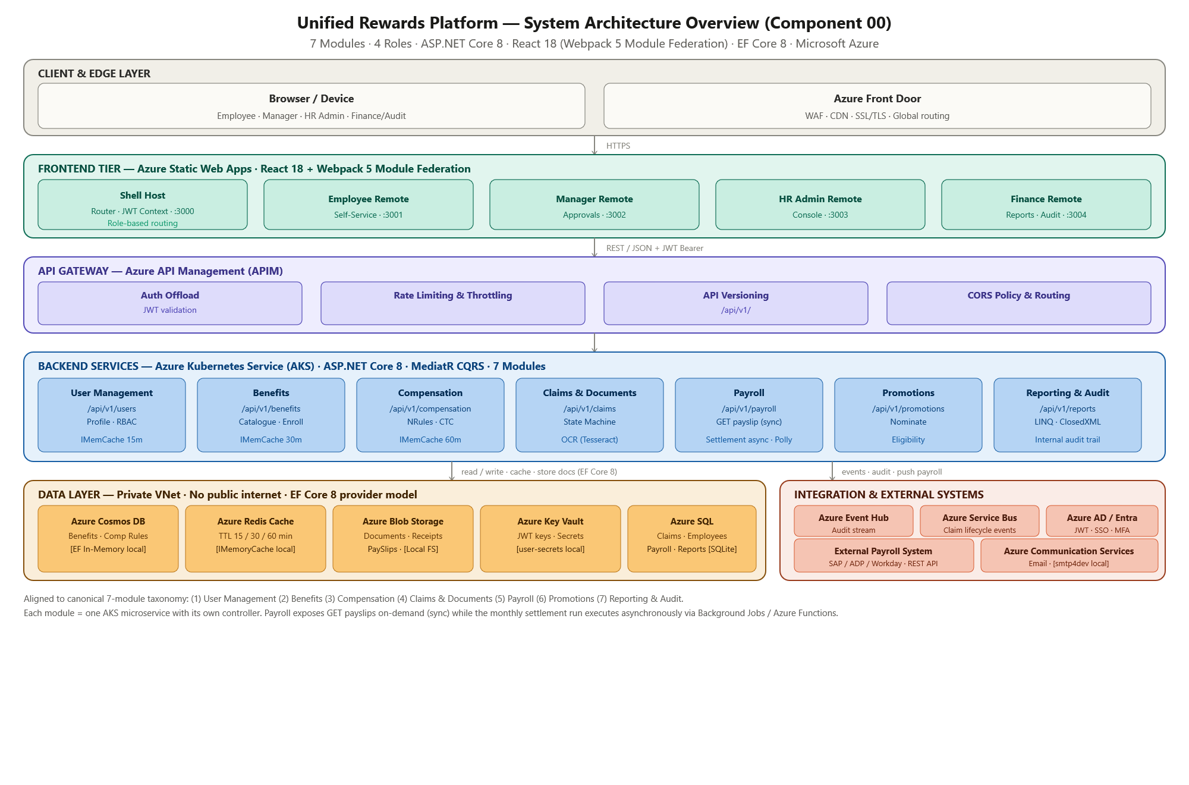
Figure: Logical Architecture Diagram — 5-Layer System View

System Flow (In Detail)
Tier 1 — User Type (User Interaction)
All four portals are web applications accessed via browser. Requests are routed through Azure Front Door (WAF + CDN + SSL/TLS termination) to Azure Static Web Apps. Users authenticate via Azure AD / Entra ID using OIDC/OAuth 2.0 PKCE flow. JWT Bearer token is issued with claims: sub, role, email, exp. Token is stored in React Context (not localStorage) to prevent XSS token theft.
Tier 2 — Presentation Layer (MFE / UI Layer)
React 18 Shell Host App served from Azure Static Web App. ModuleFederationPlugin (Webpack 5) lazy-loads role-specific Remote Apps at runtime: Employee Remote (:3001), Manager Remote (:3002), HR Admin Remote (:3003), Finance Remote (:3004). Shared singleton library provides: JWT Decoder, Role Guards, Axios Bearer Interceptor, @mui/material, React singletons. Role-based routing logic in Shell App prevents unauthorized portal access.
Tier 3 — API Façade (API Gateway Layer)
Azure API Management (APIM) acts as the sole API Gateway. Enforces JWT signature validation (Azure AD JWKS endpoint), rate limiting (100 req/min per subscription key), CORS policy (registered frontend origins only), IP allow-listing (AKS subnet), and API versioning (/api/v1/). All backend microservices are hidden behind APIM — no direct public access to AKS services.
Tier 4 — Services Façade (Application Service Layer)
7 ASP.NET Core 7 microservices deployed on Azure Kubernetes Service (AKS). Each service uses MediatR CQRS pattern (Commands, Queries, Notifications) with zero business logic in Controllers. FluentValidation validates all incoming requests. Serilog provides structured logging to Azure Event Hub. [Authorize] middleware enforces role-based access per endpoint.
Component Name | Description | Access Type
Azure Key Vault | Stores JWT signing keys, connection strings, and external API keys. Read by all services at startup. | MSI (Managed Identity)
Azure Redis Cache | Distributed cache for Employee (15 min), Benefits (30 min), and Compensation (60 min) data. | MSI
Azure Service Bus | Topic-based pub/sub broker for claim lifecycle events (Submitted/Approved/Rejected/Settled). | MSI
Azure Event Hub | Append-only audit event stream from all domain services for compliance logging. | MSI
Azure Communication Svc | Email notifications for claim updates, enrollment confirmations, payslip readiness, and promotions. | Service Account
Azure Blob Storage | Stores receipt images, PaySlip PDFs, and exported report files. | MSI
Azure Functions | Blob Trigger (OCR), Timer Trigger (scheduled reports), Queue Trigger (payroll batch processing). | MSI

Tier 4.1 — Services Façade (Upstream & Downstream External Applications)
- External Payroll System (Downstream — SAP / ADP / Workday): Payroll Service pushes finalized payroll data via REST POST. HttpClient + Polly retry policy (3× exponential back-off: 1s, 2s, 4s). Circuit breaker opens after 5 consecutive failures. Failed pushes routed to Dead Letter Queue for manual intervention.
- Azure AD / Entra ID (Upstream — Identity Provider): Issues JWT Bearer tokens via OIDC/OAuth 2.0 PKCE flow. All service-to-service calls use Managed Identity (no stored credentials). JWT RS256 signing key stored in Azure Key Vault.
Tier 5 — Database Layer
- Azure SQL Database: Accessed by Employee, Claims, Payroll, and Reporting Services via EF Core 8 with Azure MSI connection (no stored passwords). TDE (Transparent Data Encryption) at rest. TLS 1.3 in transit. Private endpoint — no public internet access. 35-day point-in-time restore (PITR). Zone-redundant + geo-replicated.
- Azure Cosmos DB: Accessed by Benefits and Compensation Services via Azure Cosmos SDK with MSI. Multi-region write enabled (East US 2 + West US 2). AES-256 encryption at rest. Private endpoint.
Tier 5.1 — Batch Layer
External Tools / Service Used
The Unified Rewards Platform integrates the following external tools and services as part of its operational architecture:
Tool / Service | Purpose & Usage
WireMock.NET | Local development mock for External Payroll System REST API (SAP / ADP / Workday). Simulates payroll push responses without connecting to live system.
smtp4dev (SMTP) | Local development SMTP mock for Azure Communication Services. Captures outbound email notifications during development and testing.
Tesseract.Net | OCR engine invoked by Azure Functions (Blob Trigger) to extract structured data from uploaded receipt images (JPEG / PNG / PDF).
ClosedXML | Report generation library used by Reporting Service to produce XLSX and PDF exports for Claim Summary, Compensation, and Audit reports.
Polly | Resilience and transient-fault-handling library used by Payroll Service for retry policies (3× exponential back-off) and circuit breaker when pushing data to external payroll systems.
Swashbuckle / OpenAPI | Auto-generates OpenAPI 3.0 documentation from ASP.NET Core controller attributes. Provides interactive Swagger UI for API exploration.

Reports
The Unified Rewards Platform provides the following built-in reports, accessible to the Finance / Audit User role via the Finance & Audit Portal:
Report Name | Description | Generated By
Claim Summary Report | Summarises all submitted, approved, rejected, and settled claims within a date range. Includes total amounts, status distribution, and SLA breach flags. | Reporting Service · ClosedXML · Azure Blob
Compensation Report | Details CTC breakdowns per employee including Basic Pay, HRA, Bonus, PF, and deductions. Supports grade-wise and department-wise aggregation. | Reporting Service · ClosedXML
Audit Report | Full immutable audit trail of all platform actions (entity changes, approvals, logins) sourced from Azure Event Hub and AuditEntry records. | Reporting Service · Azure Event Hub
PaySlip (per employee) | PDF payslip generated per employee per payroll cycle. Includes gross pay, deductions, net pay, and settled claim amounts. | Payroll Service · ClosedXML · Azure Blob

- Azure Functions (Blob Trigger): Triggered on document upload to Azure Blob Storage. Invokes Tesseract.Net for receipt OCR processing. Persists OCRResult record.
- Azure Functions (Timer Trigger): Scheduled daily/weekly report generation trigger for Reporting Service.
- Azure Functions (Queue Trigger): Processes Payroll Service batch operations from Azure Service Bus queue.

2.1.4 Functional Architecture View
The Functional Architecture View depicts the component grouping by environment, network tier, firewall boundaries, protocols, and ports for the Unified Rewards Platform on Azure.
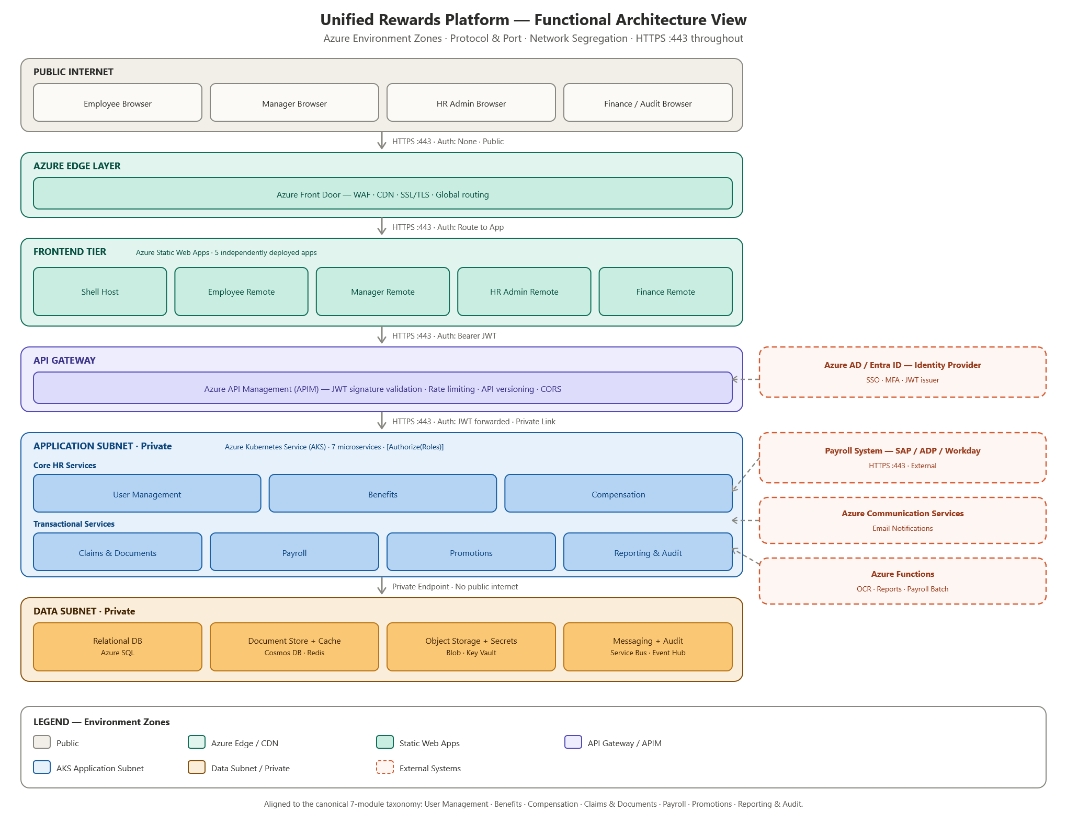
Figure: Functional Architecture View — Backend Services

Connection | Source | Target | Protocol | Port | Auth
Browser → Front Door | End User Browser | Azure Front Door | HTTPS | 443 | None (public)
Front Door → Static Apps | Azure Front Door | Azure Static Web Apps | HTTPS | 443 | None
MFE → APIM | React Portal (MFE) | Azure APIM | HTTPS | 443 | Bearer JWT
APIM → AKS Services | Azure APIM | AKS Pods | HTTPS | 443 | JWT forwarded
AKS → Azure SQL | AKS Microservices | Azure SQL | TDS/TCP | 1433 | MSI
AKS → Cosmos DB | AKS Microservices | Azure Cosmos DB | HTTPS | 443 | MSI
AKS → Redis Cache | AKS Microservices | Azure Redis | TLS | 6380 | MSI
AKS → Blob Storage | AKS Microservices | Azure Blob Storage | HTTPS | 443 | MSI
AKS → Service Bus | Claims / Payroll Svc | Azure Service Bus | AMQP/TLS | 5671 | MSI
AKS → Event Hub | All Services | Azure Event Hub | AMQP/TLS | 5671 | MSI
AKS → Key Vault | All Services | Azure Key Vault | HTTPS | 443 | MSI
Payroll Svc → Ext. Payroll | Payroll Service | SAP/ADP/Workday | HTTPS | 443 | API Key + Polly
Azure AD → APIM | Azure AD/Entra ID | Azure APIM (JWKS) | HTTPS | 443 | OIDC

2.1.5 Technology View
The table below specifies the technology platform / framework for each component across all architectural layers.
Component Name | Technology | Version / Comments
Presentation Layer (MFE Shell) | React + Webpack 5 ModuleFederationPlugin | React 18.3, Node.js 20 LTS, Azure Static Web Apps
MFE Remotes (4 portals) | React + Module Federation + MUI | Material-UI v5, Axios v1.x, React Router v6
API Layer | ASP.NET Core 8 REST API (JSON) | .NET 8 LTS, Swagger/OpenAPI 3.0, versioning /api/v1/
Business Logic / CQRS | MediatR | MediatR v12.x — Commands, Queries, Notifications
Rules Engine | NRules | NRules v0.15.x — runtime compensation rule evaluation
Request Validation | FluentValidation | v11.x — all command/request validation
Batch Layer | Azure Functions (Isolated Worker) | .NET 8, v4 runtime — Blob, Timer, Queue triggers
ORM | Entity Framework Core 8 | Code-first; SQLite (local), Azure SQL / Cosmos (cloud)
Database Layer (Relational) | Azure SQL Database | SQL Server 2022 compatible, Zone-redundant, Geo-replicated
Database Layer (NoSQL) | Azure Cosmos DB | Core (SQL) API, Multi-region write, Private endpoint
Caching | Azure Redis Cache | Premium tier, Zone-redundant, TLS 6380
Blob Storage | Azure Blob Storage | GRS (Geo-Redundant Storage), SSE encryption, Private endpoint
Secret Management | Azure Key Vault | HSM-backed, Managed Identity auth, Private endpoint
Message Broker | Azure Service Bus | Standard/Premium tier, Topic-based pub/sub, TTL 7 days
Audit Stream | Azure Event Hub | Append-only, 30-day retention, MSI access
Identity Provider | Azure AD / Microsoft Entra ID | OIDC/OAuth 2.0, MFA, JWT RS256, Managed Identity
API Gateway | Azure API Management (APIM) | Rate limit 100 req/min, JWT validation, CORS, versioning
Container Orchestration | Azure Kubernetes Service (AKS) | v1.28+, HPA 2–10 pods per service, Application Subnet
OCR Processing | Tesseract.Net | Tesseract.Net 2024.x / Tesseract 5.x — receipt field extraction
Export Engine | ClosedXML | v0.102.x — XLSX and PDF report generation
Resilience / Retry | Polly | v8.x — retry (3×), circuit breaker, timeout policies
Logging | Serilog | v3.x — structured logging; Azure Event Hub sink in cloud
Monitoring | Azure Monitor + Application Insights | Distributed tracing, custom metrics, alert rules
Edge / CDN / WAF | Azure Front Door | WAF (OWASP rules), DDoS protection, SSL/TLS termination
CI/CD | GitHub Actions | Per-service independent pipeline; container image → AKS
Local Dev — Mock Payroll | WireMock.NET | REST mock for SAP/ADP/Workday external payroll system
Local Dev — Mock Email | smtp4dev (SMTP) | SMTP mock for Azure Communication Services

Security
The application relies on Azure AD / Entra ID as the Identity Provider for all authentication. JWT Bearer tokens (RS256) are validated at APIM layer and re-validated at each microservice via AddJwtBearer() ASP.NET Core middleware. JWT signing keys are fetched from Azure Key Vault at startup using Managed Identity (no credentials in configuration). All data stores are accessible only via Managed Identity — no connection strings with passwords. Refer to Section 2.1.10 for complete Security View.

Logging
Serilog v3.x is used for structured logging across all 7 microservices. In local development, logs are output to console. In cloud environments, logs are streamed to Azure Event Hub (append-only) and ingested by Azure Monitor / Application Insights for distributed tracing, correlation ID tracking, and alerting. Audit-specific events (entity changes, user actions) are persisted as AuditEntry records in Azure SQL via the Reporting Service, which subscribes to the Event Hub audit stream.

Monitoring
Azure Application Insights provides end-to-end distributed tracing across all AKS microservices. x-correlation-id header is propagated across service calls for request correlation. Custom metrics track claim SLA breach rates, OCR confidence scores, and payroll push success rates. Azure Monitor alert rules trigger on: pod restart count > 3, HTTP 5xx error rate > 1%, payroll push Dead Letter Queue depth > 0, and Service Bus message backlog > 100.

Availability
AKS Horizontal Pod Autoscaler (HPA) scales each service between 2 (minimum) and 10 (maximum) pods based on CPU/memory metrics. Azure SQL uses zone-redundant configuration with auto-failover group for sub-30-second failover. Cosmos DB multi-region write ensures 99.999% availability SLA. Azure Blob Storage GRS provides 99.9% availability with geo-redundant replication. Azure Redis Cache Premium tier provides zone-redundant clustering.

Scalability
Each of the 7 microservices scales independently via AKS HPA — no shared state between pods. Azure Cosmos DB auto-scale throughput adjusts RU/s based on actual load (400–4000 RU/s per container). Azure Service Bus Premium tier supports elastic scaling of message processing capacity. Azure Redis Cache Premium tier supports up to 120 GB cache with cluster sharding.

Caching
IMemoryCache (in-process) is used for local development and unit testing. Azure Redis Cache (Premium, TLS 6380) is the distributed cache in UAT and Production. Cache-aside pattern is implemented in User Management Service (TTL: 15 min), Benefits Service (TTL: 30 min), and Compensation Service (TTL: 60 min). Cache keys follow the pattern: {domain}:{entityId}[:{filter}]. Cache is invalidated on write operations (enrollment, CTC update, rule change).

2.1.6 Integration View
The following integration matrix covers all inbound and outbound interfaces of the Unified Rewards Platform with external and internal systems.
Internal Integration
The Unified Rewards Platform uses the following internal integration mechanisms for services that reside within the Azure-hosted application boundary: Azure Service Bus (AMQP/TLS:5671, MSI) for asynchronous claim lifecycle event routing; Azure Event Hub (AMQP/TLS:5671, MSI) as an append-only audit stream; Azure Blob Storage (HTTPS:443, MSI) for binary asset storage and OCR trigger; Azure Redis Cache (TLS:6380, MSI) for distributed cache-aside pattern; Azure Key Vault (HTTPS:443, MSI) for secrets management; Azure SQL Database (TDS/TCP:1433, MSI) for relational transactional data; and Azure Cosmos DB (HTTPS:443, MSI) for high-read NoSQL document storage.
External Integration
The Unified Rewards Platform integrates with three external systems: External Payroll System (SAP/ADP/Workday) receives finalised payroll data via REST POST (HTTPS:443, API Key + Polly retry 3×) on a monthly basis; Azure AD / Entra ID supplies JWT Bearer tokens (RS256) via OIDC/OAuth 2.0 PKCE flow and Managed Identity for service-to-service authentication; and Azure Communication Services sends email notifications (HTTPS:443, MSI) triggered asynchronously by Azure Service Bus events.
Integration Matrix
App ID | App Name | Integration Type  (Up/Downstream) | Data Elements | Authentication Type | Mode of Integration | Intermediate Systems | Frequency
EXT-01 | SAP / ADP / Workday  (External Payroll) | Downstream | employeeId, netPay, payPeriod, settledClaims, deductions | API Key + HTTPS (Polly retry) | REST POST /payroll/push | None (Direct API) | Monthly (payroll cycle)
EXT-02 | Azure AD /  Entra ID | Upstream | JWT token: sub, role, email, exp; JWKS public key | OIDC / OAuth 2.0 (PKCE) | OIDC token issuance + JWKS endpoint | None | Real-time per user login
EXT-03 | Azure Communication  Services (Email) | Downstream | employeeEmail, templateId, dynamic content (claimId, amount, outcome) | MSI (Managed Identity) | REST (Azure SDK) | Azure Service Bus (event-triggered) | Event-driven (async)
INT-01 | Azure Service Bus | Internal | ClaimSubmitted/Approved/Rejected/Settled events {claimId, employeeId, amount} | MSI | Topic-based Pub/Sub (AMQP/TLS 5671) | None | Real-time (event-driven)
INT-02 | Azure Event Hub | Internal | AuditEvents {entityType, entityRef, action, performedBy, timestamp, ipAddress, changeSnapshot} | MSI | Append-only stream (AMQP/TLS 5671) | None | Real-time continuous
INT-03 | Azure Blob Storage | Internal | Receipt images (JPEG/PNG/PDF), PaySlip PDFs, exported XLSX/PDF reports | MSI | Azure SDK (HTTPS 443) | Azure Functions (Blob Trigger for OCR) | On-demand
INT-04 | Azure Redis Cache | Internal | Employee profiles, eligible benefit plans, CTC breakdowns | MSI | StackExchange.Redis (TLS 6380) | None | Cache-aside; TTL 15/30/60 min
INT-05 | Azure Key Vault | Internal | JWT RS256 signing key, DB connection strings, external API keys | MSI | Azure SDK (HTTPS 443) | None | At service startup; cached in-process
INT-06 | Azure SQL Database | Internal | Users, Employees, Claims, ClaimLineItems, ClaimWorkflows, ClaimStatusHistories, Documents, Receipts, OCRResults, PayrollRecords, Settlements, PaySlips, Reports, AuditEntries | MSI (Managed Identity) — no stored credentials | EF Core 8 via TDS/TCP (Port 1433) — Private endpoint; no public internet access | None | Real-time (per request)
INT-07 | Azure Cosmos DB | Internal | BenefitPlans container: BenefitPlan, EligibilityCriteria, BenefitEnrollment. CompensationRules container: CompensationRule, CTCBreakdown, CompensationComponent | MSI (Managed Identity) | Azure Cosmos SDK (HTTPS 443) — Core (SQL) API; Multi-region write; Private endpoint | None | Real-time (per request); Cache-aside via Redis (TTL 30–60 min)

2.1.7 Implementation View
The implementation view describes the internal structure of each architectural layer, integration adapters, and the technology used per layer boundary.
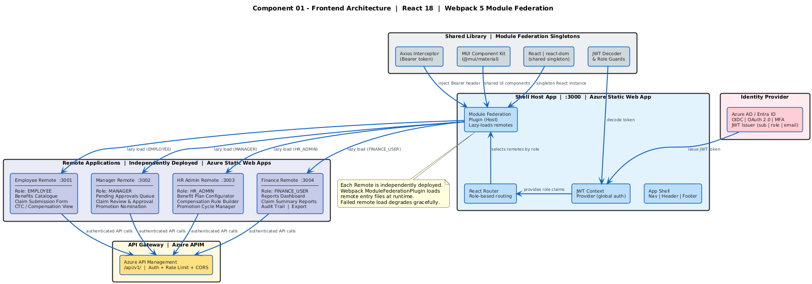
Figure: Implementation Architecture View — Frontend & MFE Portals

Presentation Layer
React 18 Shell Host App (Azure Static Web App, :3000). Webpack 5 ModuleFederationPlugin configured as Host. Lazy-loads four Remote Apps based on decoded JWT role claim. JWT Context Provider exposes decoded token claims globally. Axios instance configured with Bearer token interceptor for all API calls. Role Guards (PrivateRoute) prevent unauthorized access to portal routes. Shared singletons (react, react-dom, @mui/material, Axios) prevent multiple instances across remotes.

Services Façade
Azure API Management (APIM) acts as the API Gateway. Inbound policies: JWT signature validation (Azure AD JWKS), rate limiting (100 req/min), CORS, IP allow-listing. Outbound policies: Response caching headers, error format normalization. Routes requests to AKS microservice pods via Private Link (internal network). All APIs versioned under /api/v1/ path prefix.

Business Components
Each microservice implements MediatR CQRS: Controllers call ISender.Send(command/query), MediatR dispatches to registered IRequestHandler. Business logic lives exclusively in handlers. FluentValidation Pipeline Behavior validates all requests before handler execution. NRules Engine (Compensation Service): CompensationRule formulas compiled at runtime and evaluated against employee grade/profile to produce CTCBreakdown components. ClaimWorkflow State Machine (Claims & Documents Service): Enforces valid state transitions (DRAFT → SUBMITTED → UNDER_REVIEW → APPROVED/REJECTED → SETTLED) with SLA deadline tracking.

Data Access
EF Core 8 Repository pattern with provider abstraction: SQLite (local), Azure SQL / Cosmos DB (cloud). IQueryable-based LINQ for read operations in Reporting Service. No stored procedures — all queries via EF Core. Azure Redis Cache (IDistributedCache) wraps all frequent-read queries with cache-aside pattern. All DB connections established via Managed Identity — no connection string passwords.

Management Services
Azure Key Vault: Secrets (JWT key, connection strings, external API keys) fetched at startup via MSI. Azure Monitor + Application Insights: Distributed tracing (x-correlation-id), custom metrics, alert rules. Serilog: Structured logging to console (local) / Azure Event Hub (cloud).

Core Services
Azure Service Bus: Claims & Documents Service publishes 4 event types (Submitted/Approved/Rejected/Settled). Payroll, Reporting, and Email Services subscribe to relevant topics. Azure Event Hub: All domain services emit AuditEvents. Reporting Service ingests and persists as AuditEntry. Azure Functions: Blob Trigger invokes OCR pipeline; Timer Trigger initiates scheduled reports; Queue Trigger processes payroll batch jobs.

Integration Adapters
Adapter Interface | Implementation (Cloud) | Implementation (Local) | Consuming Service
IPayrollService | HttpClient + Polly (REST → SAP/ADP/Workday) | WireMock.NET REST mock | Payroll Service
IEmailService | Azure Communication Services SDK | smtp4dev SMTP | Triggered via Service Bus
IOCRService | Tesseract.Net (Azure Function) | Tesseract.Net local invocation | Document & OCR component
IStorageService | Azure Blob Storage SDK (MSI) | Local filesystem adapter | Document & OCR component, Payroll Service, Reporting Service
IMessagePublisher | Azure Service Bus SDK (MSI) | In-memory mock publisher | Claims & Documents Service, Payroll Service
IAuditEventEmitter | Azure Event Hub SDK (MSI) | In-memory event logger | All 7 microservices
ISecretProvider | Azure Key Vault SDK (MSI) | appsettings.Development.json | All 7 microservices
ICache | StackExchange.Redis (Azure Redis) | IMemoryCache (in-process) | Employee, Benefits, Compensation Services
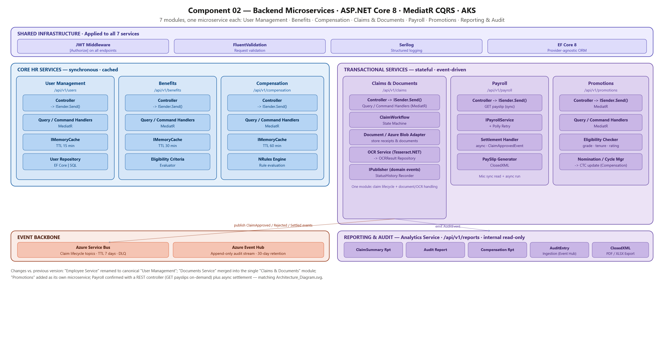
Figure: Implementation Architecture View — Backend Microservices & Integration Adapters

2.1.8 Data View
The Unified Rewards Platform uses a polyglot persistence strategy — selecting the appropriate data store for each domain based on access patterns and consistency requirements.
Data Store | Domains / Tables | Rationale | Accessing Services
Azure SQL Database | Users, Employees, Managers, HRAdmins, FinanceUsers  Claims, ClaimLineItems, ClaimWorkflows, ClaimStatusHistories  Documents, Receipts, OCRResults  PayrollRecords, Settlements, PaySlips  Reports, AuditEntries | Transactional consistency required. Foreign key relationships. ACID properties. PITR backup. | Employee, Claims, Documents, Payroll, Reporting Services
Azure Cosmos DB | BenefitPlans container (Plans, EligibilityCriteria, Enrollments)  CompensationRules container (Rules, CTCBreakdowns, Components) | High-read, flexible schema. JSON document model fits variable benefit plan structures. Multi-region write for low latency. | Benefits, Compensation Services
Azure Redis Cache | employee:{id}, benefit-plans:{grade}, ctc:{employeeId} | Reduces DB round-trips for frequently read, rarely changed data. TTL-based expiry. | Employee, Benefits, Compensation Services
Azure Blob Storage | documents/ (receipts, invoices)  payslips/ (PDF per employee/period)  reports/ (XLSX/PDF exports) | Unstructured binary data. Geo-redundant. Cost-effective large object storage. | Documents, Payroll, Reporting Services
Azure Key Vault | JWT RS256 signing key  DB connection strings (Azure SQL, Cosmos DB)  External API keys (Payroll System)  Cipher keys for data encryption | HSM-backed secure secrets store. Managed Identity access — no credentials stored in config files or environment variables. Keys rotated without service restart. | All 7 AKS Microservices (at startup via MSI)

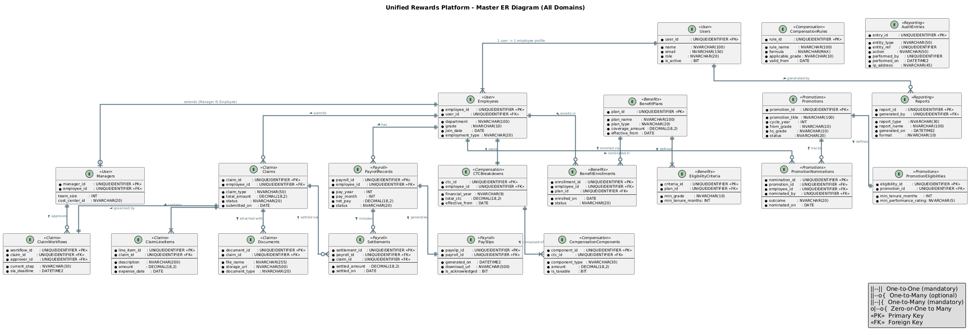
Figure: Logical Data Model — Domain Entity Relationships
Key Entity Relationships & Architectural Decisions
Employee is the central identity entity across all seven domains. Every domain aggregate — Claim, BenefitEnrollment, CTCBreakdown, PayrollRecord, Promotion, AuditEntry — carries a foreign key to the Employee record, enforcing a single source of identity truth.
Claims follow a strict state-machine lifecycle (DRAFT → SUBMITTED → UNDER_REVIEW → APPROVED/REJECTED → SETTLED). Each transition creates an immutable ClaimStatusHistory entry. A Claim can have multiple ClaimLineItems and one ClaimWorkflow; approval triggers a Settlement in the Payroll domain.
Polyglot persistence rationale: Azure SQL Database is used for all transactional domains (Employee, Claims, Payroll, Reporting) where ACID properties, foreign-key relationships, and 35-day point-in-time restore are required. Azure Cosmos DB (Core SQL API) is used for Benefits and Compensation where the JSON document model accommodates flexible eligibility criteria and configurable NRules compensation components without schema migration. Multi-region write on Cosmos DB ensures low-latency reads globally.
Data ownership boundaries: Each microservice owns its domain data exclusively. No service queries another service's database directly — all cross-domain data access goes through the API layer (APIM → target service). The Reporting Service is the sole read-only consumer that aggregates data across domains via its own SQL views and Azure Event Hub audit stream.
Caching strategy: Frequently-read, rarely-changed entities (Employee profile, benefit plans, CTC breakdowns) are cached in Azure Redis Cache using the cache-aside pattern. Cache keys are namespaced by domain ({domain}:{entityId}) with TTLs of 15 minutes (Employee), 30 minutes (Benefits), and 60 minutes (Compensation). Cache is invalidated synchronously on write operations.

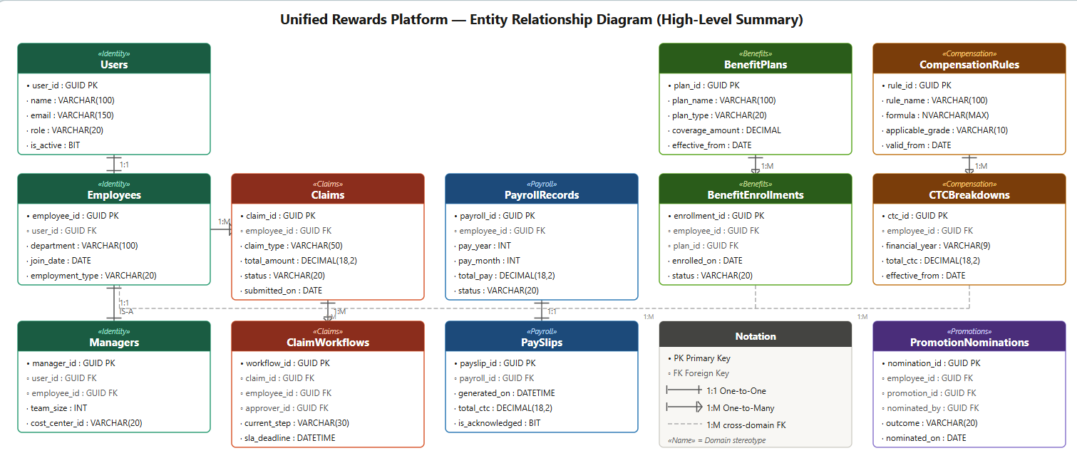

2.1.9 Deployment View
The Unified Rewards Platform is fully deployed on Microsoft Azure. All data services reside in a private Virtual Network (VNet) with no public internet access. Frontend portals are served from Azure Static Web Apps globally via Azure Front Door CDN.
S No | Host Name / FQDN | Location (AZ) | Type | Primary / DR
1 | urp-frontdoor.azurefd.net | Global | Azure Front Door (WAF + CDN) | Primary
2 | urp-shell.azurestaticapps.net | East US 2 | Static Web App — Shell Host | Primary
3 | urp-employee.azurestaticapps.net | East US 2 | Static Web App — Employee Remote | Primary
4 | urp-manager.azurestaticapps.net | East US 2 | Static Web App — Manager Remote | Primary
5 | urp-hradmin.azurestaticapps.net | East US 2 | Static Web App — HR Admin Remote | Primary
6 | urp-finance.azurestaticapps.net | East US 2 | Static Web App — Finance Remote | Primary
7 | urp-apim.azure-api.net | East US 2 | Azure APIM (API Gateway) | Primary
8 | urp-aks.eastus2.azmk8s.io | East US 2 | AKS Cluster — 7 Microservices | Primary
9 | urp-aks-dr.westus2.azmk8s.io | West US 2 | AKS Cluster — DR | DR
10 | urp-sql.database.windows.net | East US 2 | Azure SQL Database (Primary) | Primary
11 | urp-sql-dr.database.windows.net | West US 2 | Azure SQL Database (Geo-replica) | DR
12 | urp-cosmos.documents.azure.com | East US 2 + West US 2 | Azure Cosmos DB (Multi-region) | Primary + DR
13 | urp-redis.redis.cache.windows.net | East US 2 | Azure Redis Cache (Premium) | Primary
14 | urp-blob.blob.core.windows.net | East US 2 + West | Azure Blob Storage (GRS) | Primary + DR
15 | urp-keyvault.vault.azure.net | East US 2 | Azure Key Vault | Primary
16 | urp-servicebus.servicebus.windows.net | East US 2 | Azure Service Bus | Primary
17 | urp-eventhub.servicebus.windows.net | East US 2 | Azure Event Hub | Primary
18 | urp-functions.azurewebsites.net | East US 2 | Azure Functions App | Primary

Tiers
Tier | Name | Components | Network Zone
Tier 1 | Edge / CDN | Azure Front Door — WAF, DDoS protection, SSL/TLS termination, geo-routing | Public Internet
Tier 2 | Frontend | Azure Static Web Apps × 5 (Shell + 4 Remotes) — served via CDN | Public (CDN edge nodes)
Tier 3 | API Gateway | Azure APIM — JWT validation, rate limiting, CORS, versioning, Private Link to AKS | DMZ / Application Subnet
Tier 4 | Application | AKS Cluster — 7 microservices, 2–10 pods each (HPA), Azure Functions | Application Subnet (VNet)
Tier 5 | Data | Azure SQL, Cosmos DB, Redis Cache, Blob Storage, Key Vault — private endpoints only | Data Subnet (VNet — no public access)

Logical Infrastructure
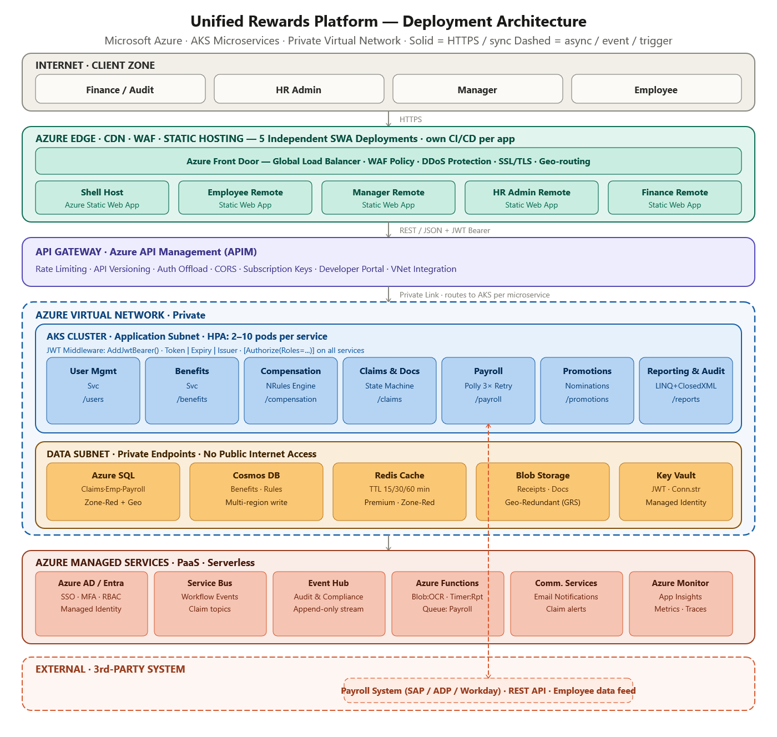
Figure: Logical Infrastructure Diagram — Azure VNet & Subnets

Physical Infrastructure
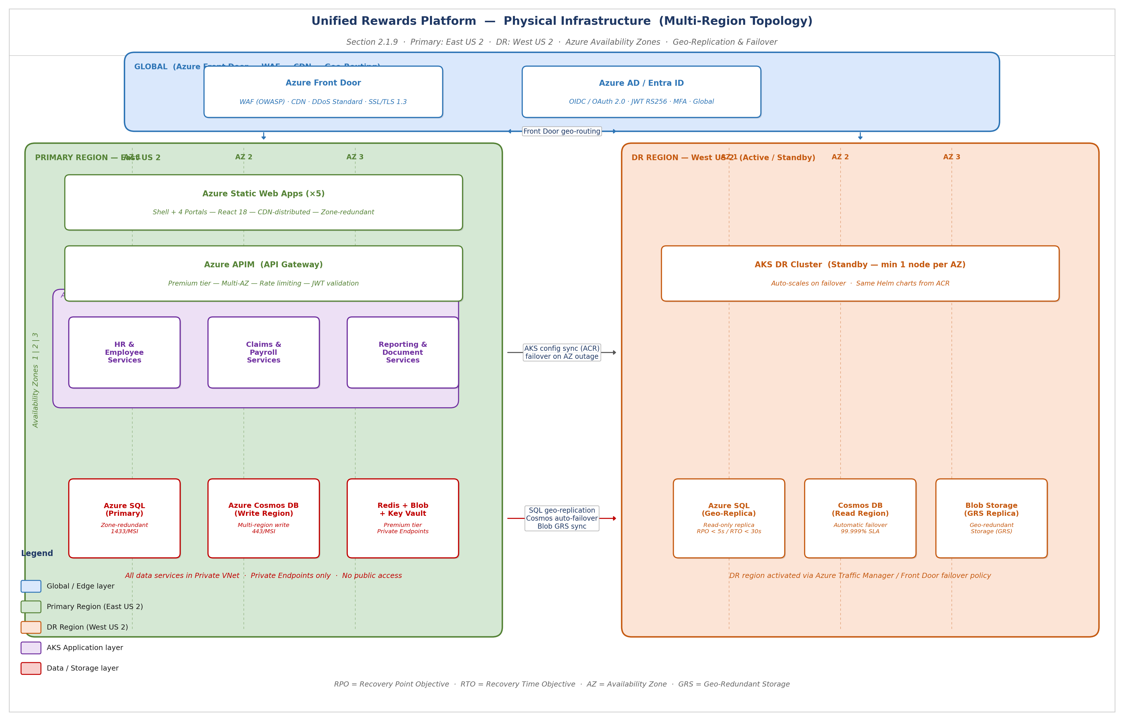
Figure: Physical Infrastructure Diagram — Multi-Region Topology

Product Deployment Model
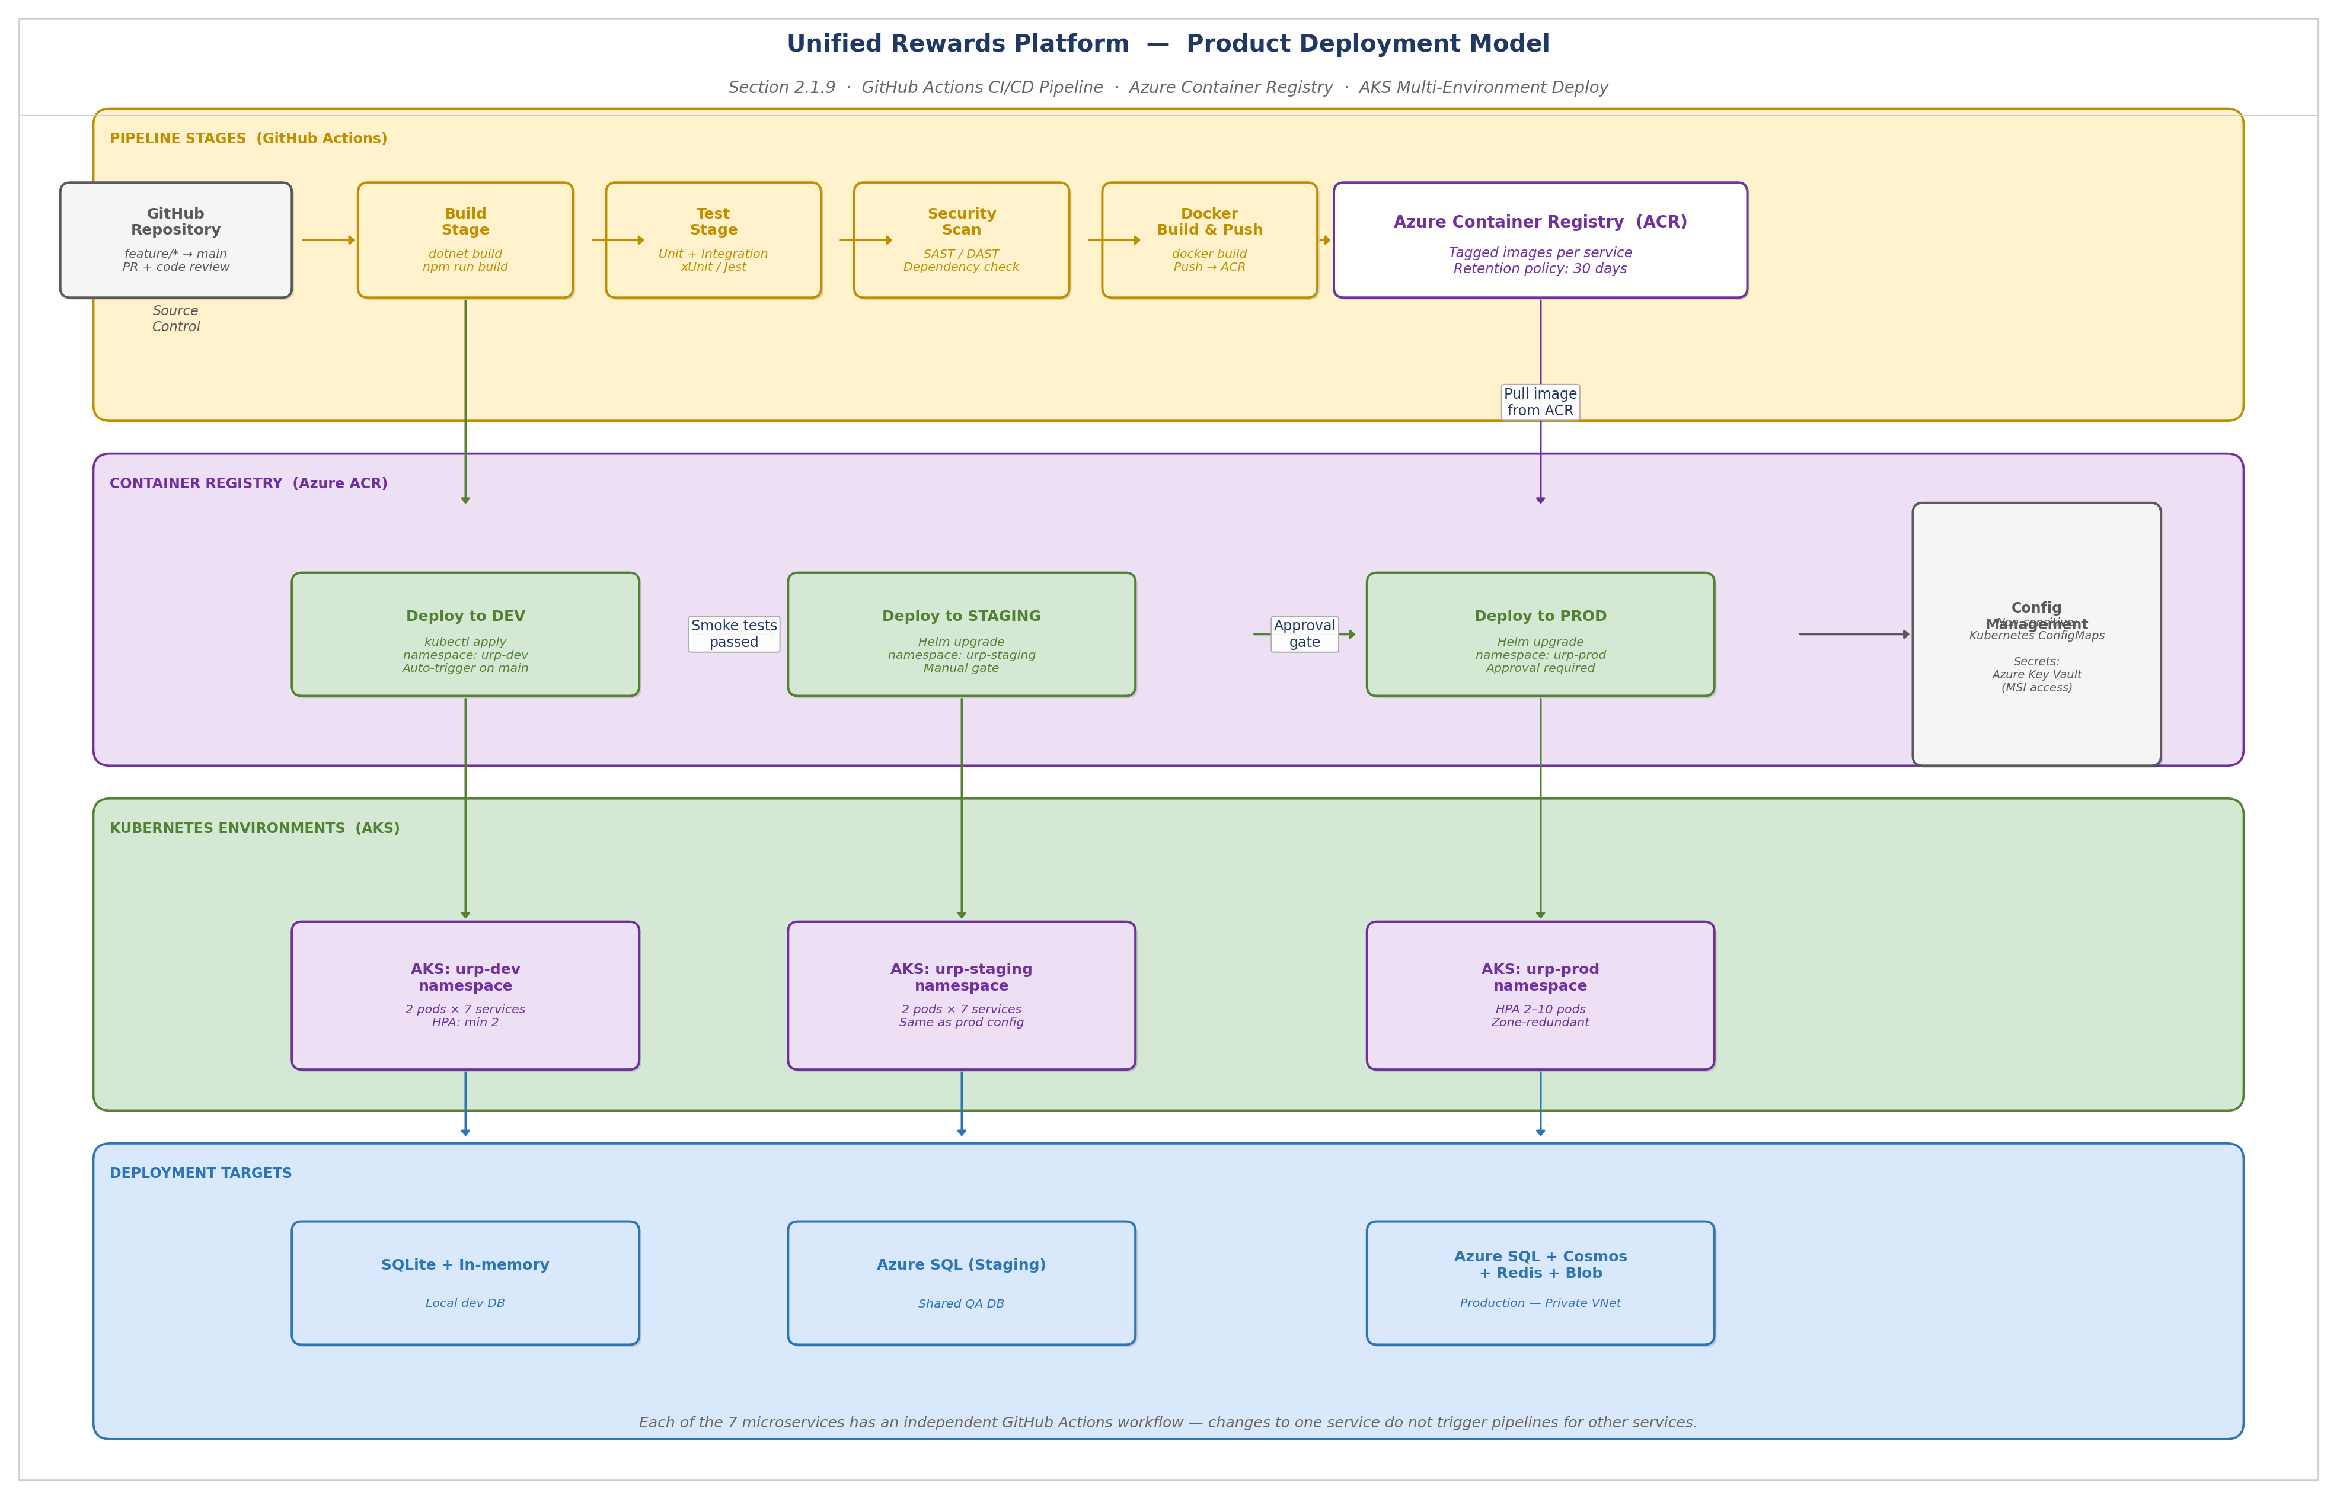
Figure: Product Deployment Model — CI/CD Pipeline & AKS Deployment
CI/CD Pipeline — Stage Descriptions
Build Stage: Each microservice has an independent GitHub Actions workflow triggered on push to the main branch. The backend services run dotnet build; the frontend portals run npm run build. Independent pipelines ensure a change in the Claims & Documents Service does not trigger a rebuild of the Benefits Service.
Test Stage: Unit tests (xUnit for .NET, Jest for React) and integration tests run in parallel. A minimum 80% code coverage gate is enforced. Integration tests use SQLite in-process and WireMock.NET for external service mocking.
Security Scan: Static Application Security Testing (SAST) runs on every build. Dependency vulnerability scanning (OWASP Dependency-Check) checks all NuGet and npm packages. Critical findings block the pipeline.
Docker Build & Push: Each service produces a container image tagged with the Git SHA and semantic version. Images are pushed to Azure Container Registry (ACR) with a 30-day retention policy.
AKS Deployment: Helm charts are used for all deployments. kubectl apply (dev) and helm upgrade (staging/prod) deploy to the respective AKS namespace. Production deployments require explicit approval from a designated release manager. Non-sensitive configuration is stored in Kubernetes ConfigMaps; all secrets are fetched from Azure Key Vault via Managed Identity.

2.1.10 Security View
Security is a foundational design principle of the Unified Rewards Platform, not an after-thought. All security controls are incorporated at the architecture level across every tier.
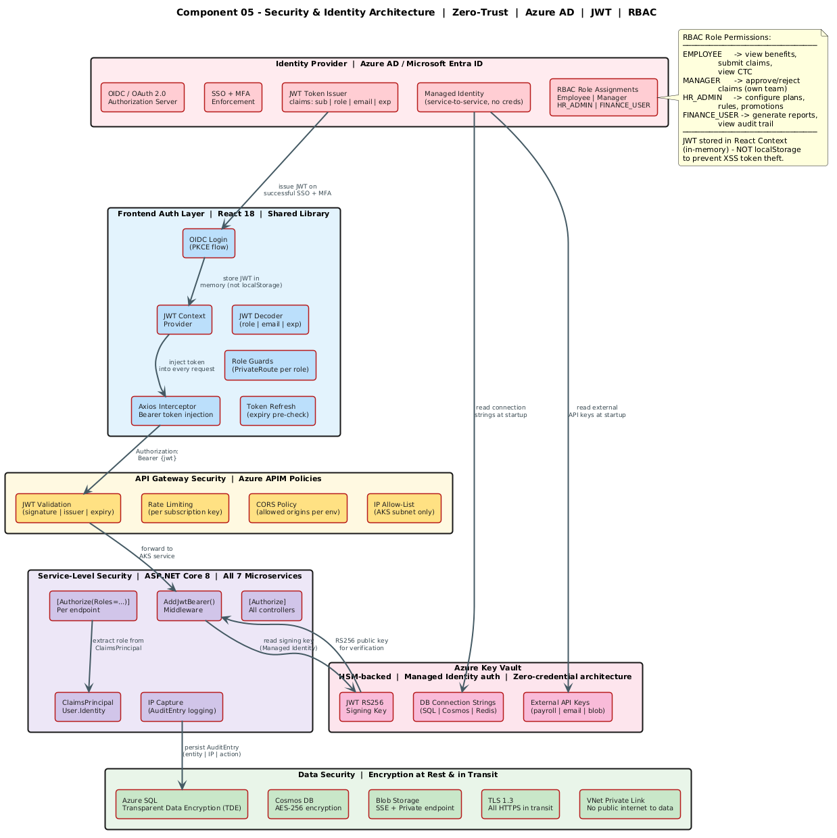
Figure: Security Architecture View — Zero-Trust Design

Secure Design Considerations
Authentication Design
Azure AD / Microsoft Entra ID provides the authentication layer via OIDC / OAuth 2.0 PKCE flow. Multi-Factor Authentication (MFA) is enforced for all users (Conditional Access Policy in Azure AD). JWT Bearer tokens (RS256 asymmetric signing) are issued with a 60-minute TTL. JWT signing keys are stored exclusively in Azure Key Vault and fetched by services via Managed Identity. Tokens are stored in React Context (in-memory heap) — never in localStorage or sessionStorage — to prevent XSS-based token theft. Token expiry is validated before every API call with automatic refresh.
Access Privilege and Authorization Design
RBAC is implemented at two levels: (1) APIM subscription key policies enforce API group access, (2) ASP.NET Core [Authorize(Roles="...")] attribute enforces endpoint-level authorization. Four roles implement Segregation of Duties (SoD): EMPLOYEE (benefits, own claims, own CTC), MANAGER (own team claims approval, nominations), HR_ADMIN (configuration only — plans, rules, promotions), FINANCE_USER (read-only reporting and audit). Role metadata is embedded in JWT claims (not stored in application DB) to prevent replay attacks. Managers can only approve claims of employees within their costCenterId (enforced in handler).
Input / Data Validation
All input is validated using FluentValidation before handler execution (MediatR Pipeline Behavior). APIM input validation policy rejects malformed requests before reaching backend services. Validation rules: required fields, type constraints, range checks (amount > 0), date constraints (expenseDate not in future), MIME type and file size validation (Document & OCR component). All output is JSON-encoded with Content-Type: application/json — no HTML rendering to prevent XSS. Error responses include errorCode and message only — no stack traces, exception details, or internal paths.
Data Protection
- Data at rest: Azure SQL — TDE (AES-256); Azure Cosmos DB — server-side AES-256; Azure Blob — SSE (AES-256); Azure Redis — in-memory (no persistence for sensitive data).
- Data in transit: TLS 1.3 enforced on all HTTPS connections; AMQP over TLS for Service Bus and Event Hub; TDS over TLS for Azure SQL (port 1433); Redis TLS on port 6380.
- PII fields (employee name, email, phone, salary): accessible only via role-authorized endpoints; EMPLOYEE can only access own data.
- Private VNet endpoints for all data services — no traffic over public internet between services and data stores.
Cryptography and Key Management
- JWT signing: RS256 (RSA 2048-bit asymmetric) — private key in Azure Key Vault; public key distributed via Azure AD JWKS endpoint.
- Data at rest encryption: AES-256 (managed by Azure — TDE for SQL, server-side encryption for Cosmos and Blob).
- Key management: Azure Key Vault (HSM-backed) — key rotation handled without service restart via Managed Identity. No keys in config files, environment variables, or source code.
- Key Management Standard: Refer to Cognizant Corporate Security Policy (QSIS-APPARCDES).
Accountability Design
All platform actions across all 7 microservices emit AuditEvents to Azure Event Hub (append-only, 30-day retention). Reporting Service consumes the event stream and persists AuditEntry records (immutable) in Azure SQL. AuditEntry captures: entityType, entityRef, action, performedBy (userId), performedOn (UTC), ipAddress (from HttpContext), and changeSnapshot (JSON diff of before/after state). ClaimStatusHistory provides a complete immutable record of all claim state transitions. Refer to Log Management Standard: Cognizant Corporate Security Policy.
Secure Integrations & Communication
- External Payroll (SAP/ADP/Workday): HTTPS/TLS 1.3, API Key authentication, IP restriction (egress from AKS NAT Gateway), Polly retry with exponential back-off.
- Azure AD (Identity): OIDC/OAuth 2.0 over HTTPS, PKCE flow for frontend, Managed Identity for service-to-service.
- Internal services (APIM → AKS): HTTPS/TLS over Private Link (no public internet routing).
- All Service Bus and Event Hub traffic: AMQP over TLS 1.2/1.3, Managed Identity access.
- No direct DB-to-DB connections across services — each service owns its data domain.
Error Handling and Exception Design
Global exception handling middleware in ASP.NET Core catches all unhandled exceptions. All errors return a standardized JSON error response: {status, errorCode, message, details, correlationId, timestamp}. No stack traces, internal paths, or exception details are included in client responses (Fail Securely). All exceptions are logged to Serilog with full context before returning sanitized response. Correlation ID (x-correlation-id) is included in all error responses for cross-service tracing.
Session Management Design
JWT Bearer tokens are stateless — no server-side session state is maintained. Token stored in React Context (in-memory) with 60-minute TTL. Axios interceptor validates token expiry before every API call and triggers Azure AD refresh flow if expired. APIM rejects any request with expired, tampered, or missing JWT (401 Unauthorized). Logout clears JWT from React Context and redirects to Azure AD logout endpoint to invalidate the SSO session.
Security by Design
- Securing the Database: Private VNet endpoint; MSI connection (no passwords); TDE; column-level access via EF Core query filters (employee can only query own records).
- Securing the Configurations: All secrets in Azure Key Vault; no plaintext secrets in appsettings.json, Kubernetes manifests, or GitHub Actions secrets; ConfigMaps for non-sensitive config only.
- Securing the Web/App Server: AKS pod security policies; non-root container execution; read-only filesystem; resource limits (CPU/memory) per pod; network policies restricting pod-to-pod communication.
- Securing the Network: Private VNet for all data and application services; Azure Front Door WAF (OWASP Top 10 rule set); DDoS Standard protection; NSG rules per subnet; no inbound rules to data subnet.
Privacy by Design
Employee PII (name, email, salary, grade) is accessible only via authenticated, role-authorized API endpoints. EMPLOYEE role users can only access their own data — enforced at handler level via JWT sub claim comparison. Audit records capture userId reference only (no PII duplication in audit log). Data retention: payroll records retained for 7 years per statutory requirement; claims retained for 3 years; audit logs retained for 30 days in Event Hub (archived to Blob for long-term). The platform design supports GDPR data subject access requests and right-to-erasure (soft delete with anonymization pattern — implementation detail in LLD).
Infrastructure Design
All infrastructure is deployed on Microsoft Azure (East US 2 primary, West US 2 DR). AKS (Azure Kubernetes Service) — application hosting with HPA auto-scaling. Azure Private Link — all data services accessible only from within VNet. Azure Policy — enforces mandatory tagging, approved SKUs, and private endpoint requirements. Azure Defender for Cloud — runtime threat detection across AKS, SQL, Cosmos DB, and Key Vault. Refer to Cognizant Enterprise/Corporate Infrastructure/Deployment Architecture for platform-level security controls.

2.1.11 Process View
The Process View maps the logical architecture to executing processes and threads of control, grouped by process category.
Process Category | Process Name | Description | Interaction Type
Management Processes | Platform Configuration Management | HR Admin configures benefit plans, compensation rules, and promotion cycles via HR Admin Portal. Changes are persisted to Cosmos DB (Benefits, Compensation) and validated by NRules Engine. | Synchronous (REST API)
Management Processes | Azure Cost Management | AKS HPA scales pods based on demand; Azure Monitor provides cost alerts and resource utilization dashboards. | Automated (Azure platform)
Business Processes | Claim Lifecycle Process | State machine transitions: DRAFT → SUBMITTED → UNDER_REVIEW → APPROVED/REJECTED → SETTLED. Governed by ClaimWorkflow with SLA deadline (7 business days) and auto-escalation. | Async event-driven (Service Bus)
Business Processes | Payroll Settlement Process | ClaimApproved event triggers Settlement record creation. PayrollRecord finalized monthly. PaySlip generated (ClosedXML) and pushed to external payroll system (Polly retry). | Async (Service Bus + REST)
Business Processes | Compensation Calculation Process | NRules Engine evaluates CompensationRules for employee grade and computes CTCBreakdown components (BasicPay, HRA, Bonus, PF). Triggered on grade change or annual CTC review. | Synchronous (rules engine)
Support Processes | Monitoring & Alerting | Application Insights distributed tracing; Azure Monitor alerts for pod restarts, error rates, Dead Letter Queue depth, and SLA breach detection. | Continuous (platform)
Support Processes | Security & Audit Logging | All domain actions emit AuditEvents to Event Hub. Reporting Service ingests and persists immutable AuditEntry records. Azure Defender for Cloud monitors for threats. | Real-time (Event Hub stream)
Support Processes | Scheduled Report Generation | Azure Function Timer Trigger invokes Reporting Service daily/weekly for scheduled report generation. Reports exported as XLSX/PDF via ClosedXML and stored in Azure Blob Storage. | Scheduled (Azure Functions)

Information View
Subject Area | Repository | Owner Service | Consumers
Employee & User Profiles | Azure SQL — Users, Employees | User Management Service | All services (cross-domain reference)
Benefit Plans & Enrollments | Azure Cosmos DB — BenefitPlans container | Benefits Service | Payroll Service (deductions)
Compensation Rules & CTC | Azure Cosmos DB — CompensationRules container | Compensation Service | Payroll Service (gross pay computation)
Claims & Documents | Azure SQL — Claims, ClaimLineItems, Documents | Claims & Documents Service | Payroll Service (Settlement), Reporting Service
Payroll & Settlements | Azure SQL — PayrollRecords, Settlements | Payroll Service | Reporting Service (CompensationReport)
Promotions | Azure Cosmos DB (or SQL) — Promotions | Promotions Service | HR Admin Portal (cycle management)
Reports & Audit Entries | Azure SQL — Reports, AuditEntries | Reporting Service | Finance Portal (report download)
Binary Assets | Azure Blob Storage — receipts, payslips, reports | Documents / Payroll / Reporting Svc | Employee Portal (download)

2.2 System Interfaces
All external and internal interfaces of the Unified Rewards Platform are exposed via RESTful APIs using JSON payloads over HTTPS/TLS 1.3, routed through Azure APIM.
- Internal Integration — All 7 microservices communicate via Azure APIM (synchronous REST) and Azure Service Bus (asynchronous event-driven). No direct service-to-service HTTP calls bypass APIM. Azure Event Hub serves as the audit integration backbone.
- External Integration — External Payroll Systems (SAP / ADP / Workday) are integrated via REST POST from Payroll Service using HttpClientFactory + Polly retry policy. Azure AD is integrated via OIDC/OAuth 2.0 for authentication and Managed Identity for service-to-service.
- Standard API contract: OpenAPI 3.0 specification (auto-generated by Swashbuckle). Refer to docs/Cognizant-UnifiedRewardsPlatform-API Specification v1.0 for full API contracts.
Interface | Technology / Method | Direction | Notes
Employee → Portal | HTTPS Browser / React MFE | Inbound | Azure Front Door → Static Web Apps
Portal → API Layer | REST HTTPS/443 + Bearer JWT | Outbound | Via Azure APIM; all APIs versioned /api/v1/
APIM → Microservices | REST HTTPS/443 Private Link | Internal | Private Link — no public routing
Claims → Service Bus | AMQP/TLS 5671 (MSI) | Outbound | Publish claim lifecycle events to topics
Payroll/Reporting → Service Bus | AMQP/TLS 5671 (MSI) | Inbound | Subscribe to relevant claim event topics
All Services → Event Hub | AMQP/TLS 5671 (MSI) | Outbound | Append-only audit event stream
Payroll → External Payroll | REST HTTPS/443 + API Key | Outbound | Polly retry 3×; DLQ on failure
Azure AD → All Services | OIDC/JWKS HTTPS/443 | Inbound | JWT token issuance and JWKS key endpoint

2.3 Reporting
The Reporting Service provides three report types, accessible exclusively to FINANCE_USER role. Reports are generated on-demand or via scheduled Azure Function (Timer Trigger).
Report Name | Description | Data Source | Format | Generation Method
Claim Summary Report | Aggregated claim statistics for a specified period: total, approved, rejected, pending counts and amounts. Filterable by department, claim type, status. | Azure SQL — Claims, Settlements | XLSX / PDF | On-demand (POST /api/v1/reports/claim-summary) or scheduled daily
Compensation Report | CTC analytics by department and grade: headcount, average CTC, total cost. Year-over-year comparison. | Azure Cosmos DB — CTCBreakdowns | XLSX / PDF | On-demand (POST /api/v1/reports/compensation)
Audit Report | Full audit trail for any entity type and date range. Captures all platform actions with user, IP, timestamp, and change snapshot. | Azure SQL — AuditEntries | XLSX / PDF | On-demand (POST /api/v1/reports/audit)

- Report generation uses LINQ + IQueryable for read-only queries against Azure SQL (Reporting Service).
- Export engine uses ClosedXML v0.102.x for XLSX workbook generation and PDF rendering.
- Generated files are stored in Azure Blob Storage reports/ container.
- Exported file URL is returned in the API response (exportUrl); expires after 24 hours.
- Reporting database: The online Azure SQL database is used for read operations (no separate reporting DB in Release 1.0). A dedicated read replica can be added in a future release if reporting query load impacts transactional performance.

3.0 Prototype Design
This section covers the UI / wireframe design for the Unified Rewards Platform portals. Design prototypes were created for all four micro-frontend portals.

3.1.1 Wireframe / Visual Design
Portal Design Summary:
Portal | Key Screens | Design Approach
Employee Self-Service Portal | Benefits Catalogue, Claim Submission Form (with OCR auto-fill), Claim Status Tracker, CTC Breakdown View, PaySlip Download | Card-based layout. MUI v5 components. Step-by-step claim form with drag-and-drop receipt upload. Real-time status progress indicator.
Manager Approval Portal | Pending Approvals Queue (sortable/filterable), Claim Detail View (with receipt viewer), Approve/Reject modal with mandatory reason, Promotion Nomination Form | List-detail pattern. Priority badges for SLA-approaching claims. In-line approval actions to minimise clicks.
HR Admin Portal | Benefit Plan Configurator (plan type selector + eligibility criteria form), Compensation Rule Builder (NRules formula editor), Promotion Cycle Manager | Form-heavy configuration UI. Rule builder with formula validation feedback. Tabbed navigation per domain.
Finance & Audit Portal | Reports Dashboard (date pickers + filter dropdowns), Report Result Table, Export button (XLSX/PDF), Audit Trail Timeline View | Data table with server-side pagination and column sorting. Chart summary for claim counts and amounts. Export confirmation dialog.

3.1.2 Program Specification
The program specifications for the Unified Rewards Platform are documented in the dedicated API Specification document. Each microservice exposes a versioned REST API (/api/v1/) with a full OpenAPI 3.0 specification auto-generated by Swashbuckle from ASP.NET Core controller attributes. Refer to: Cognizant-UnifiedRewardsPlatform-API Specification v1.0.
Service | Key API Endpoints | Purpose
User Management Service | GET /users, GET /users/{id}, GET /users/{id}/payslips | Employee profile read and PaySlip download
Benefits Service | GET /benefits, POST /benefits/enroll, DELETE /benefits/enroll/{id} | Benefit catalogue and enrollment management
Compensation Service | GET /compensation/{employeeId}, POST /compensation/rules | CTC breakdown view and rule management
Claims & Documents Service | POST /claims, PUT /claims/{id}/approve, PUT /claims/{id}/reject | Claim submission, review, and approval workflow
Document & OCR component | POST /documents/upload, GET /documents/{id}/ocr-result | Receipt upload with async OCR processing
Payroll Service | GET /payroll/{employeeId}, POST /payroll/push | Payroll record view and external system push
Reporting Service | POST /reports/claim-summary, POST /reports/compensation, POST /reports/audit | On-demand report generation with XLSX/PDF export

3.1.3 Data Entity Model
The logical data model for the Unified Rewards Platform covers 22 entities across 7 functional domains. All important relationship decisions — including cardinality, foreign key structure, and cross-domain references — are documented in Section 2.1.8 (Data View) of this document, accompanied by the master Entity-Relationship diagram (Figure: Logical Data Model — Domain Entity Relationships). The polyglot persistence strategy (Azure SQL for transactional data; Azure Cosmos DB for flexible document data) is also fully described in Section 2.1.8.

UI Wireframes and high-fidelity prototype: Available in project Figma workspace or as deployed UAT application. If already covered in BRD, refer to BRD Section 5 — UI Design Specifications.

4.0 Technology, Tools and Frameworks
Category | Technology / Tool | Version | Purpose
Frontend Framework | React | 18.3 | UI component library for all MFE portals
Module Federation | Webpack 5 MFP | 5.x | Micro-frontend host/remote orchestration
UI Component Library | Material-UI (@mui) | v5.x | Design system and UI components
HTTP Client | Axios | v1.x | API calls with Bearer token interceptor
Frontend Router | React Router | v6.x | Role-based SPA navigation
Backend Framework | ASP.NET Core | 8 (.NET 8 LTS) | REST API microservices
CQRS Mediator | MediatR | v12.x | Command/Query/Notification dispatch
Rules Engine | NRules | v0.15.x | Runtime compensation rule evaluation
Validation | FluentValidation | v11.x | Request/command validation pipeline
ORM | Entity Framework Core | 8.x | Code-first DB access (SQL + Cosmos)
Resilience | Polly | v8.x | Retry, circuit breaker, timeout policies
OCR | Tesseract.Net | 2024.x / 5.x | Receipt image text extraction
Export Engine | ClosedXML | v0.102.x | XLSX and PDF report generation
Logging | Serilog | v3.x | Structured logging framework
Testing | xUnit + Moq | Latest | Unit and integration testing
API Mock (Dev) | WireMock.NET | Latest | Mock external payroll REST API
Email Mock (Dev) | smtp4dev | N/A | SMTP mock for email notifications
Container Platform | Docker | 25.x | Container image build and push to ACR
Orchestration | Azure Kubernetes Service | v1.28+ | Production container orchestration
API Gateway | Azure APIM | v2 (APIM) | API management, security, rate limiting
Identity | Azure AD / Entra ID | v2.0 | SSO, MFA, JWT issuance, Managed Identity
Database (SQL) | Azure SQL Database | SQL 2022 compat. | Relational transactional store
Database (NoSQL) | Azure Cosmos DB | Core SQL API | Document store for benefits + comp rules
Cache | Azure Redis Cache | Premium 6.x | Distributed cache (TTL-based)
Storage | Azure Blob Storage | GRS | Binary asset storage
Messaging | Azure Service Bus | Standard/Premium | Event-driven claim lifecycle messaging
Audit Stream | Azure Event Hub | Standard | Append-only compliance audit stream
Serverless | Azure Functions | v4 / .NET 8 | Blob trigger, Timer trigger, Queue trigger
Secret Management | Azure Key Vault | HSM | Centralized secret and key management
CDN / WAF | Azure Front Door | Standard v2 | Global load balancer, WAF, DDoS, SSL
Frontend Hosting | Azure Static Web Apps | Standard | MFE portal hosting
Monitoring | Azure Monitor / App Insights | Latest | Distributed tracing and alerting
CI/CD | GitHub Actions | N/A | Per-service build and deployment pipelines
Source Control | GitHub | N/A | Monorepo (services) + polyrepo (frontends)
AI Companion | GitHub Copilot + Claude Code | N/A | Development productivity and code review

Change Details
Section No. | Changed By | Effective Date | Changes Effected
All sections | Senior Solution Architect | 23-May-2026 | V1.0.0 — Initial baseline. All 11 architectural views authored: Functional, Conceptual, Logical, Functional Architecture, Technology, Integration, Implementation, Data, Deployment, Security, Process Views. Diagrams, integration matrix, security design, and solution recommendations completed.

5.0 Solution Recommendations

5.1 Technical recommendations
- MediatR CQRS Pattern: Enforce strict CQRS separation — Commands (writes/state changes) must never return domain data; Queries (reads) must never modify state. This ensures clean auditability and testability.
- NRules Engine for Compensation: All compensation formulas must be configured via CompensationRule entities in Cosmos DB — no hardcoded salary logic. This enables HR Admin to update rules without code deployment.
- ClaimWorkflow State Machine: Implement as an explicit finite-state machine with allowed transition matrix. Reject invalid transitions at the service layer to prevent data corruption.
- Event-Driven Decoupling: Claims & Documents Service and Payroll Service must remain fully decoupled — Payroll Service must never call Claims & Documents Service API synchronously. All communication via Service Bus.
- OCR Async Processing: Large receipt files (>2 MB) should be processed asynchronously via Azure Function Blob Trigger. Return documentId immediately (201 Created) and populate ocrResult via a separate GET /documents/{id}/ocr-result endpoint.
- JWT in React Context: Store JWT exclusively in React Context (in-memory). Reject any attempt to use localStorage or sessionStorage for token storage.
- Idempotency Keys: All POST endpoints that create resources should accept an optional Idempotency-Key header to prevent duplicate resource creation on network retry.
- API Versioning Strategy: Maintain v1 API contracts permanently — never introduce breaking changes. Introduce /api/v2/ for new contracts with a 6-month deprecation notice for v1.

5.2 Infrastructure recommendations
- Private VNet Mandatory: All data services (Azure SQL, Cosmos DB, Redis, Blob, Key Vault) must be accessible exclusively via Private Link / Private Endpoint within the VNet. No firewall rules allowing public internet access to data tier.
- AKS HPA Tuning: Set minimum replica count to 2 per service for zero-downtime rolling deployments. Configure resource requests and limits per pod to prevent resource starvation. Use KEDA (Kubernetes Event-Driven Autoscaling) for Service Bus consumer services.
- Azure SQL Geo-Replication: Enable auto-failover group for Azure SQL (primary: East US 2, secondary: West US 2) with a 30-second failover SLA. Configure connection string to use the failover group endpoint.
- Azure Redis Cache Persistence: Disable RDB/AOF persistence for Redis (sensitive salary/CTC data should not be persisted to disk). Use Redis only as a non-persistent read-through cache.
- Key Vault Access Policies: Grant each AKS service identity the minimum required Key Vault permissions (Secret Get only — not List or Set). Rotate JWT signing key annually.
- Cost Optimisation: Use Azure Reserved Instances for AKS node pools (1-year reservation recommended for Production). Enable Azure Cosmos DB auto-scale (400–4000 RU/s) to avoid over-provisioning.
- Backup and Recovery: Azure SQL PITR (35 days) + weekly long-term retention backups to Azure Blob Storage. Azure Cosmos DB continuous backup with 30-day restore window. Azure Blob Storage GRS with soft-delete (14-day retention) for accidental deletion protection.
- GitHub Actions — Environment Protection Rules: Configure required reviewers for Production deployment jobs. Use OIDC federation between GitHub Actions and Azure (no stored service principal secrets in GitHub).

6.0 Reference
- API Specification — Cognizant-UnifiedRewardsPlatform-API Specification v1.0.docx
- Domain Class Diagrams — Class_Diagrams
- Sequence Diagrams — Sequence_Diagrams
- ER Diagrams — ER_Diagrams
- Component Diagrams — Component_Diagrams
- Architecture Diagrams — Architecture_Diagram.svg
- Deployment Architecture — Deployment_Architecture_Diagram.pdf
- OWASP Top 10 Security Risks — https://owasp.org/www-project-top-ten/
- Cognizant Corporate Security Policy (QSIS-APPARCDES) — Application Architecture and Design Security Standard. Available at: https://corporatesecurity.cognizant.com/Policies/Corporate_Security_Policies/Standards/QSIS-APPARCDES.pdf
- Cognizant Enterprise / Corporate Infrastructure & Deployment Architecture Standard — OneCognizant HLD. Available on Cognizant SharePoint (ITEA Documents/Standards).

7.0 Change Log
Version Number | Changes Made
V1.0.0 | Initial baseline created on 23-May-2026 by Senior Solution Architect. Full HLD covering all 11 architectural views, security design, deployment topology, integration matrix, and solution recommendations for the Unified Rewards Platform.

