An app designed to identify counterfeit medicine using CNN

GREESHMA GIRISH1, SANDEEP MATHEW2

*1,2 Student, CHRIST (Deemed To be University)*

***Abstract - Counterfeit medicines are becoming a serious threat to humanity and patient safety. Fake drugs include fake brands, misleading packaging and incorrect logos making them difficult to recognize which is fake and original. This paper proposes a method to detect counterfeit medicines using the CNN (Convolutional Neural Network) object detection model. Users can effortlessly scan medicines using their device's camera to recognize and verify whether it is real or counterfeit. This method provides a simple and reliable way for people to check the authenticity of their medicines using just an image.***

***Keywords-Counterfeit, medicines, CNN, object detection***

I. INTRODUCTION

Counterfeit medicines are a global issue that pose serious risks to public health and safety. They affect individuals of all ages, including children and the elderly. However, one of the major problems is identifying if the medicine is original or not. A counterfeit medication or a counterfeit drug is a medication or pharmaceutical item which is produced and sold with the intent to deceptively represent its origin, authenticity, or effectiveness [1].

These fake medicines can lead to harmful side effects, diseases, or deadly infections, which is a risk to human lives. The spread of fake drugs not only affect individuals but also healthcare systems by increasing treatment failures and prolonging illnesses.

One of the major reasons for the rise of fake medicines is the high cost and lack of availability of medicines in the market. Due to this, there is an abundance of counterfeit medicines in the market. This paper proposes a method to identify whether a medicine is fake or not by scanning the medicine packages. Using

the image of the medicine package the machine learning model extract the useful information from the

image and verify it and gives the result to the users immediately.

II. LITERATURE SURVEY

Many anti-counterfeiting technologies with distinct advantages and disadvantages exist today. Some of the techniques include RFID, Blockchain and IoT Device technology.

* RFID Technology

Radio Frequency Identification (RFID) uses radio frequency to identify products. The product has a tag attached to it, which contains information or data of the product and is transmitted via radio frequency channel. In medicine packaging, RFID helps track and verify drugs throughout the supply chain, reducing the risk of counterfeiting [2]. However, RFID is expensive and may not work well in crowded storage areas due to signal interference.

* Blockchain technology

Blockchain helps track medicines from manufacturers to consumers in a secure and transparent way. Each transaction is recorded in a digital ledger, making it difficult for counterfeit drugs to enter the supply chain [3]. However, blockchain requires advanced technology and high costs, which can be challenging for small pharmaceutical companies.

* IoT Device

MedSnap app uses an IoT device tray to scan and verify medicines easily. Users place pills on the tray, open the app, and take a photo. The app then

matches the image with a database to identify the medicine, its uses, and possible interactions [4]. The app works only in iOS devices. However,

the IoT device tray is not widely available and can be expensive, limiting its accessibility.

III. METHODOLOGY

# A. Dataset

The dataset consists of images of medicine packages that obtained through Roboflow computer vision dataset website. The dataset contains an equal number of real and fake medicine images. Due to the limited availability of fake medicine images, image augmentation has been applied to enhance authenticity. Filters have been used to alter the color and appearance of images, allowing the model to recognize counterfeit medicines based on color variations in the medicine.

# B. System Architecture

The dataset is trained using image augmentation techniques to enhance the model’s ability to identify counterfeit medicines, even if the image is flipped or altered. A CNN-based YOLO model is used to detect whether the medicine is authentic or counterfeit.

The trained model analyses the input image by detecting the medicine’s logo, packaging, and other visual features. It is designed to recognize inconsistencies in color, design, and other key elements that indicate counterfeit packaging. The YOLO model processes these features and classifies the medicine as either real or fake based on the dataset.

By combining this technology, the system provides an efficient and reliable method for counterfeit medicine detection.

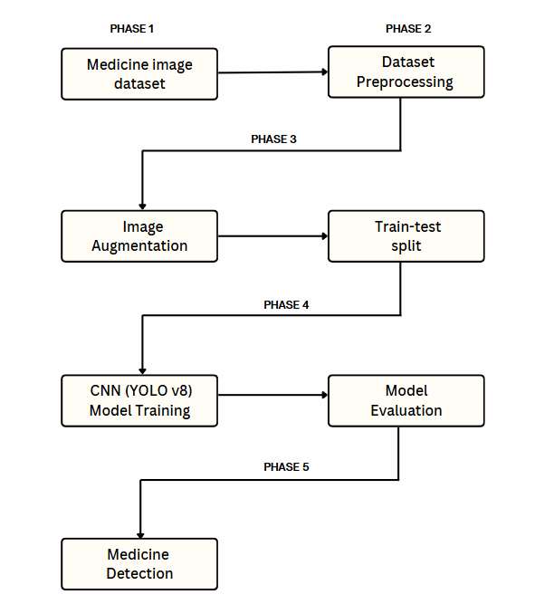

Fig1. Block Diagram

*C. Algorithms Used*

* CNN

A Convolutional Neural Network (CNN) is used to analyse and extract features from medicine package images. The model learns to recognize these patterns by training on a dataset containing both real and counterfeit medicine images. Image augmentation techniques, including flipping, rotation, and color adjustments, enhance the model's ability to detect counterfeit medicines even when the images are altered.

* YOLO v8 (You Only Look Once)

YOLO is an advanced real-time object detection algorithm used for identifying medicine packaging details efficiently. Unlike traditional object detection models, it divides an image into grids and predicts bounding boxes along with class probabilities in a single pass, making it faster and more accurate. This enables the system to detect and classify medicine packages as real or counterfeit based on visual inconsistencies such as logo design, color variations, and packaging defects.

The app uses CNN to analyse logos, color, and packaging details, while YOLO detects inconsistencies in real time. Image augmentation enhances accuracy, allowing the system to identify counterfeit medicines even if the images are altered. This combination ensures fast and reliable medicine authentication.

IV. IMPLEMENTATION

*A. Design System*

The system consists of two major modules. One for counterfeit medicine detection and reminder alerts for medicine intake. Fake medicine detection module helps users to detect the medicine is fake or not by scanning the image using device camera. The other module includes reminder alerts where users can set alerts for proper medicine intake.

*B. Mobile Application*

The application is developed in Android OS. The app not only focuses on medicine detection but also offers a wide variety of functions through a healthcare app to the users. The sign-up section provides an easy way to create an account in the app. Once an account is created, then the user can use the username and password to login to the app.

After successful login, users can make use of the features like medicine identification, prescription tracking, reminder alerts and health vital records. Medicine identification module mainly helps users to identify the medicine, its uses and side effects. Users can set alerts for medicine intake and low stock notifications if their medicine supply is running low. Furthermore, users can store their prescriptions and can view at any time.

Functionalities of the app include:

* Counterfeit medicine detection

Allows the users to scan or upload the image of medicine package and helps to identify whether the medicine is original or not.

* Medicine Identification

Helps users identify medicines and its uses. Displays detailed information about the medicine, its brand, imprint, including its uses and side effects.

* Prescription Tracking

Allows users to record and store prescriptions. Users can access stored prescriptions anytime for reference.

* Reminder Alerts

Enables users to set reminders for medicine intake. Sends notifications for low stock when medicines are running out.

* Medicine Stock Alert

Allows users to keep track of their medicine stock. Notify users when medicines are out of stock.

* Health Vitals Record

Allows users log and track their health vitals. Provides an easy way to monitor and review health data over time.

* BMI Calculator

Helps users calculate their Body Mass Index (BMI) based on height and weight. Provides insights into their health status.

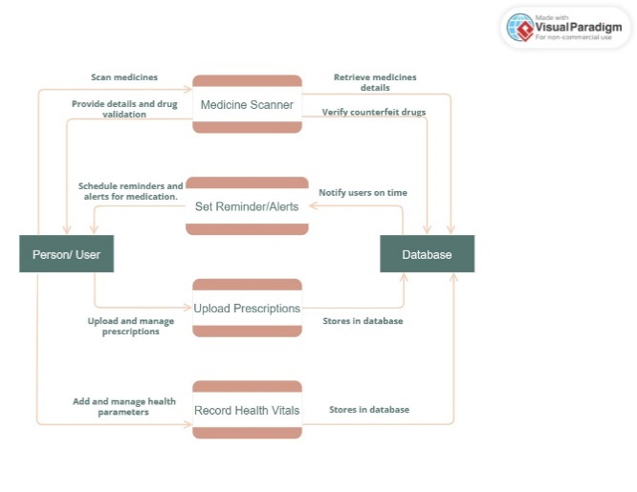

Fig1. App flow Diagram

V. EXPERIMENTAL RESULTS

For the Medicare app, the user scans a medicine package. The trained CNN-based YOLO model detects the medicine package and assigns a confidence score. If the confidence score is high, the medicine is marked as Real. If the score is low, it is marked as Fake.

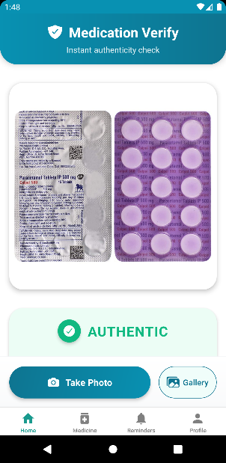 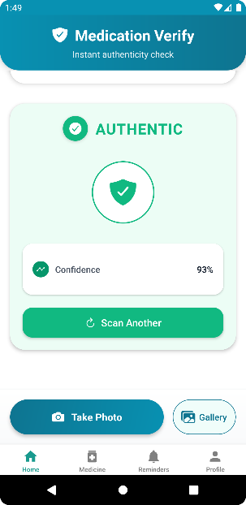

Fig4. Result Fig4. Result

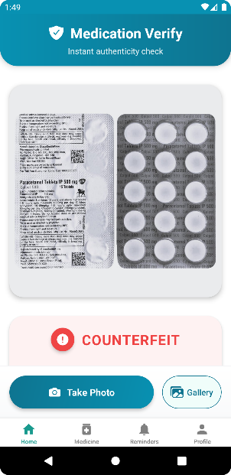 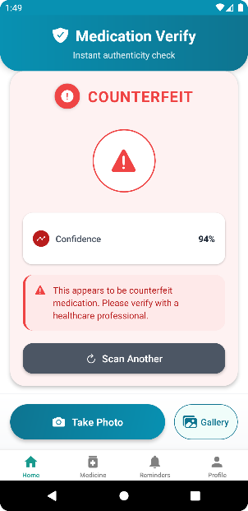

Fig4. Result Fig4. Result

VI. CONCLUSION

Medicine counterfeiting is a problem that is addressed by several countries. There is a requirement of multiple measures in order to protect the consumers and the supply chain. The proposed application makes use of CNN, YOLO(v8) which is a machine learning-based approaches to detect fake medicines. It allows the user to validate their medicines. The app offers not only a medicine detection module but also a complete healthcare system, including reminders, stock alerts, prescription tracking, and a health vitals record system.

REFERNCES

1. “DNA,” How to differentiate counterfeit medicines from genuine ones, Jun. 24, 2021. [https://www.dnaindia.com/analysis/report-dna special-how-to-differentiate-counterfeit medicines-from-genuine-ones-2897092](https://www.dnaindia.com/analysis/report-dna%20special-how-to-differentiate-counterfeit%20medicines-from-genuine-ones-2897092)
2. P. Gupta, K. Singhal, and A. Pandey, “Counterfeit (Fake) Drugs & New Technologies to Identify it in India,” vol. 3, no. 11, pp. 4057 4064, Oct. 2012.
3. R. Kumar and R. Tripathi, “Traceability of counterfeit medicine supply chain through Blockchain,” 2019, pp. 568–570. doi: 10.1109/COMSNETS.2019.8711418.
4. Big Problem, Smart Solution: An App That IDs the Pills You're Taking, Aug 8,2013. <https://www.wired.com/2013/08/an-app-thats-looking-to-document-the-worlds-pill-supply/>