Name: Namita Sandil_BatchA

ASSIGNMENT TESTING

Test any website and write the script for finding elements by including all locators.

o By.className

o By.cssSelector

o By.id

o By.linkText

o By.name

o By.partialLinkText

o By.tagName

o By.xpath

web site: <https://demoqa.com/links>

code

package day1;

import org.openqa.selenium.By;

import org.openqa.selenium.WebDriver;

import org.openqa.selenium.chrome.ChromeDriver;

public class demo3 {

public static void main(String[] args) {

System.setProperty("webdriver.chrome.driver", "C:\\Users\\balkh\\OneDrive\\Desktop\\Sellars\\chromedriver_win32\\chromedriver.exe");

WebDriver driver = new ChromeDriver();

driver.get("https://demoqa.com/automation-practice-form");

driver.findElement(By.id("firstName"));

System.out.println("Element found!");

driver.get("https://demoqa.com/automation-practice-form");

driver.findElement(By.name("gender"));

System.out.println("Element found!");

driver.get("https://demoqa.com/automation-practice-form");

driver.findElement(By.className("practice-form-wrapper"));

System.out.println("Element found!");

driver.get("https://demoqa.com/links");

driver.findElement(By.linkText("Home"));

System.out.println("Element found!");

driver.get("https://demoqa.com/text-box");

driver.findElement(By.xpath("//input[@id='userName']"));

System.out.println("Element found!");

driver.get("https://demoqa.com/text-box");

driver.findElement(By.partialLinkText("Following links will open new tab"));

System.out.println("Element found!");

driver.close();

}}

Output

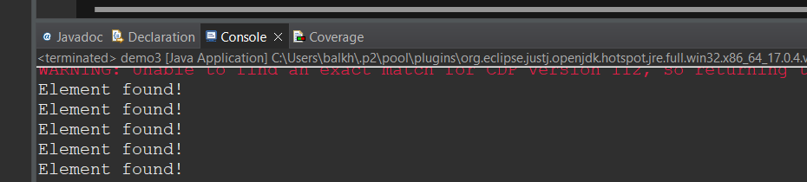

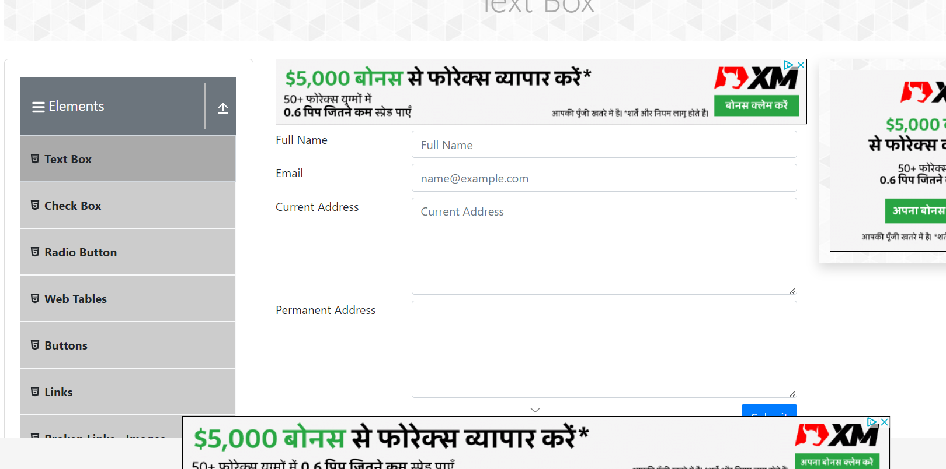

Q.2 Test any website and write the script for that involves keyboard actions dragAndDrop(source,

target), keyDown(modifier_key), keyUp(modifier_key), moveToElement(toElement),

release(),sendKeys(onElement, charsequence).

weblink: <http://www.facebook.com/>

code:

package day1;

import org.openqa.selenium.By;

import org.openqa.selenium.WebDriver;

import org.openqa.selenium.chrome.ChromeDriver;

import org.openqa.selenium.*;

import org.openqa.selenium.interactions.Action;

import org.openqa.selenium.interactions.Actions;

public class demo7 {

public static void main(String[] args) {

String baseUrl = "http://www.facebook.com/";

System.setProperty("webdriver.chrome.driver", "C:\\Users\\balkh\\OneDrive\\Desktop\\Sellars\\chromedriver_win32\\chromedriver.exe");

WebDriver driver = new ChromeDriver();

driver.get(baseUrl);

WebElement txtUsername = driver.findElement(By.id("email"));

Actions builder = new Actions(driver);

Action seriesOfActions = builder

.moveToElement(txtUsername)

.click()

.keyDown(txtUsername, Keys.SHIFT)

.sendKeys(txtUsername, "hello")

.keyUp(txtUsername, Keys.SHIFT)

.doubleClick(txtUsername)

.contextClick()

.build();

seriesOfActions.perform() ;

//driver.close();

}

}

Output

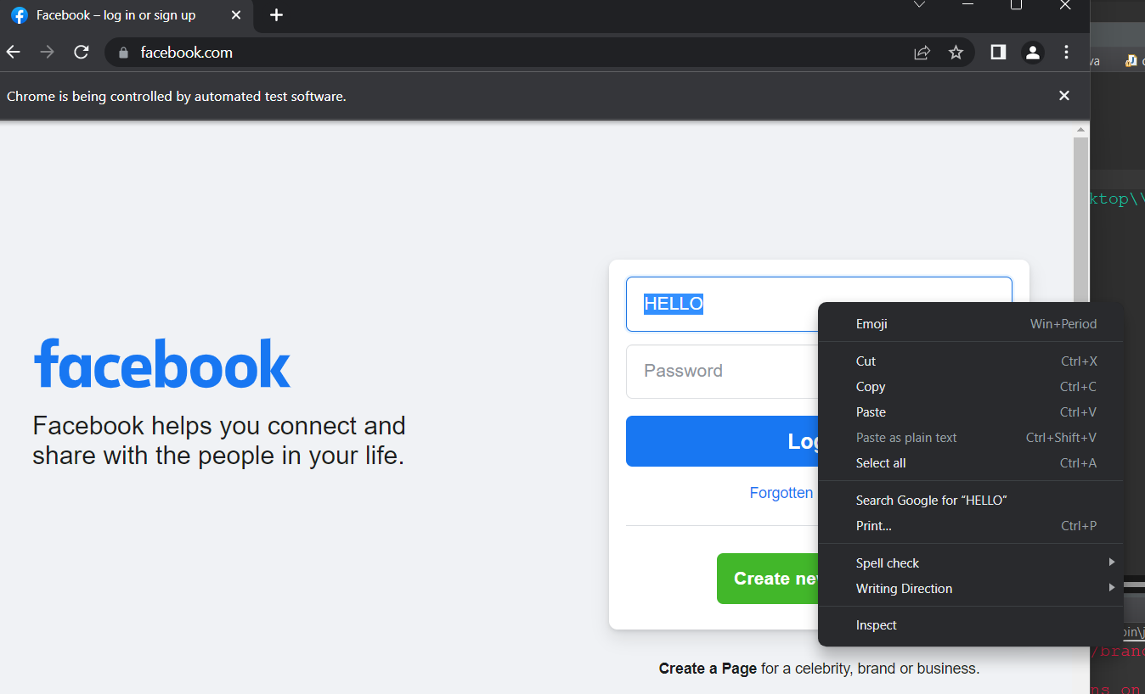

Q3.Test any website and write the script for testing textbox, dropdown,checkbox and radio button for the registration form.

Code

package day1;

import org.openqa.selenium.chrome.ChromeDriver;

import org.openqa.selenium.*;

public class demo5 {

public static void main(String[] args) {

// declaration and instantiation of objects/variables

System.setProperty("webdriver.chrome.driver", "C:\\Users\\balkh\\OneDrive\\Desktop\\Sellars\\chromedriver_win32\\chromedriver.exe");

WebDriver driver = new ChromeDriver();

String baseUrl = "https://demo.guru99.com/test/radio.html";

driver.get(baseUrl);

WebElement option1 = driver.findElement(By.id("vfb-7-1"));

option1.click();

System.out.println("Radio Button Option 1 Selected");

WebElement option2 = driver.findElement(By.id("vfb-7-2"));

option2.click();

System.out.println("Radio Button Option 2 Selected");

WebElement option3 = driver.findElement(By.id("vfb-7-3"));

option3.click();

System.out.println("Radio Button Option 3 Selected");

WebElement check = driver.findElement(By.id("vfb-6-0"));

check.click();

if (option1.isSelected()) {

System.out.println("Checkbox is Toggled On");

} else {

System.out.println("Checkbox is Toggled Off");

}

}}

Output

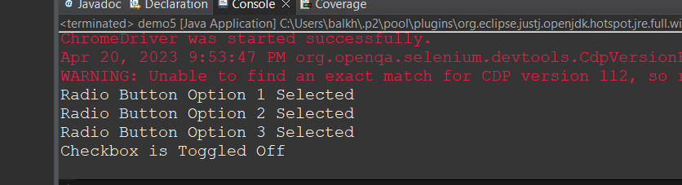

Result

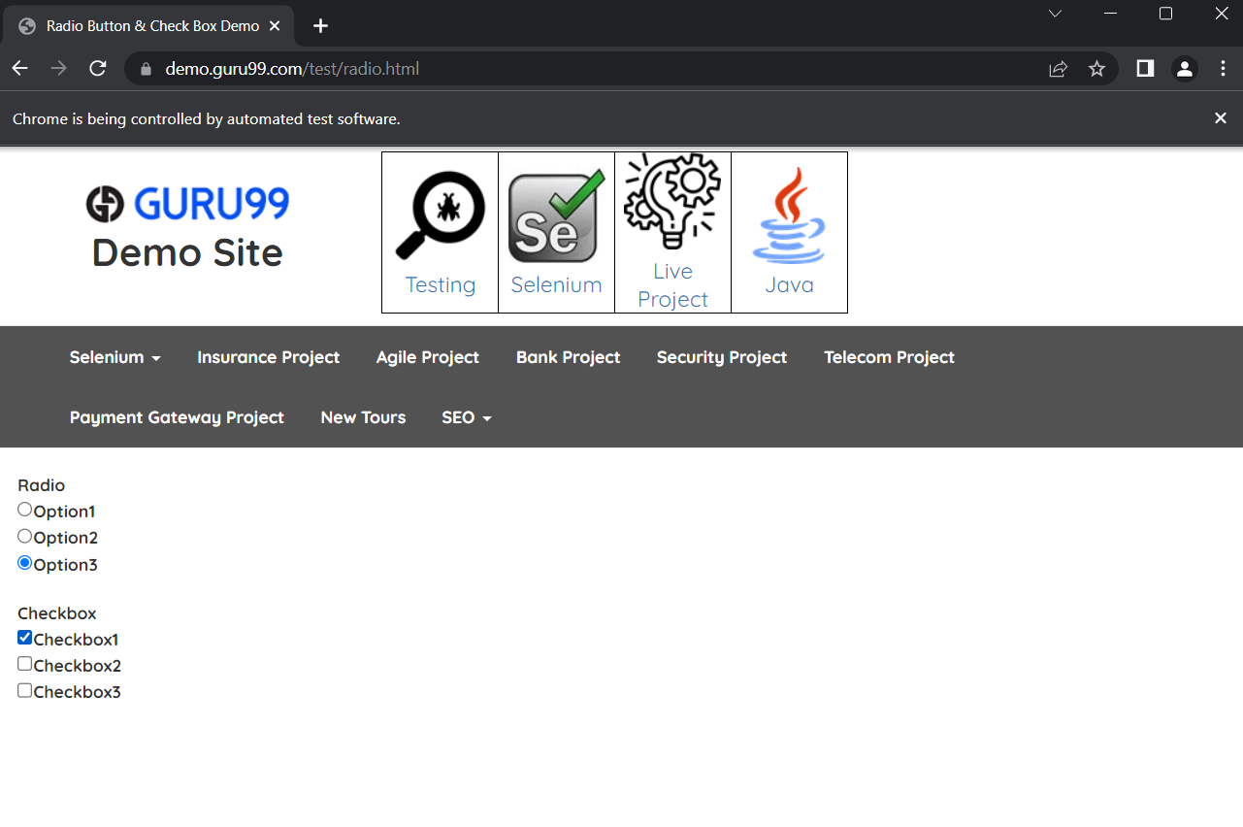

What is meant by XPath in Selenium. Explain XPath Absolute and XPath Relative.

***XML Path*** or commonly known as ***XPath***, is a query language for ***XML*** documents. It is made of path expression governed by some pre-defined conditions. Moreover, XPath can be effectively used to identify and locate almost any element present on a web page. It is quite helpful while working on a dynamic web page where the web element's unique attributes are not constant. Moreover, it allows us to write ***XML document navigation flow*** for locating web elements. Consequently, let's first understand what syntax does XPath uses to locate the web elements

package day1;

import java.util.List;

import org.openqa.selenium.By;

import org.openqa.selenium.WebDriver;

import org.openqa.selenium.WebElement;

import org.openqa.selenium.chrome.ChromeDriver;

public class demo12 {

public static void main(String[] args) {

System.*setProperty*("webdriver.chrome.driver", "C:\\Users\\balkh\\OneDrive\\Desktop\\Sellars\\chromedriver_win32\\chromedriver.exe");

WebDriver driver = new ChromeDriver();

driver.get("https://demoqa.com/automation-practice-form");

driver.findElement(By.*xpath*("//input[@id='userName']"));

System.***out***.println("Element found!");

driver.close();

}

}

Xpath Absolute:

***Absolute XPath*** is the direct way of finding the element. Moreover, it starts from the first/root node of the XML/HTML document and goes all the way to the required node following one node at a time

package day1;

import org.openqa.selenium.By;

import org.openqa.selenium.WebDriver;

import org.openqa.selenium.WebElement;

import org.openqa.selenium.chrome.ChromeDriver;

public class demo13 {

public static void main(String[] args) throws InterruptedException{

System.*setProperty*("webdriver.chrome.driver", "C:\\Users\\balkh\\OneDrive\\Desktop\\Sellars\\chromedriver_win32\\chromedriver.exe");

System.***out***.println("Absolute XPath in Selenium");

WebDriver driver = new ChromeDriver();

driver.get("https://demoqa.com");

//Locate the web element using absolute xpath

WebElement headerImage = driver.findElement(By.*xpath*("/html/body/div/header/a/img"));

// Validate that the header image is displayed on the web page

System.***out***.println("The image is displayed : " + headerImage.isDisplayed());

driver.close();

System.***out***.println("Execution complete!!");

}

}

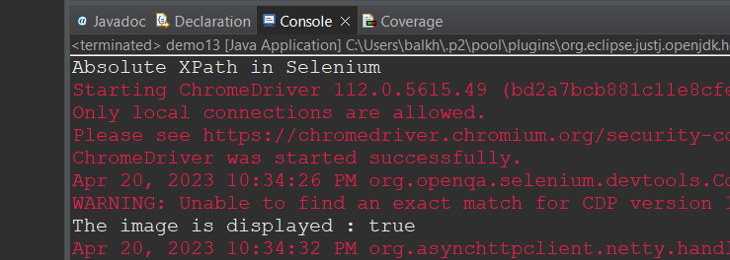

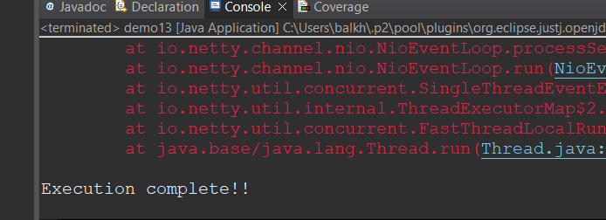

***Relative XPath*** starts from any node inside the HTML DOM; it need not start from the root node. It beings with a ***double forward slash***. For better understanding, let’s take the same example as the absolute path above.

Code:

package day1;

import org.openqa.selenium.By;

import org.openqa.selenium.WebDriver;

import org.openqa.selenium.WebElement;

import org.openqa.selenium.chrome.ChromeDriver;

public class demo14 {

public static void main(String[] args) throws InterruptedException{

System.*setProperty*("webdriver.chrome.driver", "C:\\Users\\balkh\\OneDrive\\Desktop\\Sellars\\chromedriver_win32\\chromedriver.exe");

System.***out***.println("Relative XPath in Selenium");

WebDriver driver = new ChromeDriver();

driver.get("https://demoqa.com");

//Locate the web element using relative XPath

WebElement headerImage = driver.findElement(By.*xpath*("//img[@src = '/images/Toolsqa.jpg']"));

// Validate that the header image is displayed on the web page

System.***out***.println("The image is displayed : " + headerImage.isDisplayed());

driver.close();

System.***out***.println("Execution complete!!");

}

}

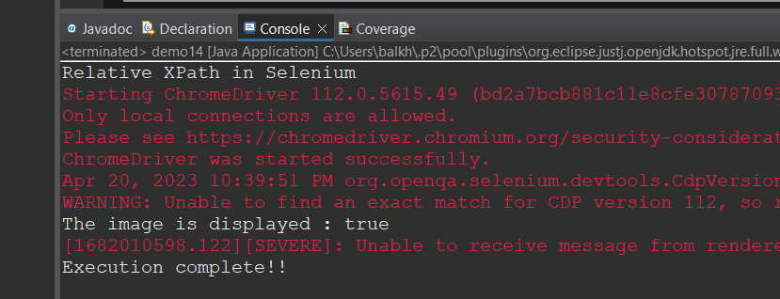

Demonstrate explicit and Implicit waits via a script

With the help of code snippets, explain how we can create right-click and mouse hover actions in

Selenium.

Can we handle a windows-based Alerts in selenium.. Demonstrate

Code:

package day1;

import org.openqa.selenium.By;

import org.openqa.selenium.WebDriver;

import org.openqa.selenium.WebElement;

import org.openqa.selenium.chrome.ChromeDriver;

import org.openqa.selenium.firefox.FirefoxDriver;

import org.openqa.selenium.interactions.Actions;

public class demo15 {

public static void main(String[] args) {

System.*setProperty*("webdriver.chrome.driver", "C:\\Users\\balkh\\OneDrive\\Desktop\\Sellars\\chromedriver_win32\\chromedriver.exe");

WebDriver driver = new ChromeDriver();

driver.get("https://demoqa.com/buttons");

System.***out***.println("demoqa webpage displayed");

driver.manage().window().maximize();

Actions actions = new Actions(driver);

WebElement btnElement = driver.findElement(By.*id*("rightClickBtn"));

actions.contextClick(btnElement).perform();

System.***out***.println("Right click Context Menu displayed");

WebElement elementOpen = driver.findElement(By.*xpath*(".//div[@id='rightclickItem']/div[1]"));

elementOpen.click();

driver.switchTo().alert().accept();

System.***out***.println("Right click Alert Accepted");

driver.close();

}

}

Output:

