Namita Sandil:

Q  1 Wap to define a class for employee having fields as empno ,name and addresss.  
       Ask employee details from user using scanner in input method .  
       Display details using display method .  
      Write whole object data to file Employee.dat .  
      Read employee data from file and display it on console.

package InputOutput;

import java.util.Scanner;

import java.io.*;

class childOf extends ObjectOutputStream

{

childOf(OutputStream o) throws Exception

{

super(o);

}

protected void writeStreamHeader()

{

// empty write stream header

}

}

public class EmployeeQ1 implements Serializable {

String E_name;

String E_addres;

int E_id;

int age;

void input()

{

Scanner sc= new Scanner(System.***in***);

System.***out***.println("Enter name of Employee:");

E_name=sc.nextLine();

System.***out***.println("Enter address of Employee:");

E_addres=sc.nextLine();

System.***out***.println("Enter ID of Employee:");

E_id=sc.nextInt();

System.***out***.println("Enter age of Employee:");

age=sc.nextInt();

}

void display()

{

System.***out***.println("NAME:"+E_name);

System.***out***.println("ADDRESS:"+E_addres);

System.***out***.println("ID:"+E_id);

System.***out***.println("age:"+age);

}

public static void main(String[] args) throws IOException {

try {

EmployeeQ1 obj= new EmployeeQ1();

obj.input();

File f= new File("employee.txt");

//write object (class data) into file (name employee.txt)

if(f.length()==0)

{

ObjectOutputStream o = new ObjectOutputStream (new FileOutputStream("employee.txt"));

o.writeObject(obj);

}

else

{

childOf c = new childOf (new FileOutputStream("employee.txt",true));

c.writeObject(obj);

}

// read data from file and print on console

EmployeeQ1 obj1= new EmployeeQ1();

ObjectInputStream p = new ObjectInputStream(new FileInputStream("employee.txt"));

obj1 = (EmployeeQ1) p.readObject();

obj1.display();

}

catch(Exception e)

{

System.***out***.println(e);

}

}

}

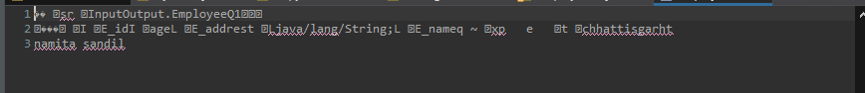

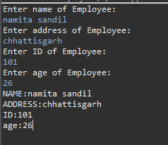

Q 2 create desktop  application for library mgt system  
  
define class book having fields like bname ,aname ,price and get method and display;  
  
define other methods like  
    writeToFile()  
  readfromFile()  
  searchfromFile()  
  
In main design menu driven application  
 1) store data to file 2) read data from file  
 3) search data from file  
 4) exit

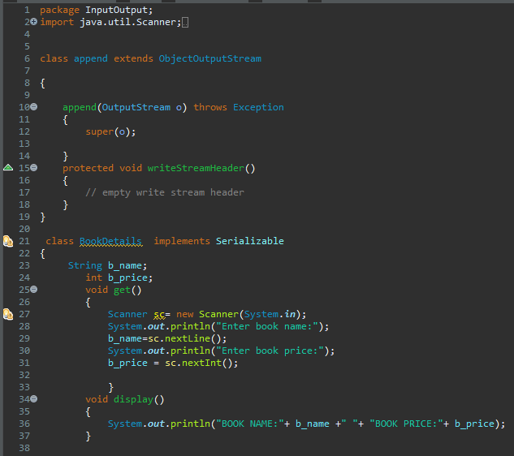

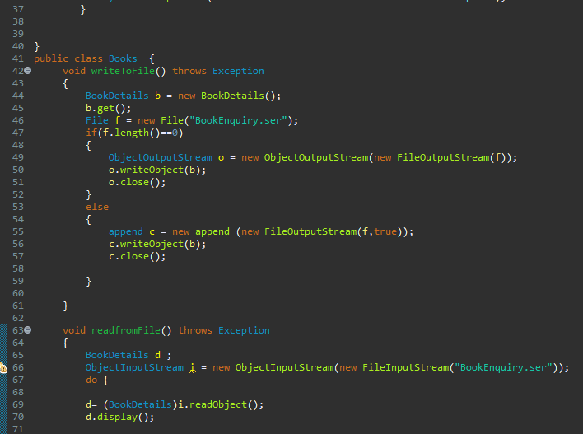

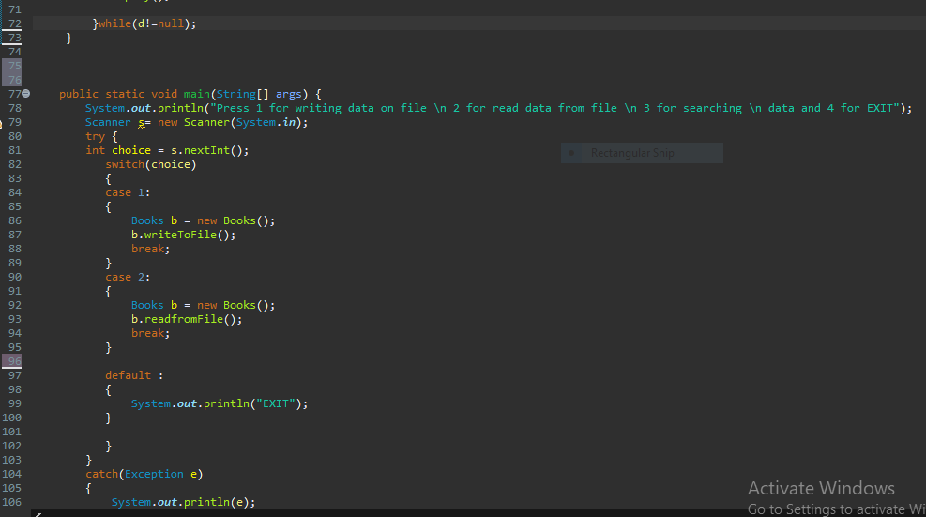

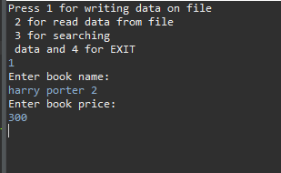

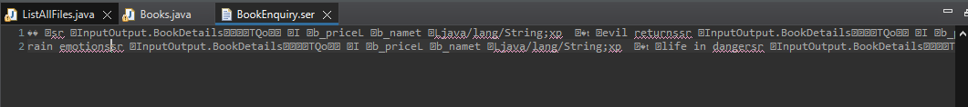

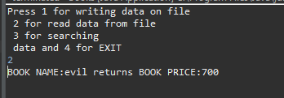

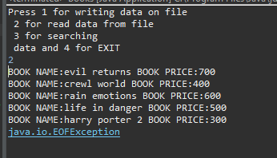

Q 3 wap to read text file and count the number of vowels in it

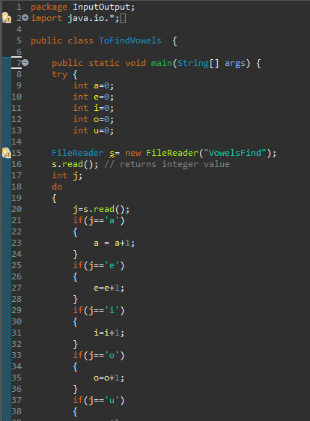

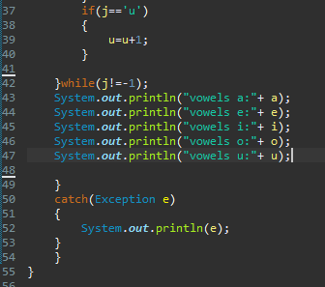

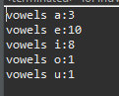

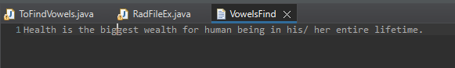

Q 4 wap to copy content of one file to another..

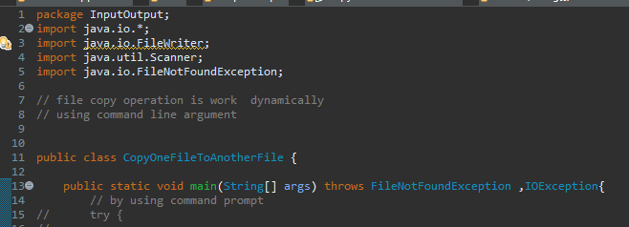

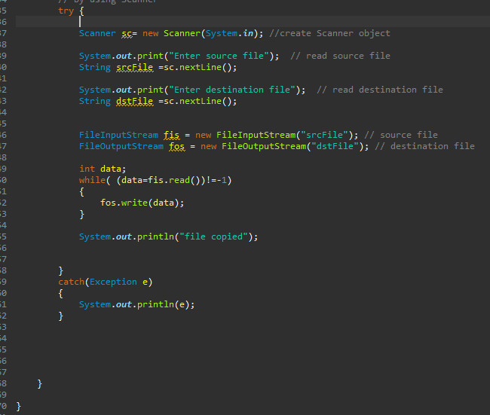

Q 5 wap to read csv file and display in formatted way hint use scaner class split method

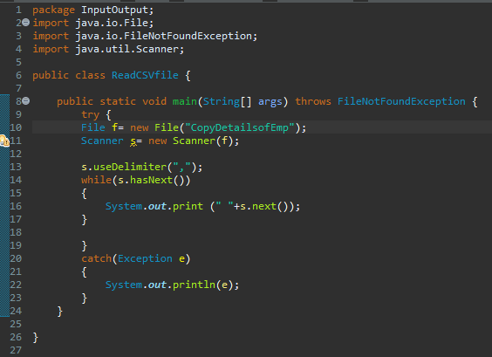

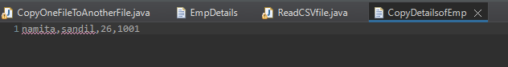

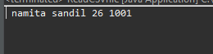

Q6 wap to list file in directory .

