Q. 1 Print the pattern.

public class Patterns {

public static void main(String[] args) {

System.***out***.print("print the pattern1 :\n");

for(int i=1;i<=4;i++)

{

for(int j = 1; j<=10 ;j++)

{

System.***out***.print("*");

}

System.***out***.print("\n");

}

}

}

OUTPUT:

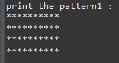

Q.2 Print the Pattern2.

package CDACASSIGNMNT;

public class Patterns {

public static void main(String[] args) {

System.***out***.print("print the pattern1 :\n");

for(int i=1;i<=5;i++)

{

for(int j = 1; j<=i ;j++)

{

System.***out***.print("*");

}

System.***out***.print("\n");

}

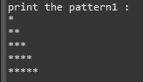

Q.3 Write a program that prompts the user to input a positive integer. It should then print the multiplication table of that number.

package namitaApplication;

// print table of any number entered by user

import java.util.Scanner;

public class table {

public static void main(String[] args) {

System.***out***.print("enter any positive integer: \n");

Scanner sc = new Scanner(System.***in***);

int num = sc.nextInt();

int ans= 0;

if(num>0)

{

for(int i=1; i<=10;i++)

{

ans = num*i;

System.***out***.println(ans);

}

}

else {

System.***out***.println("the number entered is negative");

}

}

}

OUTPUT:



OUTPUT:

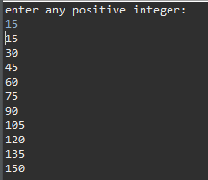

Q. 4 Write a program to calculate the sum of first 10 natural number.

package namitaApplication;

// print sum of first n natural numbers

import java.util.Scanner;

public class naturalnumbersum {

public static void main(String[] args) {

System.***out***.print("enter any number :");

Scanner sc = new Scanner(System.***in***);

int num = sc.nextInt();

int sum =0;

for(int i= 0; i<=num; i++)

{

sum = sum+i;

}System.***out***.println("the sum of entered number is :");

System.***out***.println(sum);

}

}

OUTPUT:



Q.5 Write a program to display first 1 to 20 even number on screen . Terminate the program when number 16 is found using break command.

package CDACASSIGNMNT;

public class Onetotwentyeven {

public static void main(String[] args) {

System.***out***.println("DISPLAY 1 TO 20 EVEN NUMBERS :");

for (int i=0; i<=20; i+=2)

{

System.***out***.println(i);

if(i==16) break;

}

}

}

OUTPUT:

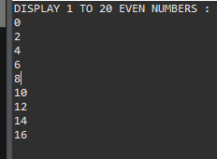

Q.6 Write a program to check if given number is prime or not

package CDACASSIGNMNT;

import java.util.Scanner;

public class Primnumbrs {

public static void main(String[] args) {

Scanner sc = new Scanner(System.***in***);

System.***out***.println("enter any number to check :");

int n = sc.nextInt();

int count=0;

for(int i =1; i<=n;i++)

{

if(n%i==0)

count++;

}

if(count==2) {

System.***out***.println("entred number is prime");

}

else

{

System.***out***.println("entred number is not prime");

}

}

}

OUTPUT:

 C:\Users\Dell\Desktop\New folder\prime1.PNG

Q. 7 The loop should ask the user whether he or she wishes to perform the operation again. If so, the loop should repeat; otherwise it should terminate.(while loop)

package CDACASSIGNMNT;

import java.util.Scanner;

public class Dowhilesum {

public static void main(String[] args) {

Scanner sc= new Scanner(System.***in***);

int t;

do {

System.***out***.println("enter any two number :");

int a= sc.nextInt();

int b= sc.nextInt();

int sum = a+b;

System.***out***.println(sum);

System.***out***.println("entr 0 to terminate and 1 to continue :");

t= sc.nextInt();

} while(t!= 0);

System.***out***.println("user don't want to continue");

}

}

OUTPUT:

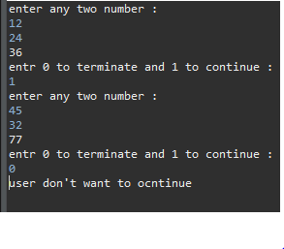

Q.8Write a program in java to find the sum of the even and odd digits of the number which is given as input.

package CDACASSIGNMNT;

import java.util.Scanner;

public class SumOfEvenOdd {

// even number - 0 to ....

// od number - 1 to ...

public static void main(String[] args) {

Scanner sc = new Scanner(System.***in***);

int num = sc.nextInt();

int sum=0;

int i;

if(num%2==0)

{

for(i=0;i<=num;i+=2)

{

sum=sum+i;

}

System.***out***.println("even sum " + sum);

}

else

{

for(i= 1; i<=num;i+=2)

{

sum= sum+i;

}

System.***out***.println("odd sum =" + sum);

}

}

}

OUTPUT:

 

Q.9 Print the pattern.

package CDACASSIGNMNT;

public class Patterns {

public static void main(String[] args) {

System.***out***.print("print the pattern1 :\n");

for(int i=1; i<=5;i++)

{

for(int j=1;j<=5;j++)

{

if(i+j<=5)

{

System.***out***.print(" ");

}

else

{

System.***out***.print("*");

}

}

System.***out***.print("\n");

}

}

}

OUTPUT:

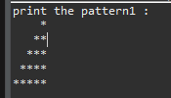

Q.10

package CDACASSIGNMNT;

public class Patterns {

public static void main(String[] args) {

System.***out***.print("print the pattern1 :\n");

for(int i= 1;i <=5; i++)

{

for(int j=1; j<=5;j++)

{

System.***out***.print(" ");

}

for(int j= 1; j<=i;j++)

{

System.***out***.print("*");

}

System.***out***.print("\n");

}

}

}

OUTPUT:

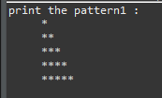

Q.11 Write a program that prompts the user to input an integer and then outputs the number with the digits reversed. For example, if the input is 12345, the output should be 54321.

package CDACASSIGNMNT;

public class ReverseDigit {

public static void main(String[] args) {

int a = 6589;

int rem=0;

int rev=0;

while(a!=0)

{

rem=a%10;

rev = rev *10 + rem;

a=a/10;

}

System.***out***.println("reverse digit is :" + rev);

}

}

OUTPUT:



Q.12 Write a program to print Fibonacci series of n terms where n is input by user :

0 1 1 2 3 5 8 13 24 ..

import java.util.*;

public class Printfibonacciseries {

public static void main(String[] args) {

System.***out***.println("enter number :");

Scanner sc = new Scanner(System.***in***);

int num = sc.nextInt();

int a=0;

int b=1;

//int c=0;

for(int i=1; i<=num;i++)

{

System.***out***.print(a+" ");

int c =a+b;

a=b;

b=c;

}

}

}

OUTPUT:

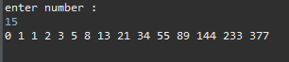

Q.13 Pattern

package CDACASSIGNMNT;

import java.util.Scanner;

public class SpacePatterns {

public static void main(String[] args) {

int space=1;

Scanner sc= new Scanner(System.***in***);

System.***out***.println("enter rows:");

int rows=sc.nextInt();

for(int i=1;i<=rows;i++)

{

for(space = 1; space<=(rows-i);space++)

{

System.***out***.print(" ");

}

for(int j=1;j<=2*i-1;j++)

{

System.***out***.print("*");

}

System.***out***.print("\n");

}

}

}

OUTPUT:

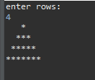

Q.14 WAP to find gratest among three.

package CDACASSIGNMNT;

public class LargestAmongThree {

public static void main(String[] args) {

int a=40,b=50,c=90;

if(a>b)

{

if(a>c)

{

System.***out***.println(a);

}

else

{

System.***out***.println(c);

}

}

else

{

if(b>c)

{

System.***out***.println(b);

}

else

{

System.***out***.println(c);

}

}

}

}

OUTPUT:



Q.15 Divisible by 3, 5 and by both.

package CDACASSIGNMNT;

public class DivisibleByNumbers {

public static void main(String[] args) {

System.***out***.println("divisible by 3");

for(int i=1; i<=100;i++)

{

if(i%3==0)

{

System.***out***.print(i+" ");

}

}

System.***out***.println("\ndivisible by 5");

for(int i=1; i<=100;i++)

{

if(i%5==0)

{

System.***out***.print(i+" ");

}

}

System.***out***.println("\ndivisible by both 3 and 5");

for(int i=1; i<=100;i++)

{

if(i%3==0 && i%5==0)

{

System.***out***.print(i+" ");

}

}}}

OUTPUT:

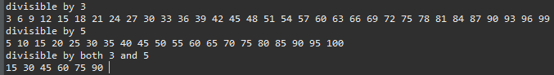

Q.16 WAP to find sum of all integers btween 100 to 200 which is divisible by 7.

package CDACASSIGNMNT;

public class SumOfIntegers {

public static void main(String[] args) {

int sum=0;

for(int i=100; i<=200;i++)

{

if(i%7==0)

{

System.***out***.print(i +" ");

sum=sum+i;

}

}

System.***out***.println("\nthe sum of the above numbers are :");

System.***out***.println(sum);

OUTPUT:



Q.17 WAP to print prime numbrs between 2 to 20.

package CDACASSIGNMNT;

// print prime number between two number ....

// divisible by 1 and itself

import java.util.Scanner;

public class PrimeNumber {

public static void main(String[] args) {

Scanner sc = new Scanner(System.***in***);

System.***out***.println("enter two numbers :");

int n1 = sc.nextInt();

int n2= sc.nextInt();

// nested for loop

int i,j;

for(i=n1;i<=n2;i++)

{

for(j= 2;j<=i;j++)

{

if(i%j==0)

break;

}

if(i==j)

System.***out***.print(j +" ");

}

}

}

OUTPUT:

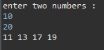

Q.18 package CDACASSIGNMNT;

import java.util.Scanner;

public class SpacePatterns {

public static void main(String[] args) {

int m=0;

for(int i=0;i<5;i++)

{

m++;

for(int j= 0;j<=5-i;j++)

{

System.***out***.print(" ");

}

for(int k=0; k<=2*i+1;k++)

{

System.***out***.print(m);

}

System.***out***.print("\n");

}

OUTPUT:

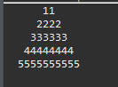

Q.19 ) ABCDEEDCBA  
 ABCD DCBA  
 ABC CBA  
 AB BA  
 A A

package CDACASSIGNMNT;

import java.util.Scanner;

public class SpacePatterns {

public static void main(String[] args) {

int space=0;

char ch='A';

for(int i=5;i>=1;i--)

{

for(int j=1;j<=i;j++) {

System.***out***.print(ch);

ch++;

}

for(int k=0;k<space;k++) {

System.***out***.print(" ");

}

for(int l=1;l<=i;l++)

{ch--;

System.***out***.print(ch);

}

System.***out***.println();

space++;

}

}

}

OUTPUT:

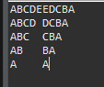

Q.20 create a menu driven application in java that show  
 "Add" Add two number  
 "subtract" Subtract two number  
 "Multiple" Multiple two numbers  
 "Exit " Exit

package namitaApplication;

//simple calculator using switch case

import java.util.Scanner;

import java.util.*;

public class calculator {

public static void main(String[] args) {

Scanner sc= new Scanner(System.***in***);

System.***out***.println("enter 1st number:");

int a =sc.nextInt();

int b= sc.nextInt();

System.***out***.println("enter choice");

String c=sc.next();

switch(c)

{

case "add": System.***out***.println("addition = " +( a+b));

break;

case "sub": System.***out***.println("substraction = " +(a-b));

break;

case "multi": System.***out***.println("multiplication = "+(a*b));

break;

default : System.***out***.println("EXIT");

}

}

}

OUTPUT:

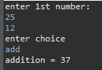 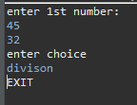

Q.21 24 Write a Java program that accepts two double variables and test if both strictly between 0 and 1 and false otherwise

package CDACASSIGNMNT;

import java.util.Scanner;

public class StrictlyZeroOrOne {

public static void main(String[] args) {

Scanner sc = new Scanner(System.***in***);

System.***out***.println("Enter first number");

double n1=sc.nextDouble();

System.***out***.println("Enter second number");

double d2=sc.nextDouble();

System.***out***.println(n1>0 && n1<1 && d2>0 && d2<1);

}

}

OUTPUT:

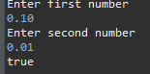

Q.22 Armstr Write a program to print out all Armstrong numbers between 1 and 500. If sum of cubes of each digit of the number is equal to the number itself, then the number is called an Armstrong number.  
For example, 153 = ( 1 * 1 * 1 ) + ( 5 * 5 * 5 ) + ( 3 * 3 * 3 )

package CDACASSIGNMNT;

public class ArmstrongNumber {

public static void main(String[] args) {

int n=159;

int m=n;

int rem=0;

int p=0;

while(n!=0)

{

rem =n%10;

p+=Math.*pow*(rem, 3);

System.***out***.println(rem);

n=n/10;

}

if(m==p)

System.***out***.println("number is armstrong");

else

System.***out***.println("not armstrong");

}

}

OUTPUT:

