**Assignment 4**

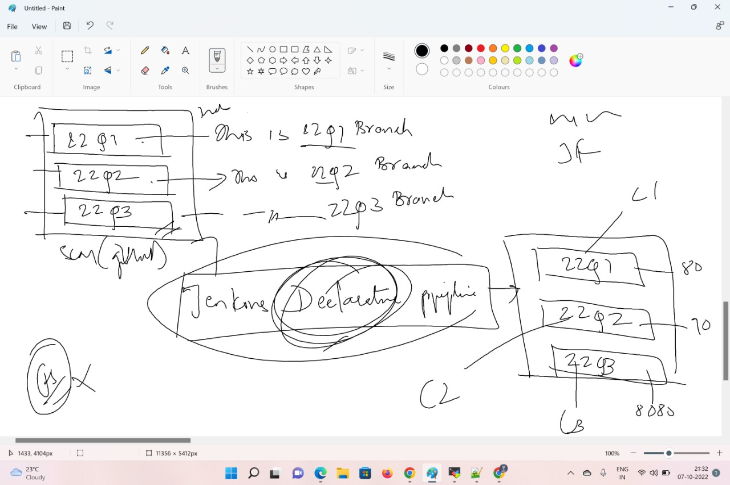**Q. Run Branch 22Q1 on (port=80),22Q2 (port=90) and 22Q3 (port=70) res.**

**Step1:**

* **Start Jenkins server (full Jenkins set-up) and tomcat up and running**
* **Install docker and start docker using this commands.**
* ***yum install docker -y***
* ***systemctl start docker***

**Step2:**

* **Install git on machine “*yum install git -y”***
* **Create git folder and create branches 22Q1,22Q2 and 22Q3 including index file and Jenkins file**
* **After that push all branches to git remote repo.**

**22Q1-Jenkins file**

**pipeline {**

**agent{**

**label{**

**label'built-in'**

**customWorkspace'/mnt/assignmet4/22Q1'**

**}**

**}**

**stages{**

**/* stage('stage1-22Q1'){**

**steps {**

**sh "docker kill 22Q1-httpd"**

**sh "docker rm 22Q1-httpd"**

**}**

**} */**

**stage('docker-stage-22Q1'){**

**steps{**

**sh "docker run --name 22Q1-httpd -itdp 80:80 httpd"**

**sh "chmod -R 777 /mnt/assignmet4/22Q1/index.html"**

**sh "cd /mnt/assignmet4/22Q1 && docker cp index.html 22Q1-httpd:/usr/local/apache2/htdocs/"**

**}**

**}**

**}**

**}**

**22Q1 index file:**

**<h1>This is index file for 22Q1 branch </h1>**

**port=80**

**22Q2 Jenkinsfile:**

**pipeline {**

**agent{**

**label{**

**label'built-in'**

**customWorkspace'/mnt/assignmet4/22Q2'**

**}**

**}**

**stages{**

**/* stage('stage1-22Q2'){**

**steps {**

**sh "docker kill 22Q2-httpd"**

**sh "docker rm 22Q2-httpd"**

**}**

**} */**

**stage('docker-stage-22Q2'){**

**steps{**

**sh "docker run --name 22Q2-httpd -itdp 90:80 httpd"**

**sh "chmod -R 777 /mnt/assignmet4/22Q2/index.html"**

**sh "cd /mnt/assignmet4/22Q2 && docker cp index.html 22Q2-httpd:/usr/local/apache2/htdocs/"**

**}**

**}**

**}**

**}**

**22Q2 index.file:**

**<h1>This is index file for 22Q2 branch </h1>**

**port=90**

**22Q3 Jenkinsfile:**

**pipeline {**

**agent{**

**label{**

**label'built-in'**

**customWorkspace'/mnt/assignmet4/22Q3'**

**}**

**}**

**stages{**

**stage('stage1-22Q3'){**

**steps {**

**sh "docker stop 22Q3-httpd"**

**sh "docker rm 22Q3-httpd"**

**}**

**}**

**stage('docker-stage-22Q3'){**

**steps{**

**sh "docker run --name 22Q3-httpd -itdp 70:80 httpd"**

**sh "chmod -R 777 /mnt/assignmet4/22Q3/index.html"**

**sh "cd /mnt/assignmet4/22Q3 && docker cp index.html 22Q3-httpd:/usr/local/apache2/htdocs/"**

**}**

**}**

**}**

**}**

**22Q3 index.html:**

**<h1>This is index file for 22Q3 branch </h1>**

**port=70**

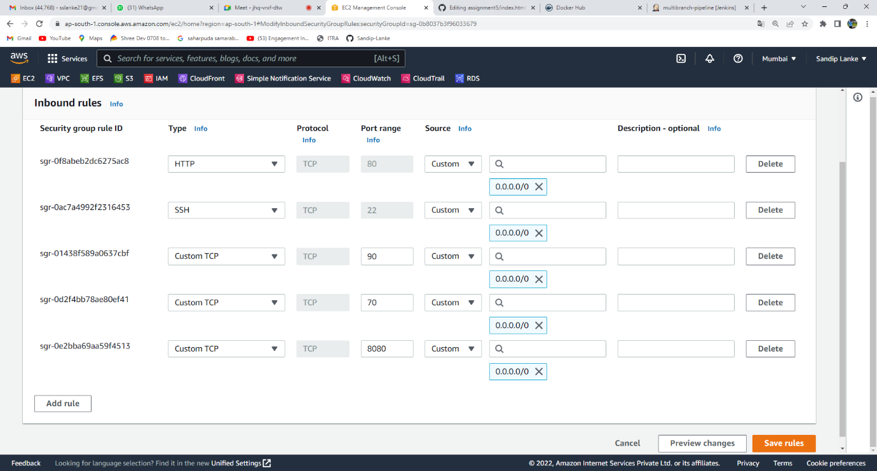**Step 3: Insert inbound rule in SG for port 80,90, and 70.**

**Step 4:Create new Multibranch pipeline job and use SCM(Git)**

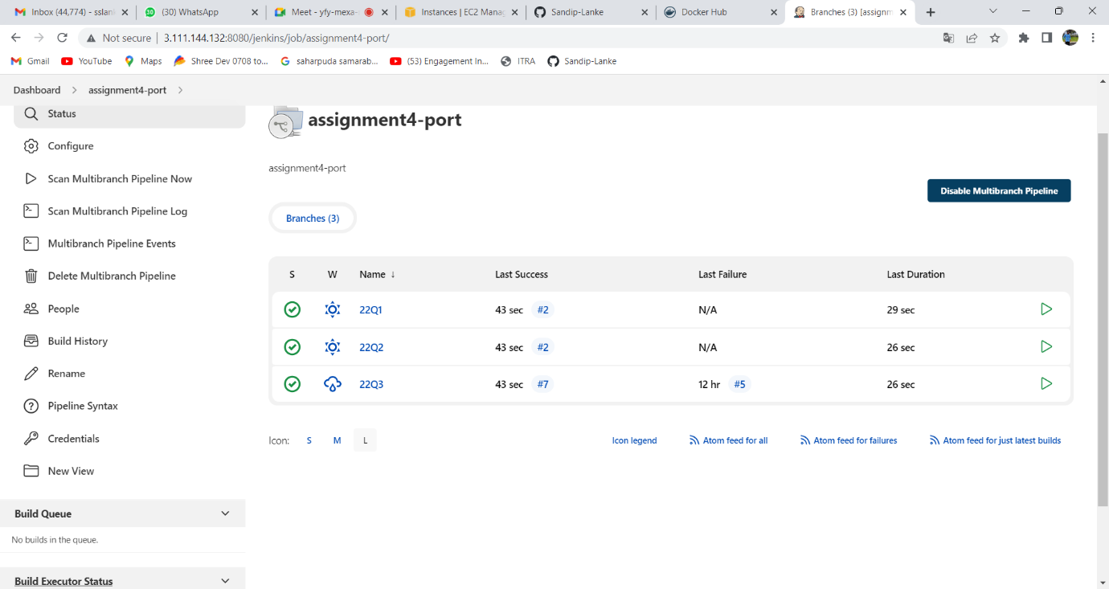

**Step 5:Check Console output and verify it using public publicIp and port (80,90,70)**

1. [**http://3.111.144.132:80/**](http://3.111.144.132:80/)
2. [**http://3.111.144.132:90/**](http://3.111.144.132:90/)
3. **http://3.111.144.132:70/**

