Sandip Maity
Roll No: UG/SOET/165/23/082
Reg. No: AU/2023/0009995
Sec: E
MongoDB Lab Assignment (Indexing & Sorting) | 16.02.2026
Create Database & Collection
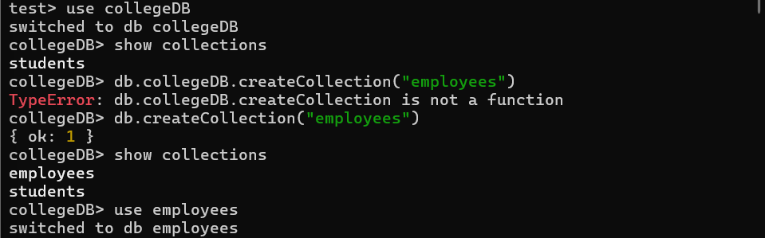
Insert All Data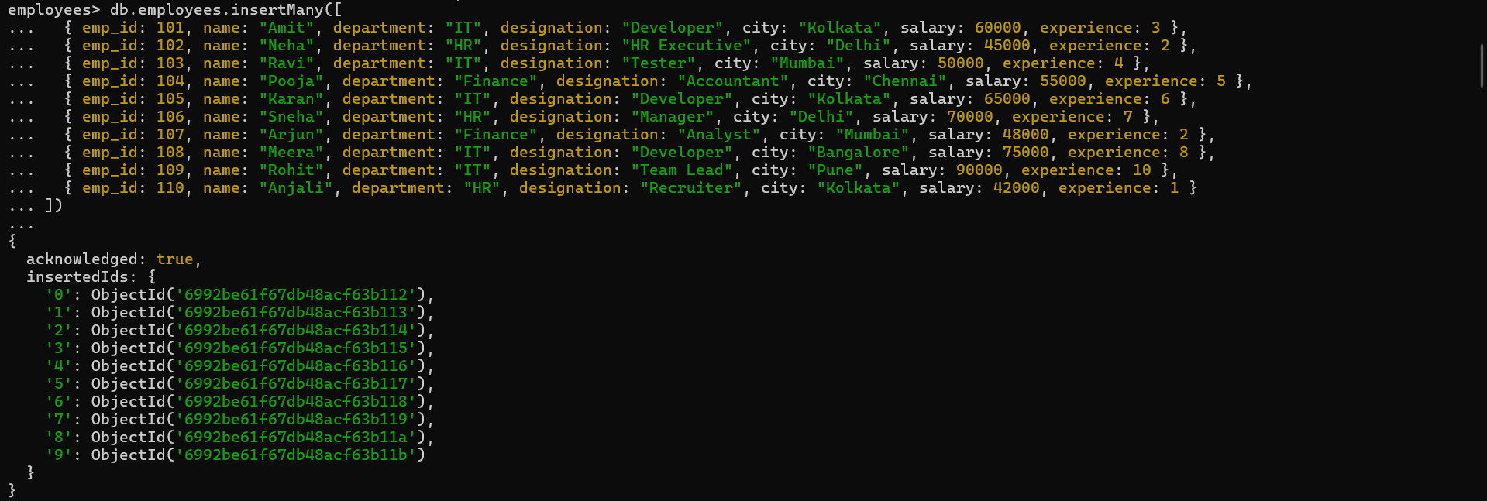
Lab Questions

Q1. Display all employee records
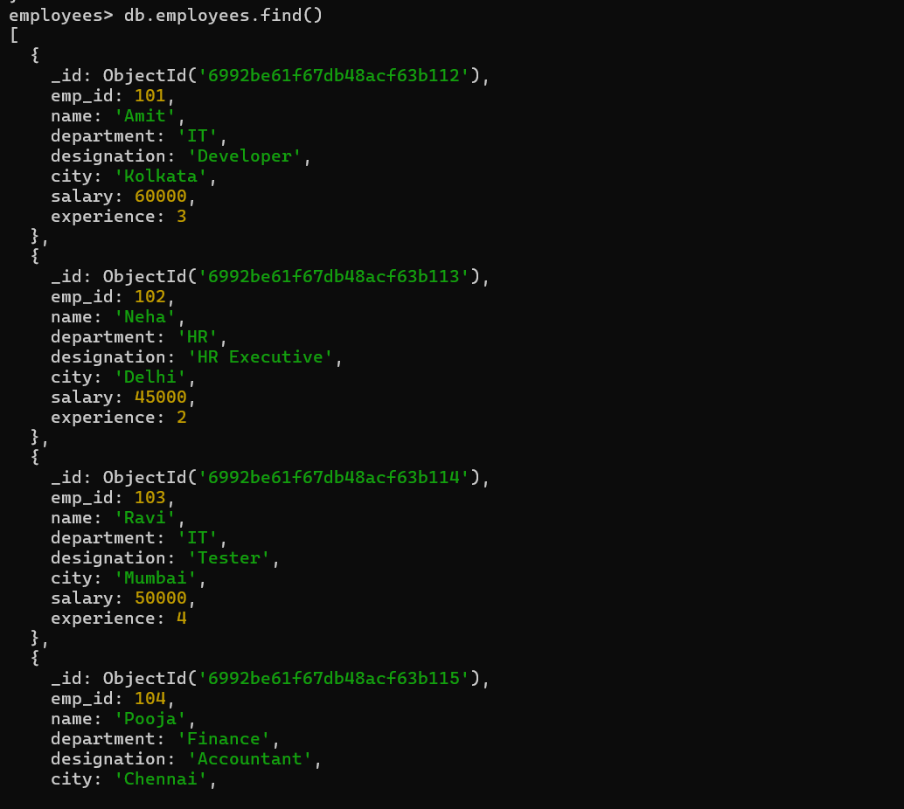
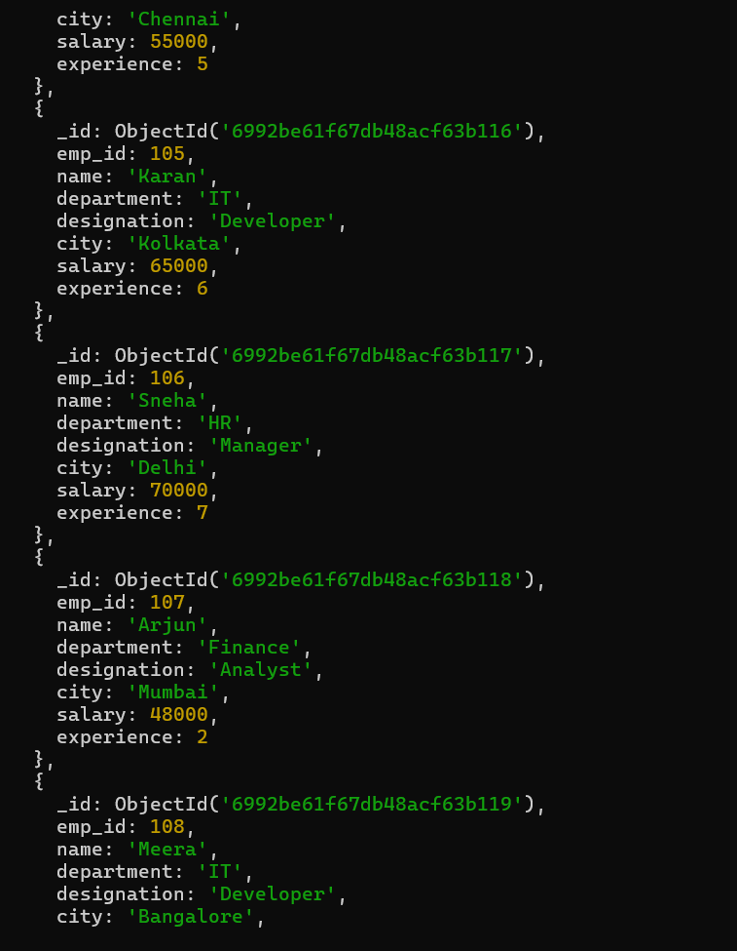
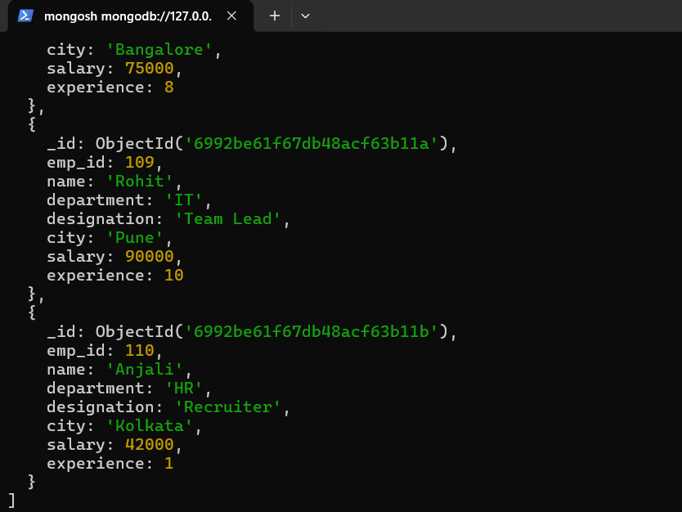
Q2. Create index on emp_id
Q3. Create index on department
Q4. Create compound index on department and salary

Q5. Find employees in IT department
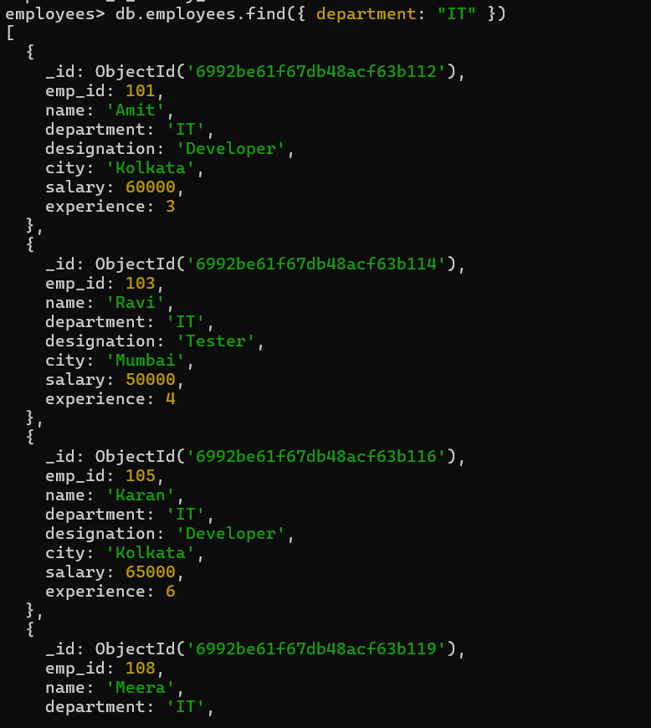
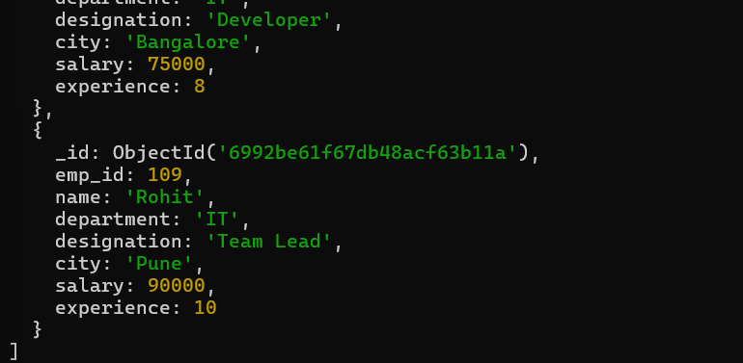

Q6. Salary greater than 60,000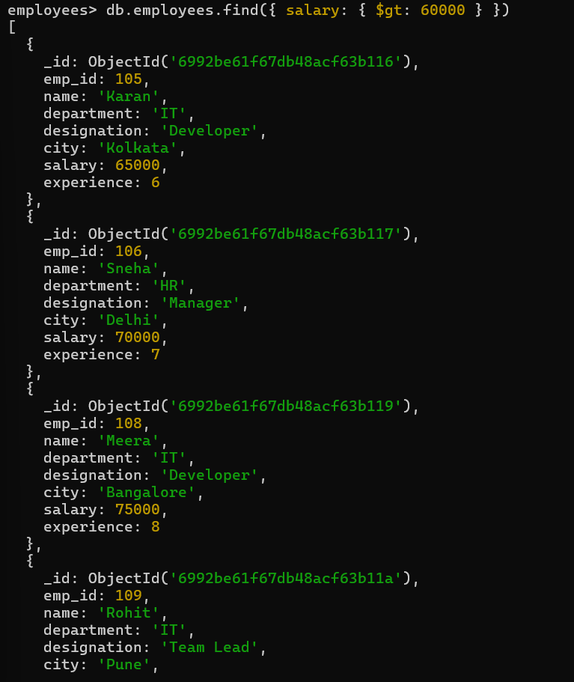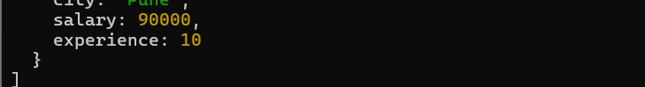
Q7. Sort employees by salary (descending)
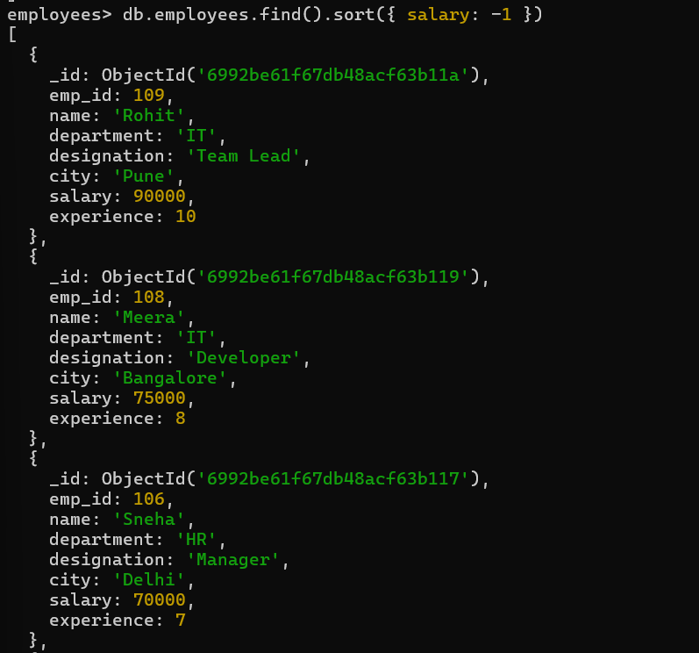
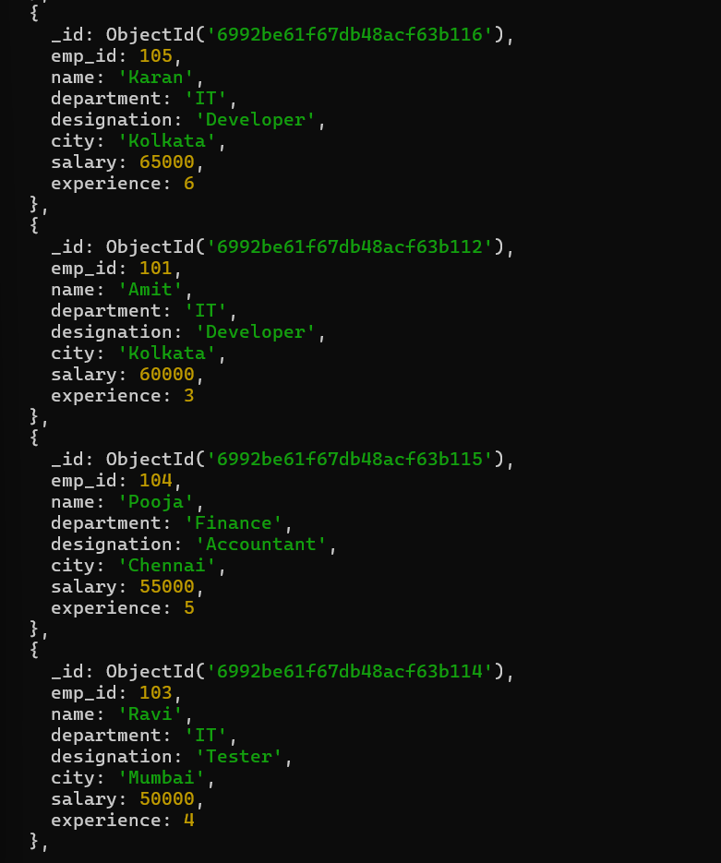
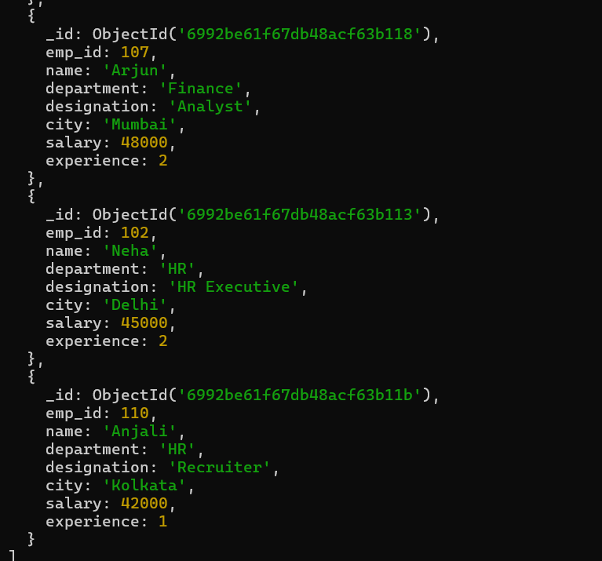

Q8. Top 3 highest paid employees
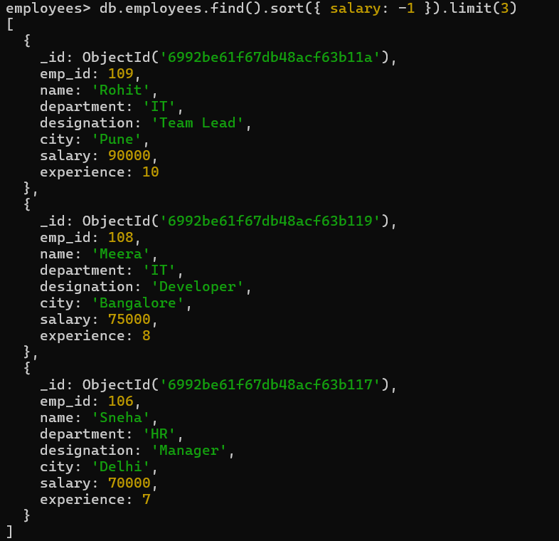

Q9. Employees with experience more than 5 years
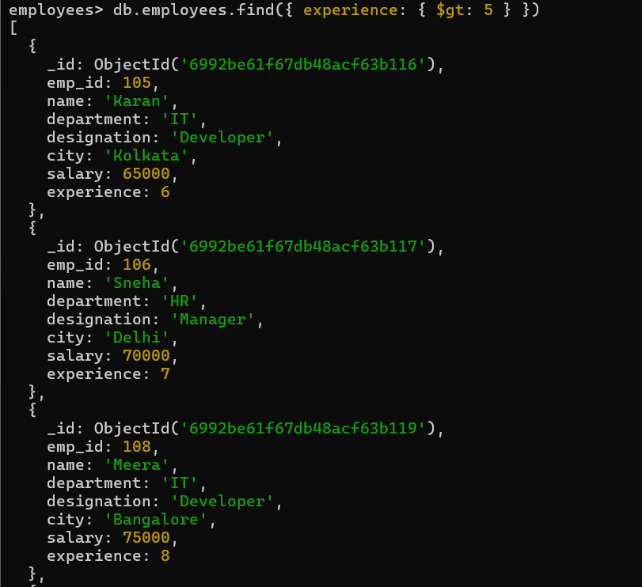
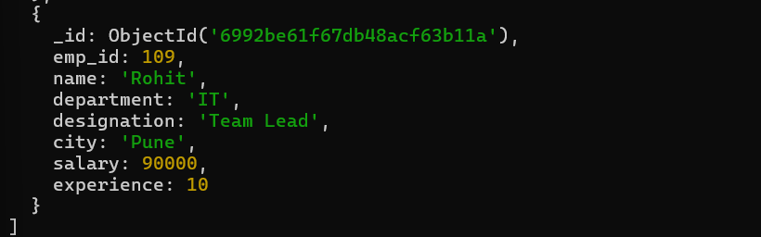
Q10. Analyze query performance using explain()
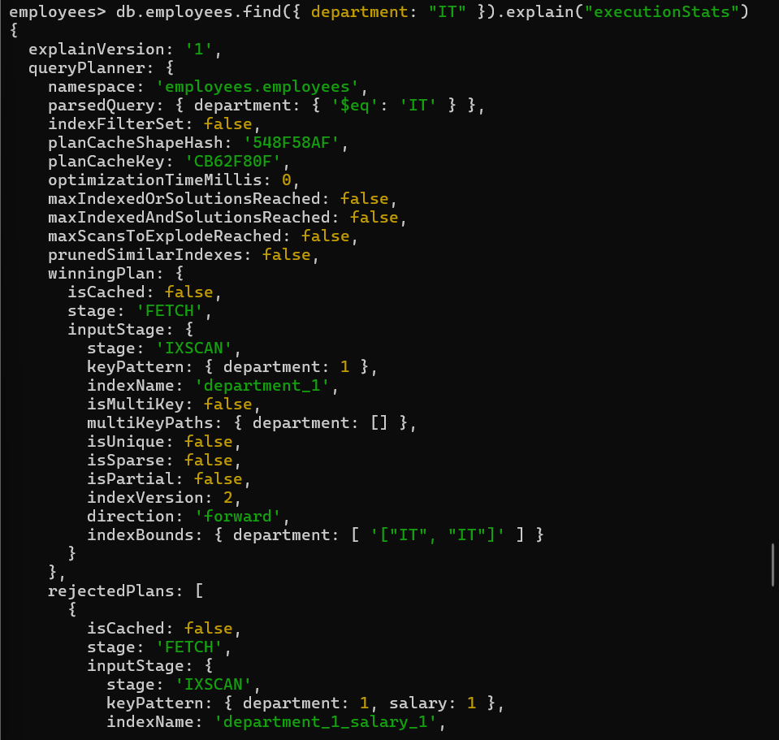
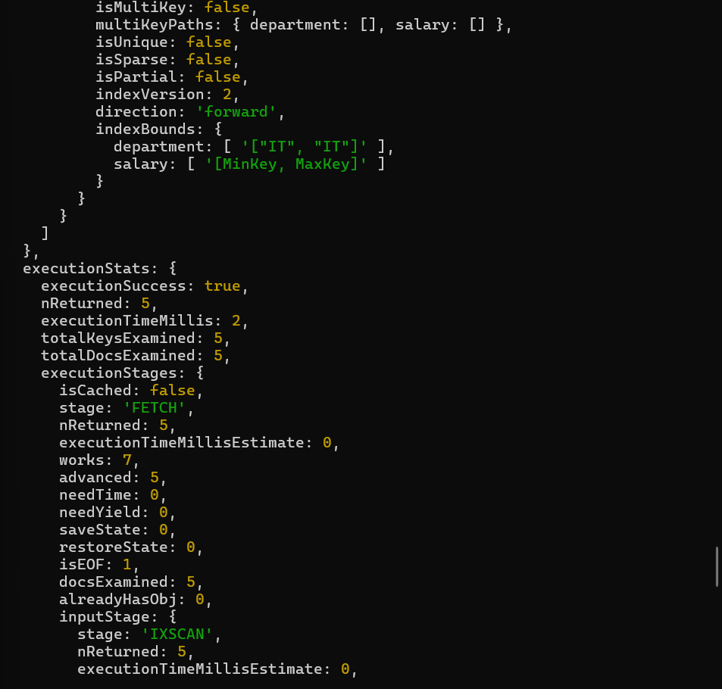
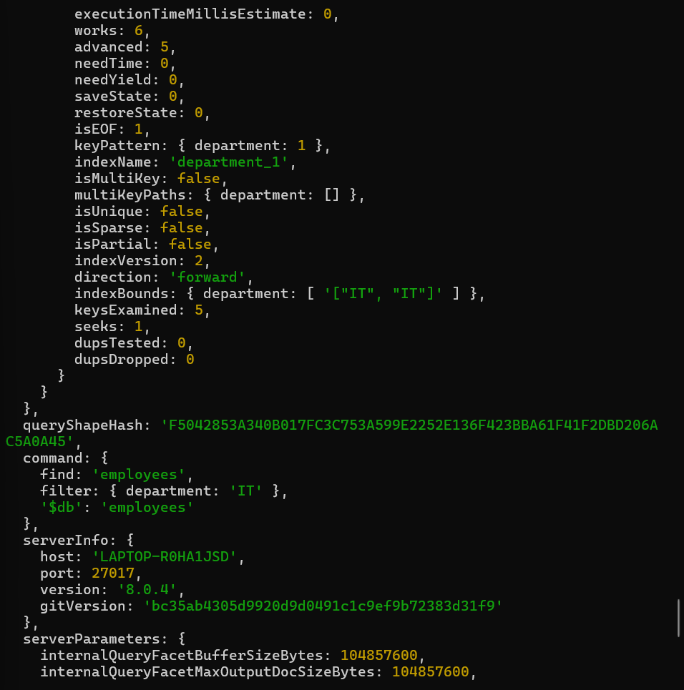
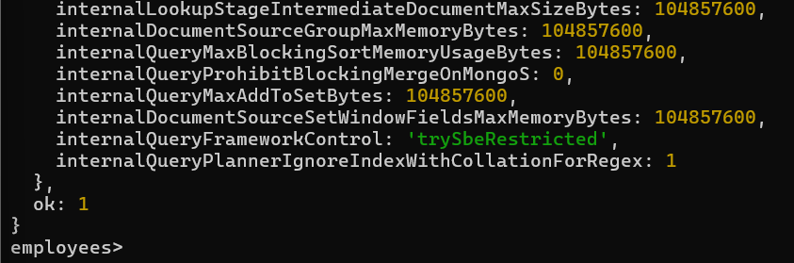
MONGODB COMPASS
