## .1 PROBLEM STATEMENT

Immunization is one of the most important ways by which parents can protect their child against serious diseases.Immunizations protect us from serious diseases and also prevent the spread of those diseases to others. And because of immunizations,we've seen the near eradication of others, such as [polio](https://www.webmd.com/children/vaccines/polio-vaccine-ipv) and [smallpox](https://www.webmd.com/a-to-z-guides/smallpox-causes-treatment).

A delay in vaccination is not good for the health of a child. Children below the age of 5 have an under-developed immune system, especially those younger than age 1 year. According to statistics, approximately 80 million below the age of 1 year live in countries where routine immunisation services were disrupted, which put the residents at risk of developing vaccine-preventable diseases.

A sustained period of disrupted immunisation can result in an accumulation of susceptible individuals, which in turn can lead to disease outbreaks.  Along with breast milk and a balanced diet, vaccine is the next important tool for the well-being of the baby.

Missing a vaccine puts your child at risk of contracting vaccine-preventable diseases. A delayed vaccination means making them susceptible to infections. The longer your child remains unimmunised, the higher their chances of getting exposed to and contracting diseases.

## 1.2 SCOPE OF THE OBJECTIVE

* The Main Objectives of this system is to provide user friendly UI for schedule the vaccination and gives reminder to parents
* This system can define immunization, vaccination, immunity, antigen and antibody awareness.
* This system will helpful for storing the child data for future analysis of the child health.
* This system will increase the knowledge and skill among parents regarding immunization.
* This system can predict the health report as per the child data

**Santoshi Kumari, Haripriya.A, Aruna.A, Vidya.D.S, Nithya.M.N,” Immunize - Baby Steps for smart healthcare”**

Smart Healthcare is one of the core infrastructure elements in building smart cities, an initiative taken up by Indian government recently. We present in this paper, a generic system to address healthcare issue, where a common platform to store and retrieve complete child medical history information. It includes mandatory vaccination schedule details of child along with the previous medical history records. Reminders to provide timely vaccinations to their child are also provided to alert parents to give their child health protection. Using Web and Mobile based technology, parents and doctors get access of the child’s medical reports online anywhere, anytime with required privileges. This work helps both parents and doctors to provide better quality healthcare services. Finally, the collection of data can further be analyzed to find the trends and pattern of diseases and this can pave a new beginning in the field of engineering and medical research for better and quality living

**Assam Hamed Abbas, Yuhanis Yusof “Children Vaccination Reminder Via SMS Alert”**

This study presents a model for children vaccination reminder using short message service (SMS). The model consists of data flow in reminding parents of their children vaccination schedule. Existing practice on vaccination schedule is via written appointment. Nevertheless, such approach may not be sufficient as parents may forget due to a tight work schedule and daily routines. The proposed model was evaluated by allowing selected respondents to use to the developed prototype. Results show that respondents do agree on the benefit of having reminder send via SMS. In addition, all of the respondents feel that the proposed system is useful

**Sneha Grampurohit ,Chetan Sagarnal “Disease Prediction using Machine Learning Algorithms ”**

The development and exploitation of several prominent Data mining techniques in numerous real-world application has led to the utilization of such techniques in machine learning environments. in order to extract useful pieces of information of the specified data in healthcare communities, biomedical fields etc. The techniques of machine learning have been successfully employed in assorted applications including Disease prediction. The aim of developing classifier system using machine learning algorithms is to immensely help to solve the health-related issues by assisting the physicians to predict and diagnose diseases at an early stage. A Sample data of 4920 patients’ records diagnosed with 41 diseases was selected for analysis. A dependent variable was composed of 41 diseases. 95 of 132 independent variables(symptoms) closely related to diseases were selected and optimized. This research work carried out demonstrates the disease prediction system developed using Machine learning algorithms such as Decision Tree classifier, Random forest classifier, and Naïve Bayes classifier.

**Shirin Hasan, Mir Mohammad Yousuf, Mubashir Farooq,” e-Vaccine: An Immunization App”**

Due to lack of adequate healthcare, India has high Infant Mortality rates. Making sure that children have access to proper healthcare and immunization against diseases that can be prevented by vaccines, is a huge challenge that is being faced by developing countries like ours. This highlights the importance and need of having a better, smarter system in place, to improve the situations. In this paper, we discuss an android application that was developed to address this concern. This application provides a system to provide information, store records and help parents schedule vaccination appointments for their children

## 3.1 HARDWARE REQUIREMENT

* Processor:- Intel Pentium 4 or above.
* Memory:- 2 GB or above.
* Other peripheral:- Printer.
* Hard Disk:- 500gb.

## 3.2 SOFTWARE REQUIREMENT

• technologies : HTML,CSS,Bootstrap,Python

• Database : MySql

• Framework: - Django

• IDE: visual studio code

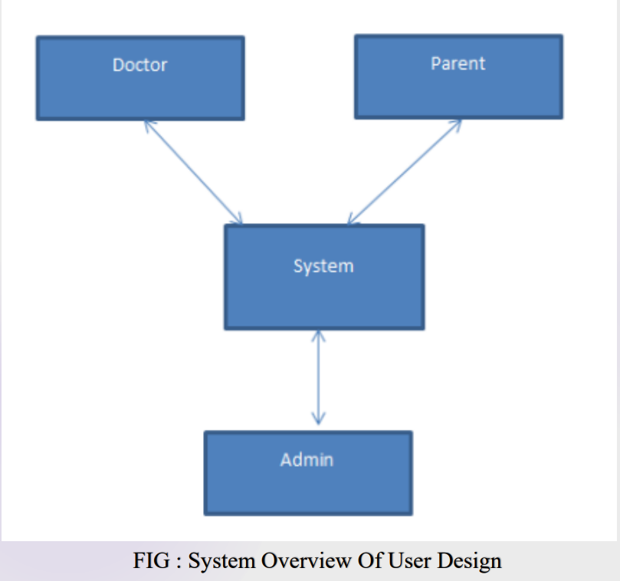

# **Algorithm**

# step 1 : start .

# step 2 : Doctors can register on system.

# step 3 : Parents register their child with their own mobile number.

# step 4 : doctors, parents and nurses can be able to login into the system.

# step 5 : Admin can manage the users and uploads all the blogs regarding. Vaccinations.

# step 6 : parents can gets appointment from the doctors by using the system.

# step 7 : Then doctors accepts the appointment and schedule baby’s vaccination.

# step 8 : both doctors and parents can be able to track the vaccination report.

# step 9 : System can be predicts the baby’s health as per the data of vaccinations.

# step 10 : system automatically send the SMS to their parents for remainder.

# step 11 : User Logout

## 5.1 TOOLS AND TECHNOLOGIES USED

### 5.1.1 Software Interfaces:

The Interface will be in the form of an application. It is designed to be functional and minimal in its styling. All options will be displayed in a menu based format. Web application will be used to setup the page layout and add minimal styling to make the interface user friendly.

* Operating system: OS.
* Coding Language : python
* Database :MYSQL
* IDE : visual studio code
* Front End:HTML,CSS,Bootstrap
* Back End: Django

### 5.1.2 Hardware Interfaces

webserver will be required so that the students and the mess admin can connect to it to exchange information. The servers have a database to store all the data entries. The Server will have to have a high speed 1 Gigabit Ethernet connection to the college’s local network.

* Processor:- Intel Pentium 4 or above
* Memory:- 2 GB or above
* Other peripheral:- Printer
* Hard Disk:- 500gb

Conclusion

As smart city concepts are taking a big leap, it is very important to adapt to smart solutions. Considering the importance of Smart Healthcare, a common platform to store and retrieve the medical history information is required to share the knowledge in medical learnings and for making efficient diagnose and to give effective treatment. In this paper, a system is proposed with an idea of providing a common platform to store and retrieve medical records of child with mandatory vaccination schedule details to start with as the child mortality rate due to vaccine preventable diseases are significantly high in numbers. As the mobile and internet technology continuous to evolve rapidly, regular alerts to parents for providing timely vaccination to their child/children for giving protection from vaccine preventable diseases are implemented using SMS and E-Mail messages. The facility to view previous medical records can help in speedy diagnose and action.

REFERENCES

[1] Ahluwalia, Isher Judge. "Challenges of Urbanisation in India." Contemporary Issues in Development Economics. Palgrave Macmillan UK, 2016. 163-177.

[2] Nijman J. India's urban challenge. Eurasian Geography and Economics. 2012 Jan 1;53(1):7-20.

[3] Ding D, Conti M, Solanas A. A smart health application and its related privacy issues. InSmart City Security and Privacy Workshop (SCSP-W), 2016 2016 Apr 11 (pp. 1-5). IEEE.

[4] Hasan AS, Malik A, Shukla I, Malik MA. Antibody levels against polioviruses in children following pulse polio immunization program. Indian Pediatr. 2004 Oct 4;41(10):1040- 4.

[5] John TJ, Thacker N, Deshpande JM. Setback in polio eradication in India in 2002: Reasons and remedies. Indian Pediatr 2003; 40: 195-203.

[6] Sharma S. Immunization coverage in India. Institute of Economic Growth, University of Delhi; 2007.

[7] Dempsey AF, Schaffer S, Singer D, Butchart A, Davis M, Freed GL. Alternative vaccination schedule preferences among parents of young children. Pediatrics. 2011 Sep 27:peds-2011.

[8] Yadav K, Srivastava R, Kumar R, Chinnakal P, Rai SK, Krishnan A. Significant vaccination delay can occur even in a community with very high vaccination coverage: evidence from Ballabgarh, India. Journal of tropical pediatrics. 2012 Apr 1;58(2):133-8.

[9] Vashishtha VM, Choudhury P, Kalra A, Bose A, Thacker N, Yewale VN, Bansal CP, Mehta PJ. Indian Academy of Pediatrics (IAP) recommended immunization schedule for children aged 0 through 18 years—India, 2014 and updates on immunization. Indian pediatrics. 2014 Oct 1;51(10):785-800.

[10] Wilson K, Atkinson KM, Westeinde J. Apps for immunization: leveraging mobile devices to place the individual at the center of care. Human vaccines & immunotherapeutics. 2015 Oct 3;11(10):2395-9.