- Most frequently used sorting algorithm is merge sort or quick sort or time sort.
->
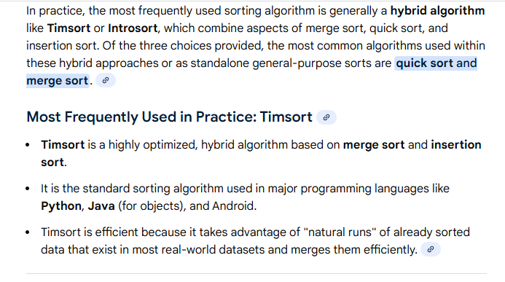
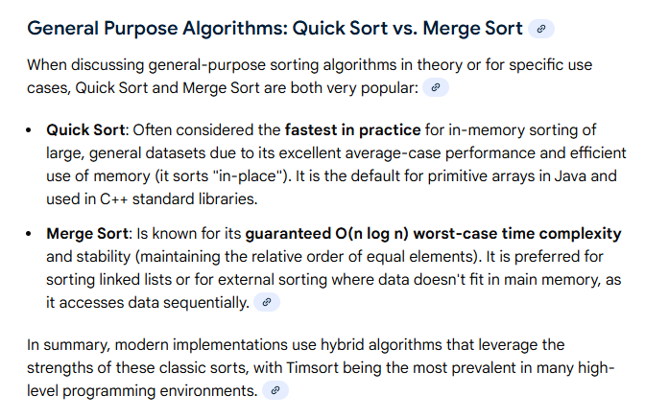

- Most frequently used searching algorithm
->
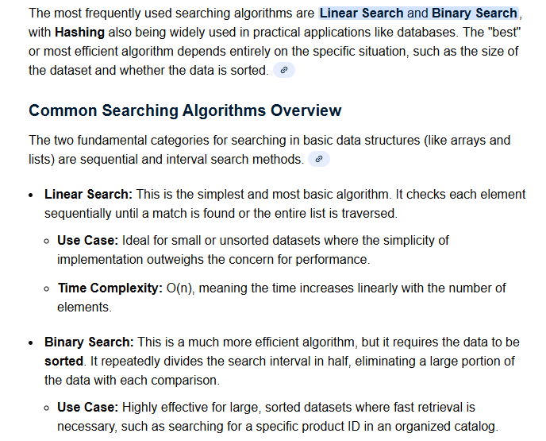
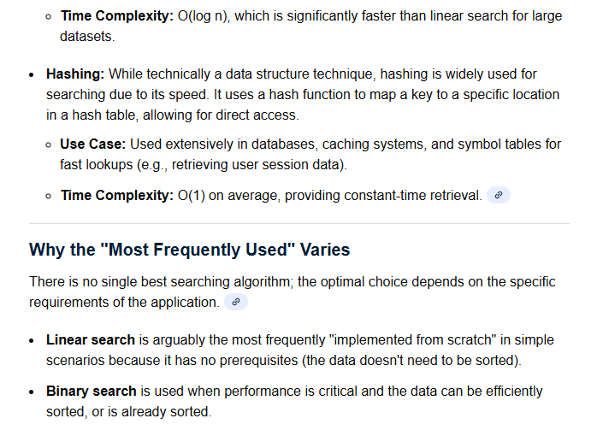
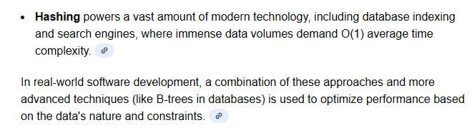

- Most frequently used searching algorithm and the searching algorithm with which we can solve most of the real world problem
->
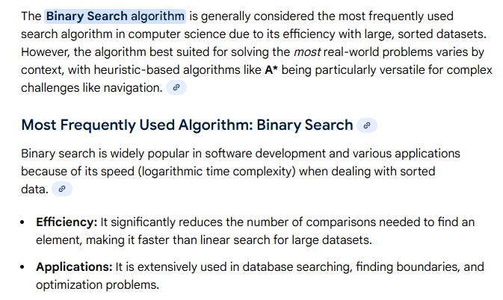
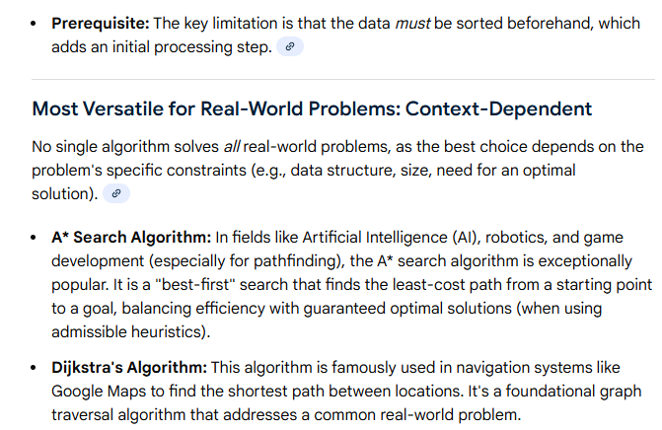
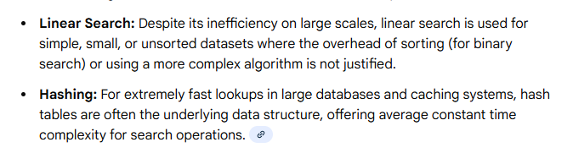

- Most optimized sorting algorithm.
->
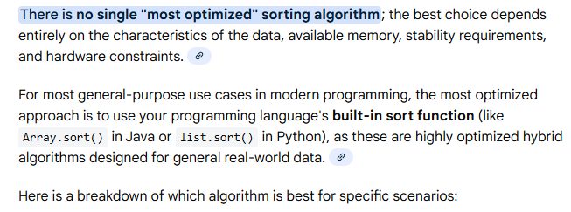
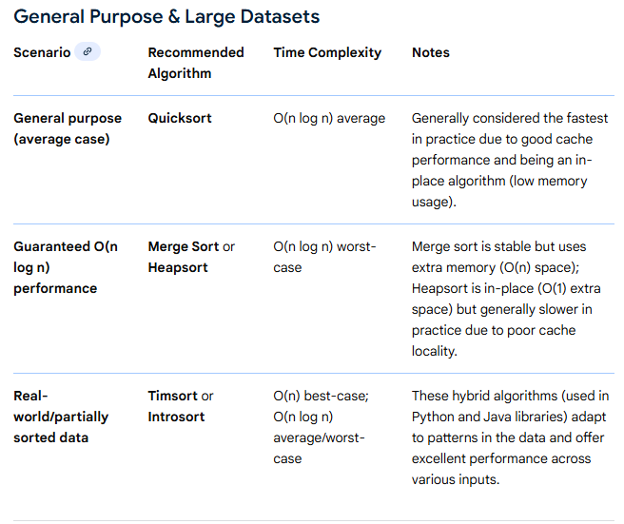
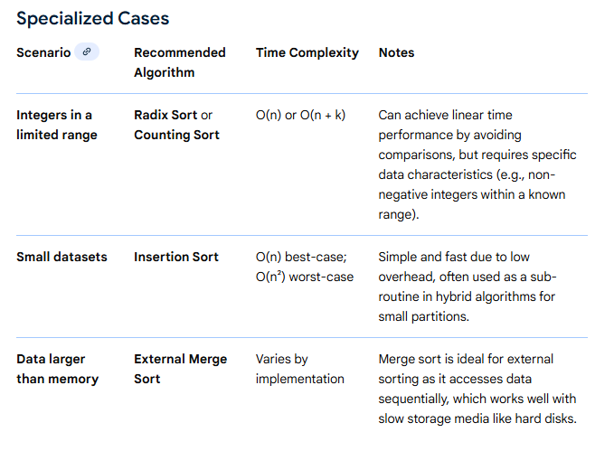
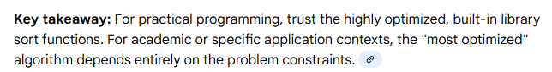
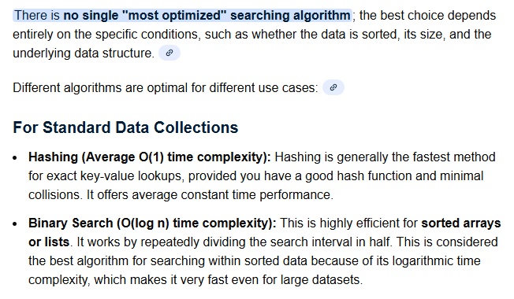
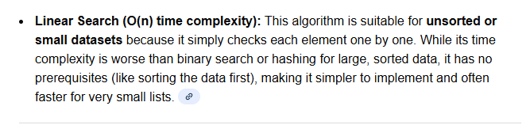
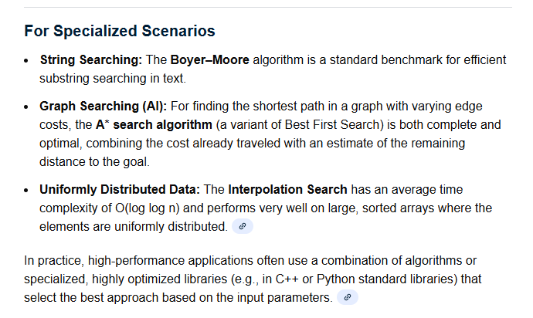

- When we can use the binary search algorithm?
- A. If array is sorted
- B. If array is increasing and decreasing
- C. Sorted array is rotated and then given as I/P
- D. Array is given is zigzak format.
- E. Looking for O(log n) solution
- F. Can determine if answer is too high/low
- G. Searching in infinite/streaming data
- H. Finding min/max of some condition

Common Patterns:

Standard binary search: Finding exact element

Finding boundaries: First/last occurrence

Binary search on answer: When answer space is monotonic
Search in infinite/unknown size: Using exponential backoff
Rotated arrays: Finding pivot, then searching halves

- Most optimized searching algorithm
->

