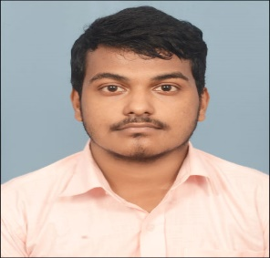 **Curriculum Vitae**

**Sandip Naskar**

Krishnapur Majher para,Kolkata-700102

Email: 2003sandipnaskar@gmail.com

Contact no: +91 7003032643

|  |
| --- |
| **Career Objective** |

To get an opportunity where I can make the best of my potential and contribute to the organization’s growth.

|  |
| --- |
| **Education** |

|  |  |  |  |  |
| --- | --- | --- | --- | --- |
| **Name of the Institution** | **Degree** | **Board** | **Year of passing** | **Percentage of Marks** |
| BWU | BCA | NA | 2021-2024 | 86.16% |
| Krishnapur Adarsha vidyamandir(HS) | 12th | WBCHSE | 2021 | 72.80% |
| Krishnapur Adarsha vidyamandir(HS) | 10th | WBCHSE | 2019 | 64% |

|  |
| --- |
| **Technical Skills/Additional Certification.** |

* Programming Languages – C, Java
* Web Technologies – HTML,CSS
* Database Management-MySQL
* Additional Certification- Data Analytic using Python

|  |
| --- |
| **Trainings & Workshops** |

* Attended a webinar on Big Data Analytics in HealthCare Industry

|  |
| --- |
| **Languages Known** |

|  |  |  |  |
| --- | --- | --- | --- |
| **Language** | **Read** | **Write** | **Speak** |
| English | Advanced | Good | Good |
| Hindi | Good | Good | Advanced |
| Bengali | Advanced | Advanced | Advanced |

|  |
| --- |
| **Hobbies** |

Hobbies include reading ,writing,games,listening music.

|  |
| --- |
| **Personal Details** |

Date of Birth:01/05/2003

Permanent Address: Krishnapur Majher Para,Kolkata-700102,

Fathers Name:Harendra Nath Naskar

Nationality:Indian

Name: Sandip Naskar

Signature:

Place:Kolkata