Lesson 07 Demo 03
Implementing Dynamic Inventories
Objective: To demonstrate how to work with dynamic inventories in Ansible, enabling the automatic fetching and usage of inventory data from external sources

Tools required: Python, Ansible, Ansible Vault, and VS Code

Prerequisites: None

Steps to be followed:
- Install the required tools
- Create and configure a dynamic inventory script
- Create and execute a playbook using the dynamic inventory script

Step 1: Install the required tools

- Install the necessary Python packages by running the following commands to interact with AWS services programmatically and manage AWS resources from the command line:
pip install boto3
pip install awscli

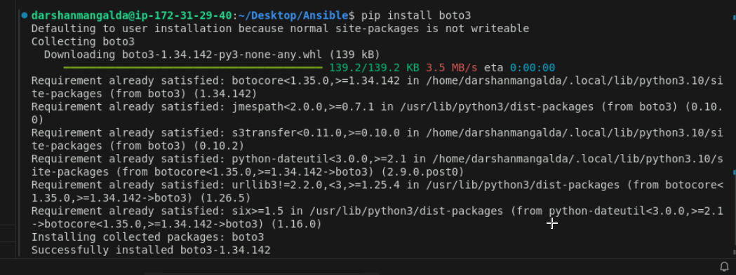
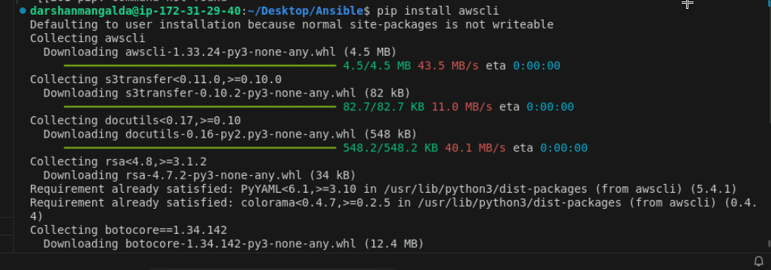

Step 2: Create and configure a dynamic inventory script

  - Execute the following command to create the dynamic inventory script file:
sudo vi /etc/ansible/dynamic_inventory.py

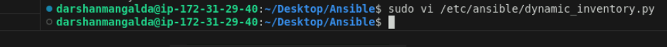

  - Add the following Python script in the dynamic_inventory.py:

#!/usr/bin/env python3
import boto3
import json

ec2 = boto3.client("ec2", region_name="us-east-1")

response = ec2.describe_instances()

inventory = {
"all": {
"hosts": []
},
"_meta": {
"hostvars": {}
}
}

for reservation in response["Reservations"]:
for instance in reservation["Instances"]:
if instance["State"]["Name"] == "running":
public_ip = instance.get("PublicIpAddress")
if not public_ip:
continue

hostname = f"ec2-{public_ip.replace('.', '-')}.compute-1.amazonaws.com"

inventory["all"]["hosts"].append(hostname)

inventory["_meta"]["hostvars"][hostname] = {
"ansible_host": public_ip,
"ansible_user": "ubuntu",
"ansible_ssh_private_key_file": "/home/labuser/mykey.pem"
}

print(json.dumps(inventory))

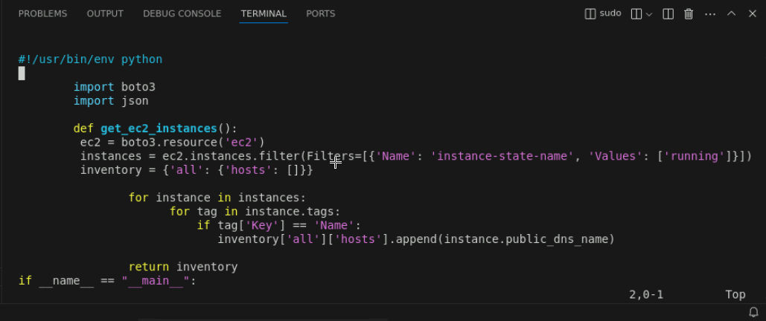

This script retrieves the public DNS names of all running EC2 instances from AWS and formats them into an Ansible-compatible inventory structure.

  - Run the following command to make the script executable:

sudo chmod +x /etc/ansible/dynamic_inventory.py

chmod 600 /home/labuser/mykey.pem

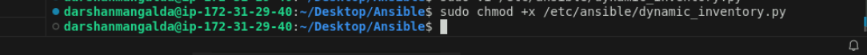

  - Execute the following command to edit your Ansible configuration file to specify the inventory script:
sudo vi /etc/ansible/ansible.cfg

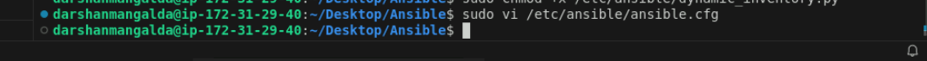

  - Add the following content in ansible.cfg:
[defaults]
inventory = /etc/ansible/dynamic_inventory.py

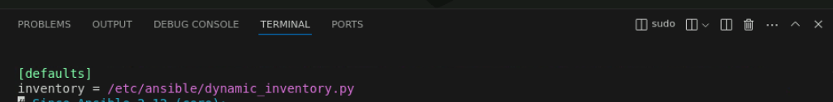

Step 3: Create and execute a playbook using the dynamic inventory script

  - Run the following command to display the inventory generated by a dynamic inventory script:
ansible-inventory -i /etc/ansible/dynamic_inventory.py --list

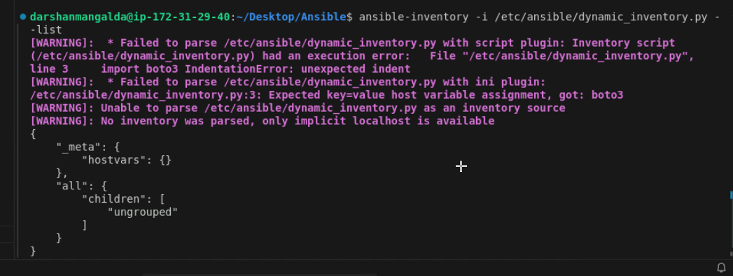
  - Execute the following command to create the playbook file:
sudo vi /etc/ansible/playbook.yml

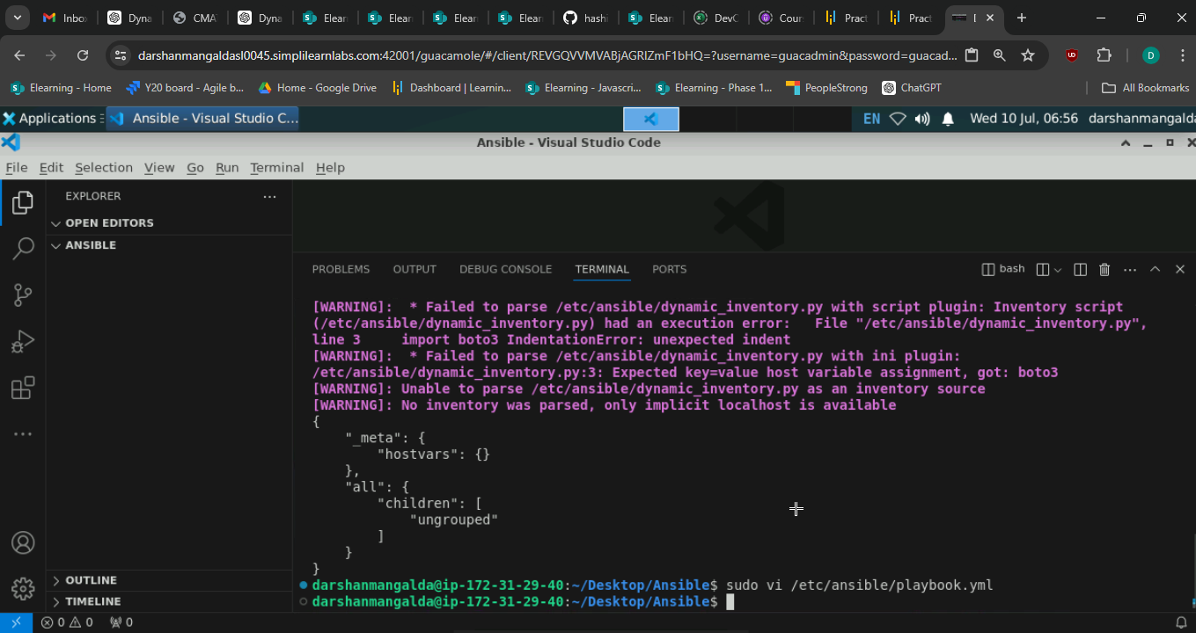

  - Add the following script in the playbook.yml file:
---
- hosts: all
tasks:
- name: Gather information about the remote hosts
ansible.builtin.setup:

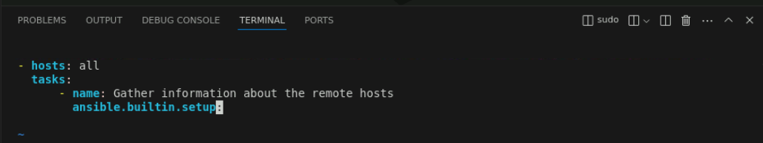

  - Run the following command to execute the Ansible playbook using the dynamic inventory script:
ansible-playbook -i /etc/ansible/dynamic_inventory.py /etc/ansible/playbook.yml

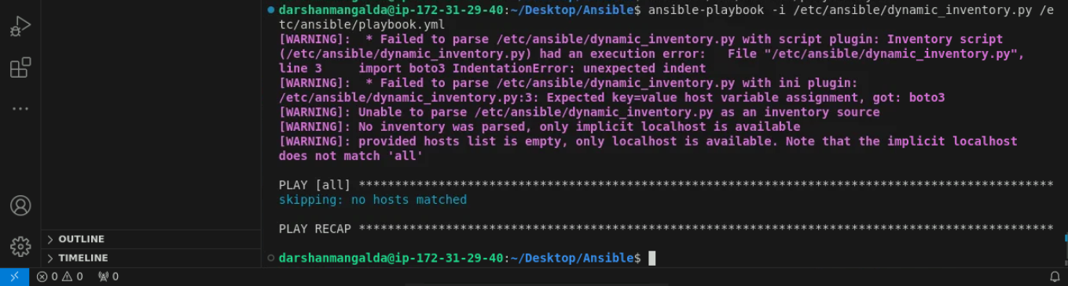

By following the above steps, you have successfully created a dynamic inventory script, configured Ansible to use it, and run a playbook leveraging this dynamic inventory.

