**Exercise 1: Create a Stored Procedure**

Goal: Create a stored procedure to retrieve employee details by department.

Steps:

1. Define the stored procedure with a parameter for DepartmentID.

2. Write the SQL query to select employee details based on the DepartmentID.

3. Create a stored procedure named `sp_InsertEmployee` with the following code:

CREATE PROCEDURE sp_InsertEmployee

@FirstName VARCHAR(50),

@LastName VARCHAR(50),

@DepartmentID INT,

@Salary DECIMAL(10,2),

@JoinDate DATE

AS

BEGIN

INSERT INTO Employees (FirstName, LastName, DepartmentID, Salary, JoinDate)

VALUES (@FirstName, @LastName, @DepartmentID, @Salary, @JoinDate);

END

**CODE:**

CREATE TABLE Departments (

DepartmentID INT PRIMARY KEY,

DepartmentName VARCHAR(100)

);

CREATE TABLE Employees (

EmployeeID INT PRIMARY KEY,

FirstName VARCHAR(50),

LastName VARCHAR(50),

DepartmentID INT,

Salary DECIMAL(10,2),

JoinDate DATE,

FOREIGN KEY (DepartmentID) REFERENCES Departments(DepartmentID)

);

INSERT INTO Departments (DepartmentID, DepartmentName) VALUES

(1, 'HR'),

(2, 'Finance'),

(3, 'IT'),

(4, 'Marketing');

INSERT INTO Employees (EmployeeID, FirstName, LastName, DepartmentID, Salary, JoinDate) VALUES

(1, 'John', 'Doe', 1, 5000.00, '2020-01-15'),

(2, 'Jane', 'Smith', 2, 6000.00, '2019-03-22'),

(3, 'Michael', 'Johnson', 3, 7000.00, '2018-07-30'),

(4, 'Emily', 'Davis', 4, 5500.00, '2021-11-05');

DROP PROCEDURE IF EXISTS sp_GetEmployeesByDepartment;

DELIMITER //

CREATE PROCEDURE sp_GetEmployeesByDepartment(IN dept_id INT)

BEGIN

SELECT

EmployeeID,

FirstName,

LastName,

DepartmentID,

Salary,

JoinDate

FROM Employees

WHERE DepartmentID = dept_id;

END //

DELIMITER ;

CALL sp_GetEmployeesByDepartment(2);

DROP PROCEDURE IF EXISTS sp_InsertEmployee;

DELIMITER //

CREATE PROCEDURE sp_InsertEmployee(

IN FirstName VARCHAR(50),

IN LastName VARCHAR(50),

IN DepartmentID INT,

IN Salary DECIMAL(10,2),

IN JoinDate DATE

)

BEGIN

INSERT INTO Employees (EmployeeID, FirstName, LastName, DepartmentID, Salary, JoinDate)

VALUES ((SELECT IFNULL(MAX(EmployeeID), 0) + 1 FROM Employees), FirstName, LastName, DepartmentID, Salary, JoinDate);

END //

DELIMITER ;

DROP TABLE IF EXISTS Employees;

CREATE TABLE Employees (

EmployeeID INT PRIMARY KEY AUTO_INCREMENT,

FirstName VARCHAR(50),

LastName VARCHAR(50),

DepartmentID INT,

Salary DECIMAL(10,2),

JoinDate DATE,

FOREIGN KEY (DepartmentID) REFERENCES Departments(DepartmentID)

);

DROP PROCEDURE IF EXISTS sp_InsertEmployee;

DELIMITER //

CREATE PROCEDURE sp_InsertEmployee(

IN p_FirstName VARCHAR(50),

IN p_LastName VARCHAR(50),

IN p_DepartmentID INT,

IN p_Salary DECIMAL(10,2),

IN p_JoinDate DATE

)

BEGIN

INSERT INTO Employees (FirstName, LastName, DepartmentID, Salary, JoinDate)

VALUES (p_FirstName, p_LastName, p_DepartmentID, p_Salary, p_JoinDate);

END //

DELIMITER ;

CALL sp_InsertEmployee('Alice', 'Taylor', 3, 7200.00, '2022-10-01');

**OUTPUT:**

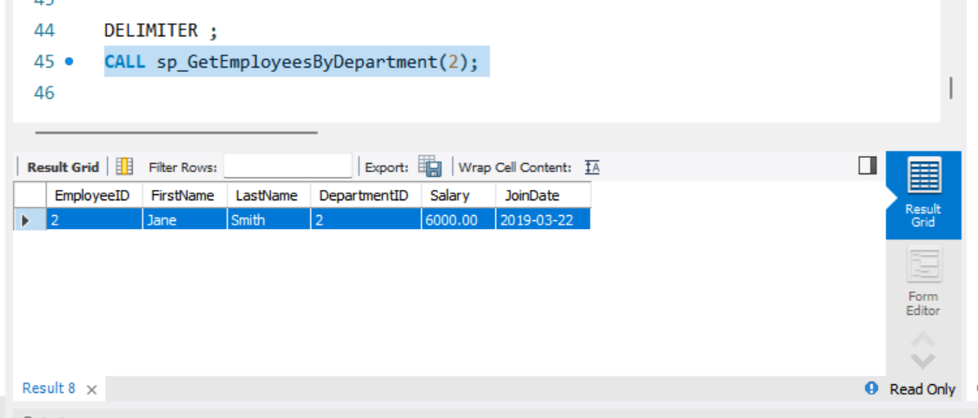

**Exercise 5: Return Data from a Stored Procedure**

Goal: Create a stored procedure that returns the total number of employees in a

department.

Steps:

1. Define the stored procedure with a parameter for DepartmentID.

2. Write the SQL query to count the number of employees in the specified department.

3. Save the stored procedure by executing the Stored procedure content.

**CODE:**

DROP TABLE IF EXISTS Employees;

DROP TABLE IF EXISTS Departments;

CREATE TABLE Departments (

DepartmentID INT PRIMARY KEY,

DepartmentName VARCHAR(100)

);

CREATE TABLE Employees (

EmployeeID INT PRIMARY KEY,

FirstName VARCHAR(50),

LastName VARCHAR(50),

DepartmentID INT,

Salary DECIMAL(10,2),

JoinDate DATE,

FOREIGN KEY (DepartmentID) REFERENCES Departments(DepartmentID)

);

-- Insert into Departments

INSERT INTO Departments (DepartmentID, DepartmentName) VALUES

(1, 'HR'),

(2, 'Finance'),

(3, 'IT'),

(4, 'Marketing');

-- Insert into Employees

INSERT INTO Employees (EmployeeID, FirstName, LastName, DepartmentID, Salary, JoinDate) VALUES

(1, 'John', 'Doe', 1, 5000.00, '2020-01-15'),

(2, 'Jane', 'Smith', 2, 6000.00, '2019-03-22'),

(3, 'Michael', 'Johnson', 3, 7000.00, '2018-07-30'),

(4, 'Emily', 'Davis', 4, 5500.00, '2021-11-05');

DELIMITER $$

CREATE PROCEDURE GetEmployeeCountByDepartment (

IN dept_id INT

)

BEGIN

SELECT COUNT(*) AS TotalEmployees

FROM Employees

WHERE DepartmentID = dept_id;

END$$

DELIMITER ;

CALL GetEmployeeCountByDepartment(3);

**OUTPUT**

