**CODE:**

**Department.cs**

namespace EmployeeWebApi.Models

{

public class Department

{

public int Id { get; set; }

public string Name { get; set; }

}

}

**Employee.cs**

using System;

using System.Collections.Generic;

namespace EmployeeWebApi.Models

{

public class Employee

{

public int Id { get; set; }

public string Name { get; set; }

public int Salary { get; set; }

public bool Permanent { get; set; }

public Department Department { get; set; }

public List<Skill> Skills { get; set; }

public DateTime DateOfBirth { get; set; }

}

}

**Skill.cs**

namespace EmployeeWebApi.Models

{

public class Skill

{

public int Id { get; set; }

public string Name { get; set; }

}

}

**EmployeeController.cs**

using Microsoft.AspNetCore.Mvc;

using EmployeeWebApiCrud.Models;

namespace EmployeeWebApiCrud.Controllers

{

[ApiController]

[Route("[controller]")]

public class EmployeeController : ControllerBase

{

// Hardcoded employee list

private static List<Employee> _employees = new List<Employee>

{

new Employee

{

Id = 1,

Name = "John Doe",

Salary = 50000,

Permanent = true,

Department = new Department { Id = 101, Name = "IT" },

Skills = new List<Skill>

{

new Skill { Id = 1, Name = "C#" },

new Skill { Id = 2, Name = "SQL" }

},

DateOfBirth = new DateTime(1990, 1, 1)

},

new Employee

{

Id = 2,

Name = "Jane Smith",

Salary = 60000,

Permanent = false,

Department = new Department { Id = 102, Name = "HR" },

Skills = new List<Skill>

{

new Skill { Id = 3, Name = "Excel" }

},

DateOfBirth = new DateTime(1992, 2, 2)

}

};

// ✅ PUT Action to update an employee

[HttpPut("{id}")]

[ProducesResponseType(typeof(Employee), 200)]

[ProducesResponseType(400)]

public ActionResult<Employee> UpdateEmployee(int id, [FromBody] Employee updated)

{

if (id <= 0)

{

return BadRequest("Invalid employee id");

}

var employee = _employees.FirstOrDefault(e => e.Id == id);

if (employee == null)

{

return BadRequest("Invalid employee id");

}

// ✅ Update the employee fields

employee.Name = updated.Name;

employee.Salary = updated.Salary;

employee.Permanent = updated.Permanent;

employee.DateOfBirth = updated.DateOfBirth;

employee.Department = updated.Department;

employee.Skills = updated.Skills;

return Ok(employee);

}

}

}

**Program.cs**

var builder = WebApplication.CreateBuilder(args);

builder.Services.AddControllers();

builder.Services.AddEndpointsApiExplorer();

builder.Services.AddSwaggerGen();

var app = builder.Build();

if (app.Environment.IsDevelopment())

{

app.UseSwagger();

app.UseSwaggerUI();

}

app.UseAuthorization();

app.MapControllers();

app.Run();

**OUTPUT**

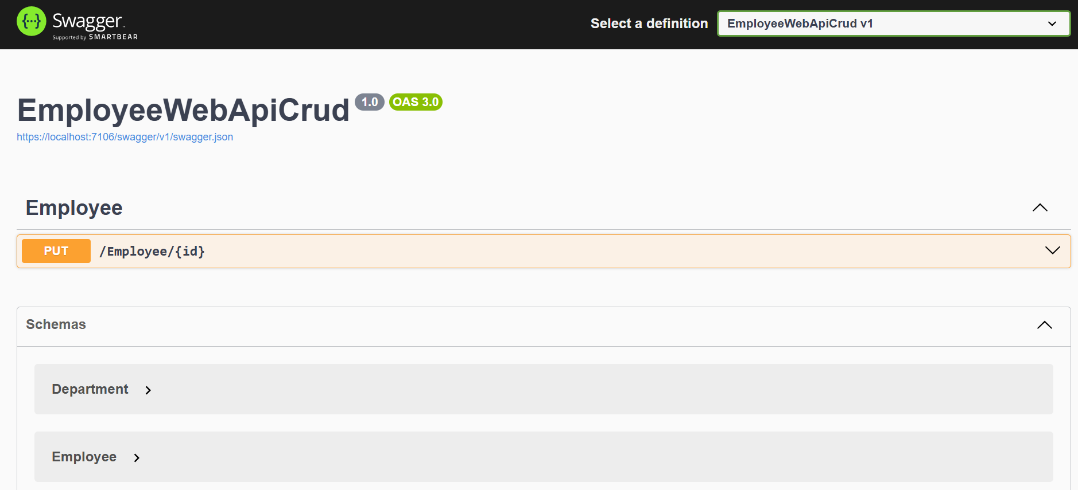

**Handling Exception**

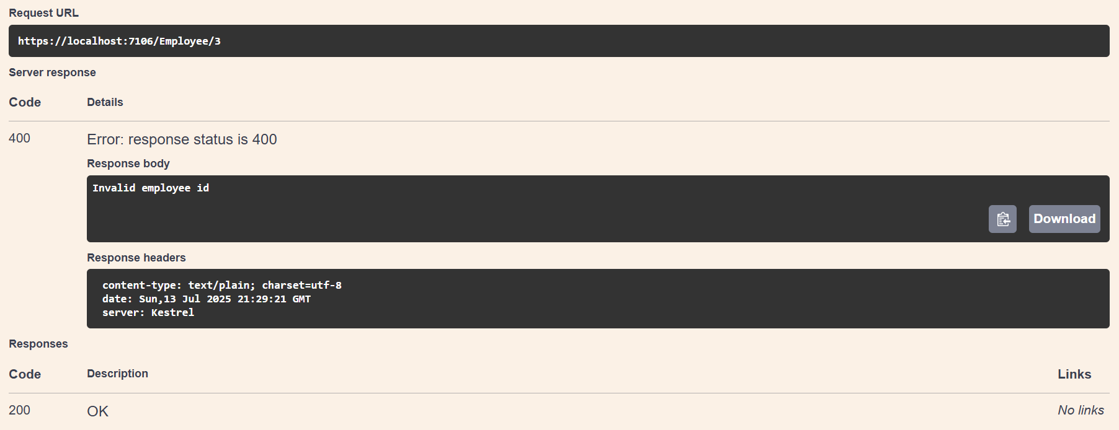

**PUT Operation**

