Industry 4.0 Operator RFID Correction Document

Architecture Name : Industry 4.0 RFID Correction

Document Version : 1.0

Prepared By : Aditya Kadam & Sandip Kumbhar

Date Created : 22.06.2024



|  |  |
| --- | --- |
| Contact: | Aditya Kadam & Sandip Kumbhar |
| Department: | IT |
| Location: | Pune, India |
| E-Mail: | [Aditya.kadam@gewis.in , Sandip.kumbhar@gewis.in](mailto:Aditya.kadam@gewis.in%20,%20Sandip.kumbhar@gewis.in) |

**Steps how to Authorized the Operator_id**

**&**

**How to get Identity_Number of Operator from RFID with Substitution Technique**

**For Manual Operator RFID Correction:**

1. Start->Proram->**SqlManagementstudio**

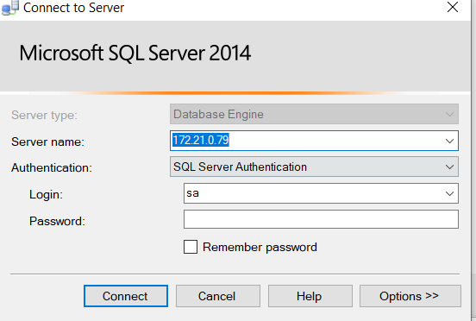

1. Select I40 Database->Select table **Tbl_User**

3 .Find the **identity_Number** which you want to exact **operator Id.**

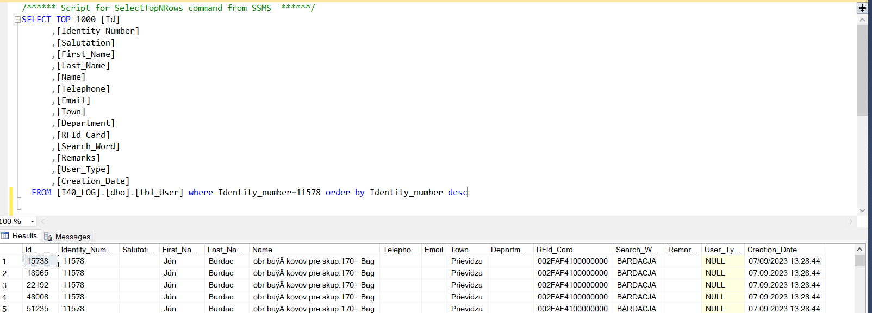

& Update the RFId_Card using this command on SQL-Server.

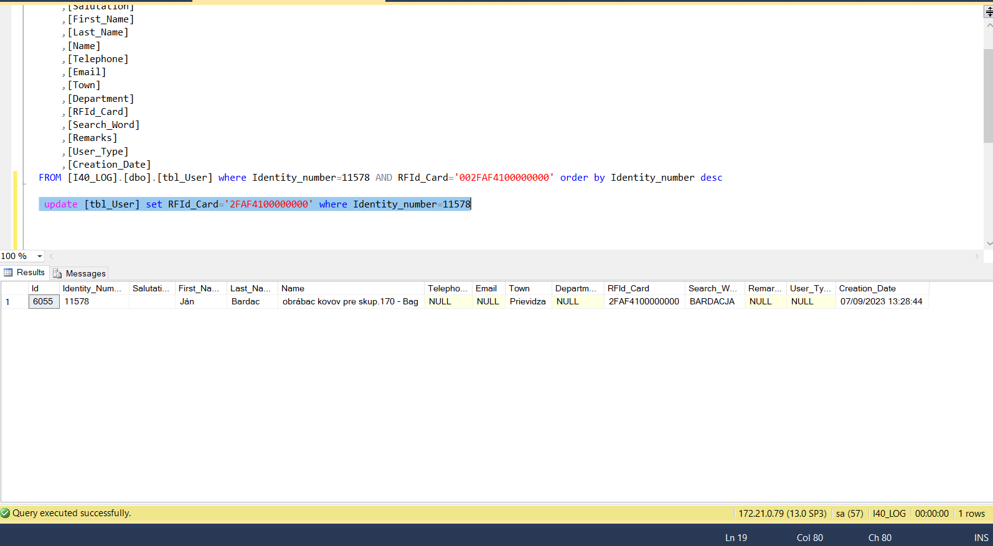

4. Now open Visual Studio **(Administrator Mode)**

5. Open **I40_Comm_Layer** Project in that Project you select **I40Connectivity Layer** Project then open **Authontication** folder & Select **UserAuthentication**.cs file.

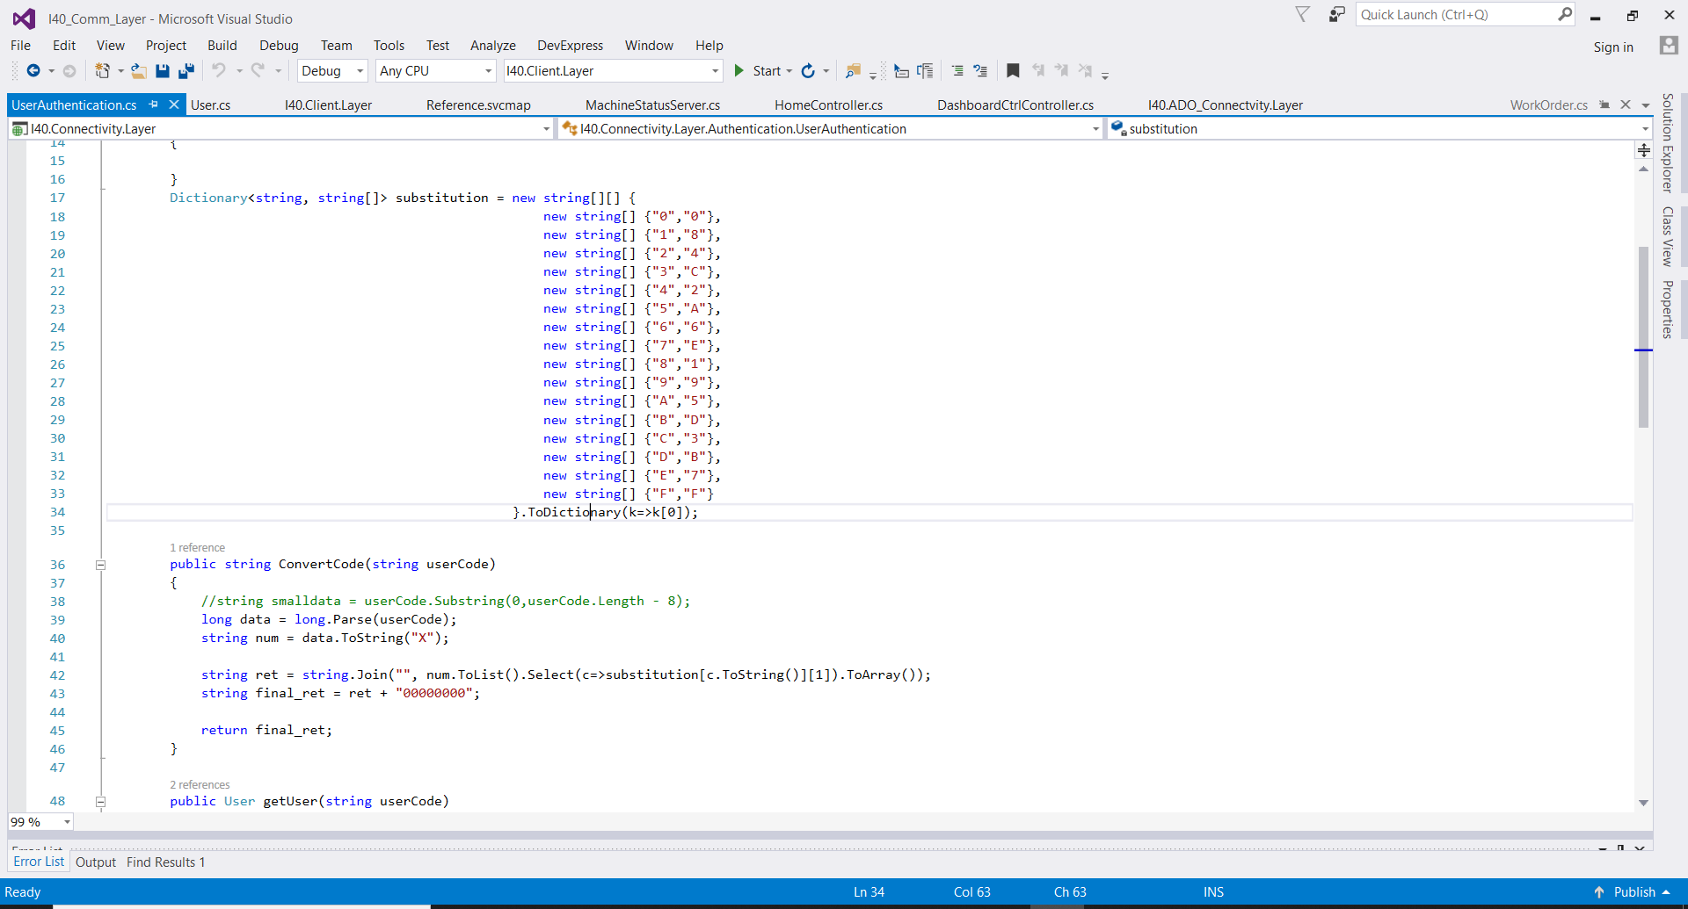

Now Select one **Identity_number** and **RFId_Card** from User table and check the Substitution method in the program

Identity_Number - **11578**

RFid_Card - **002FAF4100000000**

Take first 8 Digit from RFid_Card Number

**002FAF41** Choose the Number from Substitution chart

for e.g:

0 --- 0

0 --- 0

2 --- 4

F --- 5

A --- F

4 --- 2

1 --- 8

**004F5F28** - this is hexadecimal number Convert in to decimal number using Following Link

[**https://www.rapidtables.com/convert/number/hex-to-decimal.html**](https://www.rapidtables.com/convert/number/hex-to-decimal.html)

After Converting Hexa decimal number you get Operator ID Number for Login On HMI

**005201704** From this number you can login HMI.

**Final Output:**

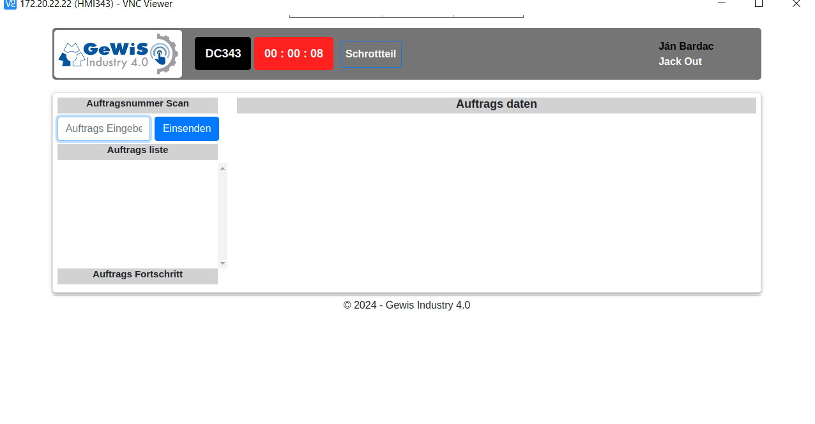

**For Automatic RFID Correction :**

**Document Auto Recorrect the RFId_Card Data in I40_Database tbl_User**

CREATE TRIGGER trg_CorrectRFIDNumbersOnce

ON tbl_User

AFTER INSERT

AS

BEGIN

-- Check if the trigger has already executed

IF NOT EXISTS (SELECT 1 FROM TriggerExecutionLog WHERE TriggerName = 'trg_CorrectRFIDNumbersOnce')

BEGIN

-- Update the RFID_Card by removing the first two characters if they start with '00' for newly inserted rows

UPDATE tbl_User

SET RFId_Card = CASE

WHEN LEFT(RFId_Card, 2) = '00' THEN SUBSTRING(RFId_Card, 3, LEN(RFId_Card) - 2)

ELSE RFId_Card

END

WHERE Id IN (SELECT Id FROM Inserted WHERE LEFT(RFId_Card, 2) = '00'); -- Update only newly inserted rows that start with '00'

-- Log the execution of the trigger

INSERT INTO TriggerExecutionLog (TriggerName, ExecutionTime)

VALUES ('trg_CorrectRFIDNumbersOnce', GETDATE());

-- Disable the trigger

DISABLE TRIGGER trg_CorrectRFIDNumbersOnce ON tbl_User;

END

END;

**For Testing**

**INSERT INTO tbl_User (RFId_Card, Identity_Number)**

**VALUES ('0012345678', 202122);**

**SELECT * FROM TriggerExecutionLog WHERE TriggerName = 'trg_CorrectRFIDNumbersOnce';**

**Document Responsibilities**

|  |  |  |
| --- | --- | --- |
|  | **Date** | **Name** |
| Created by | 22/06/2016 | Aditya Kadam & Sandip Kumbhar |
| Approved by management |  |  |

**Document properties**

|  |  |
| --- | --- |
| Valid from | 22.06.2024 |
| Document type | I40 RFID Correction |
| Version | 1.0 |
| Replaces | - |
| Distribution list | <Recipients of document> |
| Reason for revision | <Implementation> |
| Change from most recent previous version: |  |

**Relationship with other documents**

<If a relationship with other documents exist, please name documents.>