<https://github.com/SandmanDP/cmpe207/tree/master/hw5/thomas>

* Implement the following  Lambda functions, and an Amazon API Gateway endpoint to trigger them:
  + POST: Create an item (e.g. to a DynamoDB table)
  + PUT: Update an item
  + GET: scan table and return all items
  + DELETE: delete an item
* Show your work with test cases showing each function in operation
* Submission: Word Document describing your work, including Github link

**Initial AWS DynamoDB with a Couple of Entries**

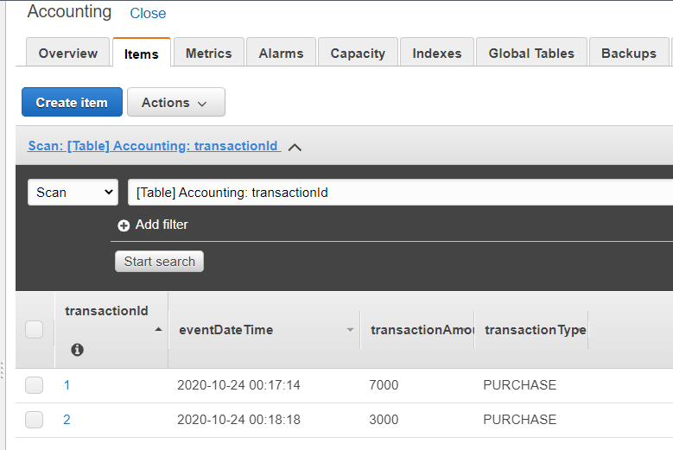

**AWS API Gateway Endpoint**

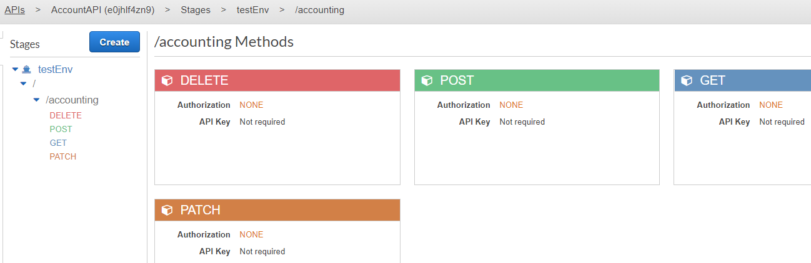

**Testing POST Request with API Tester**

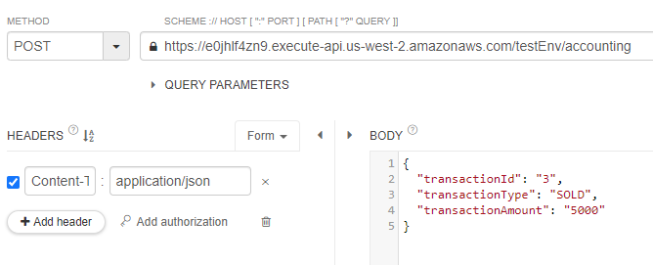

**Checking DynamoDB After POST Request**

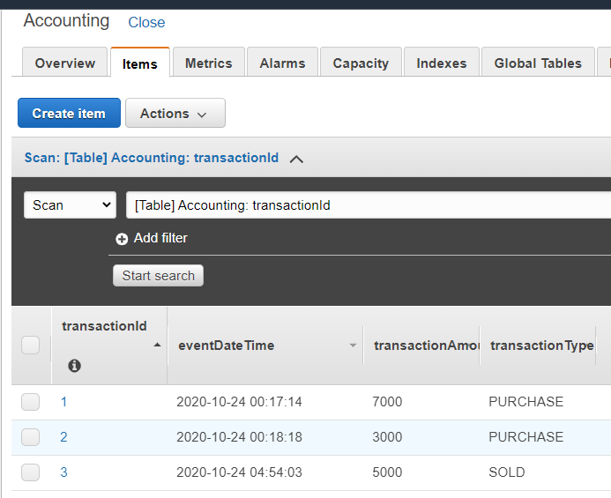

**Testing GET Request with API Tester**

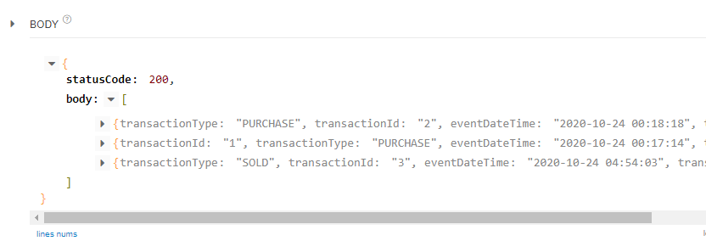

**Testing PUT Request with API Tester**

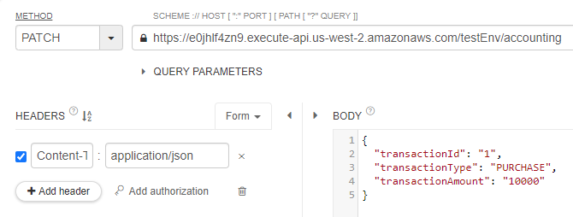

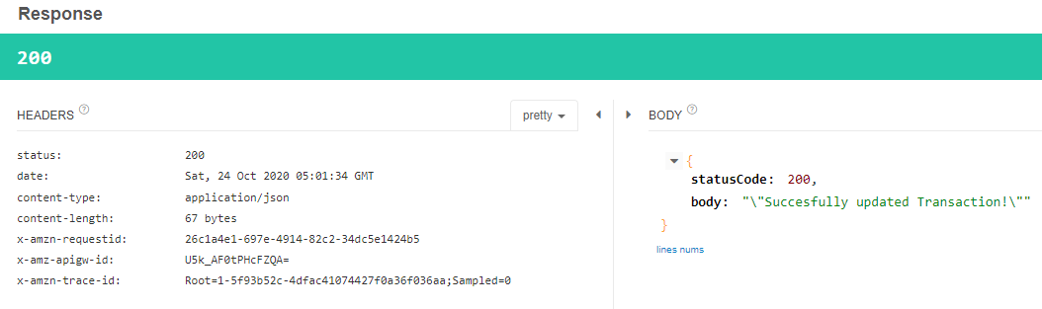

**Checking DynamoDB After PUT Request**

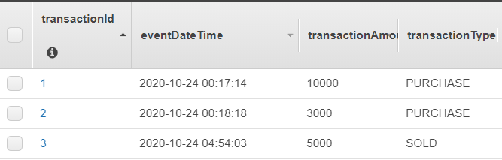

**Testing DELETE Request with API Tester**

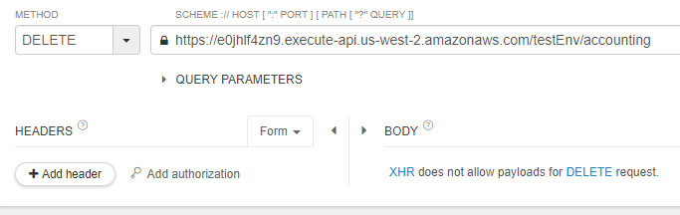

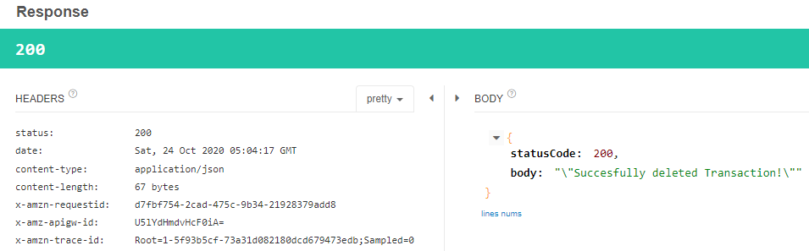

**Checking DynamoDB After DELETE Request**

