**Project Outline**

1. **Project Name: LIVE-ON**

* Project Type: Android Game
* Game Type: 2D Horror game

1. **Building Tool:**

* **Main development tool:** Unity3D engine
  + **Map build:** Tilemap
* **Develop language:** C#, Java
* **APK building tool:** Android studio.
* The game will be built in unity3d and converted into one activity in the Android application. At last, there should be only one activity in the application.
* **Remote repository:** <https://github.com/Sandoleathy/LIVE-ON>
  + The repository is public and can be accessed by everyone

1. 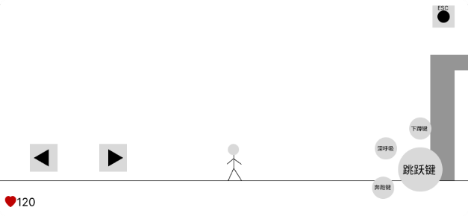**Game Design:**

* **World Overview:** In the year 2024, the game unfolds in the troubled region of Grania… (see more detail in GitHub)
* **Core Gameplay:** Players can explore the 2D map and find the props to help their journey. They still need to avoid enemies and there is no way to fight with them. The player’s movement is slow and heavy. They also need to manage their body status through the heartbeat system

**Figure 1: Concept graph**

* 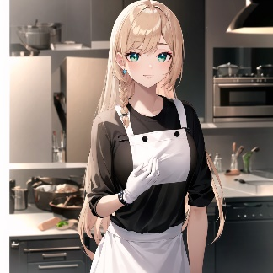**HeartBeatSystem:** This is the core gameplay of the game. The player will always have a heartbeat attribute. The player’s heartbeat rate will affect his movement, body status, and even his life. This idea has never appeared in the history of games. So I think it’s a feature of this game.
* **Level(Scene):** There will be total of 5 levels in the game. To discover the whole story and the secret behind the word overview, the player needs to complete them all.

Figure : example of heroine

* 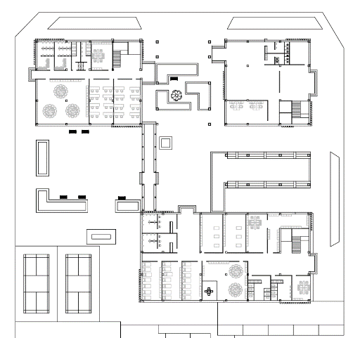**Characters:** There are 2 main characters in the game for now. The art materials will be generated by **Stable Diffusion**. There is an example of heroin. All these AI-generated images will be used for the dialogue and cut scenes. The game script is not finished yet. So there might be more characters in the future.
* **Map:** Each scene will have at least one map. The map will be created by the map editor **Tilemap** from unity3D. For reference, I managed to get some design drawings from one of my friends who study at BUCEA. Here is an example. All these drawings are published and also have his consent.

Figure : Design drawing

1. 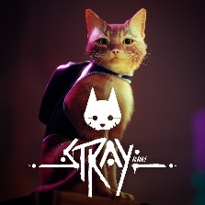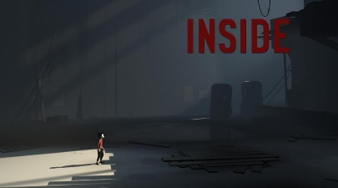**Prototype & Inspiration**

* 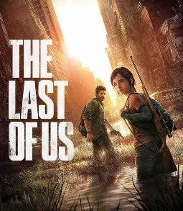The idea of this game was created by myself. But there are some excellent games that give me very good inspiration. Such as “Inside”, “The last of us”, “Stray”
  + These games give me lots of inspiration for horror games and puzzle games. They also have excellent stories and a smooth linear narrative process, which is one additional goal I want to achieve.

1. **Work Plan(From Week7)**
   * **Week 7-Week 9:** Finish the development of Scene 1, master the development environment of Unity3D, allocate all development resources (art resources, scripts, audio materials), and submit the game content of Scene 1 as Alpha submission.
   * **Week 10-Week 12:** Develop all the contents of Scenes 2 to 4, further master the development environment of Unity3D, and submit the first four scenes as the content of Beta submission.
   * **Week 13-Week 15:** Finish developing the final scene, test the game as a whole, and add the rest of the art and audio. Package the final version of the game as a final submission