**Outline**

1. **Project Overview:**
   * Type: Game
   * Game Type: LVG (Love game)
2. **Building Tools**

* Android Studio
* Language: Java, XML, kotlin(if I learn this in the future)
* Remote repository: <https://github.com/Sandoleathy/Star-Chinese-2023>
* Prototype drawing link: https://www.figma.com/file/g6630s2dNuKG4vJf6TRqNp/Star-Chinese?type=design&node-id=0%3A1&mode=design&t=KepoCyIAI49G68uk-1

1. **Reference & inspiration**

* “Star Chinese” series of games
* This type of game does not require complex graphical views. The XML file can do all the screen work

1. 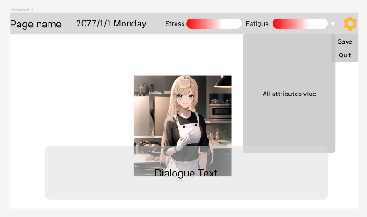**Layouts**

* There are lots of layouts for this application
* 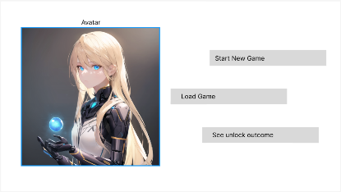Universal layout: Some element that will frequently be used in the application
* Menu layout
  + The menu is the entry of the application
  + 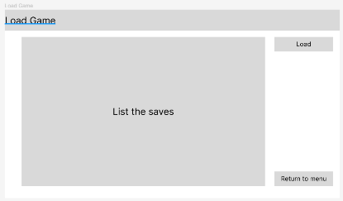Players can visit other pages from the menu
* Load save layout
  + Players use this interface to select saved games and continue it
* 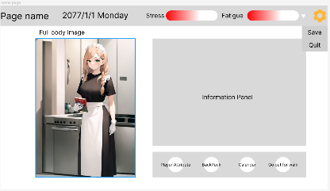Home Layout
  + Players on this page when they are at home
  + 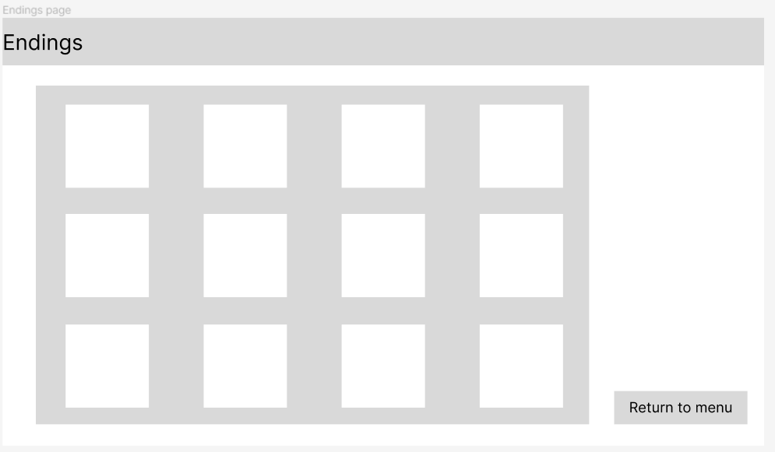Different choices of panels will show different information on the panel
* Outcome Layout
  + Players can view unlocked endings of the game. They can also see how many endings does the game have
  + Each white rectangle reflects an ending. The size of the rectangle will depend on the number of endings. The number of endings is uncertain now.

1. **Image resources & audio resources**

* Because art design is not my major field (either in this course). Almost every image resource especially the avatars and backgrounds will be generated by **Stable Diffusion.**
* Audio resources will be provided by some online music or AI-generated voice.

1. **Game System Overview**

* 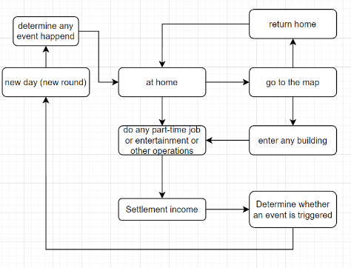The game is turn-based. Every single day is a round.
* Everyday system will check if there are any events that happen twice times
* A new day will always start at home (except there are some long-term events)
* The system will compute player’s attributes and incomes after they do any operations.

1. **Player’s Attributes**

* The player has 9 attributes. They are respectively knowledge, acting, singing, strength, charisma, morality, fame, stress, fatigue
* Each attribute will affect the player’s future reaction and choice. Also, these attributes will be changed due to the player’s behaviors.

1. **Work plan(From Week7)**

* **Week 7-Week 9:** Design all the required systems and complete the design of the game's story flow. Determine all text content. Complete the main page, load the save game page, and the view ending page. Find a way to save the game. In this section, the game can not work. All source code and the planning case will be submitted to Alpha submission
  + **Week 10-Week 12:** Complete the code of the main interface in the game. Complete the back-end code of the game logic, including schedule, save system, favorability system, all attributes, some events, etc. Make a few endings. In this section, the game works but lacks events and endings. The flow of the game should be able to run fully to the end of the schedule. All source code will be submitted to Beta submission.
  + **Week 13-Week 15:** Add events and endings to the game, refine ancillary content such as character graphics and audio, do as much as I can, and prepare the final version for submission