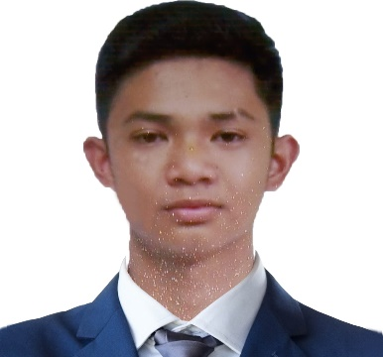**AIRYSH XANDER M. ESPERO**

*Address: Blk 1 Lot 18 Lilac St. Summer Pointe Residences,*

*Imus City, Cavite*

*Email Address: derespero@gmail.com*

*Contact No: 09561578770*

*Facebook Link: www.facebook.com/xander.espero.7*

**EDUCATION**

**College / 2021 – present:** Technological University of the Philippines - Manila

**Senior High School / 2019 – 2021:** Emilio Aguinaldo College – Cavite

**Junior High School / 2015 - 2019:** Dr. Espero Educational Foundation Colleges Inc.

**Elementary School / 2009 - 2015:** Dr. Espero Educational Foundation Colleges Inc.

**AWARDS**

* **With Honors** – Emilio Aguinaldo College Cavite – Senior High School

**2019-2021**

* **Dean’s Lister** – Technological University of the Philippines - Manila

**2022-2023**

* **Certificate of Participation** – National Computer Emergency Response Team Philippines – HackForGov

**2023**

**PERSONAL INFORMATION**

Nickname: Buboy

Birthdate: February 13, 2003

Birthplace: Sto. Domingo, Albay

Name of Mother: Ilyn R. Mortega

Occupation: Canteen Personnel

Name of Father: Leonardo G. Espero Jr.

Occupation: Athletic Director

*I hereby certify that all information above are true and correct with the best of my knowledge and ability.*

**AIRYSH XANDER M. ESPERO**