Fire Alarm Market - What is Driving It?

The market for commercial fire alarm systems continues to grow. These systems provide varying functions, from those that provide automatic fire detection and alarm, to those that only provide manually activated fire alarm, to monitoring fire protection systems, such as sprinkler systems, for alarm and supervision. It is estimated that the market for the installation of commercial fire alarm systems in the United States represents $3 billion and will continue to grow at a 3% to 5% pace. The market covers all categories of building occupancies; therefore it will tend to be balanced by both upward and downward trends in the individual categories. This estimate covers eleven categories of occupancy: Assembly, Education, Health Care, Lodging, Manufacturing, Mercantile, Mutli-Family/Apartment, Office, Public, Religious, and Warehouse, with the largest segments being office and mercantile occupancies at just under 25% and just over 19% market share, respectively.

The market has seen shifts over the last few years that have resulted in a net increase in the annual market. Further development in the addressable and analog technologies has resulted in higher equipment costs while this technology reduced installation costs, and the advent of the Americans with Disabilities Act has resulted in increased requirements for alarm notification appliances and power supplies to support them. In the future there will be more use of voice evacuation systems, as the requirement for their use has been expanded to smaller assembly occupancies.
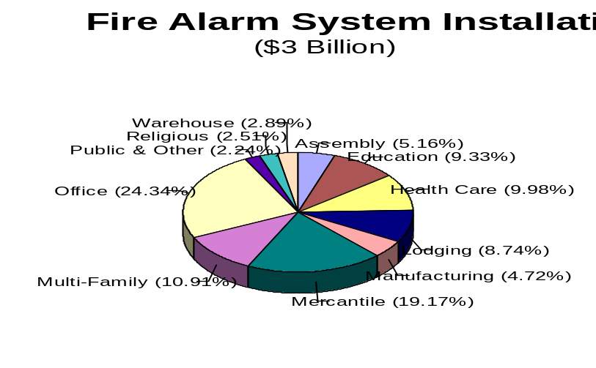

The system installations are grouped into three types of installation activity: new building construction, building modernization, and system upgrades. The new building construction group represents systems installed in new buildings and new additions to existing buildings. Building modernization systems are those systems which are being installed in existing buildings that do not have systems. Systems grouped as system upgrades are those system or component installations performed to upgrade or replace existing systems. New building construction represents $600 million; modernization, $1,800 million; and upgrades, $600 million. This is an estimated requirement for 320,000 systems annually, 65,000 for new construction, 190,000 for modernization, and 65,000 for upgrades. The modernization and upgrade of 255,000 buildings in a year may seem high, but they only represent five percent of the country’s inventory of commercial buildings, meaning that on average, buildings are upgraded once every twenty years.
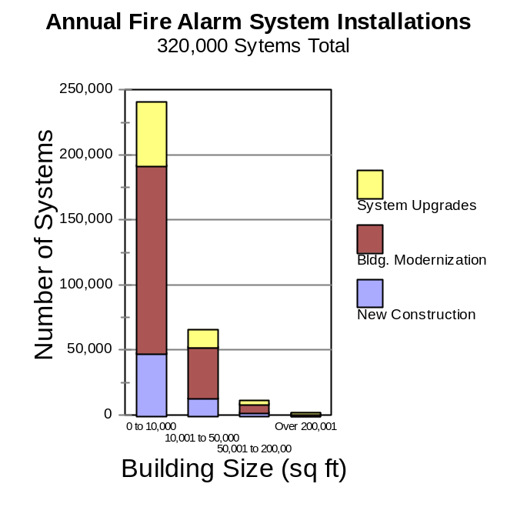

Modernization is the largest portion of the activity. The installation of full automatic fire alarm systems is a relatively young industry compared to the age of America’s building stock. Affordable mass produced equipment has been available for roughly twenty-five to thirty years, and various code requirements have been adopted for only twenty to twenty-five years, while fifty-five percent of America’s commercial buildings are over twenty-five years old.
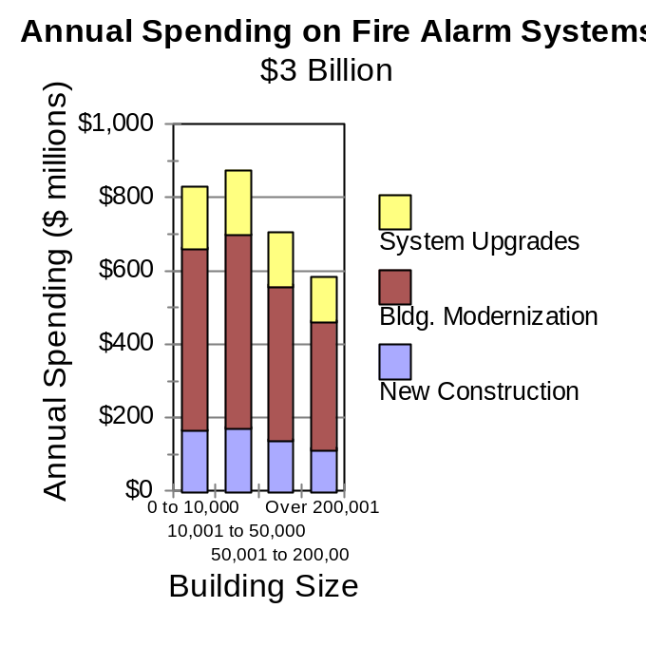

Many buildings which were constructed prior to the adoption of modern building codes were never equipped with fire alarm equipment. As these buildings age, they are modernized with new modern interiors, energy efficient glazing, and air conditioning systems. When these buildings are upgraded for visual, environmental, and occupant comfort, many building codes also trigger requirements that fire alarm and fire protection systems be installed. The trigger point in many of these codes is called substantial renovation. The substantial renovation point is a monetary point where the money spent on voluntary modernization passes a defined threshold. After this threshold is met it is deemed that the work on the building is not simply maintenance, and it is reasonable to expect that the fire alarm systems and other fire protection features should be upgraded to a new building performance standard.

Factors driving upgrade requirements for existing systems are a result of market consolidation, advancements in system technology, and codes and standards changes. Market consolidation, with some manufacturers ceasing operation, while others have discontinued the manufacture and support of older technology product models, has caused a void for service and replacement parts for those older systems, thus creating a market for system upgrades. Codes have increased the requirements for systems, and standards have changed how systems and components are to be applied, located, and tested.

Additionally, the increased market for the replacement of aging systems is a result of an increased enforcement of system testing and an intolerance for nuisance alarms by the local authorities having jurisdiction. Enforcing testing requirements forces the discovery of failing or failed components, resulting in system upgrades. Also many jurisdictions are implementing a fine system for repeat offenders for nuisance alarms and for properties without a written nuisance alarm reduction policy. Some nuisance alarms are caused by dirty detectors or aging electronics. Intolerance to these nuisance alarms by responding fire departments pressure building owners and managers to address system root causes, typically resulting in equipment replacement.

Systems will be installed in buildings varying in size from under 10,000 square feet of floor space to over 500,000 square feet. Suppliers will find that the amount of spending will be balanced through out the demographics of building size, although the majority of the systems will be required for small buildings, those less than 10,000 square feet in floor space. The smaller building system functions will be mostly combined with security systems into a single control panel, while the larger systems will be stand-alone, full-function systems.

Although building codes require many buildings to have fully automatic fire detection and alarm systems, some buildings are not required to have a fire alarm systems at all. Some building codes do not require occupancies such as storage and industrial to install a fire alarm system. These occupancies, however, may be required to have sprinkler systems, and those systems are required to be supervised, and OSHA may require them to have employee notification systems. The supervision of these sprinkler systems requires less fire alarm equipment than complete detection and alarm systems. Generally, the devices being installed consist of multiple flow switches and tamper switches. Also, transmission of trouble, supervisory, and fire alarm signals to a central station is normally required. Therefore, a small fire alarm panel is installed.

The occupancies in which the largest quantity of systems will be installed are mercantile, office, and multi-family housing complexes. These three areas represent over 65% of the annual systems market at 216,000 systems, 84,000 in mercantile buildings, 79,000 in office buildings, and 53,000 in multi-family residential complexes. 175,000 of these systems will be in buildings of less than 10,000 square feet of floor space.
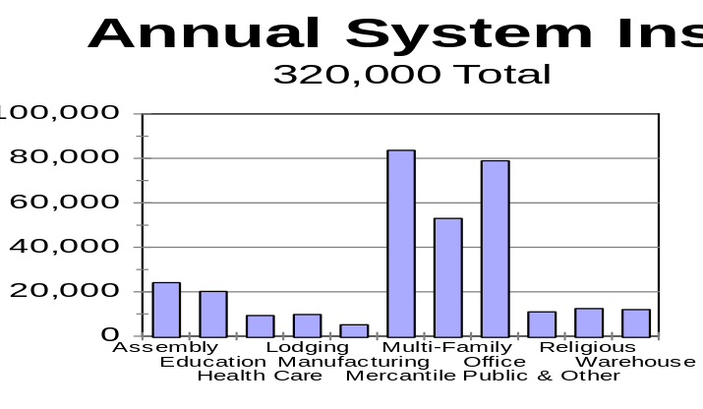

The $3 billion market value is the final installed cost that building owners will pay for the systems. The value added chain for this market includes the installation cost; the cost of installation materials such as wire, conduit, boxes, and mounting hardware; the cost from the manufacturer of the system equipment; and the cost from the distributor for designing the system and selling and handling the equipment.
Over half of the market value 55% will go to the system installers, while approximately 28% will go to the system equipment manufacturers, with the remaining 17% being split between the distributors of the systems and the suppliers of the installation materials. When comparing specific systems the installation factor is estimated to be consistent with all sizes of systems. The other percentages will vary, depending upon the size of the systems. The equipment manufacturers’ portion will range from 34% for smaller systems to 26 % for larger systems. The distributors’ portion will increase from 7% for smaller system to 9% for larger systems. As systems become larger the distribution support activity changes from “over the counter selling” to include the provision of system design and final installation checkout. The value received by the installation equipment supplier will range from 4% to 10%, as the smaller systems utilize lower cost installation techniques.
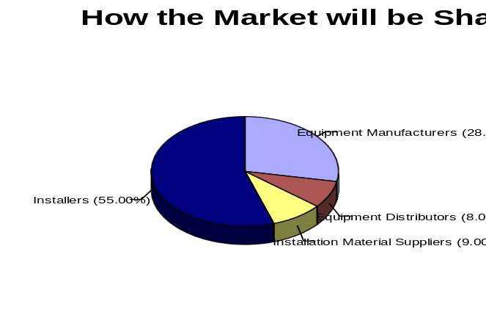

The development of these estimates considered the normal use of various common system components. These estimates indicate that fire alarm systems will annually use 2.3 million smoke detectors, 550,000 heat detectors, 1.4 million manual stations, and 4.5 million notification appliances. They will also monitor 500,000 switches providing sprinkler and standpipe system water flow and valve tamper indications, and 400,000 air conditioning duct detectors.

The two most common distribution mechanisms for these fire alarm systems and components are through wholesale distributors and security system alarm dealers, and engineered systems distributors. The smaller systems tend to be primarily sold through the wholesale and security system alarm dealer channels, while the larger systems are sold through engineered systems distributors. Our estimates indicate that, on an installed value basis, the value of the installed equipment that passes through these channels is evenly split between these two primary channels.

