Fish excretion & AgNPs

Sandra Klemet-N'Guessan

January 21, 2021

### eff_size function in {emmeans} package R documentation

*Description*

Standardized effect sizes are typically calculated using pairwise differences of estimates, divided by the SD of the population providing the context for those effects. This function calculates effect sizes from an emmGrid object, and confidence intervals for them, accounting for uncertainty in both the estimated effects and the population SD.

# ..N excretion anova + figure ----  
 # testing linear model with log-transformed data  
 lm.Nxnorm <- lm(log(massnorm.N.excr) ~ Lake*Year,   
 data = NPexcr %>% filter(Year != '2014'))  
   
 # pairwise comparisons using emmeans  
 lm.Nxnorm_emmeans <- emmeans(lm.Nxnorm, ~ Lake|Year, type = 'response')  
   
 # extracting effects from emmeans  
 lm.Nxnorm_marginal_means <- as.data.frame(summary(lm.Nxnorm_emmeans))  
   
 # calculating effect sizes + extracting effects  
 eff_sizeNx <- eff_size(lm.Nxnorm_emmeans, sigma = sigma(lm.Nxnorm),   
 edf = df.residual((lm.Nxnorm)))  
 eff_sizeNx

## Year = 2012:  
## contrast effect.size SE df lower.CL upper.CL  
## 222 - 239 -0.301 0.343 56 -0.9872 0.386  
##   
## Year = 2015:  
## contrast effect.size SE df lower.CL upper.CL  
## 222 - 239 0.893 0.453 56 -0.0149 1.801  
##   
## sigma used for effect sizes: 0.9088   
## Confidence level used: 0.95

eff_sizeNxdf <- as.data.frame(summary(eff_sizeNx))

## Output plot

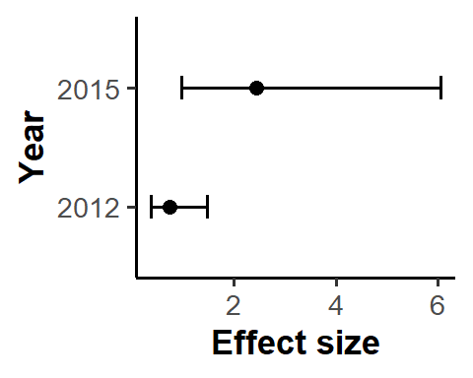

# testing linear model with log-transformed data  
 lm.Pxnorm <- lm(log(massnorm.P.excr) ~ Lake*Year,   
 data = NPexcr)  
  
 # pairwise comparisons using emmeans  
 lm.Pxnorm_emmeans <- emmeans(lm.Pxnorm, ~ Lake|Year, type = 'response')  
   
 # extracting effects from emmeans  
 lm.Pxnorm_marginal_means <- as.data.frame(summary(lm.Pxnorm_emmeans))  
   
 # calculating effect sizes + extracting effects  
 eff_sizePx <- eff_size(lm.Pxnorm_emmeans, sigma = sigma(lm.Pxnorm),   
 edf = df.residual((lm.Pxnorm)))  
 eff_sizePx

## Year = 2012:  
## contrast effect.size SE df lower.CL upper.CL  
## 222 - 239 -2.955 0.377 111 -3.70 -2.209  
##   
## Year = 2014:  
## contrast effect.size SE df lower.CL upper.CL  
## 222 - 239 -2.302 0.359 111 -3.01 -1.589  
##   
## Year = 2015:  
## contrast effect.size SE df lower.CL upper.CL  
## 222 - 239 -0.418 0.317 111 -1.05 0.211  
##   
## sigma used for effect sizes: 0.5799   
## Confidence level used: 0.95

eff_sizePxdf <- as.data.frame(summary(eff_sizePx))

## Output plot

