Contents

Project goal 2

Example of inputs 2

Example of output 2

Pseudocode 3

# Project goal

To convert a variant table into graphical representation of the variants.

# Example of inputs

* RefSeq: TGCCTGCATTTTAGTCGTGAGATGGAGAATAAAGAAACTCTCAAAGGGTTGCACAAGATGGATGATCGTCCAGAGGAACGAATGATCAGGGAGAAACTGAAGGCAACCTGTATGCCAGCCTGGAAGCACGAATGGTTGGAAAGGAGAAATAGGCGAGGGCCTGTGGTAAGTGGCTATGGG
* sgRNA: AGCCTGGAAGCACGAATGGT
* Variant table:



# Example of output

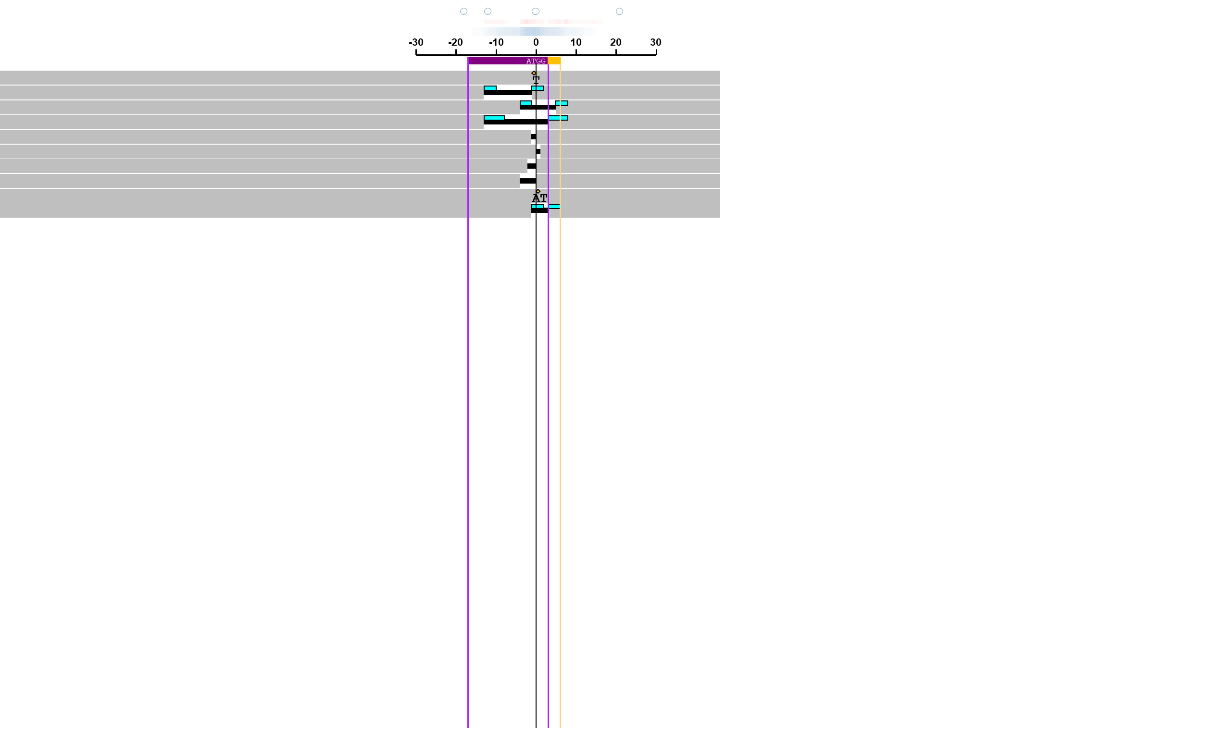



# Pseudocode

1. Read the inputs into python code and assign them to variables.
2. Import required libraries for graphical shapes.
3. For each variant, identify type and size.
4. For each variant draw a corresponding graphical presentation.
5. Save the final output as PDF file.
6. Notify the user where the report is saved.