Contents

Project goal 2

Example of inputs 2

Example of output 2

Pseudocode 3

# Project goal

Calculating the percentage of editing efficiency, insertion, deletion and knock-ins from total mapped reads and mutated reads. Graphical representation in Pie-charts.

# Example of inputs

* Variant table:



* Amplicon Seq Mapping Statistics
  + Tsv file

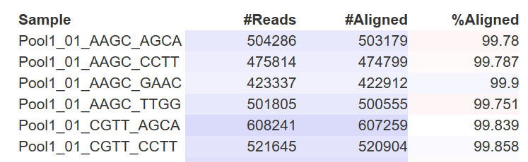

# Example of output

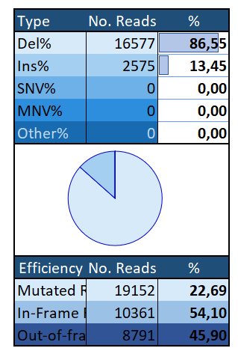 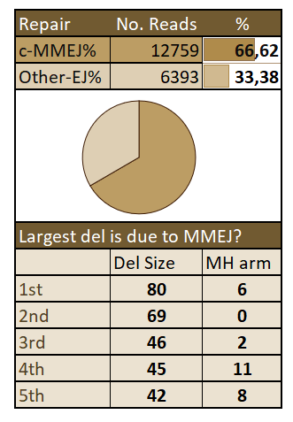

# Pseudocode

1. Read the inputs into python code and assign them to variables
2. Import required libraries for statistical analysis and graphical representation
3. Statistics on editing efficiency
   1. Input1: from Amplicon-seq paired Mapping Statistics table is number of aligned reads
   2. Input2 from variants table is the sum of mutated read counts
   3. Calculate editing efficiency
   4. Generate pie-chart and table
4. Same workflow for insertions, deletion & knock-ins
5. Generate a report file in PDF format