***ADVANCED DATABASE MANAGEMENT SYSTEM***

*A study of different database management system.*

***DBMS***

*Database management system is a software for storing and retrieving user’s data while considering appropriate security measures. DBMS allow users to create their own database as per their requirements.*

***DIFFERENT TYPES DATABASE MANAGEMENT SYSTEMS***

*Different types of database management system are:*

* *Relational database.*
* *Object oriented database.*
* *Hierarchical database.*
* *Network database.*

*Relational database:*

*Relational database management system is the system where data is arranged in two dimensional tables using rows and columns.*

*It is based on SQL. Popular data model used in industries,* *every table in a database has a key field which uniquely identifies each record.*

*This type of system is the most widely used DBMS.*

*Example:*

|  |  |  |  |
| --- | --- | --- | --- |
| *Id* | *Name* | *Class* | *city* |
| *101* | *Anu* | *S1A* | *cherthala* |
| *102* | *Shehra* | *S1B* | *aroor* |

Object oriented database:

*It is the system information or data are represented in the form of objects which used in object oriented programming.*

*It requires less code and is easy to maintain, it is the combination of relational database concept and oops concept.*

*Example:*

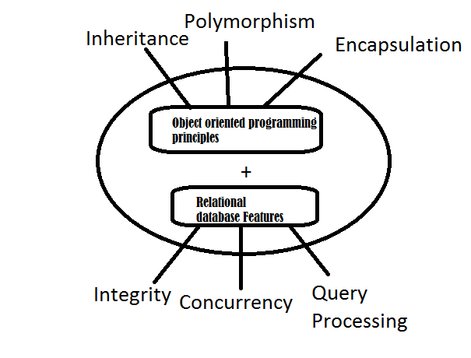

*Hierarchical database:*

*It is a system where the data elements have one to many relationships, data is organized like a tree.*

*The hierarchy starts from root node and child nodes are connected to the parent node.*

*It is used in industry on mainframe platforms.*

*Advantages:*

*A hierarchical database can be accessed and updated rapidly. As shown in the figure above, its model structure is like a tree and the relationships between records are defined in advance. This feature is a double-edged sword.*

*Disadvantages:*

*This type of database structure is that each child in the tree may have only one parent. Relationships or linkages between children are not permitted, even if they make sense from a logical standpoint. Hierarchical databases are like this in their design. Adding a new field or record requires that the entire database be redefined.*

*Example:*

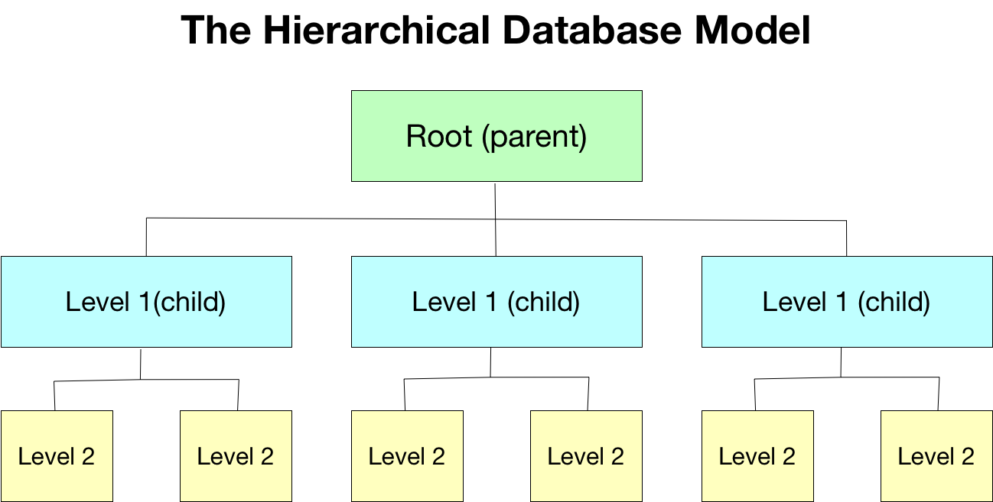

*Network database:*

*Networked database management system is the system where data elements maintained one to one relationship or many to many relationship.it is also a hierarchical structure, but data is arranged as graph.*

*It is mainly used on large digital computers. Network databases are hierarchical databases, but unlike hierarchical databases where one node can have a single parent only, a network node can have a relationship with multiple entities. A network database looks more like a cobweb or interconnected network of records.*

*Example:*

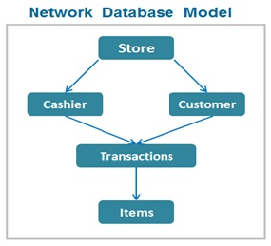

***Popular database management systems:***

*MYSQL:*

*Works on Linux and Windows*

*Language used c and c+ +*

*Features:*

*High speed data processing.*

*Use of triggers increase productivity.*

*With commit and rollback helps data recovery.*

*IBM DB2:*

*Developed in 1983.*

*Language used assembly language, c and c+ + .*

*Supports on Windows, UNIX and Linux.*

*Feature:*

*Easy to install and set up.*

*Easily accessible.*

*Store huge amount of data.*

*Maria DB:*

*Maria DB is a fork of the MYSQL database management system.it is created by its original developers*

*It has higher uptime or availability and is highly scalable, has multicore support, uses multiple threads, supports Internet Protocol.*

*It provides real-time database access.*