**Mongodb**

Create database in mongodb

Use mydb

Create tables

Db.createCollection(“flowers”)

Insert tuples

Db.flowers.insertMany([{“name”:”rose”},{“name”:”lotus”}])

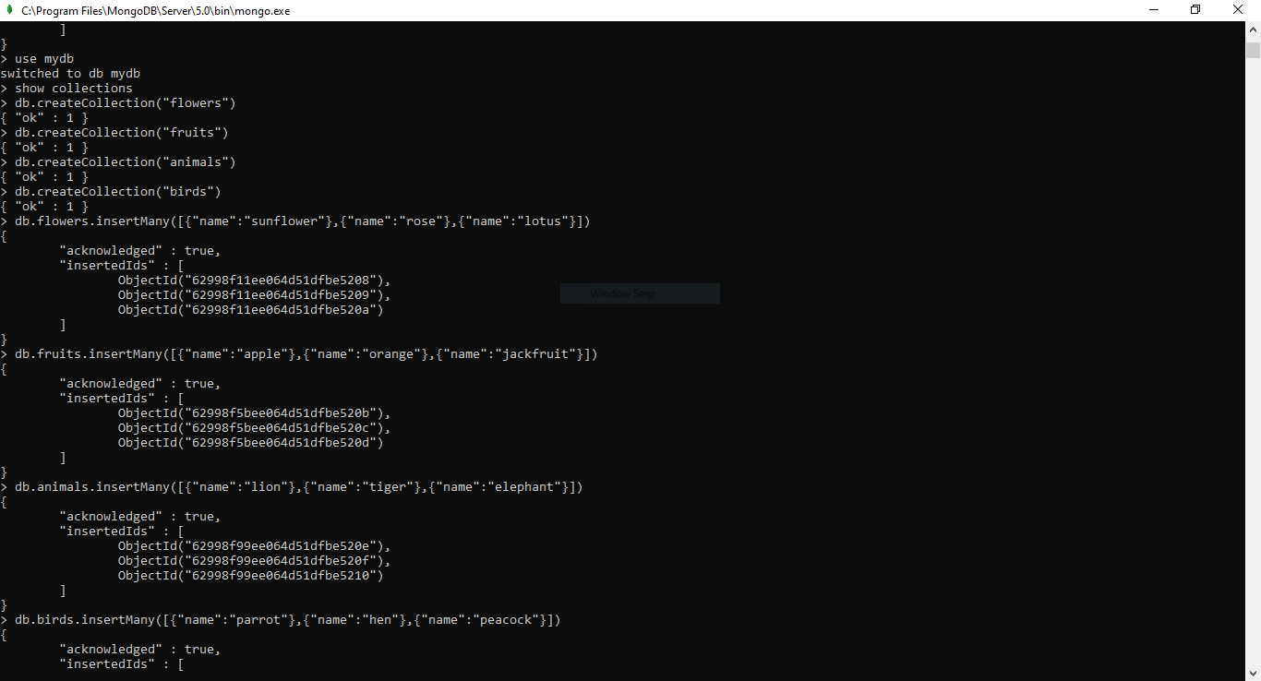

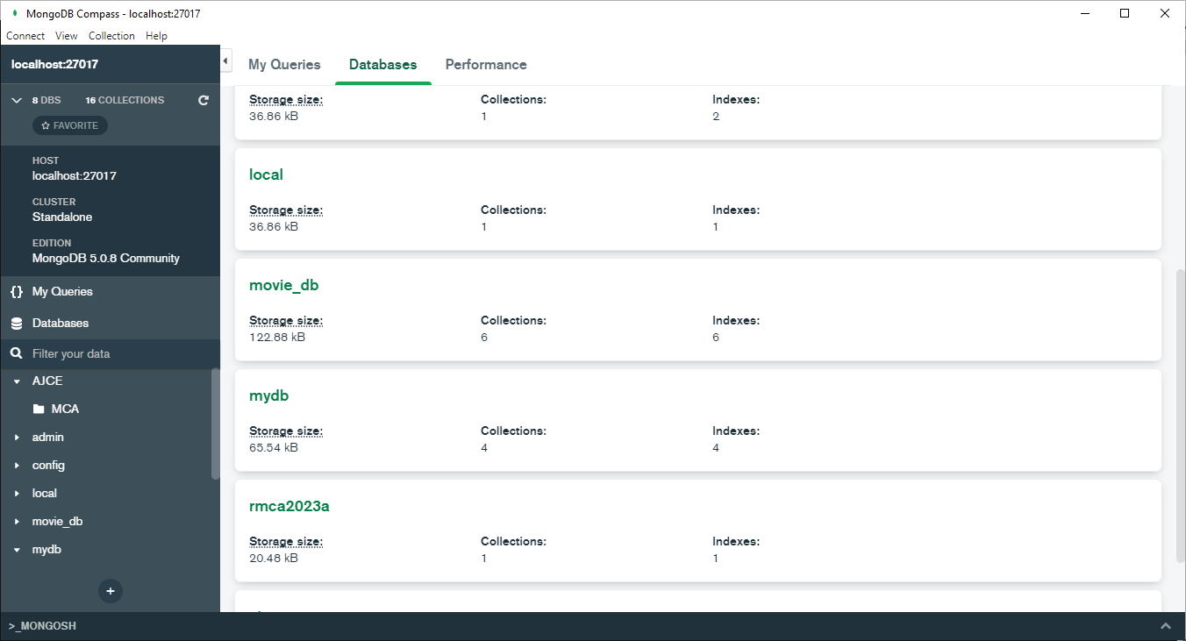

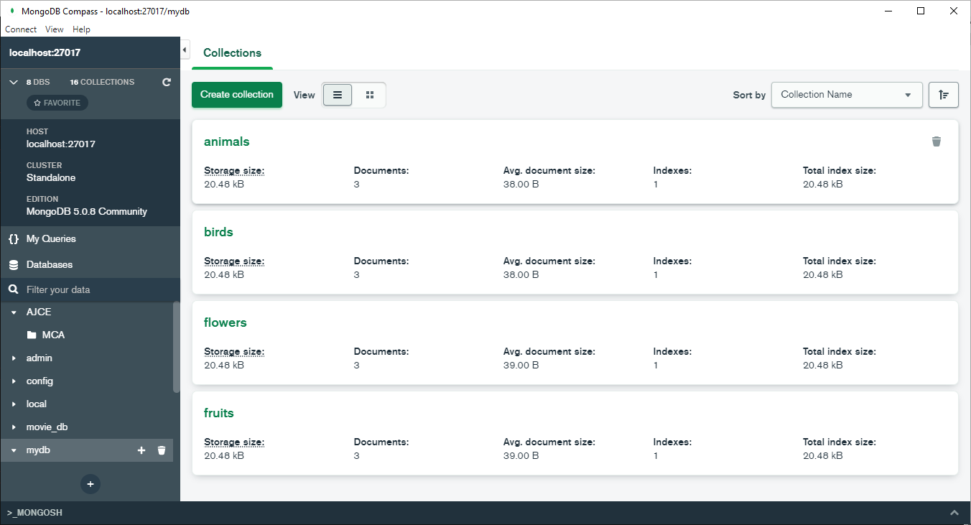

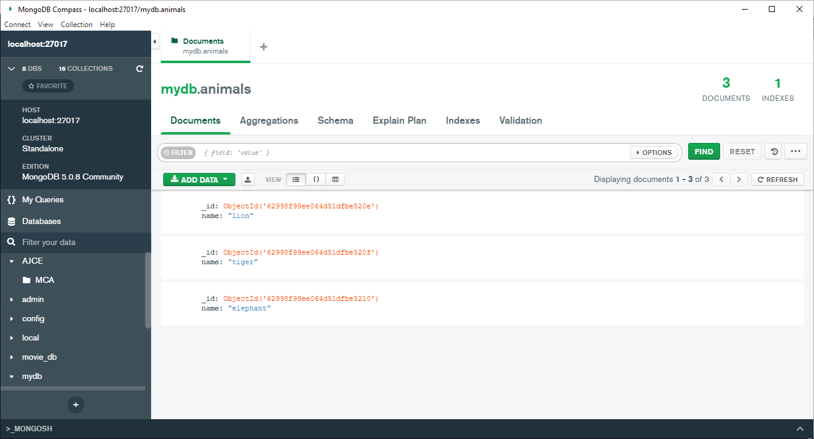

**read**

db.animals.find()

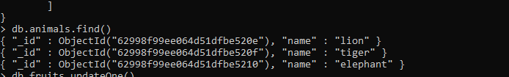

**Update**

db.flowers.update({“name”:”lotus”},{$set: {“name”:”lily”}})

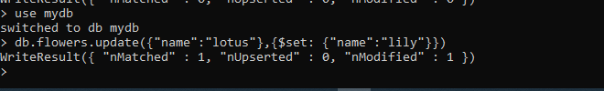

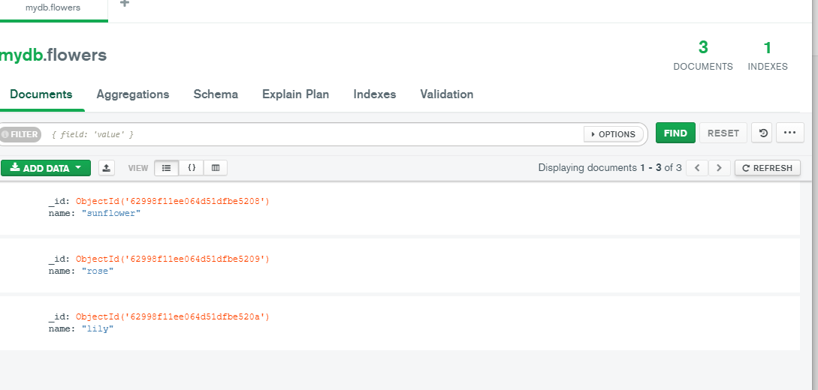

**Delete**

db.flowers.deleteOne({“name”: ”rose”})



