

**ADVANCED DATABASE MANAGEMENT LAB**

**Experiment No.: 1**

**Aim**

To study various DDL commands – CREATE

#### Table 1: DEPOSIT

ACTNO VARCHAR2(5) PRIMARY KEY, FIRST LETTER MUST START WITH ‘D’ CNAME VARCHAR2(15) FOREIGN KEY REFERENCES CUSTOMER

BNAME VARCHAR2(20) FOREIGN KEY REFERENCES BRANCH AMOUNT NUMBER (8,2) NOT NULL, CANNOT BE 0

ADATE DATE

#### Table 2: BRANCH

BNAME VARCHAR2(20) PRIMARY KEY

CITY VARCHAR2(30) NOT NULL , any one of NAGPUR, DELHI, BANGALORE, BOMBAY

#### Table 3: CUSTOMER

CNAME VARCHAR2(15) PRIMARY KEY CITY VARCHAR2(20) NOT NULL ,

#### Table 4: BORROW

LOANNO VARCHAR2(8) PRIMARY KEY / FIRST LETTER MUST START WITH ‘L’ CNAME VARCHAR2(15) FOREIGN KEY REFERENCES CUSTOMER

BNAME VARCHAR2(20) FOREIGN KEY REFERENCES BRANCH AMOUNT NUMBER(8,2) NOT NULL, CANNOT BE 0

**Procedure:**

create table Deposit(ACTNO VARCHAR(25) PRIMARY KEY,CNAME VARCHAR(15) REFERENCES CNAME(CUSTOMER) , BNAME VARCHAR(20) REFERENCES BNAME (BRANCH), AMOUNT NUMERIC NOT NULL ,ADATE DATE);

insert into DEPOSIT(ACTNO,CNAME,BNAME,AMOUNT,ADATE)VALUES('D100','ANIL','VRCE','1000.00','1995-03-01');

insert into DEPOSIT(ACTNO,CNAME,BNAME,AMOUNT,ADATE)VALUES('D101','SUNIL','ANJNI','500.00','1996-01-04');

insert into DEPOSIT(ACTNO,CNAME,BNAME,AMOUNT,ADATE)VALUES('D102','MEHUL','KAROLBAGH','3500.00','1995-11-17');

insert into DEPOSIT(ACTNO,CNAME,BNAME,AMOUNT,ADATE)VALUES('D104','MADDURI','CHANDNI','1200.00','1995-12-17');

insert into DEPOSIT2(ACTNO,CNAME,BNAME,AMOUNT,ADATE)VALUES('D105','PRAMOD','MG ROAD','3000.00','1996-03-27');

insert into DEPOSIT(ACTNO,CNAME,BNAME,AMOUNT,ADATE)VALUES('D106','SANDIP','ANDHERI','2000.00','1996-03-31');

insert into DEPOSIT2(ACTNO,CNAME,BNAME,AMOUNT,ADATE)VALUES('D107','SHIVANI','VIRAR','1000.00','1995-09-05');

insert into DEPOSIT(ACT NO,CNAME, BNAME,AMOUNT, ADATE)VALUES('D108',' KARNTI','NEHRU PLACE','5000.00','1995-07-02');

insertintoDEPOSIT(ACTNO,CNAME,BNAME,AMOUNT,ADATE)VALUES('D109','MINU','POWAI','7000.00','1995-08-10');

select * from DEPOSIT2;

create table BORROW(LOANNO VARCHAR(25) PRIMARY KEY,CNAME VARCHAR(15) REFERENCES CNAME(CUSTOMER) , BNAME VARCHAR(20) REFERENCES BNAME (BRANCH), AMOUNT NUMERIC NOT NULL);

INSERT INTO BORROW(LOANNO,CNAME,BNAME,AMOUNT)VALUES('L201','ANIL','VRCE','1000.00');

INSERT INTO BORROW(LOANNO,CNAME,BNAME,AMOUNT)VALUES('L206','MEHUL','ANJI','5000.00');

INSERT INTO BORROW(LOANNO,CNAME,BNAME,AMOUNT)VALUES('L311','SUNIL','DHARAMPETH','3000.00');

INSERT INTO BORROW(LOANNO,CNAME,BNAME,AMOUNT)VALUES('L321','MADHURI','ANDHERI','2000.00');

INSERT INTO BORROW(LOANNO,CNAME,BNAME,AMOUNT)VALUES('L371','PRAMOD','VIRAR','8000.00');

INSERT INTO BORROW(LOANNO,CNAME,BNAME,AMOUNT)VALUES('L381','KRANTI','NEHRU PLACE','3000.00');

SELECT * FROM BORROW;

create table CUSTOMER(CNAME VARCHAR(15) PRIMARY KEY,CITY VARCHAR(20) NOT NULL);

INSERT INTO CUSTOMER(CNAME,CITY)VALUES(‘ANIL’,’CULCATTA’);

INSERT INTO CUSTOMER(CNAME,CITY)VALUES(‘KRANTI',’BOMBAY’);

INSERT INTO CUSTOMER(CNAME,CITY)VALUES(‘MADHURI',’NAGPUR’);

INSERT INTO CUSTOMER(CNAME,CITY)VALUES(‘MANDAR’,’PATNA’);

INSERT INTO CUSTOMER(CNAME,CITY)VALUES(‘MEHUL’,’BARODA’);

INSERT INTO CUSTOMER(CNAME,CITY)VALUES(‘NARIN’,’BOMBAY’);

INSERT INTO CUSTOMER(CNAME,CITY)VALUES(‘PRAMOD’,’NAGPUR’);

INSERT INTO CUSTOMER(CNAME,CITY)VALUES(‘SANDIP’,’SURAT’);

INSERT INTO CUSTOMER(CNAME,CITY)VALUES(‘SHIVANI’,’BOMBAY’);

INSERT INTO CUSTOMER(CNAME,CITY)VALUES(‘SUNIL’,’DELHI’);

**Output Screenshot**

**DEPOSIT TB**

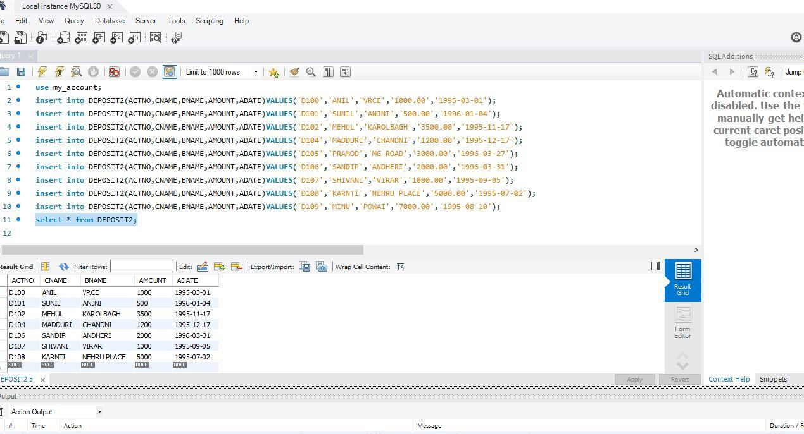

**CUSTOMER TB**

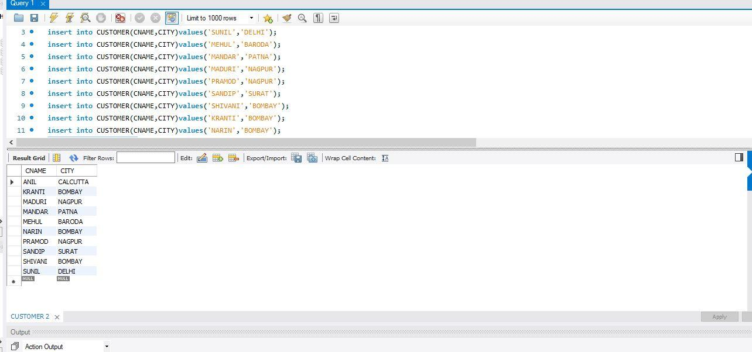

**BRANCH TB**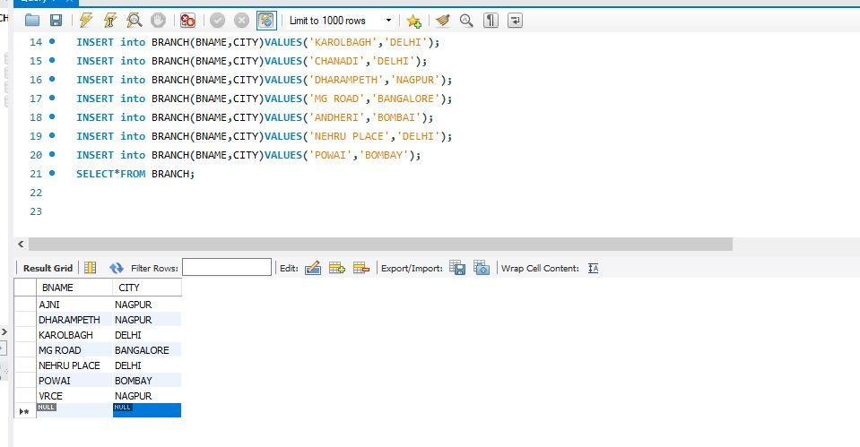

**BORROW**