**Name: Sandra pm**

**Roll No: 34**

**Batch:B**

**Date:30-05-2022**

**NETWORKING & SYSTEM ADMINISTRATION LAB**

**Experiment No.: 25**

**Aim**

Install the latest version of Ubuntu on an Oracle VM VirtualBox.

**Procedure**

**Step 1:**

**Syntax :- $ sudo docker run -dit --name tecmint-web -p 8080:80 -v /home/user/website/:/usr/local/apache2/htdocs/ httpd:2.4**

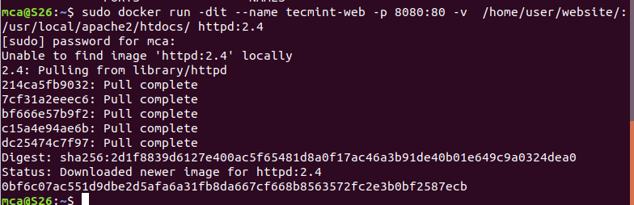

**Step 2:**

**Syntax :- $ sudo docker ps**



**Step 3:**

**Syntax :- $ sudo gedit /home/user/website/docker.html**



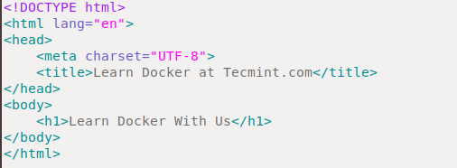

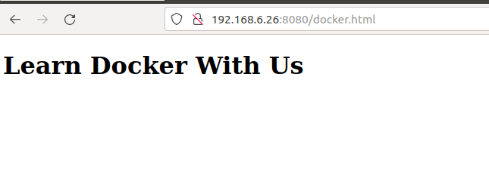

**Step 4:**

**Syntax :- $ sudo docker stop tecmint-web**

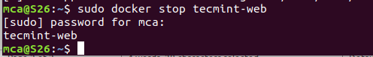

**Step 5:**

**Syntax :- $ sudo docker rm tecmint-web**



**Step 6:**

**Syntax :- $ sudo docker image remove httpd:2.4**

