

**NETWORKING & SYSTEM ADMINISTRATION LAB**

**Experiment No.:**

**Aim**

familiarity with systemd

**$sudo gedit /usr/bin/script.sh**

add the following script

#!/bin/bash

while true

do

sleep 10

done

**$sudo chmod +x/usr/bin/script.sh**

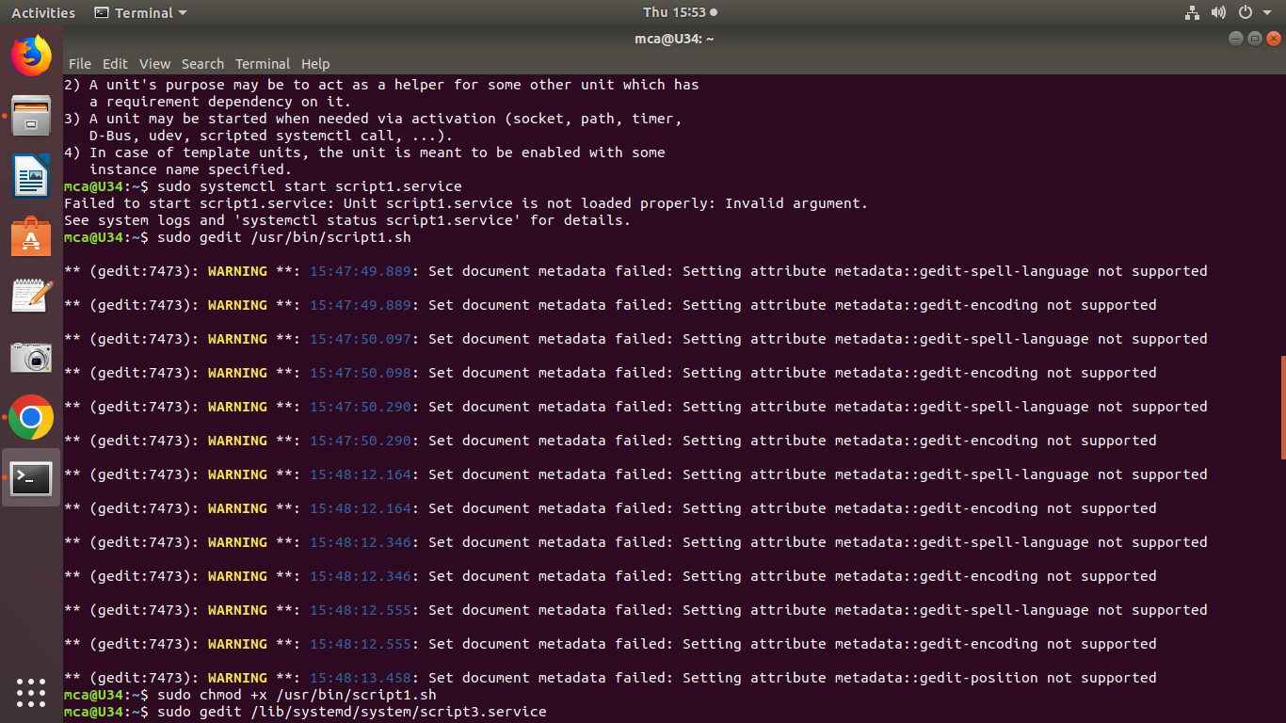

**step 2**

**create a systemD file**

**$sudo gedit /lib/system/script3.service**

**[Unit]**

**Description=My shell script**

**[Service]**

**ExecStart=/usr/bin/script.sh**

**[Install]**

**WantedBy=multi-user.target**

**$sudo systemctl daemon-reload**

**$sudo systemctl enable script3.service**

**$sudo systemctl start script3.service**

**$sudo systemctl status script3.service**

