**NETWORKING & SYSTEM ADMINISTRATION LAB**

**Experiment No.: sandra pm**

**rollno:34**

**MCA B**

**sudo tcpdump -i emp3s0 -c port80**

To capture the packets of specific protocol

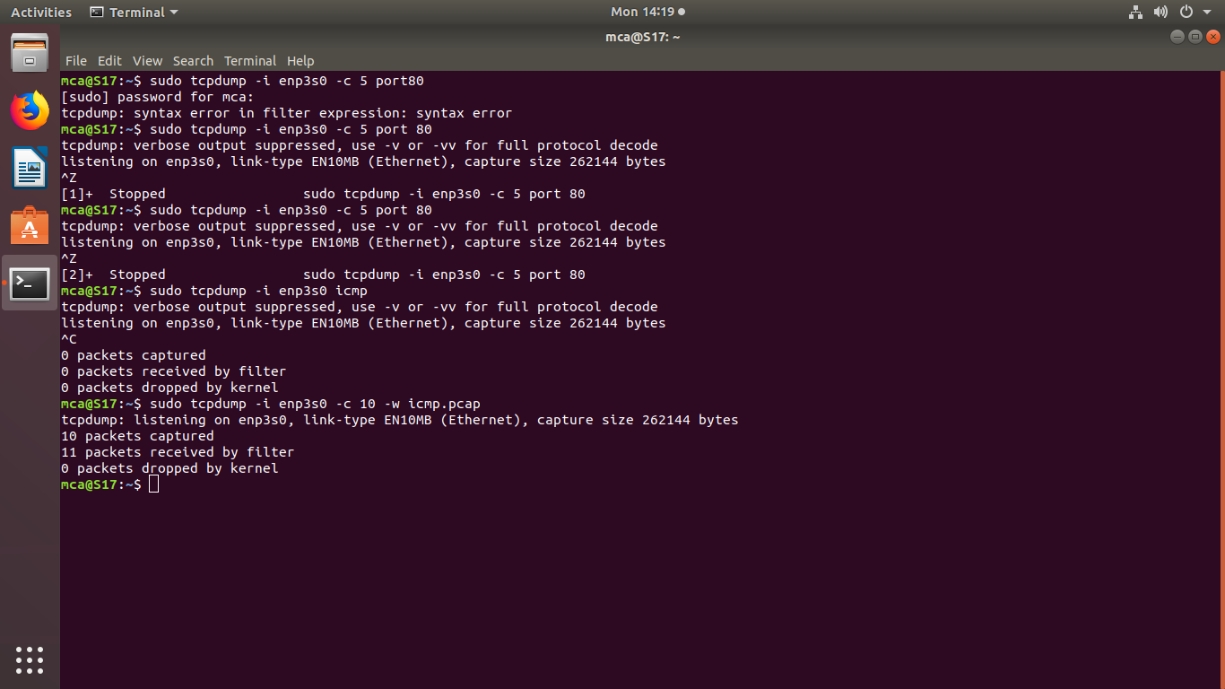

**sudo tcpdump -i emp3s0 icmp**



**sudo tcpdump -i emp3s0 -c 10 -w icmp.pcap**

saves 10 lines of output on the interface to icmp.pcap



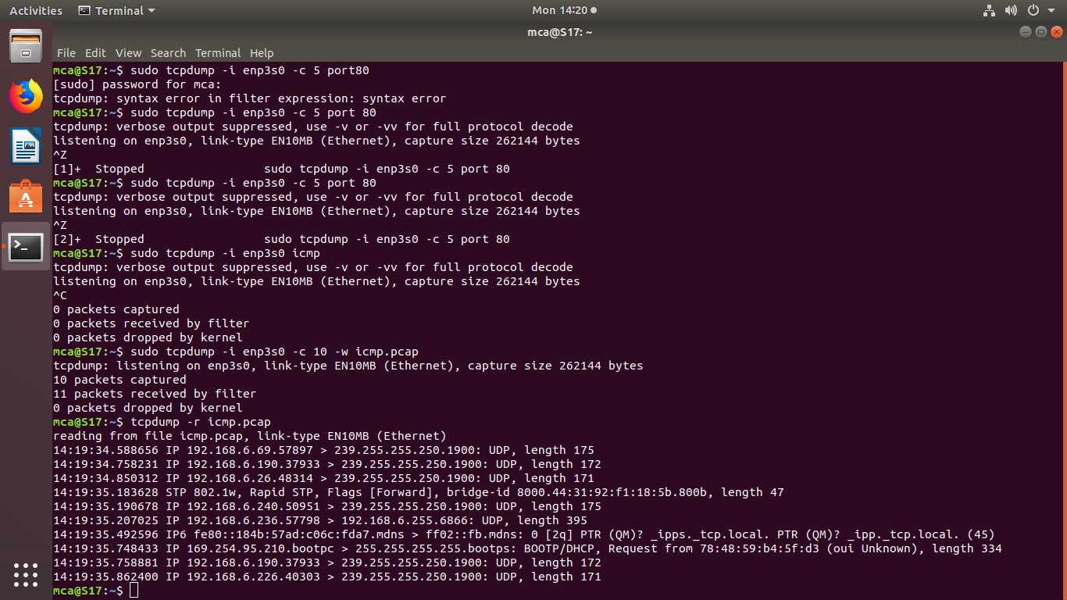**sudo tcpdump -r icmp.pcap**

**wireshark**

**sudo apt update**

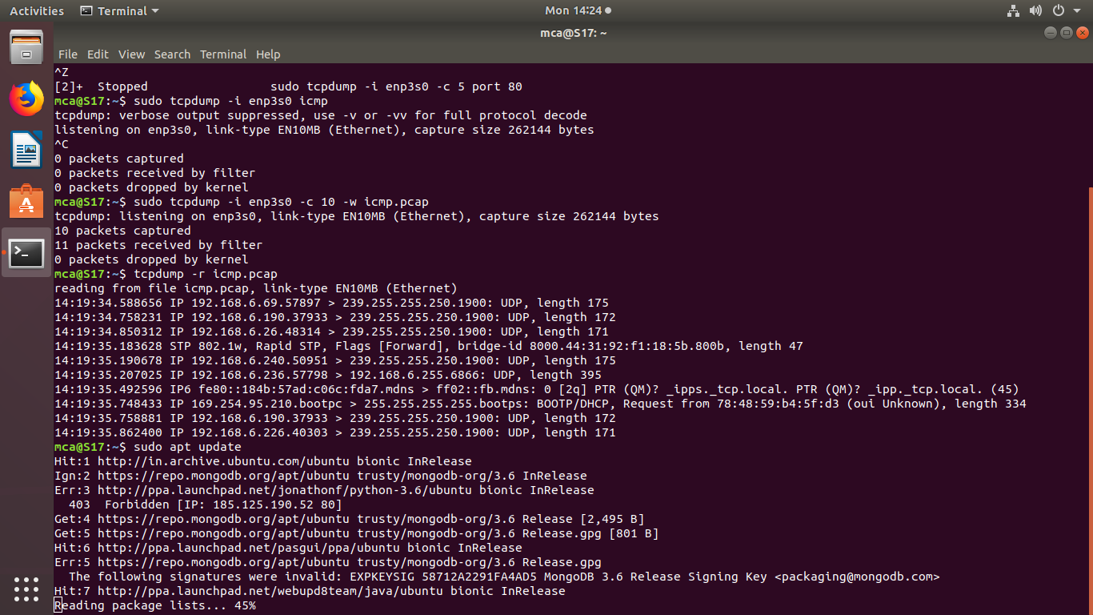

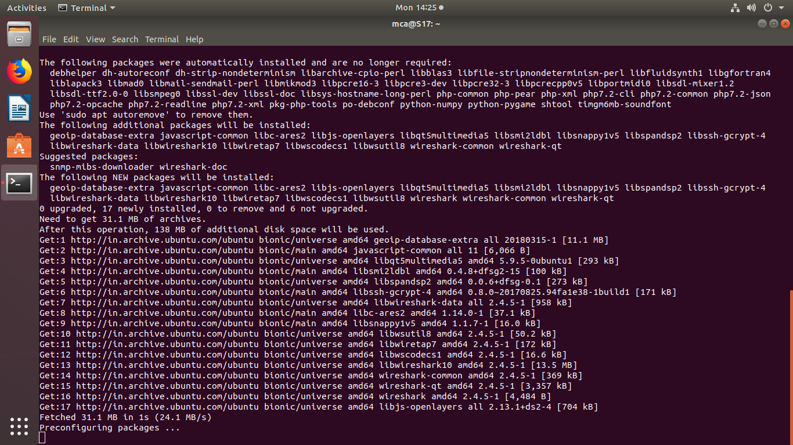

**sudo apt install wireshark**

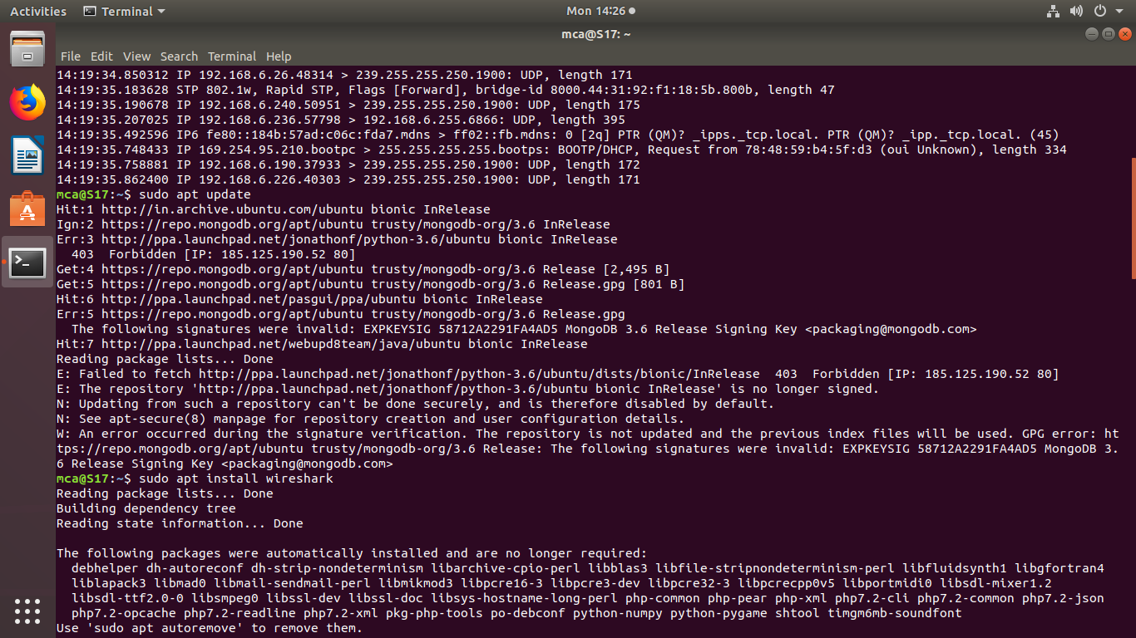**sudo adduser $mca wireshark**

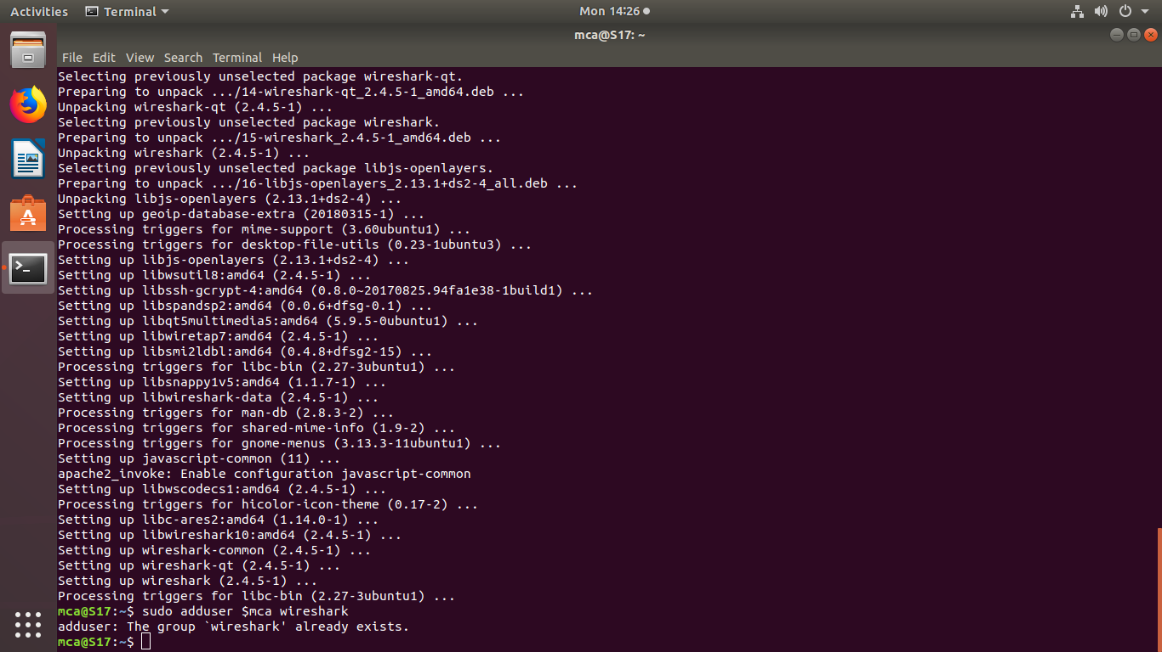

**sudo wireshark**

