**Name: Sandra P M**

**Roll No:34**

**Batch: MCA B**

**Date:31-05-2022**

**OBJECT ORIENTED PROGRAMMING LAB**

**Experiment No.: co4**

**Aim**

**1. Create a Graphics package that has classes and interfaces for figures Rectangle, Triangle,**

**Square and Circle. Test the package by finding the area of these figures.**

**AreaCalculation.java**

import java.util.*;

import graphics.*;

public class AreaCalculation {

public static void main(String[] args) {

Scanner sc= new Scanner(System.in);

int choice,isexit=0;

while(isexit==0){

double length, breadth, side, radius;

System.out.println("\n1. Area of Triangle.\n2. Area of Circle.\n3. Area of Square.\n4. Area of Rectangle.\n5. Exit");

System.out.print("Please enter the operation choice to perform - ");

choice= sc.nextInt();

System.out.println("\n");

switch(choice){

case 1:{

System.out.print("Enter the length of the triangle : ");

length= sc.nextDouble();

System.out.print("Enter the height of the triangle : ");

breadth= sc.nextDouble();

Triangle triangle = new Triangle(length, breadth);

triangle.Area();

break;

}

case 2:{

System.out.print("Enter the radius of the circle : ");

radius= sc.nextDouble();

Circle cir= new Circle(radius);

cir.Area();

break;

}

case 3:{

System.out.print("Enter the side length of the square : ");

side= sc.nextDouble();

Square square= new Square(side);

square.Area();

break;

}

case 4:{

System.out.print("Enter the length of the rectangle : ");

length= sc.nextDouble();

System.out.print("Enter the breadth of the rectangle : ");

breadth= sc.nextDouble();

Rectangle rec= new Rectangle(length, breadth);

rec.Area();

break;

}

case 5:{

isexit=1;

break;

}

default:{

break;

}

}

}

sc.close();

}

}

Triangle.java

package graphics;

interface AreaInterface {

void Area();

}

public class Triangle implements AreaInterface{

double length, breadth;

public Triangle(double length, double breadth){

this.length= length;

this.breadth= breadth;

}

public void Area() {

double area= 0.5 * this.length * this.breadth;

System.out.println("The area of the given triangle is : "+area);

}

}

Rectangle.java

package graphics;

interface AreaInterface {

public void Area();

}

public class Rectangle implements AreaInterface{

double length, breadth;

public Rectangle(double length, double breadth){

this.length= length;

this.breadth= breadth;

}

public void Area() {

double area= 0.5 * this.length * this.breadth;

System.out.println("The area of the given rectangle is : "+area);

}

}

Circle.java

package graphics;

interface AreaInterface {

void Area();

}

public class Circle implements AreaInterface{

double radius;

public Circle(double radius){

this.radius= radius;

}

public void Area() {

double area= 3.14 * this.radius * this.radius;

System.out.println("The area of the given circle is : "+area);

}

}

Square.java

package graphics;

interface AreaInterface {

void Area();

}

public class Square implements AreaInterface{

double side;

public Square(double side){

this.side= side;

}

public void Area() {

double area= this.side * this.side;

System.out.println("The area of the given square is : "+area);

}

}

**Output**

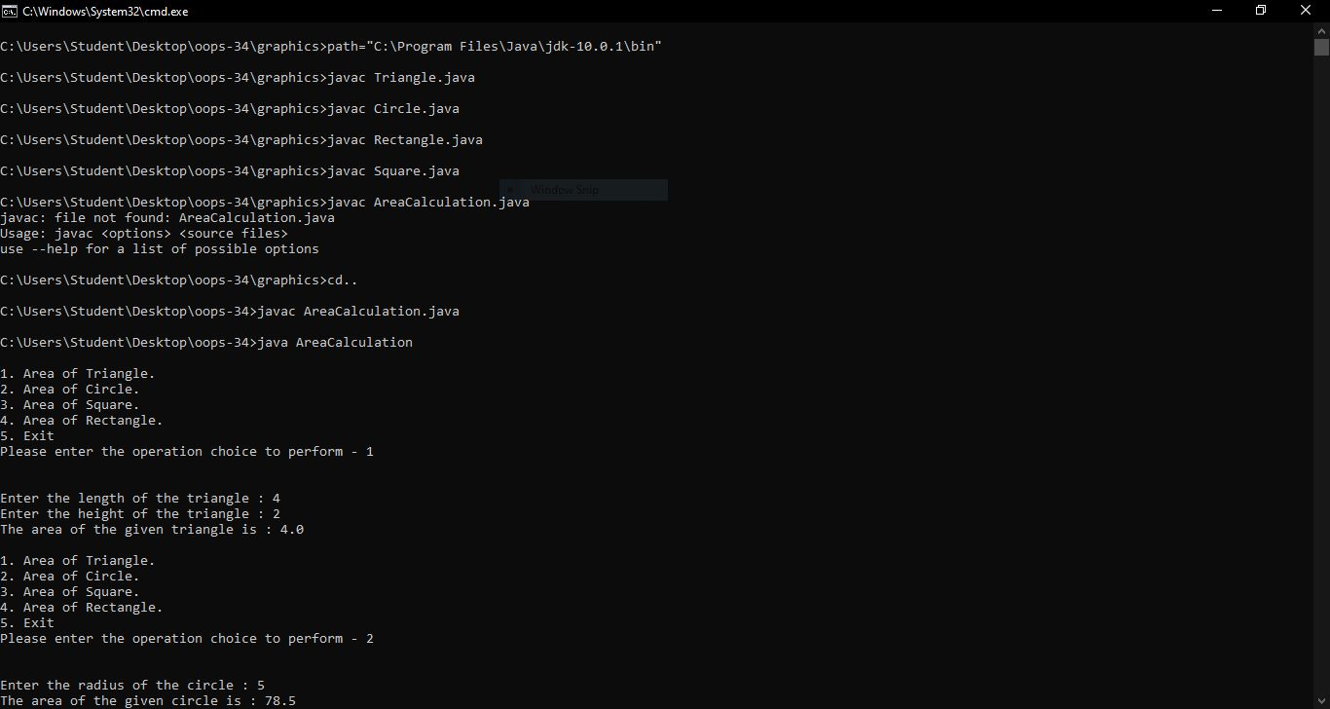

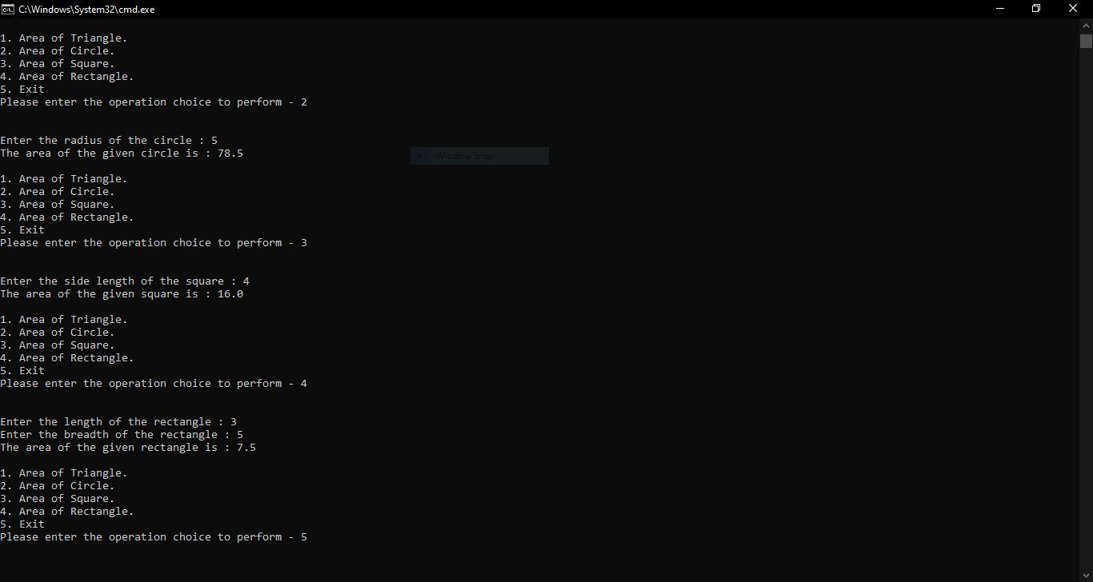

**2. Write a user defined exception class to authenticate the user name and password.**

**Procedure**

public class CustomExceptionExample {

public static class InvalidUserException extends Exception {

public InvalidUserException() {

super("Invalid username / password provided!");

}

}

public static void main(String[] args) {

String username = "san";

String password = "pass";

try {

if (username.equals("user") && password.equals("pass")) {

System.out.println("Authenticated successfully!");

} else {

throw new InvalidUserException();

}

} catch (InvalidUserException e) {

System.out.println(e);

}

}

}

**Output**

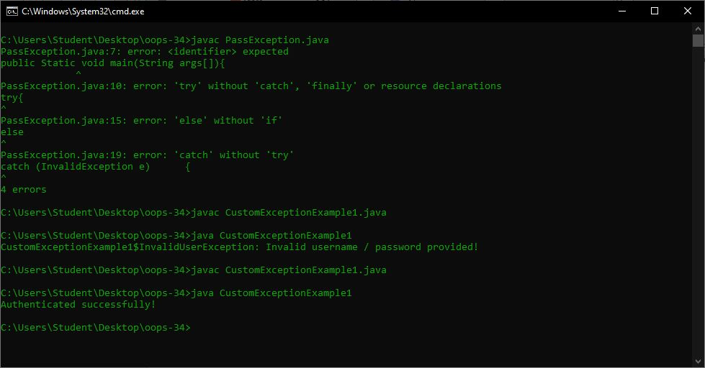

**3.Find the average of N positive integers, raising a user defined exception for each negative input.**

**Procedure**

import java.util.*;

class MyException extends Exception {

public MyException(String value) {

super(value);

}

}

class Main {

public static void main(String args[]) {

int totalNums;

int i;

int temp, count = 0;

int sum = 0;

Scanner sc = new Scanner(System.in);

System.out.println("Total numbers");

totalNums = Integer.parseInt(sc.nextLine());

for (i = 0; i < totalNums; i++) {

try {

temp = Integer.parseInt(sc.nextLine());

if (temp > 0) {

sum += temp;

count += 1;

} else {

throw new MyException(Integer.toString(temp));

}

} catch (MyException ex) {

System.out.print(ex.getMessage());

System.out.println(" - Not a positive number");

}

}

System.out.print("Count : ");

System.out.println(count);

System.out.print("sum: ");

System.out.println(sum);

System.out.print("Average : ");

System.out.println(sum / count);

}

}

**Output**

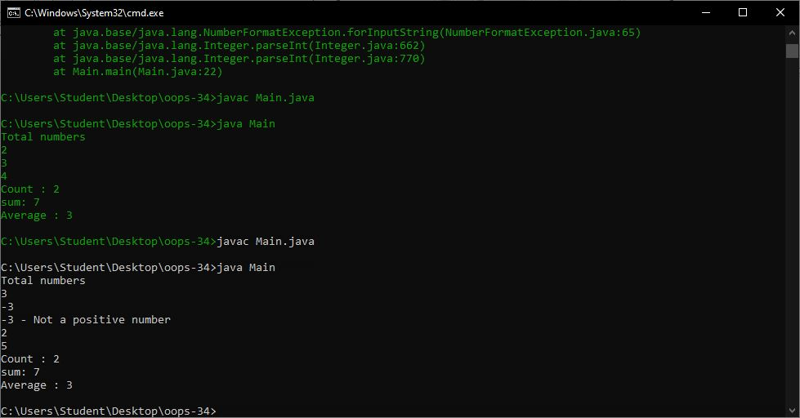

**5.Program to create a generic stack and do the Push and Pop operations**.

**Procedure**

class Stack {

private int arr[];

private int top;

private int capacity;

Stack(int size) {

arr = new int[size];

capacity = size;

top = -1;

}

public void push(int x) {

if (isFull()) {

System.out.println("Stack OverFlow");

System.exit(1);

}

System.out.println("Inserting " + x);

arr[++top] = x;

}

public int pop() {

if (isEmpty()) {

System.out.println("STACK EMPTY");

System.exit(1);

}

return arr[top--];

}

public int getSize() {

return top + 1;

}

public Boolean isEmpty() {

return top == -1;

}

public Boolean isFull() {

return top == capacity - 1;

}

public void printStack() {

for (int i = 0; i <= top; i++) {

System.out.print(arr[i] + ", ");

}

}

public static void main(String[] args) {

Stack stack = new Stack(5);

stack.push(1);

stack.push(2);

stack.push(3);

System.out.print("Stack: ");

stack.printStack();

stack.pop();

System.out.println("\nAfter popping out");

stack.printStack();

}

}

}

**Output**

