MAD LAB CYCLE – 2

- Create two activities,from the first activity move to the second activity on a button click.
Code : XML – activity_main.xml
<LinearLayout
android:layout_height="match_parent"
xmlns:android="http://schemas.android.com/apk/res/android"
android:layout_width="match_parent"
android:orientation="horizontal"
android:gravity="center">
<Button
android:layout_width="wrap_content"
android:layout_height="wrap_content"
android:id="@+id/btn"
android:text="Go To New Activity"
android:onClick="NewActivity"/>
</LinearLayout>
Code : activity_second.xml
<LinearLayout xmlns:android="http://schemas.android.com/apk/res/android"
android:id="@+id/activity_main2"
android:layout_width="match_parent"
android:layout_height="match_parent"
android:orientation="horizontal"
android:gravity="center">
<TextView
android:layout_width="wrap_content"
android:layout_height="wrap_content"
android:text="WELCOME NEW ACTIVITY:"
android:textColor="@color/colorPrimaryDark"
android:textSize="32dp"/>
</LinearLayout>
Code : JAVA – MainActivity.java
public class MainActivity extends AppCompatActivity {
Button btn;
@Override
protected void onCreate(Bundle savedInstanceState) {
super.onCreate(savedInstanceState);
setContentView(R.layout.activity_main);
}
public void NewActivity(View view) {
btn = findViewById(R.id.btn);
Intent Intent = new Intent(this, Activity_Second.class);
startActivity(Intent);
}
}

Code : ActivitySecond.java
public class Activity_Second extends AppCompatActivity {
@Override
protected void onCreate(Bundle savedInstanceState) {
super.onCreate(savedInstanceState);
setContentView(R.layout.activity__second);
}
}
Output :
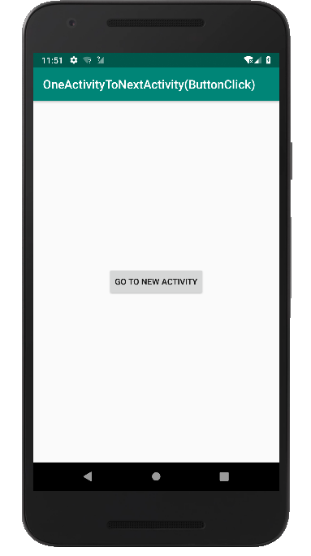
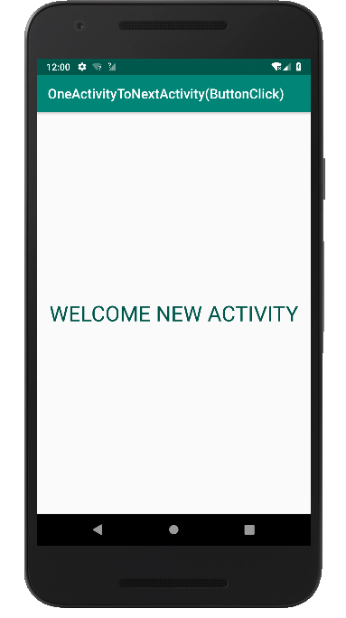

- Create an acticity,and move to facebook login page on button click.
Code : XML – activity_main.xml
<LinearLayout
android:layout_height="match_parent"
xmlns:android="http://schemas.android.com/apk/res/android"
android:layout_width="match_parent"
android:orientation="horizontal"
android:gravity="center">
<Button
android:layout_width="wrap_content"
android:layout_height="wrap_content"
android:id="@+id/btn"
android:text="FaceBook Login"
android:onClick="FBLogin"
android:gravity="center"/>
</LinearLayout>
Code : JAVA – MainActivity.java
import android.content.Intent;
import android.net.Uri;
import android.support.v7.app.AppCompatActivity;
import android.os.Bundle;
import android.view.View;
import android.widget.Button;
public class MainActivity extends AppCompatActivity {
Button btn;
@Override
protected void onCreate(Bundle savedInstanceState) {
super.onCreate(savedInstanceState);
setContentView(R.layout.activity_main);
btn = findViewById(R.id.btn);
btn.setOnClickListener(new View.OnClickListener() {
@Override
public void onClick(View v) {
Intent intent = new Intent(Intent.ACTION_VIEW,Uri.parse("https://www.facebook.com/"));
startActivity(intent);
}
});
}
}
Output :
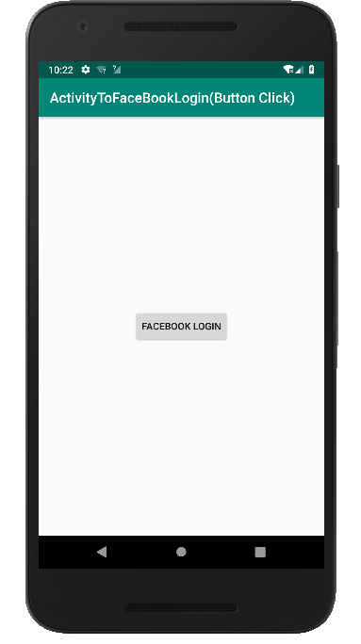
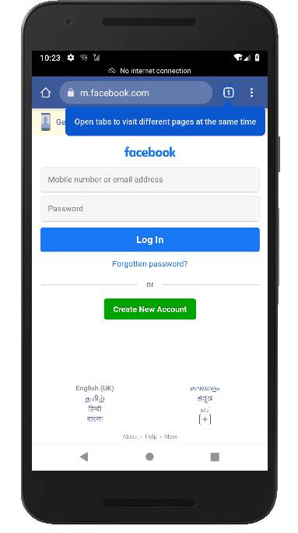

- Read a message in the first actiity and pass it to the second activity on a button click.
Code : XML – activity_main.xml
<?xml version="1.0" encoding="utf-8"?>
<LinearLayout
android:layout_width="match_parent"
xmlns:android="http://schemas.android.com/apk/res/android"
android:layout_height="match_parent"
android:orientation="horizontal"
android:gravity="center">
<EditText
android:layout_width="wrap_content"
android:layout_height="wrap_content"
android:id="@+id/edt"
android:hint="Enter Message To Pass"/>
<Button
android:layout_width="wrap_content"
android:layout_height="wrap_content"
android:id="@+id/btn"
android:text="Send"
android:onClick="pass"/>
</LinearLayout>
Code : activity_two.xml
<LinearLayout
android:layout_height="match_parent"
xmlns:android="http://schemas.android.com/apk/res/android"
android:layout_width="match_parent"
android:orientation="horizontal"
android:gravity="center">
<TextView
android:layout_width="wrap_content"
android:layout_height="wrap_content"
android:id="@+id/txv"
android:textStyle="bold"
android:textSize="40dp"
android:layout_marginTop="20dp"
android:layout_marginLeft="40dp"
/>
</LinearLayout>
Code : JAVA – MainActivity.java
public class MainActivity extends AppCompatActivity {
EditText edt;
Button btn;
@Override
protected void onCreate(Bundle savedInstanceState) {
super.onCreate(savedInstanceState);
setContentView(R.layout.activity_main);
edt = findViewById(R.id.edt);
btn = findViewById(R.id.btn);
}
public void pass(View view) {
String str = edt.getText().toString();
Intent intent = new Intent(getApplicationContext(), Activity_two.class);
intent.putExtra("message_key", str);
startActivity(intent);
}
}
Code : Activity_two.java
public class Activity_two extends AppCompatActivity {
TextView txv;
@Override
protected void onCreate(Bundle savedInstanceState) {
super.onCreate(savedInstanceState);
setContentView(R.layout.activity_two);
txv = findViewById(R.id.txv);
Intent intent = getIntent();
String str = intent.getStringExtra("message_key");
txv.setText(str);
}
}

Output :
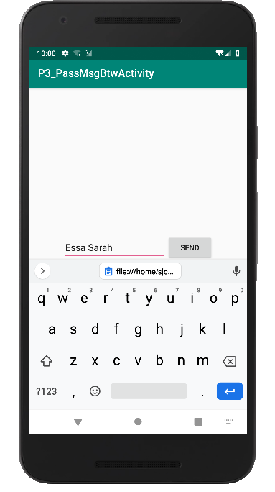
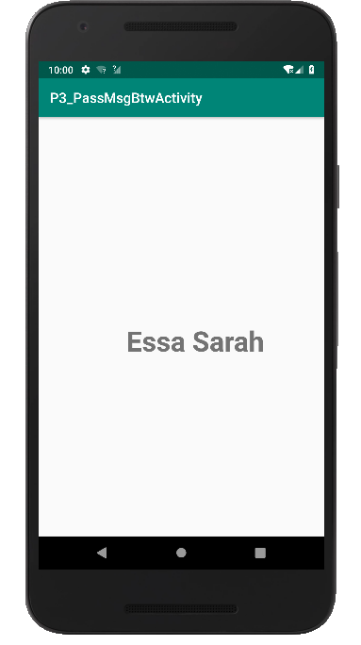

4. Create a registration page with full validation and pass the information to the second activity (using shared preference)
Mandatory fields : fname,lname,gender,email,phone number,password,dob(date picker)

Code : XML – activity_main.xml
<LinearLayout
android:layout_height="match_parent"
android:layout_width="match_parent"
android:orientation="vertical"
android:layout_gravity="left"
xmlns:android="http://schemas.android.com/apk/res/android">
<TextView
android:layout_width="match_parent"
android:layout_height="wrap_content"
android:layout_centerHorizontal="true"
android:layout_marginTop="32dp"
android:gravity="center"
android:text="Registration Form"
android:textColor="@android:color/black"
android:textSize="24sp" />
<EditText
android:layout_width="match_parent"
android:layout_height="wrap_content"
android:id="@+id/fname"
android:padding="10dp"
android:hint="First Name"/>
<EditText
android:layout_width="match_parent"
android:layout_height="wrap_content"
android:id="@+id/lname"
android:padding="10dp"
android:hint="Last Name"/>
<EditText
android:layout_width="match_parent"
android:layout_height="wrap_content"
android:id="@+id/gen"
android:padding="10dp"
android:hint="Gender"/>
<EditText
android:layout_width="match_parent"
android:layout_height="wrap_content"
android:id="@+id/email"
android:padding="10dp"
android:hint="Email Id"/>
<EditText
android:layout_width="match_parent"
android:layout_height="wrap_content"
android:id="@+id/phno"
android:padding="10dp"
android:hint="Contact"/>
<EditText
android:layout_width="match_parent"
android:layout_height="wrap_content"
android:id="@+id/pswd"
android:padding="10dp"
android:hint="Password"/>
<EditText
android:layout_width="match_parent"
android:layout_height="wrap_content"
android:id="@+id/dob"
android:padding="10dp"
android:hint="Date Of Birth"/>
<Button
android:layout_width="wrap_content"
android:layout_height="wrap_content"
android:id="@+id/btn"
android:text="Submit"
android:onClick="Save"/>
</LinearLayout>

Code : XML – activity_main2.xml
<LinearLayout android:layout_width="match_parent"
android:layout_height="match_parent"
android:orientation="vertical"
android:gravity="center"
xmlns:android="http://schemas.android.com/apk/res/android">
<TextView
android:layout_width="wrap_content"
android:layout_height="wrap_content"
android:text="WELCOME "
android:textColor="@color/colorPrimaryDark"
android:textSize="32dp"/>
<TextView
android:layout_width="match_parent"
android:layout_height="wrap_content"
android:gravity="center"
android:id="@+id/tv"
android:textColor="@color/colorPrimaryDark"
/>
<TextView
android:id="@+id/tv1"
android:layout_width="match_parent"
android:layout_height="wrap_content"
android:gravity="center"
android:textColor="@color/colorPrimaryDark" />
<TextView
android:layout_width="match_parent"
android:layout_height="wrap_content"
android:id="@+id/tv2"
android:gravity="center"
android:textColor="@color/colorPrimaryDark"
/>
<TextView
android:layout_width="match_parent"
android:layout_height="wrap_content"
android:id="@+id/tv3"
android:gravity="center"
android:textColor="@color/colorPrimaryDark"
/>
<TextView
android:layout_width="match_parent"
android:layout_height="wrap_content"
android:id="@+id/tv4"
android:gravity="center"
android:textColor="@color/colorPrimaryDark"
/>
<TextView
android:layout_width="match_parent"
android:layout_height="wrap_content"
android:id="@+id/tv5"
android:gravity="center"
android:textColor="@color/colorPrimaryDark"
/>
<TextView
android:layout_width="match_parent"
android:layout_height="wrap_content"
android:id="@+id/tv6"
android:gravity="center"
android:textColor="@color/colorPrimaryDark"
/>
</LinearLayout>

Code : JAVA – MainActivity.java
public class MainActivity extends AppCompatActivity {
EditText fname,lname,gen,phno,email,pswd,dob;
Button btn;
SharedPreferences sharedpreferences;
public static final String MyPREFERENCES = "MyPrefs" ;
@Override
protected void onCreate(Bundle savedInstanceState) {
super.onCreate(savedInstanceState);
setContentView(R.layout.activity_main);
fname = findViewById(R.id.fname);
lname = findViewById(R.id.lname);
gen = findViewById(R.id.gen);
email = findViewById(R.id.email);
phno = findViewById(R.id.phno);
pswd = findViewById(R.id.pswd);
dob = findViewById(R.id.dob);
btn = findViewById(R.id.btn);
sharedpreferences = getSharedPreferences(MyPREFERENCES, Context.MODE_PRIVATE);
btn.setOnClickListener(new View.OnClickListener() {
@Override
public void onClick(View v) {
checkDataEntered();
SharedPreferences MyPrefs = getSharedPreferences("activity_main2.xml",0);
SharedPreferences.Editor editor=MyPrefs.edit();//only write editor
editor.putString("fname",fname.getText().toString());
editor.putString("lname",lname.getText().toString());
editor.putString("phno", phno.getText().toString());
editor.putString("gen", gen.getText().toString());
editor.putString("mail", email.getText().toString());
editor.putString("dob", dob.getText().toString());
editor.putString("pswd",pswd.getText().toString());
editor.commit();
Intent intent = new Intent(getApplicationContext(), Main2Activity.class);
intent.putExtra("fname",fname.getText().toString());
intent.putExtra("lname",lname.getText().toString());
intent.putExtra("phno", phno.getText().toString());
intent.putExtra("gen", gen.getText().toString());
intent.putExtra("mail", email.getText().toString());
intent.putExtra("dob", dob.getText().toString());
intent.putExtra("pswd",pswd.getText().toString());
startActivity(intent);
Toast.makeText(MainActivity.this,"Thanks",Toast.LENGTH_LONG).show();
}
});
}
boolean isEmail(EditText text) {
CharSequence email = text.getText().toString();
return (!TextUtils.isEmpty(email) && Patterns.EMAIL_ADDRESS.matcher(email).matches());
}
boolean isEmpty(EditText text) {
CharSequence str = text.getText().toString();
return TextUtils.isEmpty(str);
}
void checkDataEntered() {
if (isEmpty(fname)) {
Toast t = Toast.makeText(this, "You must enter first name to register!", Toast.LENGTH_SHORT);
t.show();
}
if (isEmpty(lname)) {
lname.setError("Last name is required!");
}
if (isEmpty(phno)) {
phno.setError("mobile number is required!");
}
if (isEmpty(gen)) {
gen.setError("Gender is required!");
}
if (isEmpty(pswd)) {
pswd.setError("Password is required!");
}
if (isEmpty(dob)) {
dob.setError("DOB is required!");
}
if (isEmail(email) == false) {
email.setError("Enter valid email!");
}
}

}

Code : JAVA – Main2Activity.java

public class Main2Activity extends AppCompatActivity {
TextView tv,tv1,tv2,tv3,tv4,tv5,tv6;
@Override
protected void onCreate(Bundle savedInstanceState) {
super.onCreate(savedInstanceState);
setContentView(R.layout.activity_main2);
tv =findViewById(R.id.tv);
tv1 =findViewById(R.id.tv1);
tv2 =findViewById(R.id.tv2);
tv3 =findViewById(R.id.tv3);
tv4 =findViewById(R.id.tv4);
tv5 =findViewById(R.id.tv5);
tv6 =findViewById(R.id.tv6);
Intent intent = getIntent();
SharedPreferences mypref=getSharedPreferences("activity_main2.xml",0);
String str = mypref.getString("fname",null);
String str1 = mypref.getString("lname",null);
String str2 = mypref.getString("gen",null);
String str3 = mypref.getString("phno",null);
String str4 = mypref.getString("pwd",null);
String str5 = mypref.getString("email",null);
String str6 = mypref.getString("dob",null);
tv.setText(str);
tv1.setText(str1);
tv2.setText(str2);
tv3.setText(str3);
tv4.setText(str4);
tv5.setText(str5);
tv6.setText(str6);
}
}

Output:

