**Cycle-1**

1. Print your name to the screen with every letter being a different heading size.

**<html>**

**<title>Program No:1</title>**

**<body>**

**<h1>S</h1>**

**<h2>A</h2>**

**<h3>N</h3>**

**<h4>D</h4>**

**<h5>R</h5>**

**<h6>A</h6>**

**</body>**

**</html>**

**Output:**

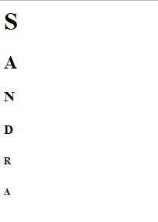

1. Display the following text:

H2O

12th April 2016

HTML stands for ~~High Text Markup Language~~

He said <**I am fine**>

**<html>**

**<head>**

**<title>WELCOME</title>**

**</head>**

**<body>**

**<link rel="stylesheet" href="home.html"**

**</body>**

**</html>**

**Output:**

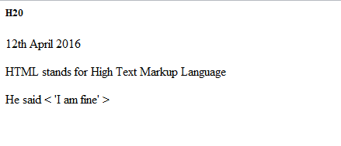

1. Print a paragraph with 4 - 5 sentences. Each sentence should be a different font.

**< html>**

**<body>**

**<p>**

**<font face="Courier New">**

**HTML stands for Hyper Text Markup Language.**

**</font>**

**<font face="Times new Roman">**

**It describes the structure of Web pages using markup.**

**</font>**

**<font face="helvetica">**

**HTML elements are the Building blocks of Html page.**

**</font>**

**<font face="Georgia">**

**HTML elements are represented by tagd.**

**</fonts>**

**<font face="Tahoma">**

**HTML tags label pieces of content such as "heading", "paragraph" , "table" and so on.**

**</font>**

**</p>**

**</body>**

**</html>**

**Output:**

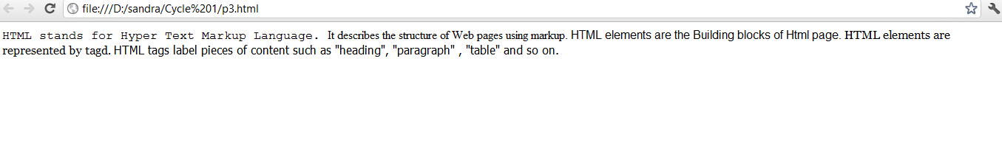

1. Print a paragraph that is a description of a book, include the title of the b ook as well as its author. Names and titles should be underlined, adjectives should be italicized and bolded

**<html>**

**<body>**

**<h1>**

**<u>A PASSAGE TO INDIA</u>**

**</h1>**

**is a novel by English author <h3><u> E M Forster</u></h3>.**

**<p>**

**A PASSAGE TO INDIA , by E M Forster set against the backdrop of the British Raj and the Indian independence movement in the 1920s. It was selected as one of the 100 great works of 20th century English literature by the Modern Library and won the 1924 James Tait Black Memorial Peize for fiction.**

**<u> A PASSAGE TO INDIA</u> is a <b><i> great</i></b> book.**

**It is <b><i> Well Written </i></b>and<b><i> intersting</i></b>.**

**</p>**

**</body>**

**</html>**

**Output:**

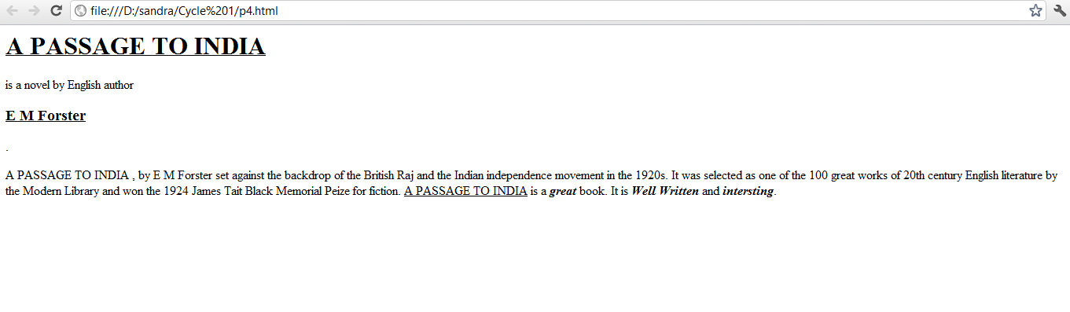

1. Print two lists with any information you want. One list should be an ordered list, the other list should be an unordered list.

**<html>**

**<body>**

**<b> Web Languages : Ordered List </b>**

**<ol>**

**<li> HTML</li>**

**<li> PHP</li>**

**<li> JAVA </li>**

**</ol>**

**<b>Web Languages : Unordered List </b>**

**<ul>**

**<li> HTML </li>**

**<li> PHP </li>**

**<li> JAVA </li>**

**</ul>**

**</body>**

**</html>**

**Output:**

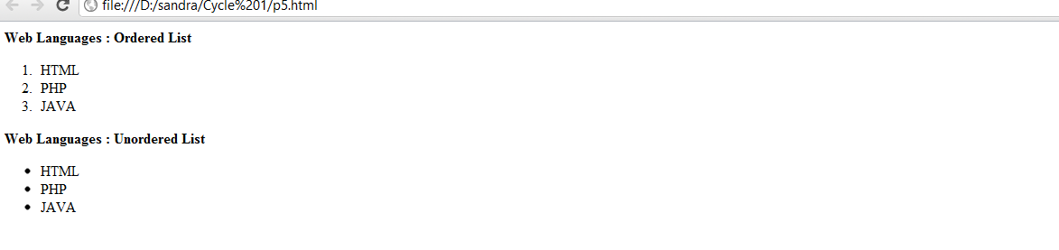

1. Prints 10 names with a line break betwe en each name. The list should be alphabetized, and to do this place a subscripted number next to each name based on where it will go in the alphabetized list. (Example: Alan1). Print first, the unalphabetized list with a subscript number next to each name, then the alphabetized list. Both lists should have an <h1> level heading

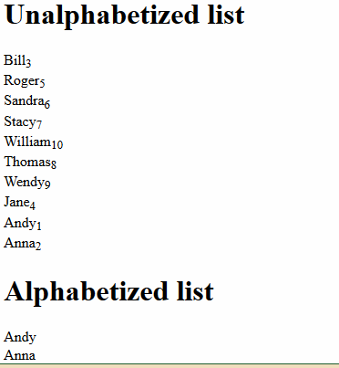

**<html>**

**<body>**

**<h1>Unalphabetized list</h1>**

**<ol>**

**<li>Bill<sub>3</sub></li>**

**<br />**

**<li>Roger<sub>5</sub></li>**

**<br />**

**<li>Sandra<sub>6</sub></li>**

**<br />**

**<li>Stacy<sub>7</sub></li>**

**<br />**

**<li>William<sub>10</sub></li>**

**<br />**

**<li>homas<sub>8</sub></li>**

**<br />**

**<li>Wendy<sub>9</sub></li>**

**<br />**

**<li>Jane<sub>4</sub></li>**

**<br />**

**<li>Andy<sub>1</sub></li>**

**<br />**

**<li>Anna<sub>2</sub></li>**

**</ol>**

**<h1>Alphabetized list</h1>**

**<ul>**

**<li>Andy</li>**

**<br />**

**<li>Anna</li>**

**<br />**

**<li>Bill</li>**

**<br />**

**<li>Jane</li>**

**<br />**

**<li>Roger</li>**

**<br />**

**<li>Sandra</li>**

**<br />**

**<li>Stacy</li>**

**<br />**

**<li>Thomas</li>**

**<br />**

**<li>Wendy</li>**

**<br />**

**<li>William</li></ul>**

**</body>**

**</html>**

**Output:**

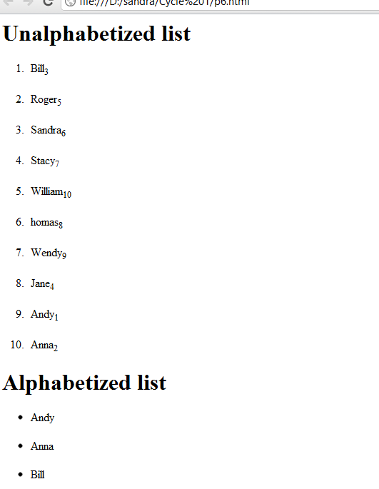

1. Print the squares of the numbers 1 - 20. Each number should be on a separate line, next to it the number 2 superscripted, an equal sign and the result

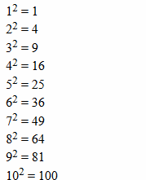

**<html>**

**<body>**

**1<sup>2</sup> = 1**

**<br />**

**2<sup>2</sup> = 4**

**<br />**

**3<sup>2</sup> = 9**

**<br />**

**4<sup>2</sup> = 16**

**<br />**

**5<sup>2</sup> = 25**

**<br />**

**6<sup>2</sup> = 36**

**<br />**

**7<sup>2</sup> = 49**

**<br />**

**8<sup>2</sup> = 64**

**<br />**

**9<sup>2</sup> = 81**

**<br />**

**10<sup>2</sup> = 100**

**<br />**

**11<sup>2</sup> = 121**

**<br />**

**12<sup>2</sup> = 144**

**<br />**

**13<sup>2</sup> = 169**

**<br />**

**14<sup>2</sup> = 196**

**<br />**

**15<sup>2</sup> = 225**

**<br />**

**16<sup>2</sup> = 256**

**<br />**

**17<sup>2</sup> = 289**

**<br />**

**18<sup>2</sup> = 324**

**<br />**

**19<sup>2</sup> = 361**

**<br />**

**20<sup>2</sup> = 400**

**</body>**

**</html>**

**Output:**

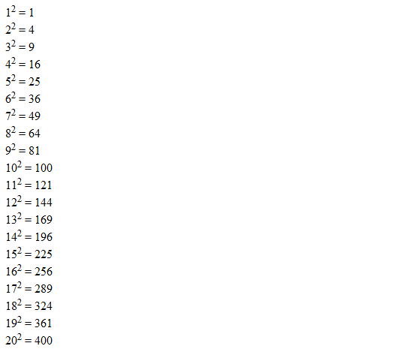

1. Print a definition list with 5 items.

**<html>**

**<body>**

**<dl>**

**<dt>HTML</dt>**

**<dd>A markup language</dd>**

**<dt>Pen</dt>**

**<dd>A writing tool</dd>**

**<dt>Apple</dt>**

**<dd>A Fruit</dd>**

**<dt>Yellow</dt>**

**<dd>A <Colour/dd>**

**<dt>Lotus</dt>**

**<dd>A Flower</dd>**

**</dl>**

**</body>**

**</html>**

**Output:**

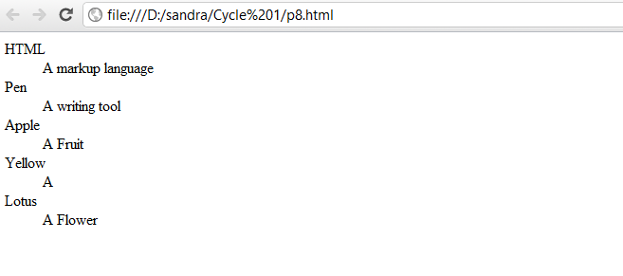

1. Display an image that has a border of size 2, a width of 200, and a height of 200.

**<html>**

**<body>**

**<img src="D:\sandra\images\raindrop.jpg" width="200" height="200" alt="Raindrop" border="2" />**

**</body>**

**</html>**

**OutPut:**

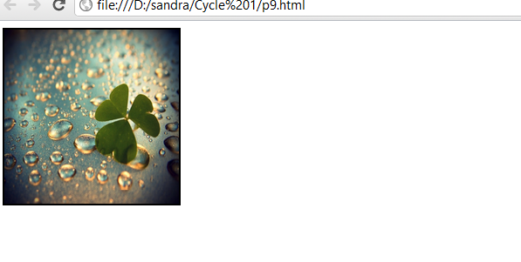

1. Print ten acronyms and abbreviations of your choosing, each separated by two lines. Specify the data that the abbreviations and acronyms represent

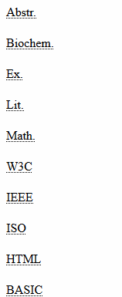

**<html>**

**<body>**

**<abbr title="Abstract">Abstr.</abbr>**

**<br /><br />**

**<abbr title="Biochemistry">Biochem.</abbr>**

**<br /><br />**

**<abbr title="Example">Ex.</abbr>**

**<br /><br />**

**<abbr title="Literature">Lit.</abbr>**

**<br /><br />**

**<a bbr title="Mathematics">Math.</abbr>**

**<br /><br />**

**<acronym title="World Wide Web Consortium">W3C</acronym>**

**<br /><br />**

**<acronym title="Institute of Electrical**

**and Electronic Engineers">IEEE</acronym>**

**<br /><br />**

**<acronym title="International Standards Organization">**

**ISO**

**</acronym>**

**<br /><br />**

**<acronym title="Hyper Text Markup Language">HTML</acronym>**

**<br /><br />**

**<acronym title="Beginners All Purpose**

**Symbolic Instruction Code">BASIC**

**</acronym>**

**<p>**

**Move your mouse over an abbreviation or acronym to get more data.**

**</p>**

**</body>**

**</html>**

**Output:**

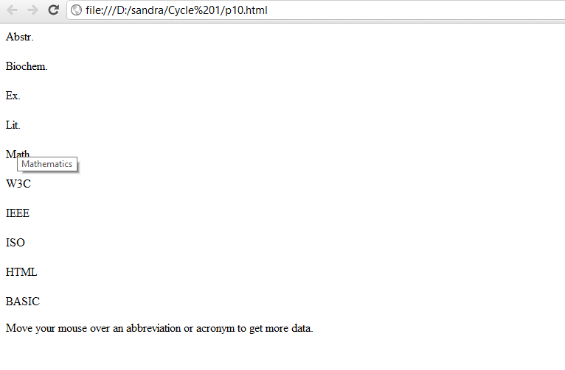

1. Print two addresses in the same format used on the front of envelopes (senders address in top left corner, receivers address in the center

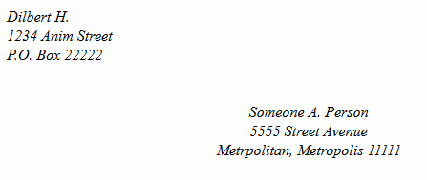

**<html>**

**<body>**

**<address>**

**Dilbert H.<br />**

**1234 Anim Street<br />**

**P.O. Box 22222**

**</address>**

**<br /><br />**

**<center>**

**<address>**

**Someone A. Person<br />**

**5555 Street Avenue<br />**

**Metrpolitan, Metropolis 11111**

**</address>**

**</center>**

**</body>**

**</html>**

**Output:**

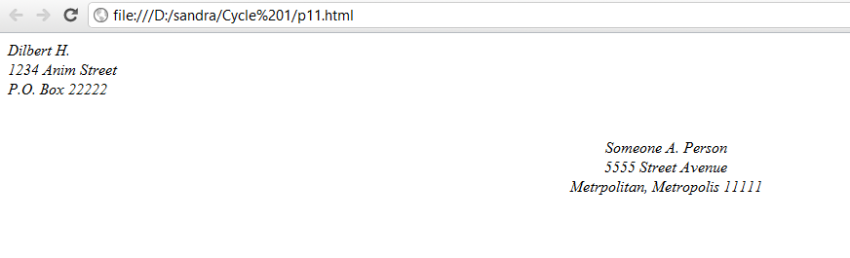

1. Create an HTML page with the following contents:

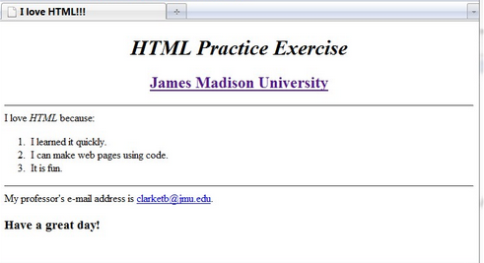

**<html>**

**<head>**

**<title> I love HTML!!!</title>**

**</head>**

**<body bgcolor="pink">**

**<div style align="center">**

**<h1>HTML Practise Excercise</h1>**

**<font size="5" color="brown" ><u> James Madison University</u></font>**

**</div>**

**<hr color="black">**

**I love HTML because**

**<ol>**

**<li> I learned it quickly</li>**

**<li> I can make web pages using code </li>**

**<li> It is fun </li>**

**</ol>**

**<hr color="black">**

**My professor's email address is <a href="#">clarketb@jmu.edu</a>**

**<h2> Have a great day!</h2>**

**</body>**

**</html>**

**Output:**

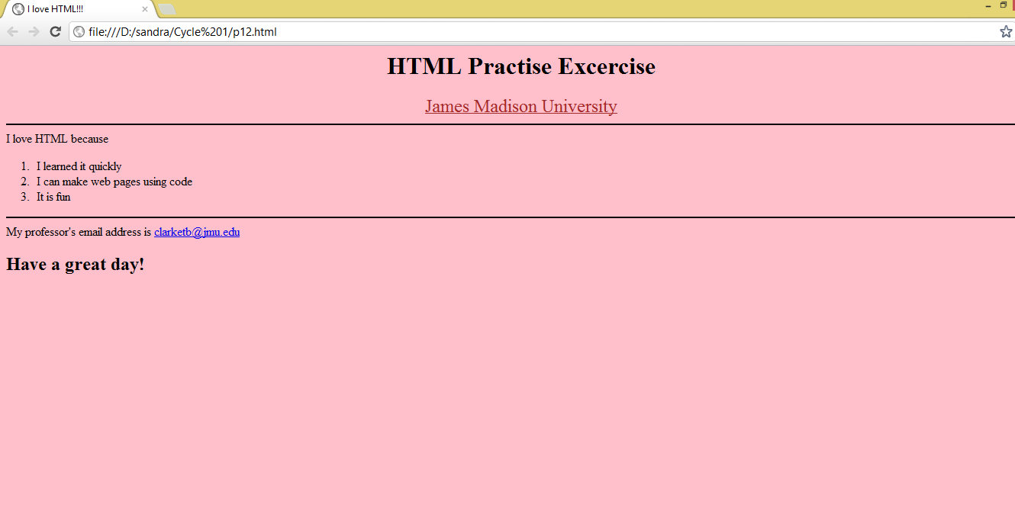

1. Create the following table

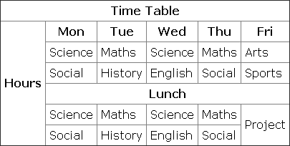

**<html>**

**<head>**

**<title> </title>**

**</head>**

**<body bgcolor="pink">**

**<table border="1">**

**<tr>**

**<th colspan="6">Time Table</th>**

**</tr>**

**<tr>**

**<th rowspan="6">Hour's</th>**

**<th>Monday</th>**

**<th>Tuesday</th>**

**<th>Wednesday</th>**

**<th>Thursday</th>**

**<th>Friday</th>**

**</tr>**

**<tr>**

**<td>Science</td>**

**<td>Maths</td>**

**<td>Science</td>**

**<td>Maths</td>**

**<td>Arts</td>**

**</tr>**

**<tr>**

**<td>Social</td>**

**<td>History</td>**

**<td>English</td>**

**<td>Social</td>**

**<td>Sports</td>**

**</tr>**

**<tr>**

**<th colspan="5">Lunch</th>**

**</tr>**

**<tr>**

**<td>Science</td>**

**<td>Maths</td>**

**<td>Science</td>**

**<td>Maths</td>**

**<td>Project</td>**

**</tr>**

**<tr>**

**<td>Social</td>**

**<td>History</td>**

**<td>English</td>**

**<td>Social</td>**

**<td>Project</td>**

**</tr>**

**</body>**

**</html>**

**Output:**

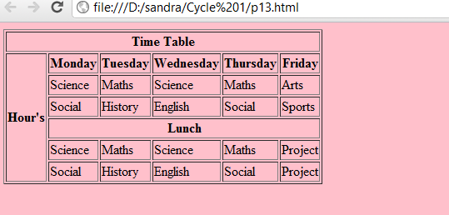

1. Create a HTML Page which looks like the one given below

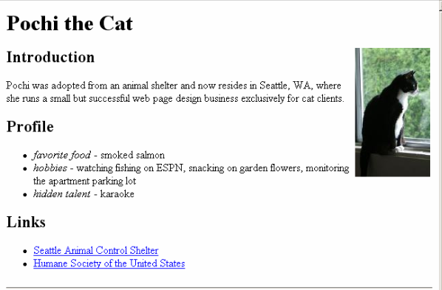

**<html>**

**<head>**

**<title> </title>**

**</head>**

**<body bgcolor="pink">**

**<h1>Pochi the Cat</h1>**

**<img src="D:\sandra\images\cat.jpg" alt="cat" style align="right" width="250" height="300">**

**<h2>Indroduction</h2>**

**<p>Pochi was adopted from animal shelter and now resides in Seattle, WA, where she runs a small but successful web page design business exclusively for cat clients.</p>**

**<h2>Profile</h2>**

**<ul>**

**<li><i> favorite food </i>- smoked salmon</li>**

**<li><i>Hobbies</i> - watching fishing on ESPN, snacking on garden flowers.</li>**

**<li><i>Hidden talent</i> - karaoke</li>**

**<h2>Links</h2>**

**<ul> <li><a href="#"> Seattle Animal Control Shelter</a></li>**

**<li><a href="#"> Humane Society of the United States</a></li>**

**</ul>**

**</body>**

**</html>**

**Output:**

