**Cycle-3**

1. Change the color of all <p> elements to "red".

<html>

<head>

<style>

.colortext {

color: red;

}

</style>

</head>

<body>

<h1>This is a Heading</h1>

<p class="colortext">This is a paragraph.</p>

<p class="colortext">This is another paragraph.</p>

<p class="colortext">This is also a paragraph.</p>

</body>

</html>

Output:

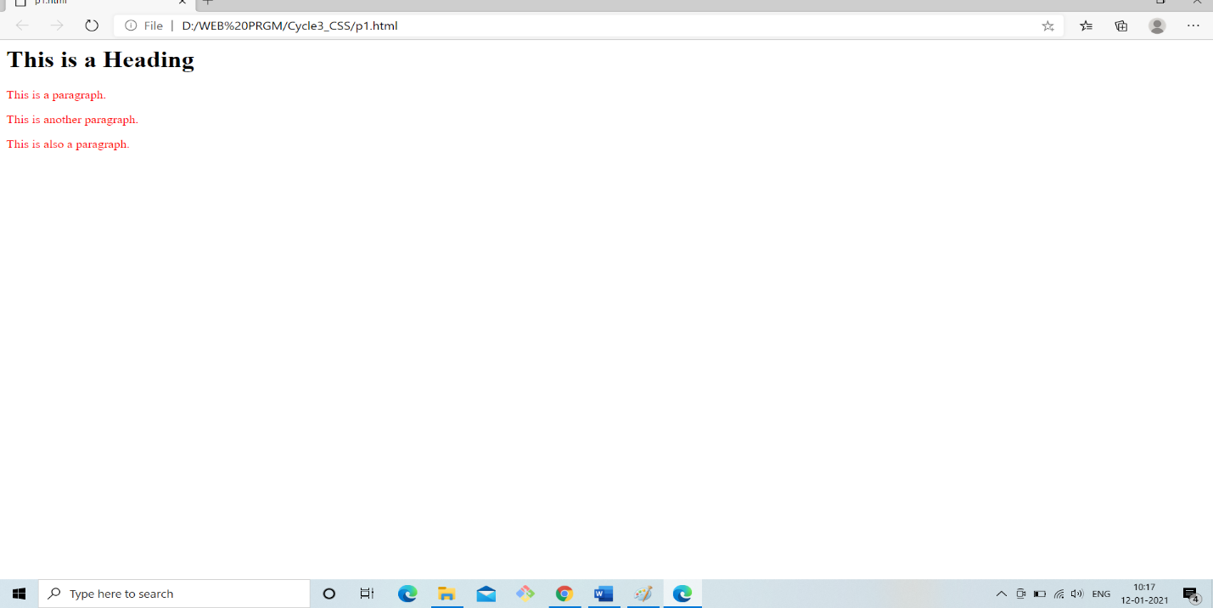

1. Create all <p> elements will be center-aligned, with a red text color.

<html>

<head>

<style>

.center {

text-align: center;

color: red;

</style>

</head>

<body>

<h1 class="center">Red and center-aligned heading</h1>

<p class="center">This is a paragraph.</p>

<p class="center">This is another paragraph.</p>

</body>

</html>

Output:

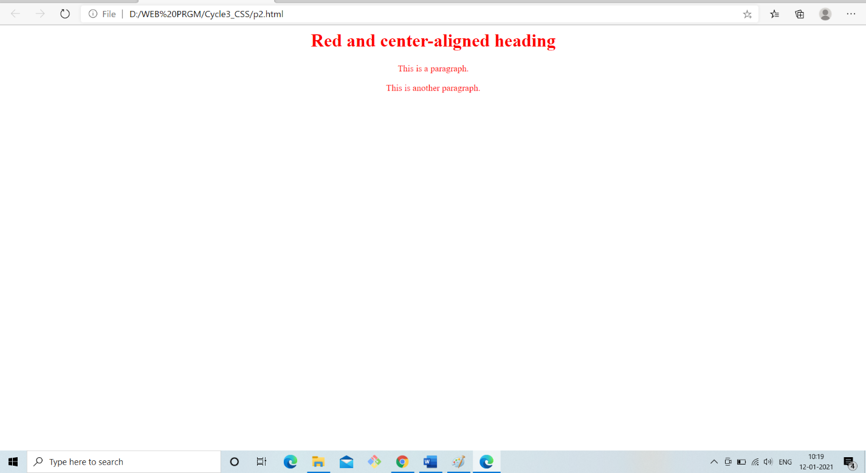

1. Create CSS comment starts with /* and ends with */.

<html>

<head>

<style>

p {

color: red; /* Set text color to red */

}

</style>

</head>

<body>

<!-- These paragraphs will be red -->

<h1><p>Hello World!</p></h1>

</body>

</html>

Output:

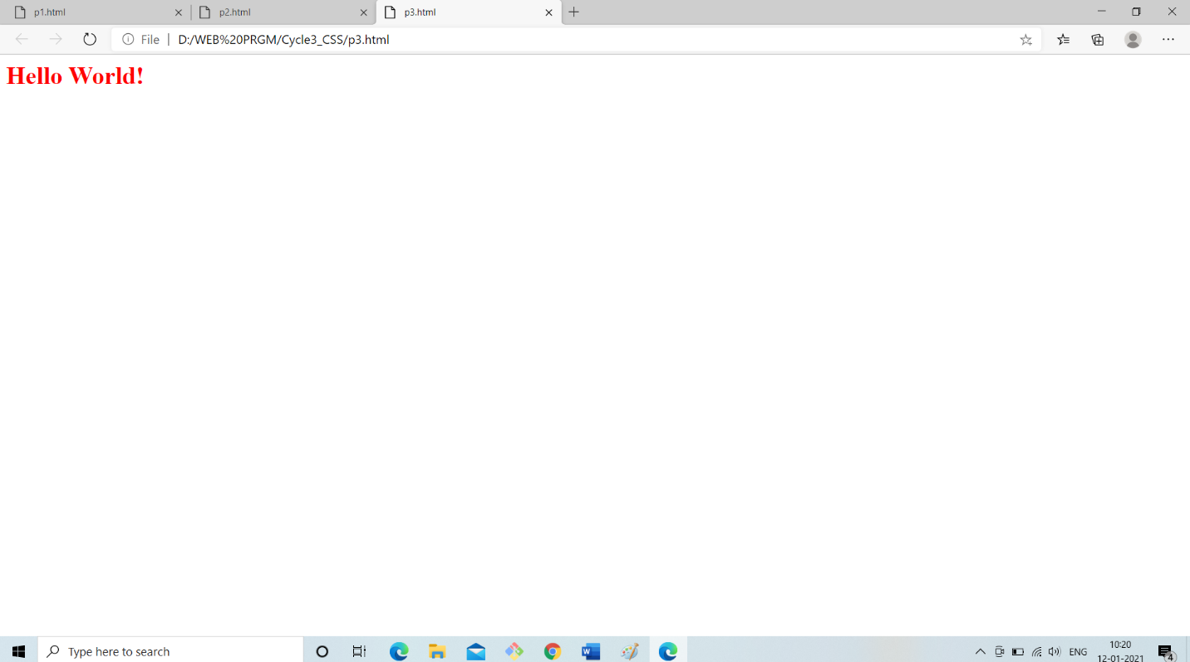

1. Set the background color for the page to "linen" and the background color for <h1> to "lightblue".

<html>

<head>

<style>

body {

background-color: linen;

}

h1 {

background-color: lightblue;

}

</style>

</head>

<body>

<h1>This is a Heading</h1>

<p>This is a paragraph.</p>

</body>

</html>

Output:

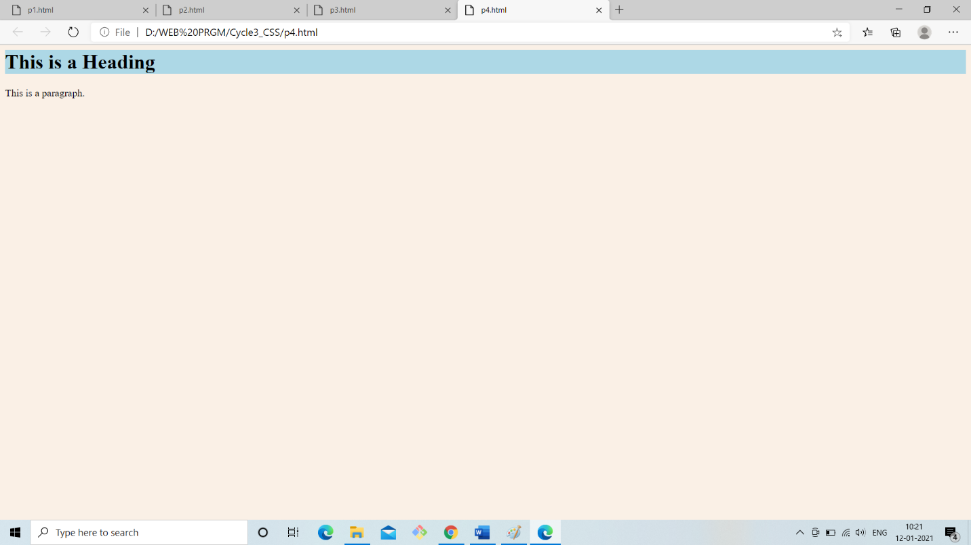

1. Set the font family for the page to "Courier New", and the font family for <h1> to "Verdana".

<html>

<head>

<style>

body {

font-family: "Courier New";

}

h1 {

font-family: Verdana;

}

</style>

</head>

<body>

<h1>This is a Heading</h1>

<p>This is a paragraph.</p>

</body>

</html>

Output:

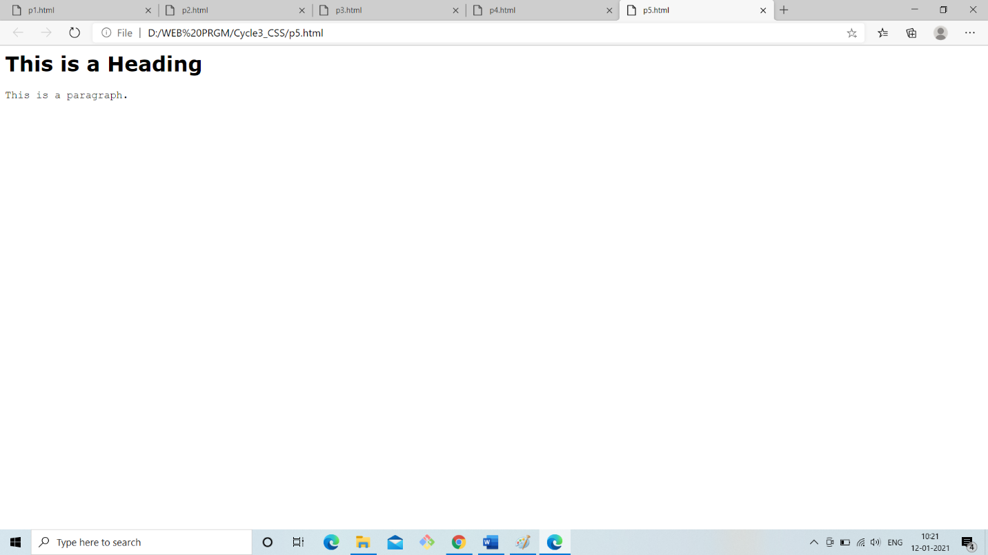

1. Change the color of all <p> and <h1> elements, to "red". Group the selectors to minimize code.

<html>

<head>

<style>

h1, p {

color: red;

}

</style>

</head>

<body>

<h1>This is a heading</h1>

<h2>This is a another heading</h2>

<p>This is a paragraph.</p>

<p>This is another paragraph.</p>

</body>

</html>

Output:

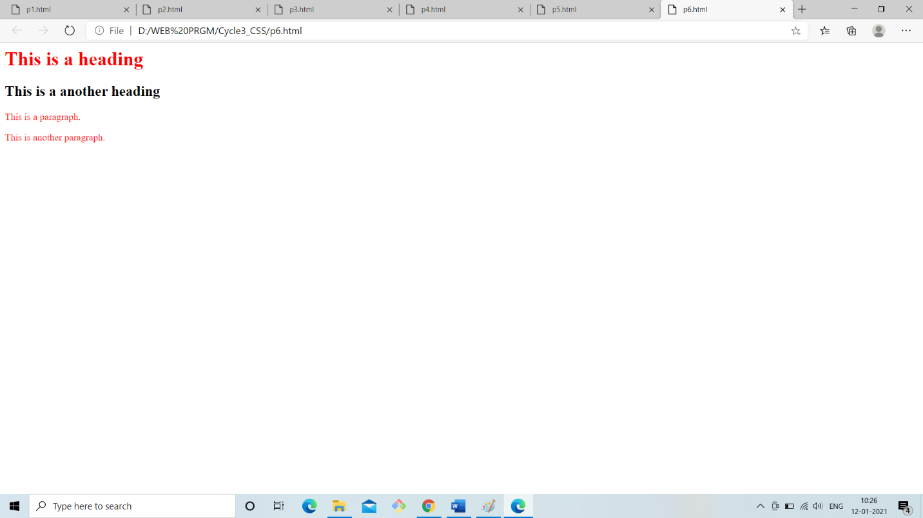

1. Specify that the background image should be shown once, in the top right corner.

<html>

<head>

<style>body {

background-image: url("file:///C:/Users/Sandra/Pictures/images/cat.jpg");

background-repeat: no-repeat;

background-position: top right;

}

</style>

</head>

<body>

<h1>This is a Heading</h1>

<p>This is a paragraph.</p>

</body>

</html>

Output:

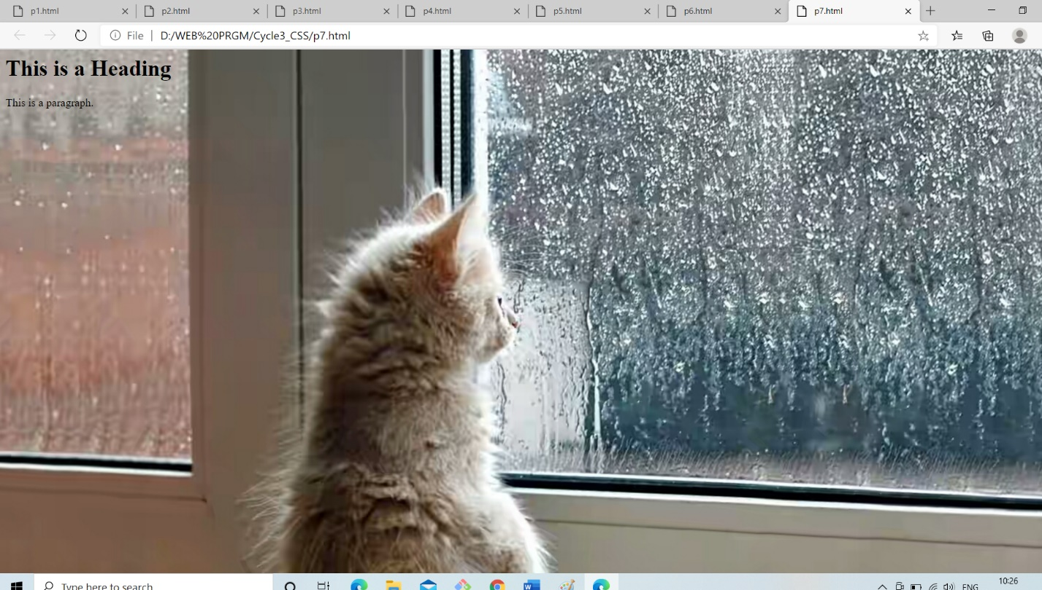

1. With the font property: Set the <p> to "italic", "20px" and "Verdana".

<html>

<head>

<style>

p {

font: italic 20px Verdana;

}

</style>

</head>

<body>

<h1>This is a Heading</h1>

<p>This is a paragraph.</p>

<p>This is another paragraph.</p>

</body>

</html>

Output:

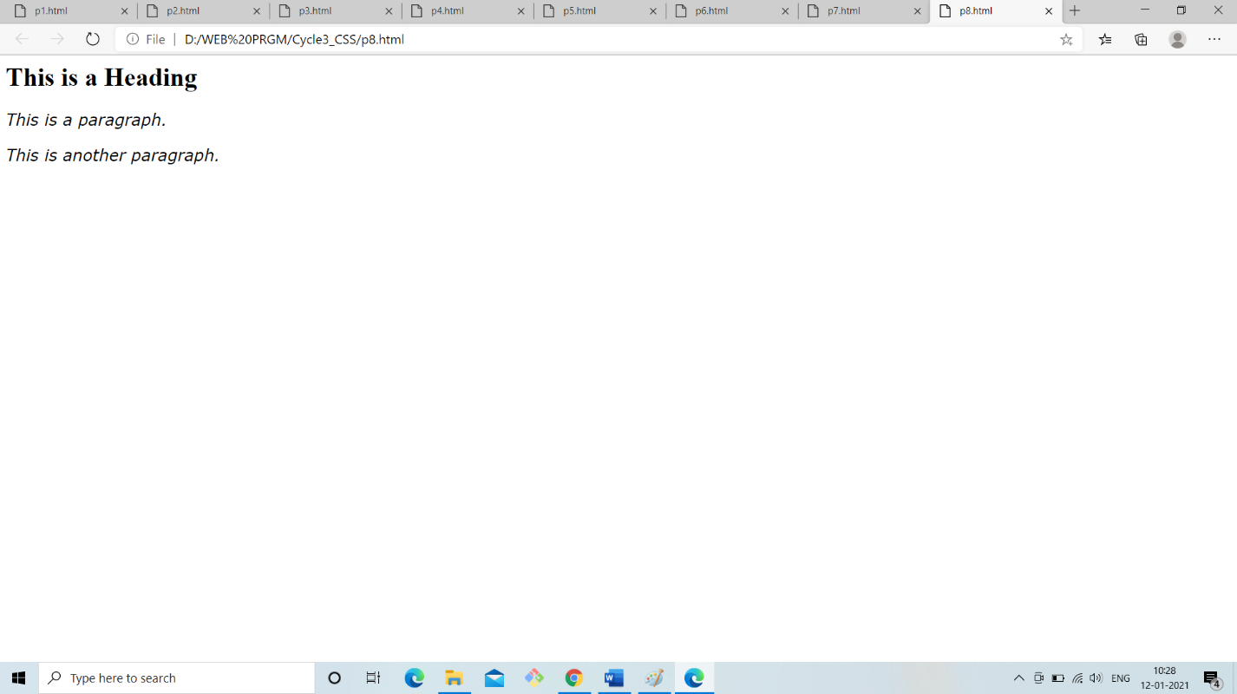

1. Set " gif image" as the background image of the page.

<html>

<head>

<style>body {

background-image: url("file:///C:/Users/Sandra/Desktop/Gif.jpg");

}

</style>

</head>

<body>

<h1>This is a Heading</h1>

<p>This is a paragraph.</p>

<p>This is another paragraph.</p>

</body>

</html>

Output:

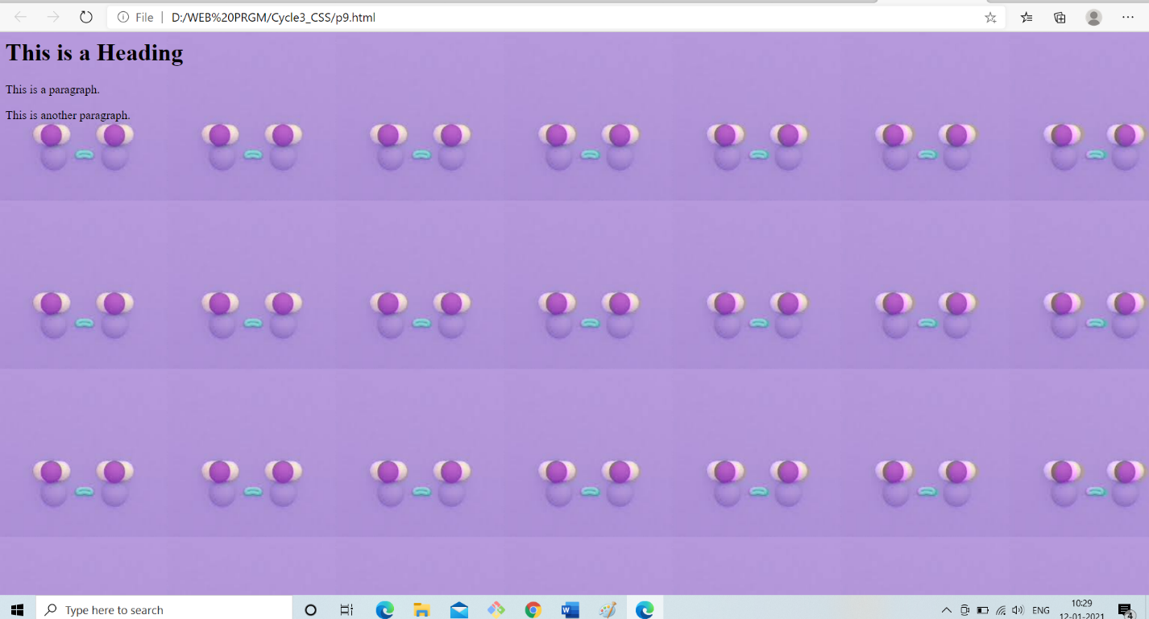

1. Set " png image" as the background image of the page, and repeat it vertically only.

<html>

<head>

<style>body {

background-image: url("file:///C:/Users/Sandra/Desktop/PngImage.jpg");

background-repeat: repeat-y;

}

</style>

</head>

<body>

<h1>This is a Heading</h1>

<p>This is a paragraph.</p>

<p>This is another paragraph.</p>

</body>

</html>

Output:

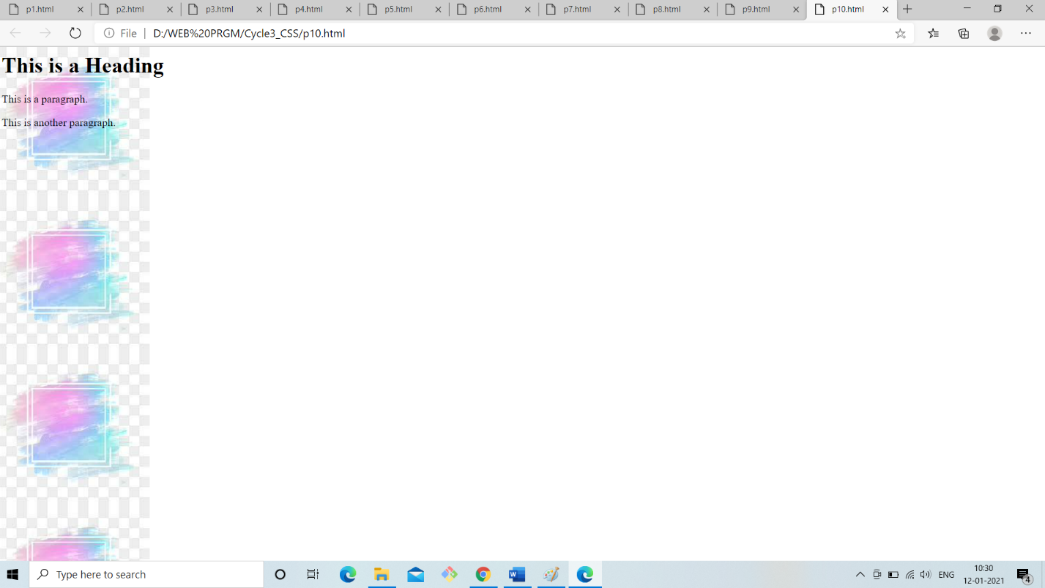

1. Indent the first line of the <p> element with 20px.

<html>

<head>

<style>

p {

text-indent: 20px;

}

</style>

</head>

<body>

<h1>This is a Heading</h1>

<p>CSS stands for Cascading Style Sheets

CSS describes how HTML elements are to be displayed on screen, paper, or in other media

CSS saves a lot of work. It can control the layout of multiple web pages all at once

External stylesheets are stored in CSS files.

Cascading Style Sheets is a style sheet language used for describing the presentation of a document written in a markup language such as HTML.

CSS is a cornerstone technology of the World Wide Web, alongside HTML and JavaScript.</p>

</body>

</html>

Output:

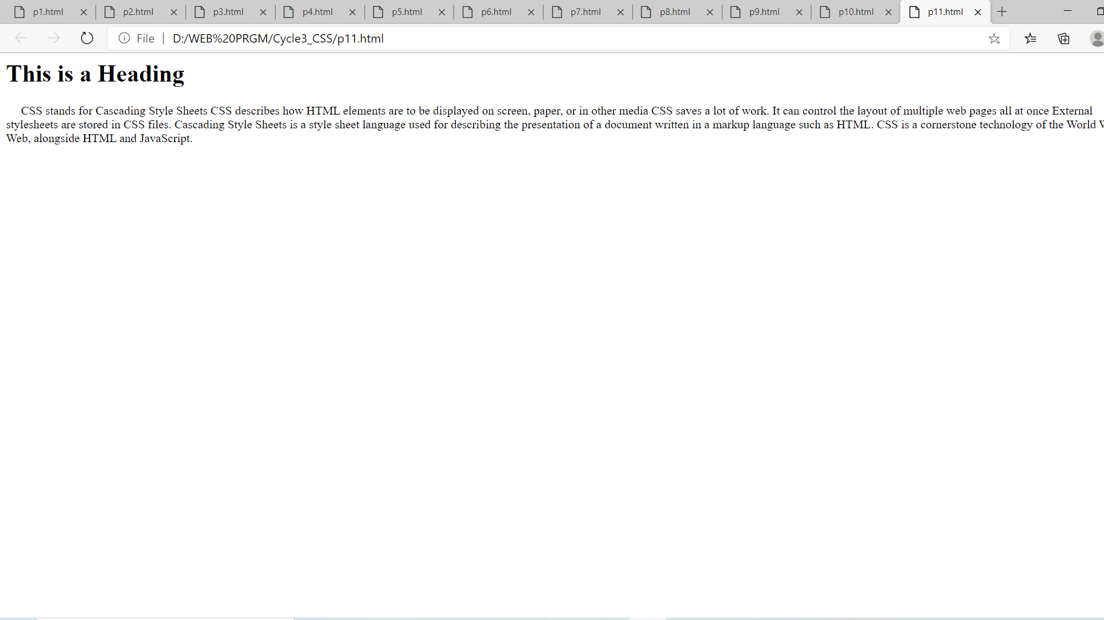

1. Set the color for links to "green".

<html>

<head>

<style>

a {

color: green;

}

</style>

</head>

<body>

<h1>This is a Heading</h1>

<p>This is a paragraph.</p>

<p><a>Whatsapp.com</a></p>

</body>

</html>

Output:

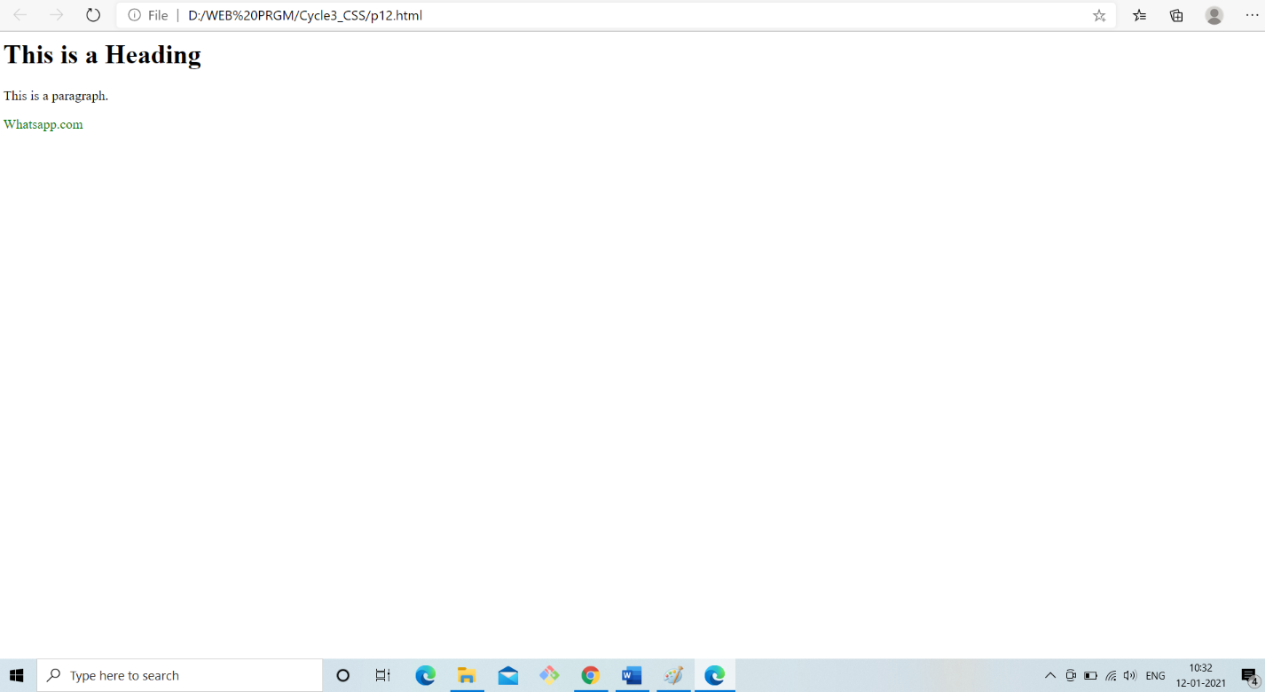

1. Show <p> elements as "italic" text.

<html>

<head>

<style>

p {

font-style: italic;

}

</style>

</head>

<body>

<h1>This is a Heading</h1>

<p>This is a paragraph.</p>

<p>This is another paragraph.</p>

</body>

</html>

Output:

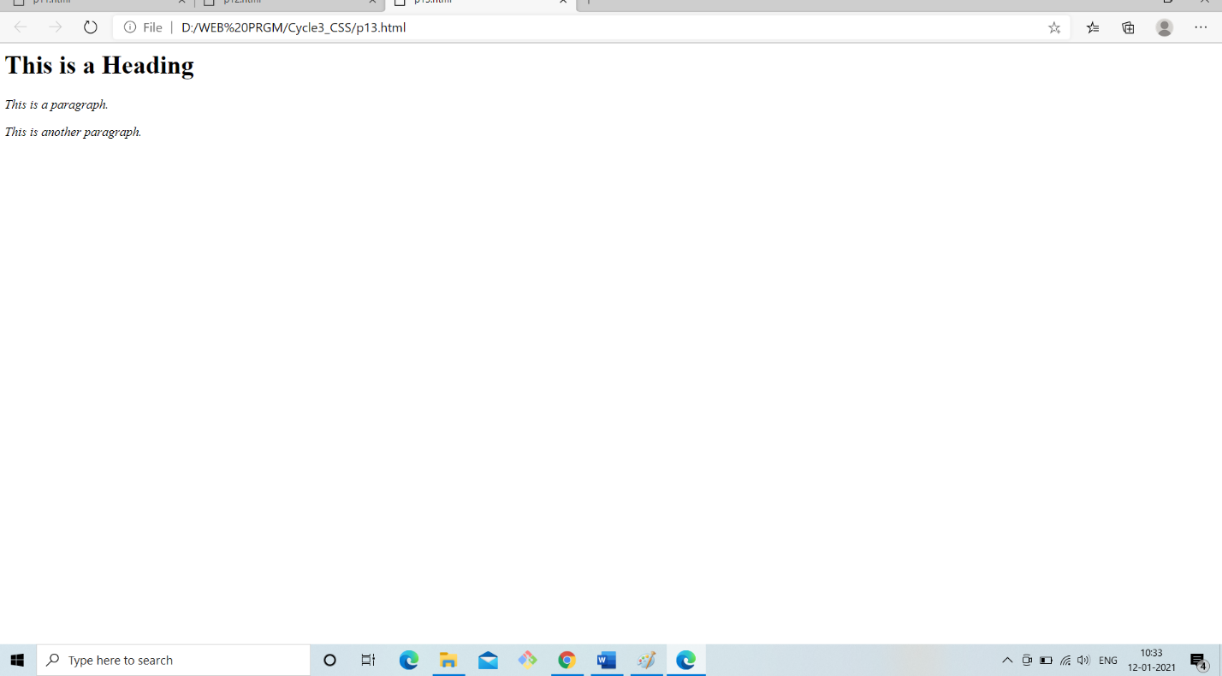

1. Change the color of the element with id="para1", to "red".

<html>

<head>

<style>

#para1 {

color: red;

}

</style>

</head>

<body>

<h1>This is a Heading</h1>

<p id="para1">This is a paragraph.</p>

<p>This is another paragraph.</p>

</body>

</html>

Output:

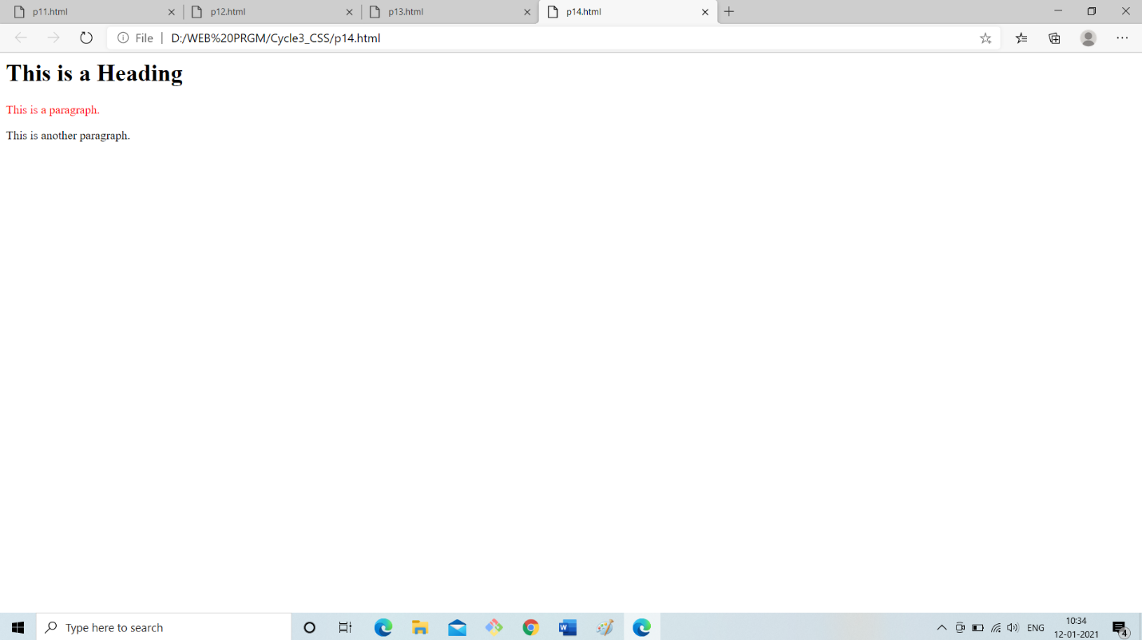

1. Change the color of all elements with the class "colortext", to "red".

<html>

<head>

<style>

.colortext {

color: red;

}

</style>

</head>

<body>

<h1>This is a Heading</h1>

<p>This is a paragraph.</p>

<p class="colortext">This is another paragraph.</p>

<p class="colortext">This is also a paragraph.</p>

</body>

</html>

Output:

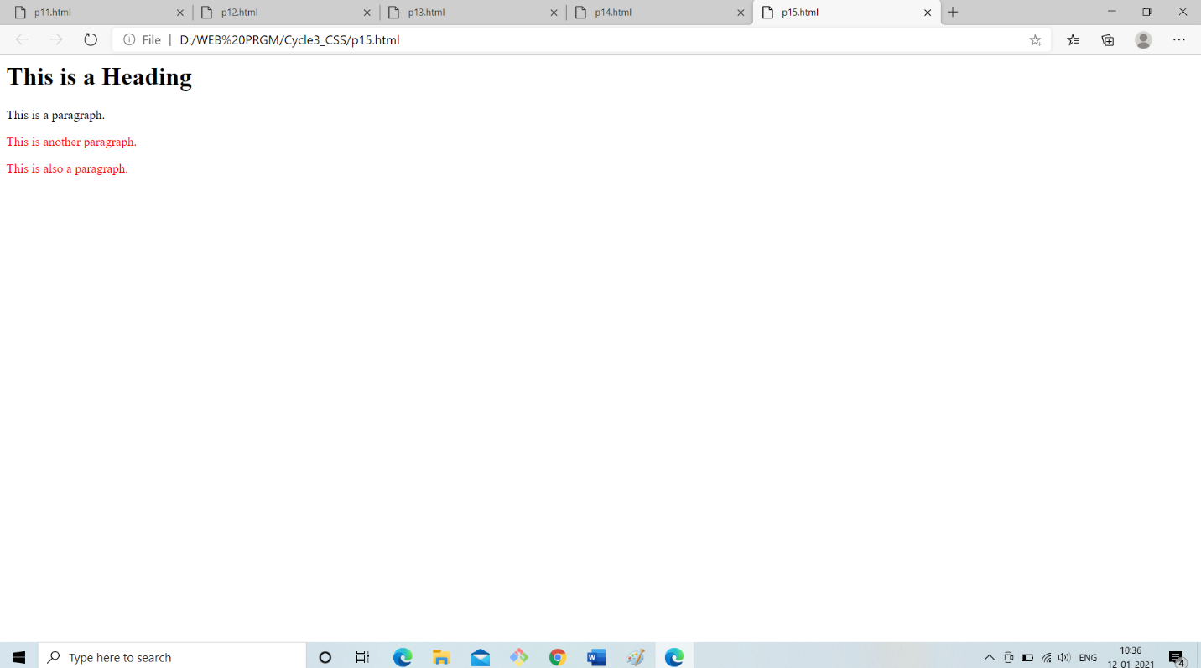

1. Show <p> elements as "bold" text.

<html>

<head>

<style>

p {

font-weight: bold;

}

</style>

</head>

<body>

<h1>This is a Heading</h1>

<p>This is a paragraph.</p>

<p>This is another paragraph.</p>

</body>

</html>

Output:

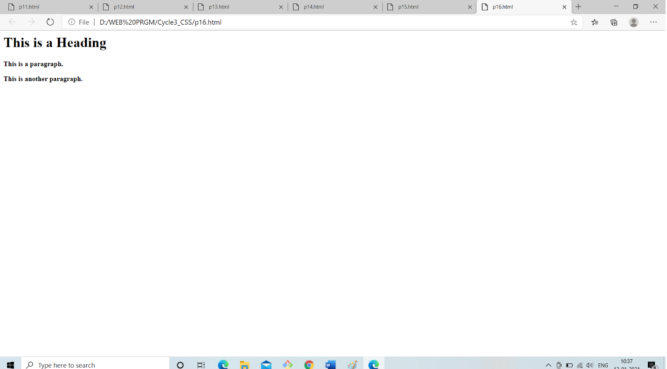

1. Add an external style sheet with the URL: "mystyle.css".

<html>

<head>

<link rel="stylesheet" type="text/css" href="mystyle.css">

</head>

<body>

<h1>This is a Heading</h1>

<p>This is a paragraph.</p>

<p>This is another paragraph.</p>

</body>

</html>

Output:

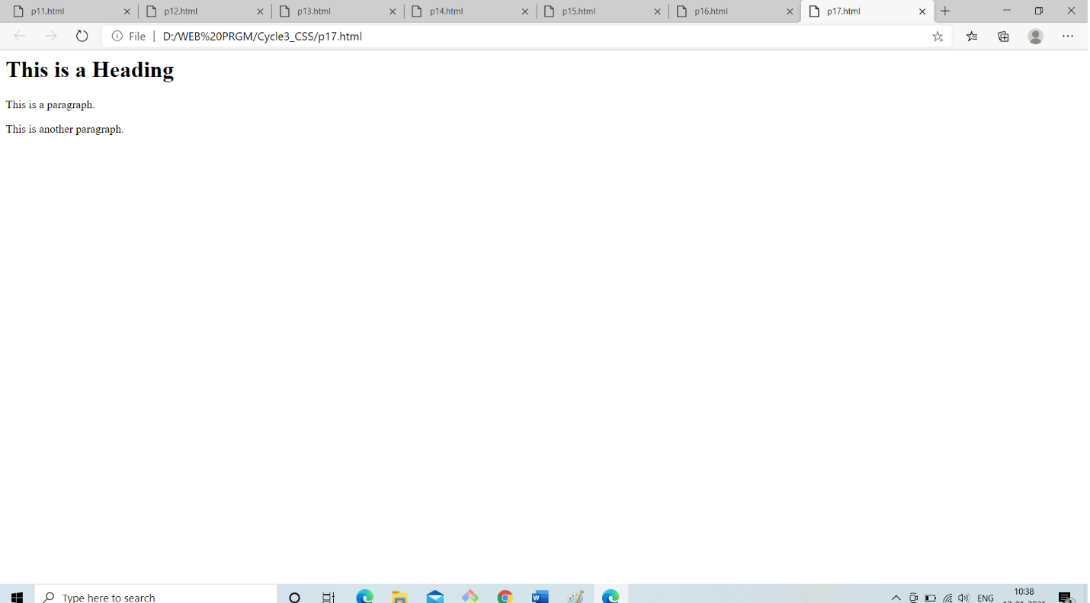

1. Set the font size for the page to "20px", and the font size for <h1> to "3em".

<html>

<head>

<style>

body {

font-size: 20px;

}

h1 {

font-size: 3em;

}

</style>

</head>

<body>

<h1>This is a Heading</h1>

<p>This is a paragraph.</p>

<p>This is another paragraph.</p>

</body>

</html>

Output:

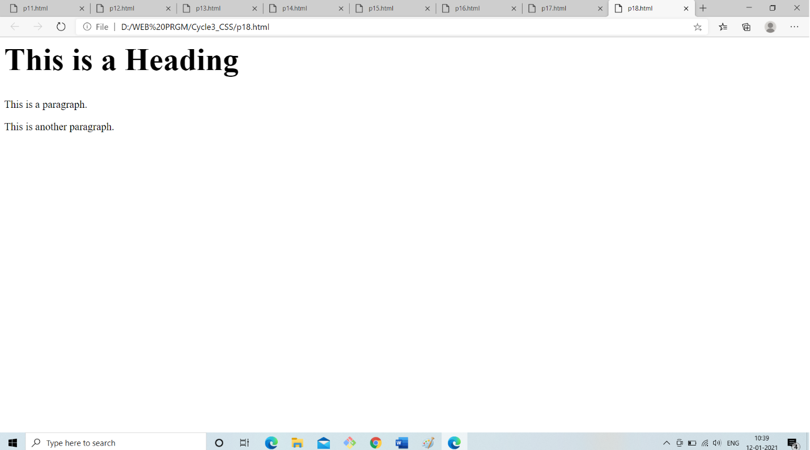

1. Set "background-color: linen" for the page, using an internal style sheet.

<html>

<head>

<style>

body {

background-color: linen;

}

</style>

</head>

<body>

<h1>This is a Heading</h1>

<p>This is a paragraph.</p>

<p>This is another paragraph.</p>

</body>

</html>

Output:

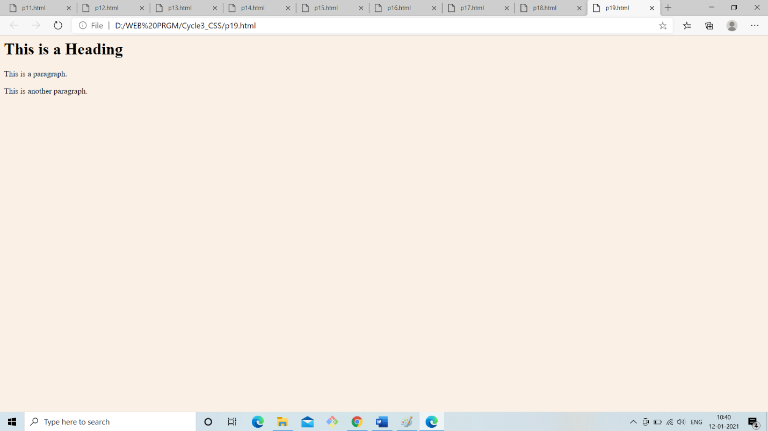

1. Set "background-color: linen" for the page, using an inline style.

<html>

<head>

</head>

<body style="background-color: linen">

<h1>This is a Heading</h1>

<p>This is a paragraph.</p>

<p>This is another paragraph.</p>

</body>

</html>

Output:

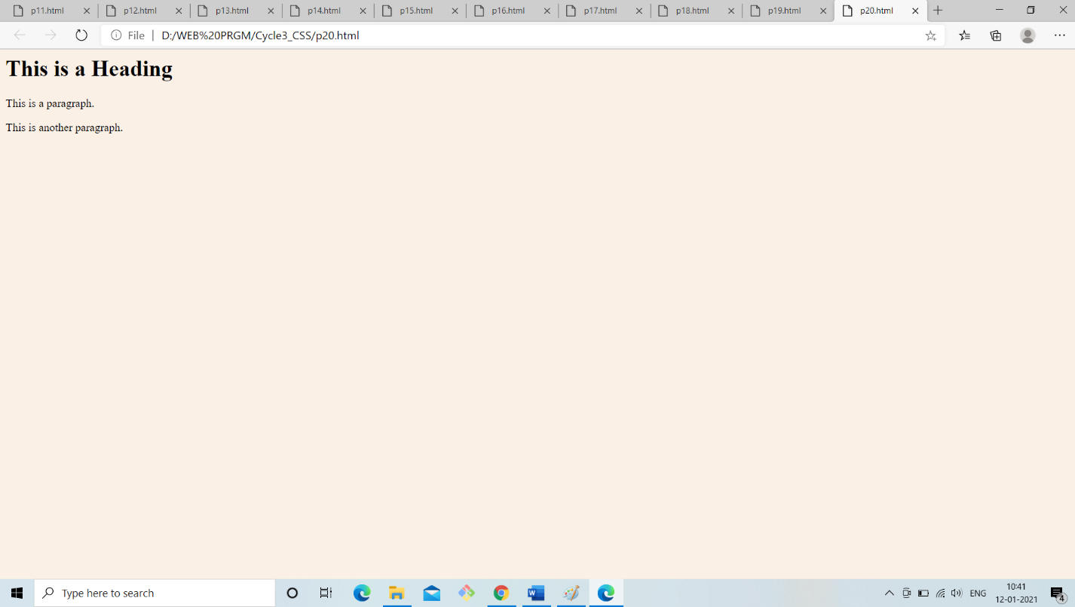

1. Set the text color for the page to "red", and the text color for <h1> to "blue".

<html>

<head>

<style>

body {

color: red;

}

h1 {

color: blue;

}

</style>

</head>

<body>

<h1>This is a Heading</h1>

<p>This is a paragraph.</p>

<p>This is another paragraph.</p>

</body>

</html>

Output:

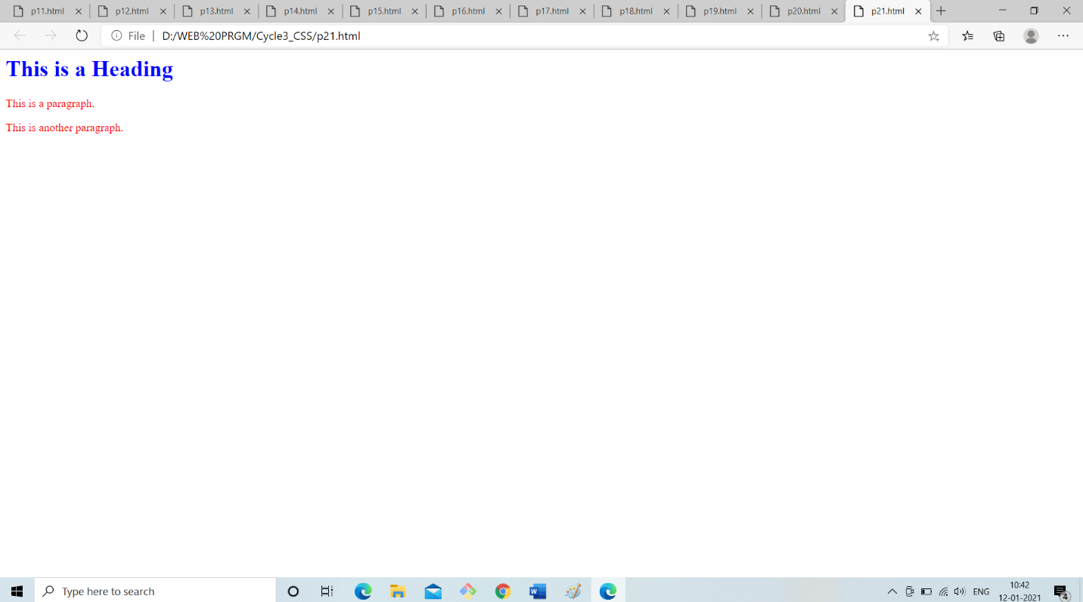

1. Center align the <h1> element.

<html>

<head>

<style>

h1 {

text-align: center;

}

</style>

</head>

<body>

<h1>This is a Heading</h1>

<p>This is a paragraph.</p>

</body>

</html>

Output:

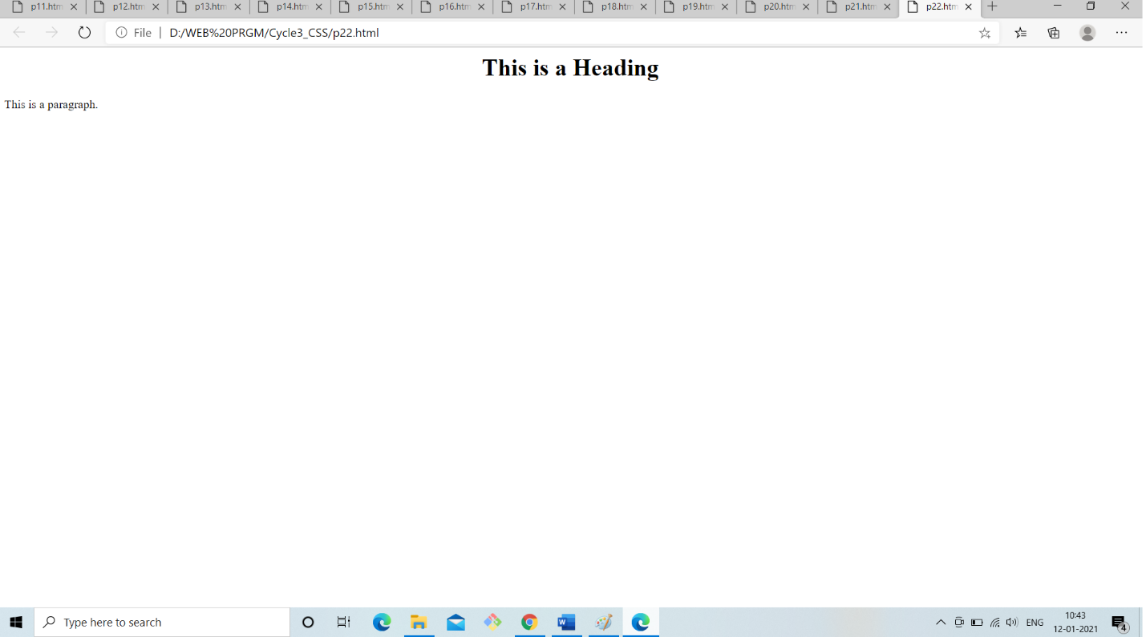

1. Remove the underline from the link.

<head>

<style>

a {

text-decoration: none;

}

</style>

</head>

<body>

<h1>This is a Heading</h1>

<p>This is a paragraph.</p>

<p><a href="css_text.asp.html">CSS text</a></p>

</body>

</html>

Output:

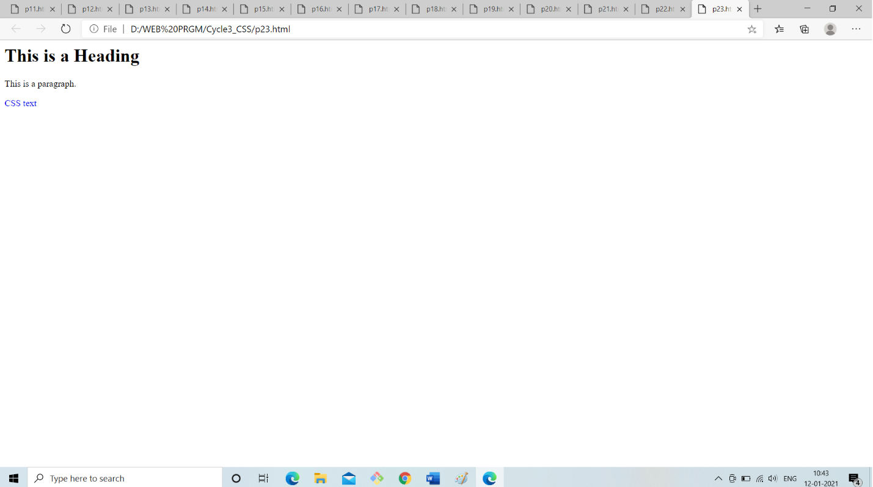

1. Use the padding property to set the top and bottom paddings for <p> to "25px", and left and right paddings to "50px".

<html>

<head>

<style>

p {

background-color: lightblue;

padding: 25px 50px;

}

</style>

</head>

<body>

<h1>This is a Heading</h1>

<p>This is a paragraph.</p>

</body>

</html>

Output:

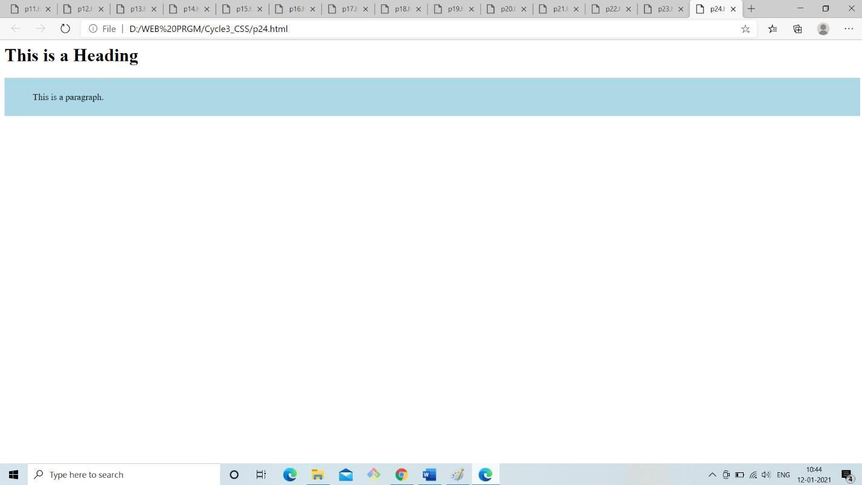

1. Style text in <h1> to uppercase letters, and text in <p> to capitalized letters.

<html>

<head>

<style>

div.a {

text-transform: uppercase;

}

div.c {

text-transform: capitalize;

}

</style>

</head>

<body>

<h1>text-transform: uppercase:</h1>

<div class="a">CSS stands for Cascading Style Sheets.</div>

<p><b>text-transform: capitalize:</b></p>

<div class="c">CSS describes how html elements are to be displayed on screen, paper, or in other media.</div>

</body>

</html>

Output:

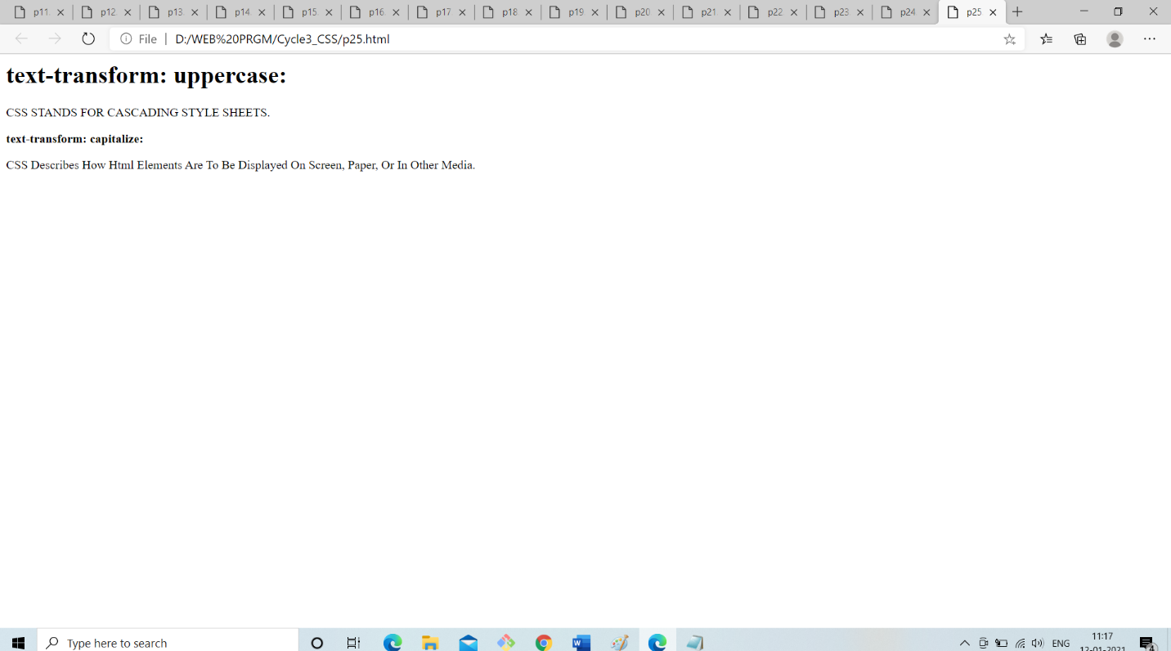

1. Set the width of <h1> to "50%".

<html>

<head>

<style>

h1 {

background-color: powderblue;

width: 50%;

}

</style>

</head>

<body>

<h1>This is a Heading</h1>

<p>This is a paragraph.</p>

</body>

</html>

Output:

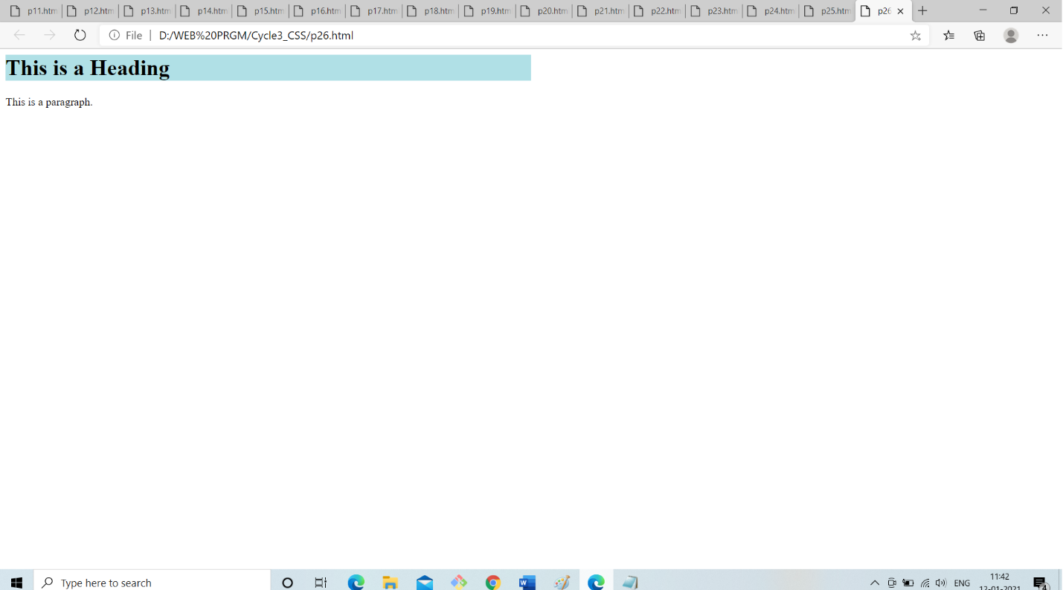

1. With the border property: Set the border for p to "10px", "solid" and

"green".

<html>

<head>

<style>

p {

border: 10px solid green;

}

</style>

</head>

<body>

<h1>This is a Heading</h1>

<p>This is a paragraph.</p>

</body>

</html>

Output:

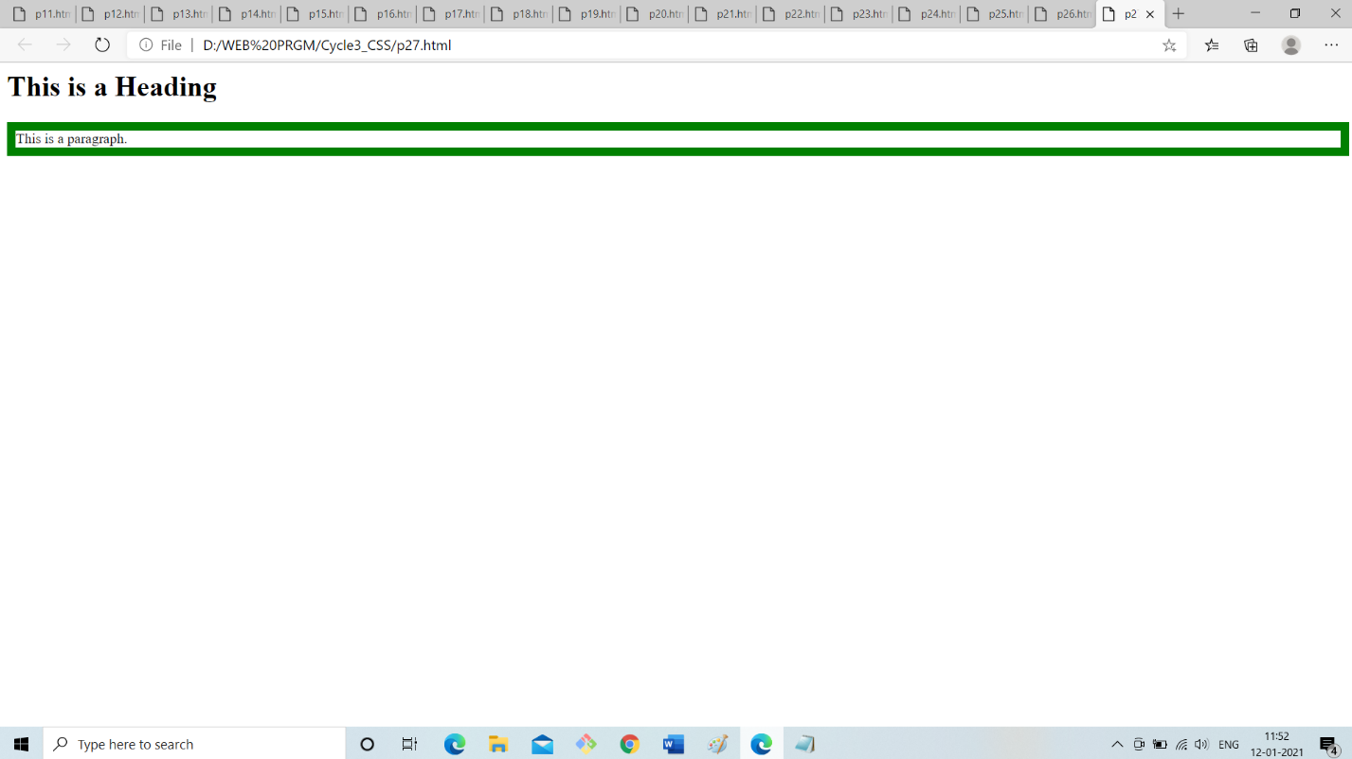

1. Use the margin property to center align the <h1> element.

<html>

<head>

<style>

h1 {

background-color: lightblue;

width: 300px;

margin: auto;

}

</style>

</head>

<body>

<h1>This is a Heading</h1>

<p>This is a paragraph.</p>

</body>

</html>

Output:

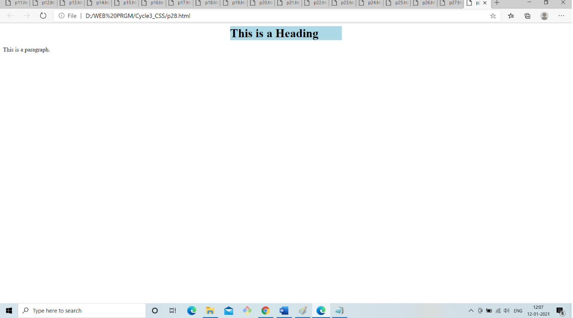

1. Set the color for unvisited links to "red", and the color for visited links

"blue”.

<html>

<head>

<style>

/* unvisited link */

a:link {

color: red;

}

/* visited link */

a:visited {

color: blue;

}

</style>

</head>

<body>

<h1>This is a Heading</h1>

<p>This is a paragraph.</p>

<p><a href="https://www.facebook.com">Facebook.com</a></p>

</body>

</html>

Output:

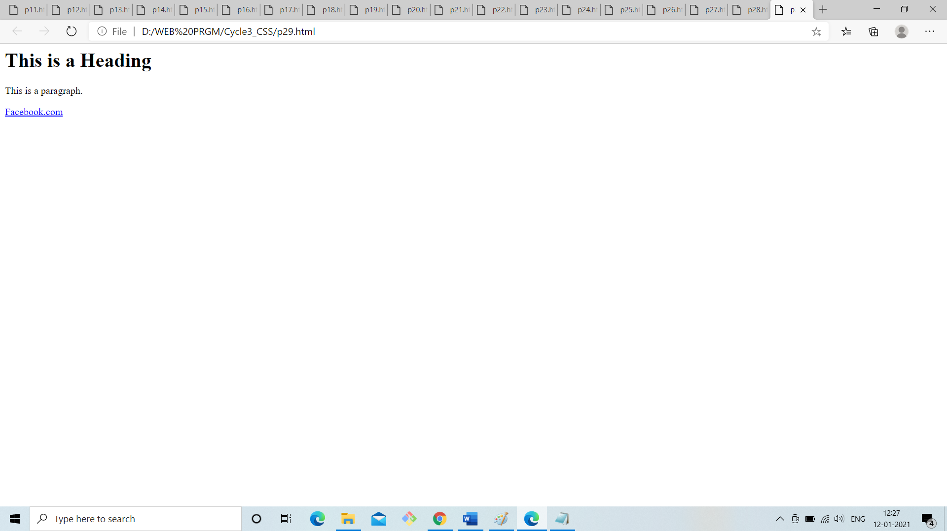

1. Remove the bullets/markers from the list items.

<html>

<head>

<style>

ul

{

list-style-type: none;

}

</style>

</head>

<body>

<ul>

<li>Apple/li>

<li>Mango</li>

<li>Orange</li>

</ul>

</body>

</html>

Output:

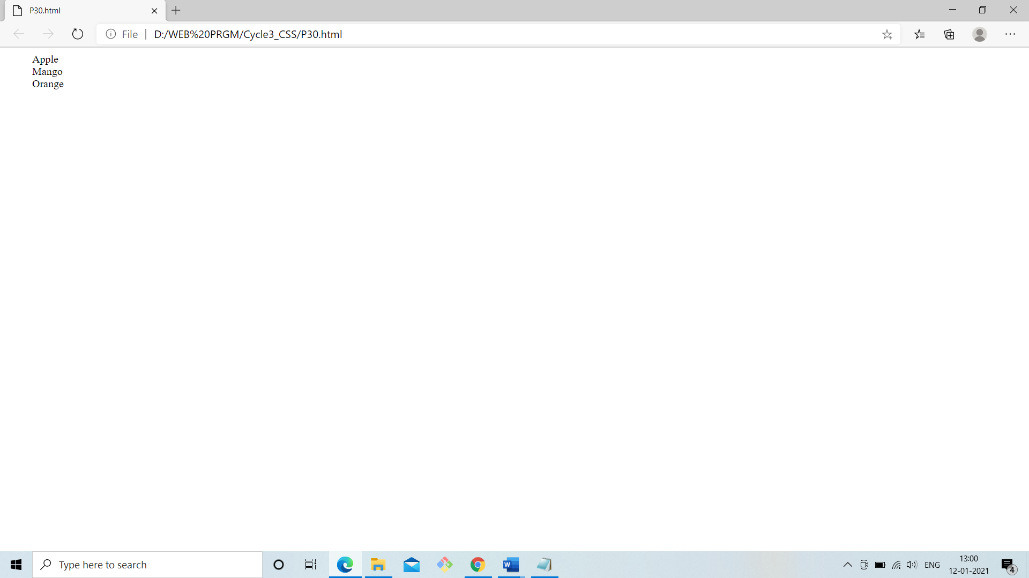

1. Set the list style for unordered lists to "square", and the list style for ordered lists to "upper-roman".

<html>

<head>

<style>

ul {

list-style-type: square;

}

ol {

list-style-type: upper-roman;

}

</style>

</head>

<body>

<p>This is an unordered list:</p>

<ul>

<li>Apple</li>

<li>Mango</li>

<li>Orange</li>

</ul>

<p>This is an ordered list:</p>

<ol>

<li>Red</li>

<li>Yellow</li>

<li>Green</li>

</ol>

</body>

</html>

Output:

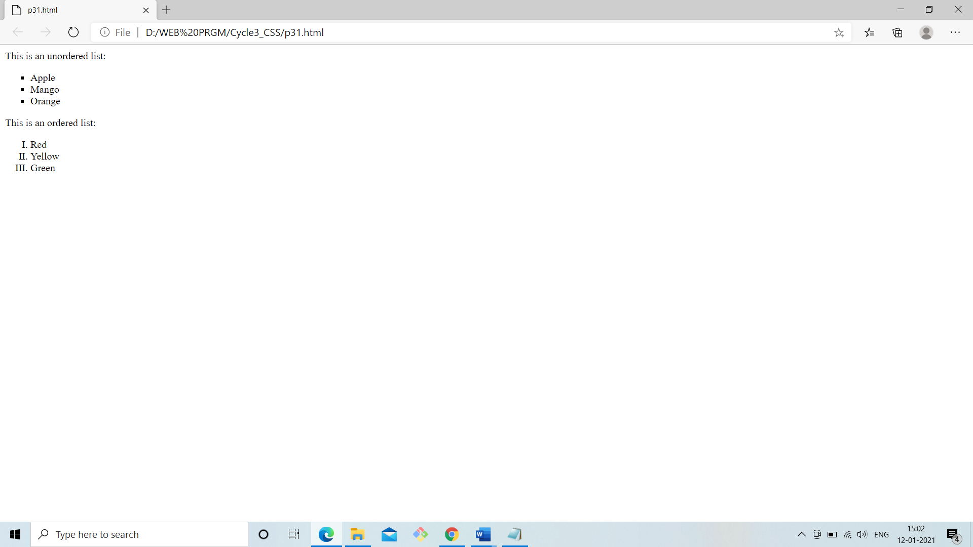

1. Remove underlines for visited and unvisited links, and specify "underline" for the hover and active link states.

<html>

<head>

<style>

/* unvisited link */

a:link {

text-decoration: none;

}

/* visited link */

a:visited {

text-decoration: none;

}

/* selected link */

a:active {

text-decoration: underline;

}

</style>

</head>

<body>

<h1>This is a Heading</h1>

<p>This is a paragraph.</p>

<p><a href="https://www.whatsapp.com">Whatsapp.com</a></p>

</body>

</html>

Output:

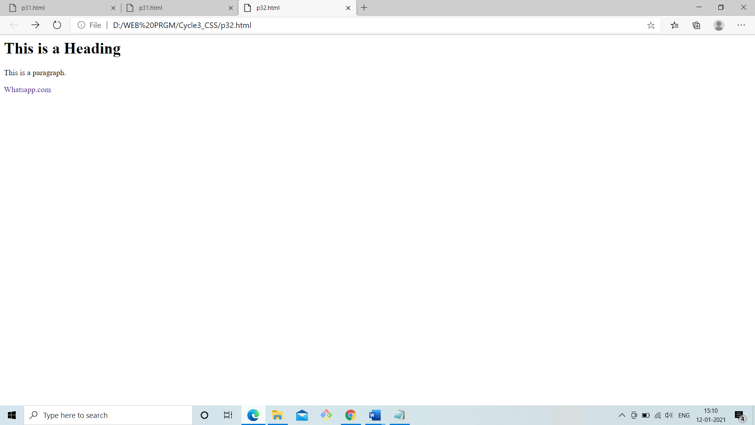

1. Set the image "gif image" as the list item marker for the unordered list.

<html>

<head>

<style>

ul {

list-style-image : url('file:///C:/Users/Sandra/Desktop/purple.jpg');

}

</style>

</head>

<body>

<p>This is an unordered list:</p>

<ul>

<li>Red</li>

<li>Yellow</li>

<li>Green</li>

</ul>

</body>

</html>

Output:

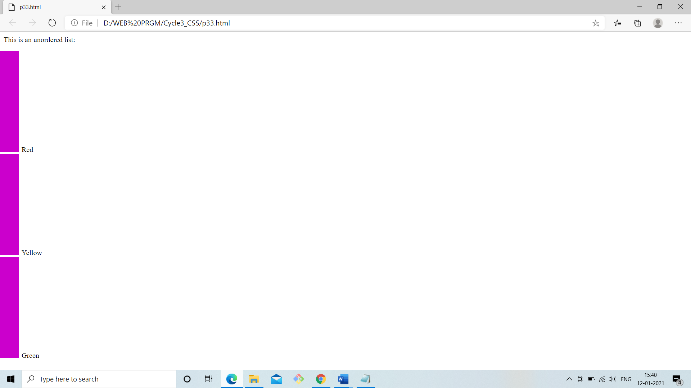

1. Set the background color for visited and unvisited links to "lightblue", and the background color for the hover and active link states to "yellow".

<html>

<head>

<style>

/* unvisited link */

a:link {

background-color: lightblue;

}

/* visited link */

a:visited {

background-color: lightblue;

}

/* mouse over link */

a:hover {

background-color: yellow;

}

/* selected link */

a:active {

background-color: yellow;

}

</style>

</head>

<body>

<h1>This is a Heading</h1>

<p>This is a paragraph.</p>

<p><a href="https://www.facebook.com">Facebook.com</a></p>

</body>

</html>

Output:

