CYCLE : 2

1. **Create an html page to display the following nested list.**

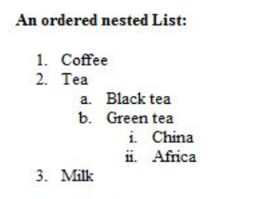

<html>

<body>

<ol>

<li>Coffee</li>

<li>Tea</li>

<ol type="a">

<li>Black tea</li>

<li>Green tea</li>

</ol>

<ol type="i">

<li>China</li>

<li>Africa</li>

</ol>

<li>Milk</li>

</ol>

</b

</body>

</html>

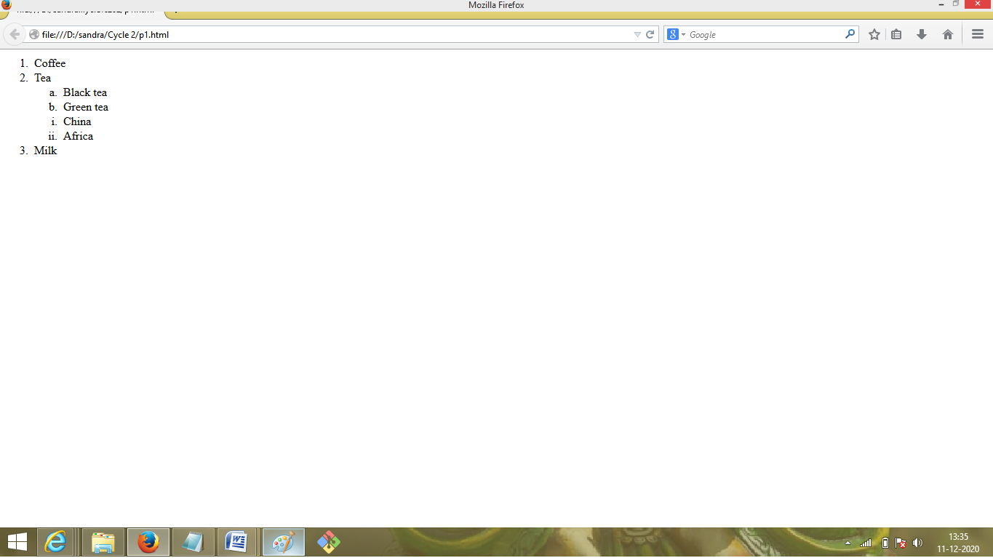

1. **Create links to three different pages on three different websites that should all open in a new window**.

<html>

<head>

<title>Links to various pages</title>

</head>

<body>

<a href="http://www.hostforweb.com" target="_blank">

HostForWeb Web Hosting

</a>

<br /><br />

<a href="http://www.weather.com" target="_blank">

Find out local weather

</a>

<br /><br />

<a href="http://www.math.com/homeworkhelp/Algebra.html"

target="_blank">

Learn about algebra

</a>

</body>

</html>

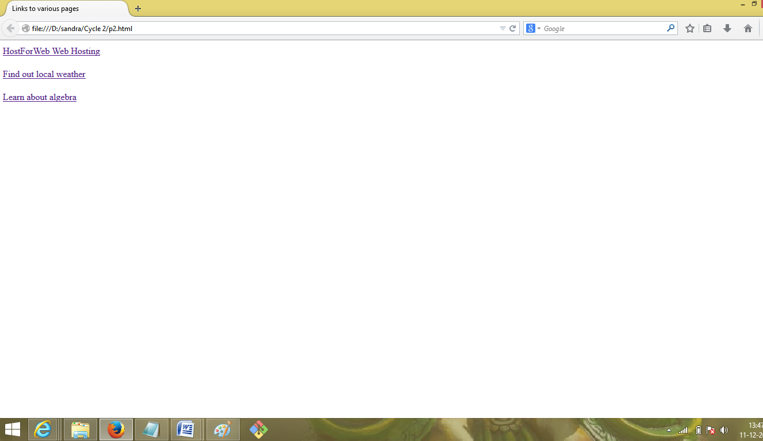

1. **Create a page with a link at the top of it that when clicked will jump all the way to the bottom of the page.**

<html>

<body>

<a href="#bottom">Click here to jump to the bottom of the page</a>

<p>Some text</p>

<p>Some text</p>

<p>Some text</p>

<p>Some text</p>

<p>Some text</p>

<p>Some text</p>

<p>Some text</p>

<p>Some text</p>

<p>Some text</p>

<p>Some text</p>

<p>Some text</p>

<p>Some text</p>

<p>Some text</p>

<p>Some text</p>

<p>Some text</p>

<p>Some text</p>

<p>Some text</p>

<p>Some text</p>

<p>Some text</p>

<p>Some text</p>

<a name="bottom">The bottom of the page</a>

</body>

</html>

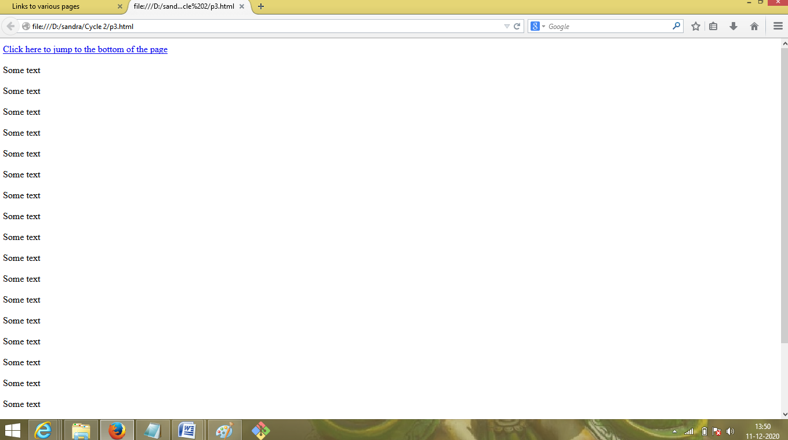

1. **Display three different images. Skip two lines between each image. Each image should have a heading.**

<html>

<head>

<title>Three Images</title>

</head>

<body>

<p>Apple</p>

<img src="C:\Users\Butterfly\Desktop\Apple.jpg" alt="Apple" title="Apple" />

<br /><br />

<p>Birds</p>

<img src="C:\Users\Butterfly\Desktop\Birds.jpg" alt="Bird" title="Bird" />

<br /><br />

<p>Cat</p>

<img src="C:\Users\Butterfly\Desktop\cat.jpg" alt="Cat" title="Cat" />

</body>

</html>

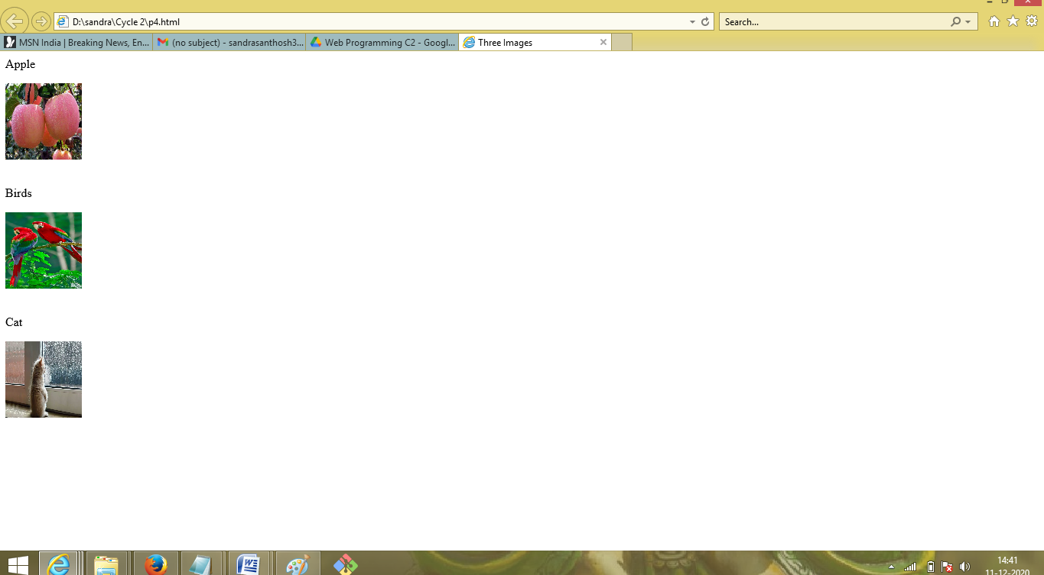

1. **Display an image that when clicked will link to a search engine of your choice in a different window.**

<html>

<body>

<a href="http://www.yahoo.com" target="_blank">

<img src="C:\Users\Butterfly\Desktop\Apple.jpg" alt="Apple" />

</a>

</body>

<p>

Click on the image to be taken to the Yahoo search engine.

</p>

</html>

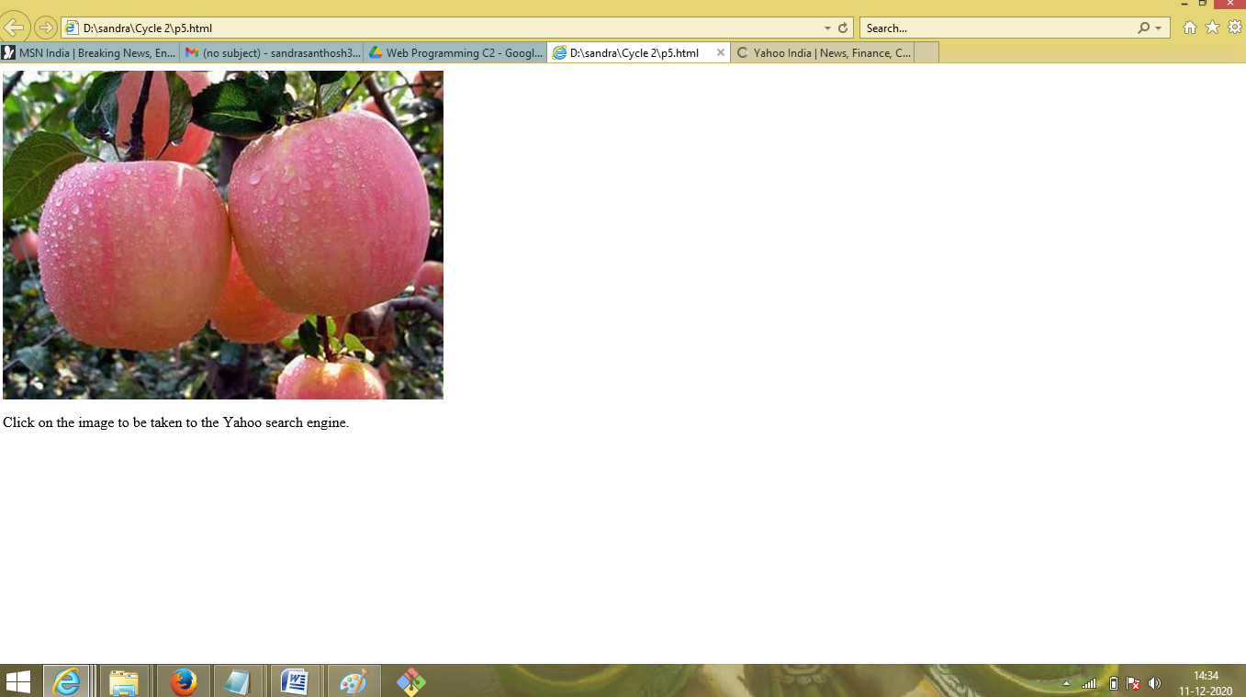

1. **Create the following Html Page using appropriate form controls.**

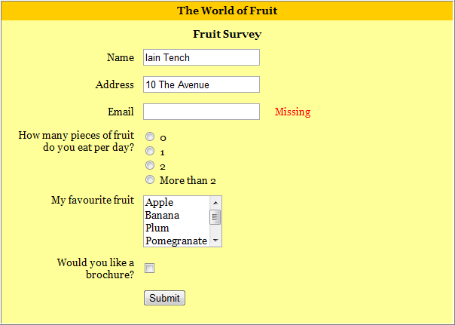

<html>

<head>

<style>

.div_1{background-color:orange;margin:20px;}

.div_2{background-color:yellow;margin:20px;}

</style>

</head>

<body>

<center>

<div class="div_1">

<font size="4" face="cooper">

<h1>The world of fruit</h1>

</font>

</div>

<div class="div_2">

<form method="post">

<font size="4" face="cooper">

<h1 align="center">fruit survey</h1>

</font>

<table align="center">

<tr>

<th>Name</th>

<td>

<input type="text" name="name" style="width:400px;" class="form-control" required="">

</td>

</tr>

<tr>

<th>Address</th>

<td>

<input type="text" name="address" style="width:400px;" class="form-control" required="">

</td>

</tr>

<tr>

<th>Email</th>

<td>

<input type="text" name="email" style="width:400px;" class="form-control" required="">

</td>

</tr>

<tr>

<th>How many pieces of fruit<br>do you eat per day?</th>

<td>

<input type="radio" name="0" value="0">0<br>

<input type="radio" name="1" value="1">1<br>

<input type="radio" name="2" value="2">2<br>

<input type="radio" name="more than 2" value="more than 2">more than 2

</tr>

<tr>

<th>My favourite fruit</th>

<td>

<textarea rows="4" cols="12" name="favourite fruit">Apple Banana Plum Pomegranate Orange </textarea>

</td>

</tr>

<tr>

<th>Would you like a<br>brochure?</th>

<td>

<input type="checkbox" name="yes" value="on">

</td>

</tr>

<tr>

<td align="center" colspan="2">

<input type="submit" name="submit" value="submit">

</td>

</tr>

</table>

</form>

</div>

</center>

</body>

</html>

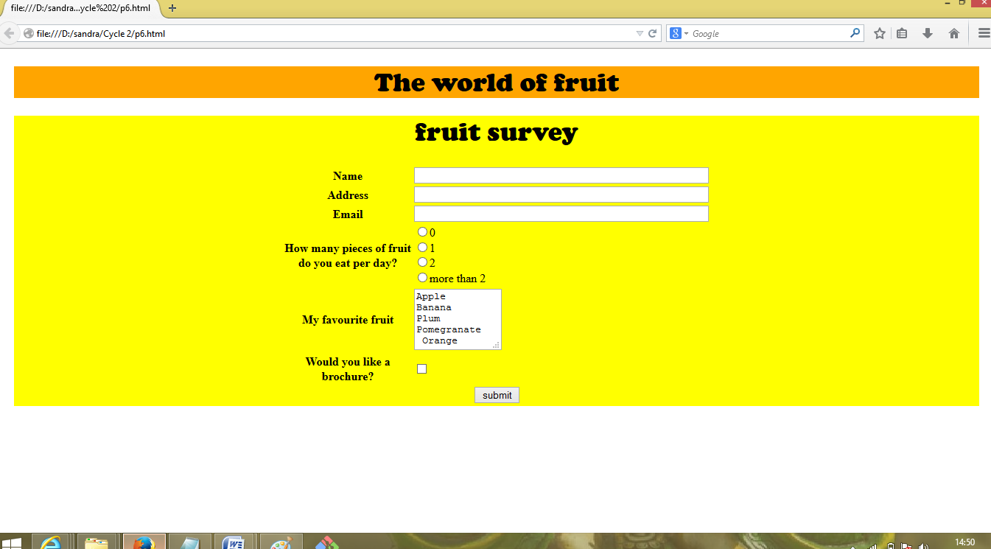

1. **Create an image map for ‘Kerala Map’. Map at least 3 districts so that when you click on that particular district the details regarding that district(eg: population, Area, Tourist Spots(with images), Monuments, Interesting Facts ) should be displayed on a new page.**

<!DOCTYPE html>

<html>

<head>

<center>

<body>

<h1><u><font color="grey"face="cooper">KERALA MAP</font></u></h1>

<map name="kerala">

<area shape="rect" coords="300,440,470,500" href="ernakulam.html"/>

<area shape="rect" coords="324,451,395,501" href="kottayam.html"/>

<area shape="rect" coords="402,358,469,499" href="idukki.html"/>

</map>

<img src="C:\Users\Butterfly\Desktop\kerala_map.jpg" alt="kerala" usemap="#kerala"/>

</center>

</body>

</head>

</html>

<html>

<head>

<style>

.div_1 { background-color:red;margin:20px; }

.div_2 { background-color:yellow;margin:20px; }

</style>

</head>

<body>

<center>

<br>

<div class="div_1"><h1><font color="white" size="6" face="Cooper"> ERNAKULAM</font></h1></div>

<div class="div_2"><h1><font color="green" size="6" face="Comic sans MS">

<h1><u>POPULATION</U></H1>

<P>Ernakulam (IPA: /eːrɐɳaːkʊɭɐm/; IAST: Eṟaṇākuḷaṁ) is a district of Kerala, India. Situated in the central part of the state and spanning an area of about 3,000 square kilometres

(1,200 sq mi), Ernakulam district is home to over 9% of Kerala's population. Its headquarters is located at Kakkanad. </P>

<h1><u>AREA</U></H1>

<P> 30.63km<sup>2</sup></P>

<h1><u>TOURIST SPOTS</u></h1>

<h2>CHERAI BEACH</h2>

<img src="C:\Users\Butterfly\Desktop\cheraibeach.jpg" alt="beach" height="260" width="525"/>

<P>Cherai Beach is a beach located in Cherai in the northern side of Vypin Island, a suburb of the city Kochi in the state of Kerala, India. One of the most visited beaches in the state,

it is situated at around 25 km from downtown Kochi and 20 km from Cochin International Airport. </P>

<h2>MATTANCHERY PALACE</h2>

<img src="C:\Users\Butterfly\Desktop\palace.jpg" alt="palace" height="260" width="525"/>

<P>The Mattancherry Palace is a Portuguese palace popularly known as the Dutch Palace, in Mattancherry, Kochi, in the Indian state of Kerala which features Kerala murals

depicting portraits and exhibits of the Rajas of Kochi. The palace was included in the "tentative list" of UNESCO World Heritage Site.</p>

</div>

</body>

</html>

<html>

<head>

<style>

.div_1{background-color:red; margin:20px;}

.div_2{background-color:yellow;margin:20px;}

</style>

</head>

<body>

<center>

<br>

<div class="div_1">

<h1><font color="white" size="6" face="cooper">KOTTAYAM</font></h1>

</div>

<div class="div_2">

<font color="green" face="Comic sans MS">

<h1><u>POPULATION</u></h1>

<p>As of 2001 India census,[13] Kottayam Urban Agglomeration had a population of 172,878,

while Kottayam district had a population of 1,974,551.

<h1><u>Area</u></h1>

<p>77.8km<sup>2</sup></p>

<h1><u>TOURIST SPOTS</u></h1>

<h2>ILLICKAL KALLU</h2>

<img src="C:\Users\Butterfly\Desktop\illikkal-kallu-attractions.jpg" alt="illickal kallu" height="260" width="525"/>

<p>located at the height of 6000 ft above the sea level in the western ghats of kottayam,kerala,Illickal kallu is a major tourist attraction.</p>

<h2>MARMALA WATERFALLS</h2>

<img src="C:\Users\Butterfly\Desktop/marmala-waterfall.JPG" alt="marmala waterfalls" height="260" width="525"/>

<p>Located at a distance of few kms from Erattupetta in kottayam inside a private rubber estate.</p>

</div>

</body>

</html>

<html>

<head>

<style>

.div_1{background-color:red; margin:20px;}

.div_2{background-color:yellow;margin:20px;}

</style>

</head>

<body>

<center>

<br>

<div class="div_1"><h1><font color="white" size="6" face="cooper">IDUKKI</font></h1></div>

<div class="div_2"><font color="green" face="Comic sans MS">

<h1><u>POPULATION</u></h1><p>according to 2011 census idukki district has a population of 1108974.The density of population is 255 per sq.km.

<h1><u>Area</u></h1>

<p>4,358<sup>2</sup></p>

<h1><u>TOURIST SPOTS</u></h1>

<h2>Eravikulam national park</h2>

<img src="C:\Users\Butterfly\Desktop\eravikulam.jpg" alt="eravikulam" height="260" width="525"/>

<p>Eravikulam national park is a 97km<sup>2</sup> national park located along the western ghats in the idukki district.</p>

<h2>Anamudi</h2>

<img src="C:\Users\Butterfly\Desktop\anamudi.jpg" alt="anamudi" height="260" width="525"/>

<p>Anamudi is a mountain located in the indian state of kerala. It is the highest peak in the western ghats of south india.</p>

</div>

</body>

</html>

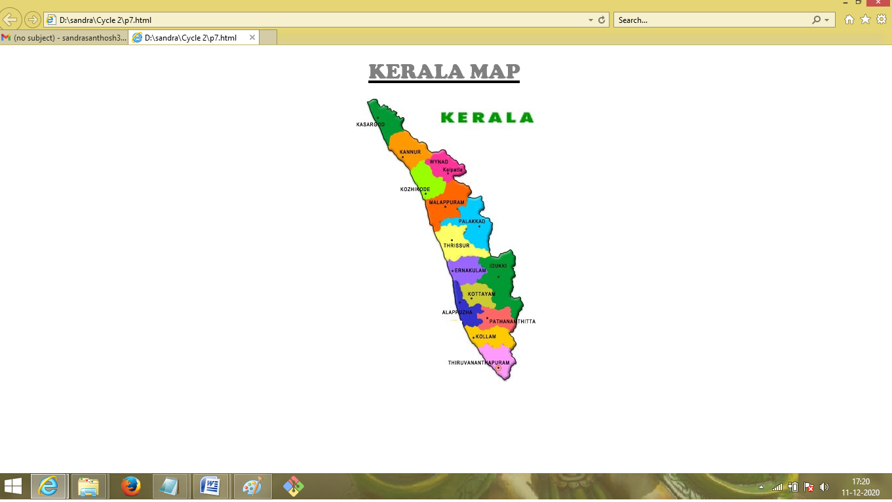

1. **Construct this puzzle looking thing**

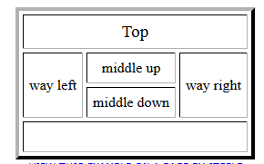

<html>

<head>

<body>

<br><br>

<table align="center" border="2" cellspacing="0">

<tr>

<th colspan="6">Top</th>

</tr>

<tr>

<th rowspan="2">way left</th>

<th colspan="2">middle up</th>

<th rowspan="2">way right</th>

</tr>

<tr>

<th colspan="2">middle down</th>

</tr>

<tr>

<th colspan="6">down</th>

</tr>

</table>

</body>

</html>

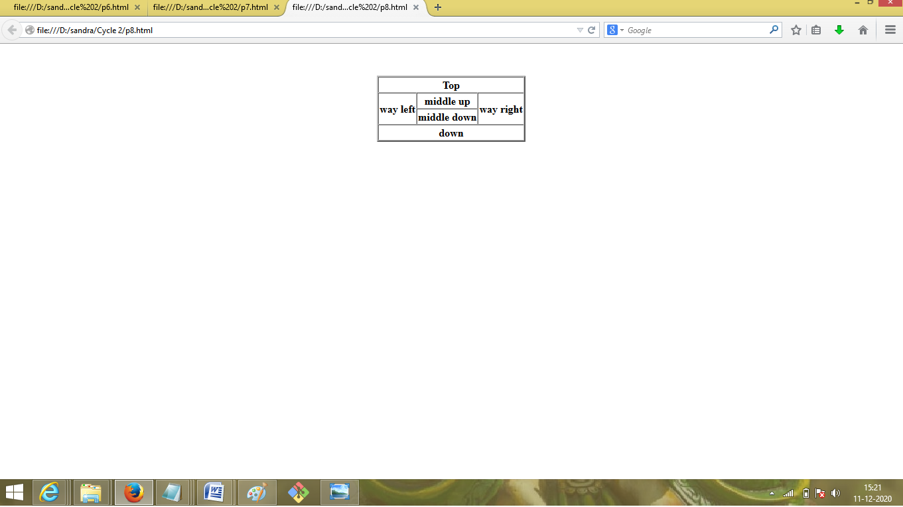

1. **Make up three image links for 3 web browsers and put them in a borderless table. Construct the table so that there is just a little space between the images.**

<html>

<head>

<body>

<br><br>

<table align="center" style="border-collapse:collapse;">

<tr>

<td>

<a href="https://www.firefox.com/" target="_blank">

<img src="C:\Users\Butterfly\Desktop\Firefox_logo.jpg" alt="firefox" height="220" width="220"/>

</td>

</tr>

<tr>

<td><a href="https://www.google.com/chrome/" target="_blank">

<img src="C:\Users\Butterfly\Desktop\chrome-logo.jpg" alt="chrome" height="220"

width="220"/>

</td>

</tr>

<tr>

<td><a href="https://microsoft.com" target="_blank">

<img src="C:\Users\Butterfly\Desktop\edge.jpg" alt="edge" height="200" width="220"/>

</td>

</tr>

</table>

</body>

</head>

</html>

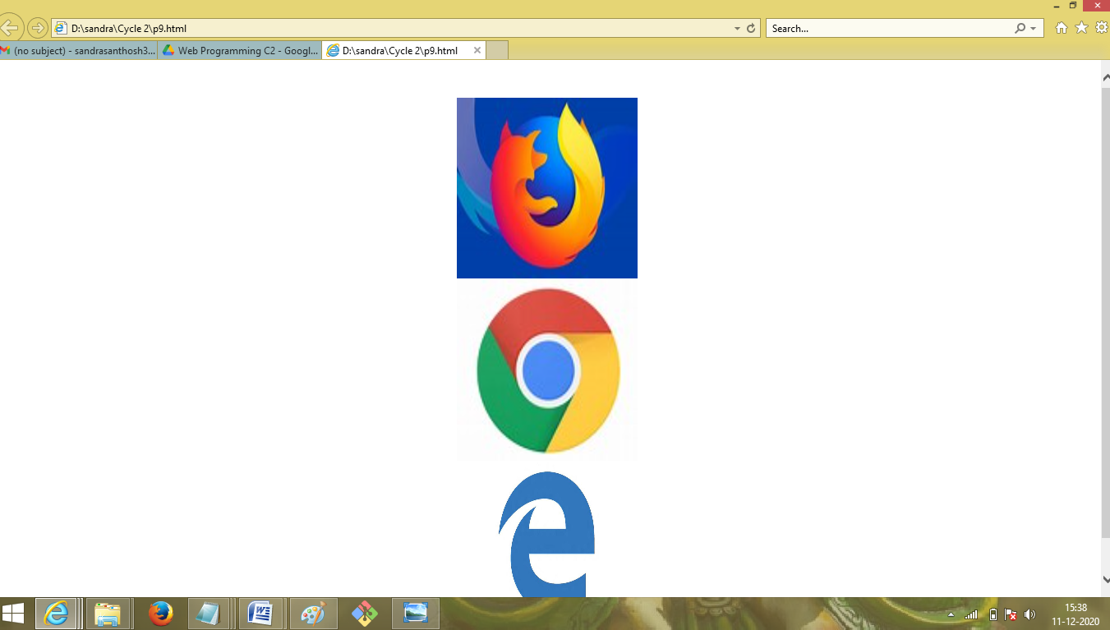

1. **Create the following html page using frames**

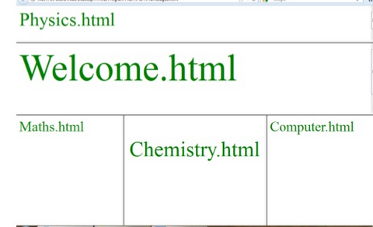

<html>

<frameset rows="15%,25%,*" border="3">

<frame src="physics.html">

<frame src="welcome.html">

<frame src="frame3.html">

</frameset>

</html>

<html>

<body>

<h1>

<font color="green">

Chemistry.html

</font>

</h1>

</body>

</html>

<html>

<body>

<h1>

<font color="green">

Computer.html

</font>

</h1>

</body>

</html>

<html>

<frameset cols="33.5%,33.5%,*" border="3">

<frame src="maths.html">

<frame src="chemistry.html">

<frame src="computer.html">

</frameset>

</html>

<html>

<body>

<h1>

<font color="green">

Maths.html

</font>

</h1>

</body>

</html>

<html>

<body>

<h1>

<font color="green">

Physics.html

</font>

</h1>

</body>

</html>

<html>

<body>

<h1>

<font color="green">

Welcome.html

</font>

</h1>

</body>

</html>

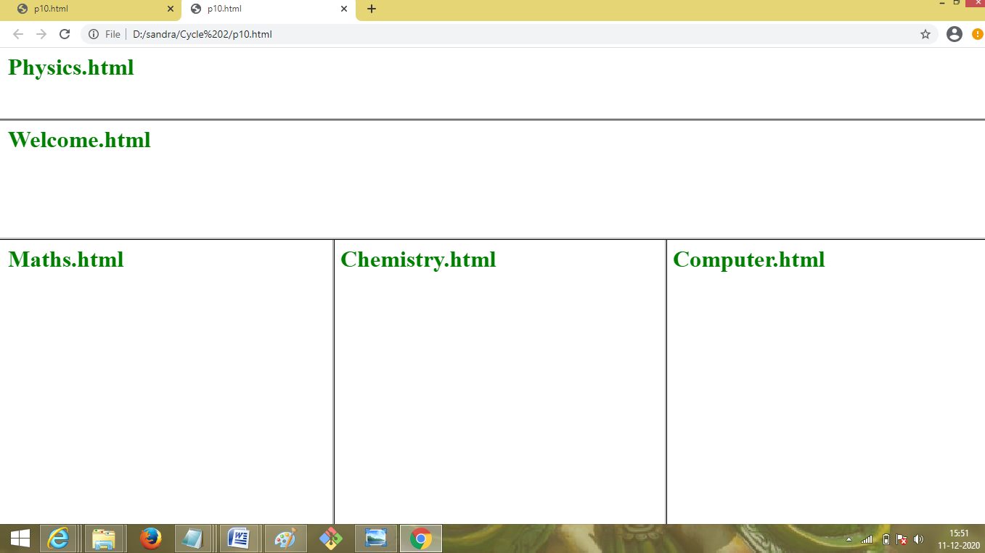

1. **Create an HTML page using frames which is similar to the following one.**

**In the left frame provide hyperlinks to 3 important monuments in world. On clicking that hyperlink an image of the monument should be displayed in right frame with suitable description**

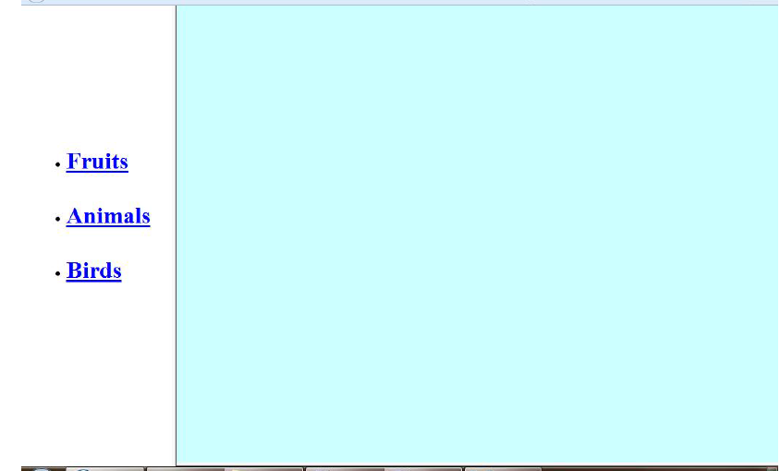

<html>

<head>

<title>navigation</title>

</head>

<frameset cols="25%,*">

<frame src="link.html"/>

<frame src="home.html" name="z"/>

</frameset>

<body>

</body>

</html>

<html>

<head>

<title> index </title>

<style>

.div_1{ background-color:yellow; margin:20px; }

.div_2{ background-color:grey; margin:20px; }

</style>

</head>

<body>

<center>

<br>

<div class="div_1">

<h1><font color="green" size="6" face="cooper">famous

monuments</font></h1>

</div>

<div class="div_2"><font color="white" size="6" face="Cooper">

<ul>

<li>India Gate</li>

<li>Taj Mahal</li>

<li>Qutub Minar</li>

</ul>

</div>

</center>

</body>

</html>

