**CYCLE - 5**

1. Create a php webpage and print “hello world”.

<?php

echo "<h2>Hello World!!!</h2>";

echo "Hello World!!!";

?>

**Output:**

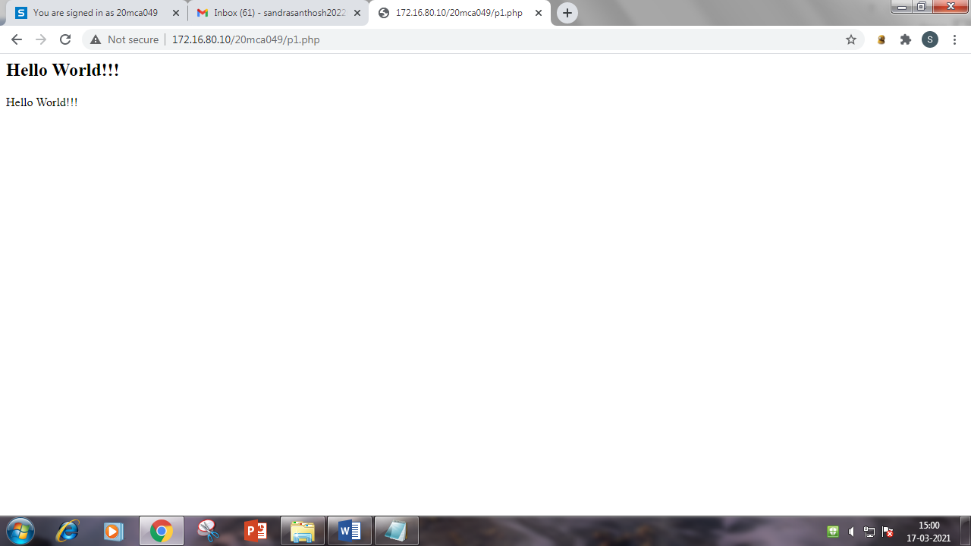

1. Write a php program to find maximum of three numbers.

<?php

$a = 3;

$b=5;

$c=8;

if(($a>$b) && ($a>$c))

echo "Maximum is $a ";

else if(($b>$a) && ($b>$c))

echo "Maximum is $b ";

else

echo "Maximum is $c ";

?>

**Output:**

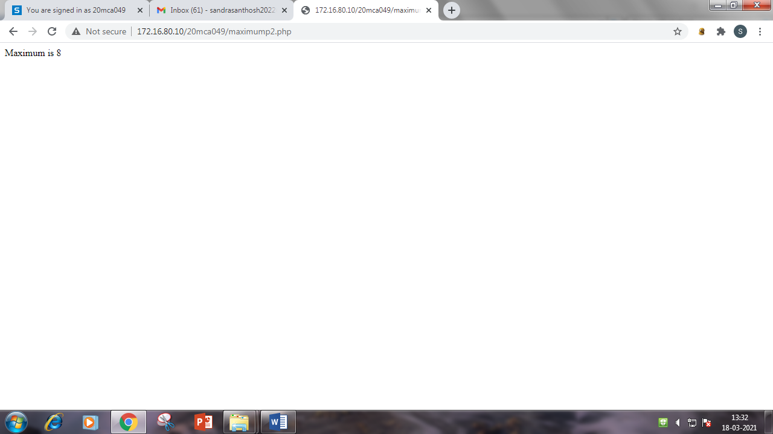

1. Give the example of variable function: print_r()

<html>

<head>

<title>Variable Function:print_r()</title>

</head>

<body>

<pre>

<?php

$data = array('e_no'=>106680307009,'e_name'=>'Bipin R.Prajapati','S.P.I'

=>array('1st'=>7.75,'2nd'=>8.27,'3rd'=>8.20,'4th'=>7.57));

print_r($data);

?>

</pre>

</body>

</html>

**Output:**

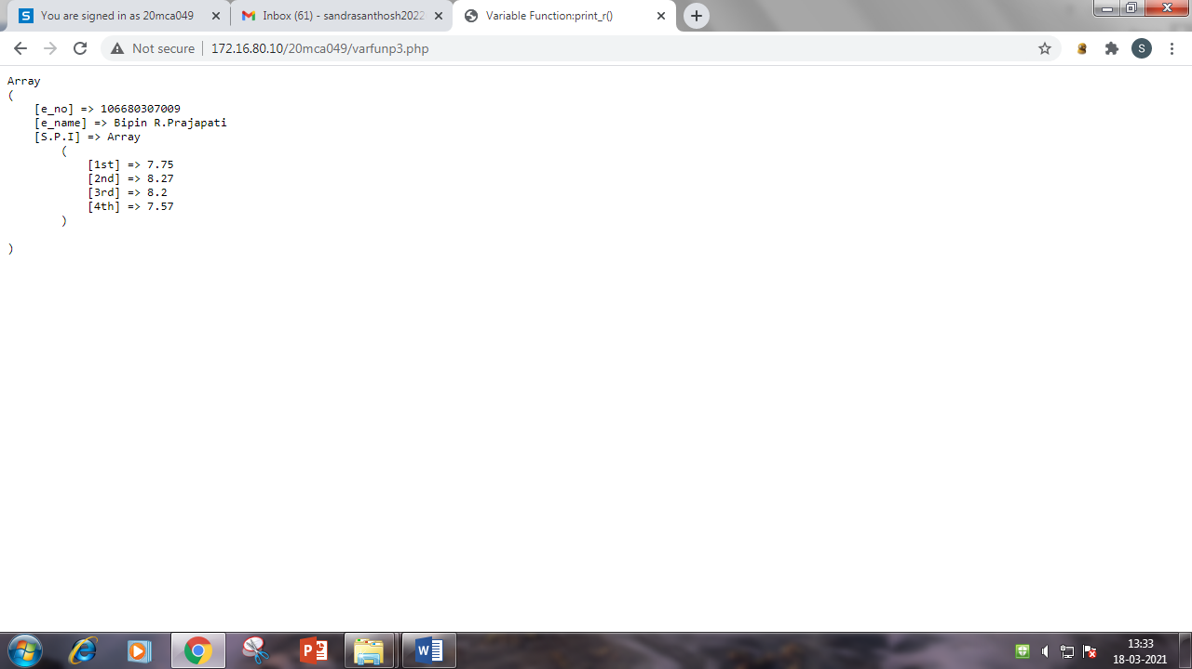

1. Write a program to Develop student registration form and display all the submitted data on another page.

**FillP4.php:**

<html>

<head>

<title>Insert Data In Form</title>

</head>

<body>

<form action = "getdatap4.php" method= "POST">

Name:

<input type = "text" name = "txtname">

<br><br>

Roll No:

<input type = "text" name = "txtr_no">

<br><br>

Address:

<textarea name = "add" type = "txtarea"></textarea>

<br><br>

Contact No:

<input type = "text" name = "txtc_no">

<br><br>

Email Id:

<input type = "text" name = "txteid">

<br><br>

<input type = "Submit" name = "Insert" value= "SAVE">

<input type = "Reset" value = "Cancel">

</form>

</body>

</html>

**Output:**

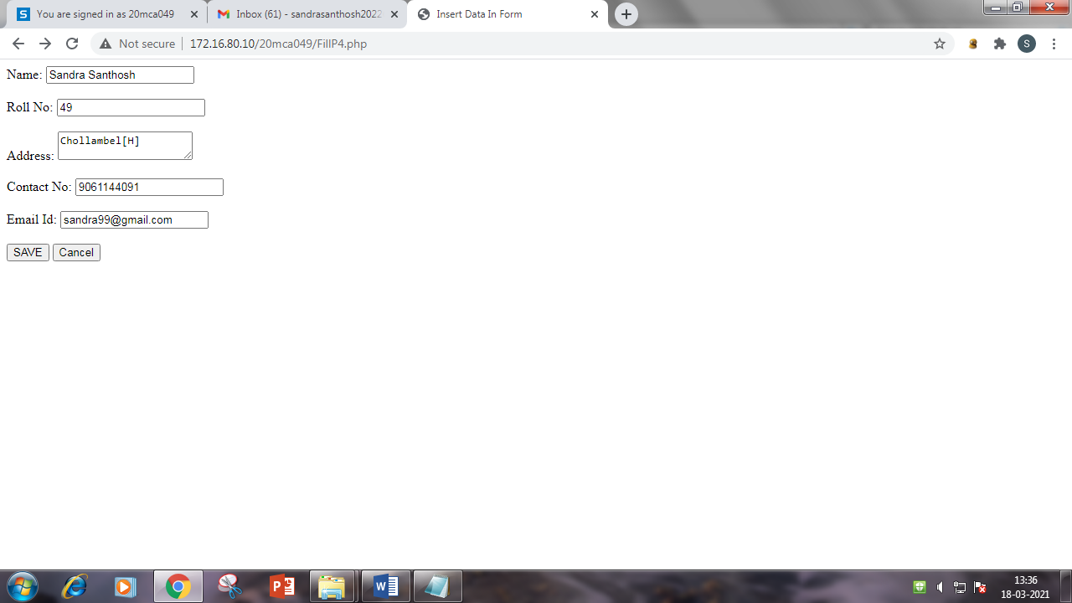

**GetdataP4.php:**

<html>

<head>

<title>Get data from another page</title>

</head>

<body>

<?php

echo "Name :" .$_POST["txtname"]."</br>";

echo "Roll No :" .$_POST["txtr_no"]."</br>";

echo "Address :" .$_POST["add"]."</br>";

echo "Contact No :" .$_POST["txtc_no"]."</br>";

echo "Email Id :" .$_POST["txteid"]."</br>";

?>

</body>

</html>

**Output:**

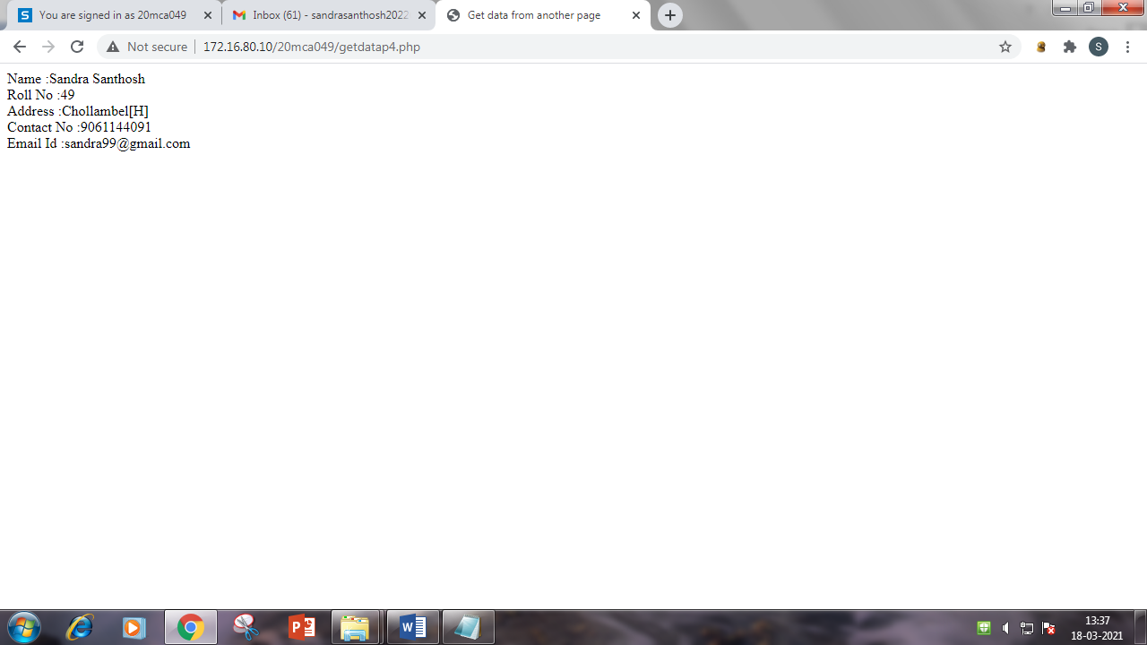

1. PHP Sessions –Illustrated with a simple login system.

**Homep5.php**:

<html>

<head>

<title>Login</title>

</head>

<body>

<form method = "post" action = "loginP5.php">

<p>Username : <input type = "text" name = "username" /></p>

<p>Password : <input type = "text" name = "password" /></p>

<p><input type = "submit" value = "Let me in" /></p>

</form>

</body>

</html>

**Output:**

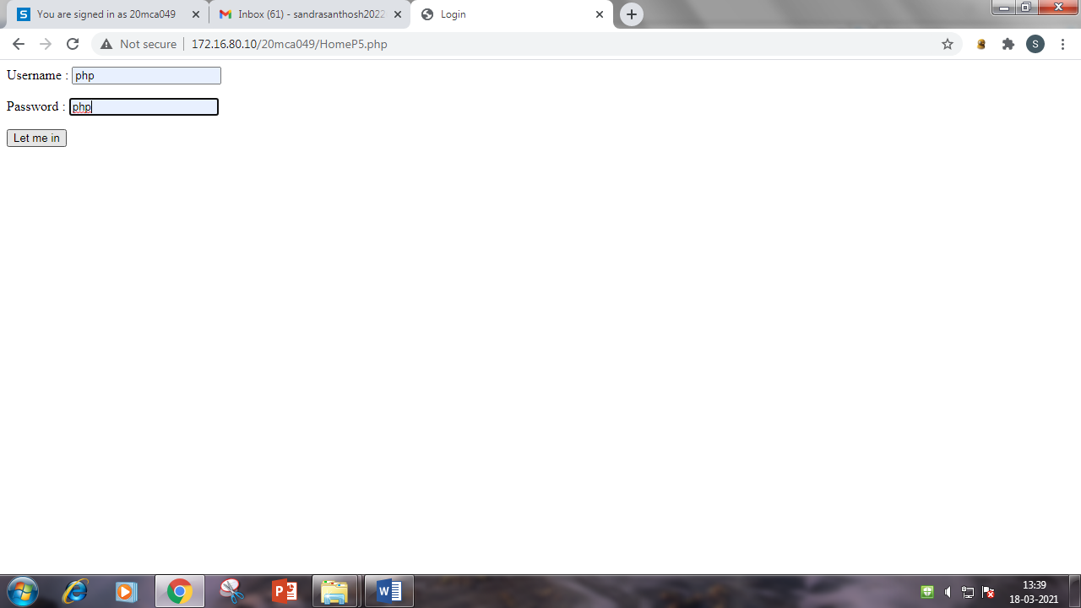

**LoginP5.php:**

<html>

<head>

<title>Login</title>

</head>

<body>

<?php

if ($_POST["username"] == "php" && $_POST["password"] == "php")

{

session_start();

$_SESSION["Login"] = "YES";

echo "<h1>You Are Now Logged Correctly In</h1>";

echo "<p><a href='document.php'>Link To Protected File</a></p>";

}

else

{

session_start();

$_SESSION["Login"] = "NO";

echo "<h1>You Are Not Logged Correctly In </h1>";

echo "<p><a href='document.php'>Link To Protected File</a></p>";

}

?>

</body>

</html>

**Output:**

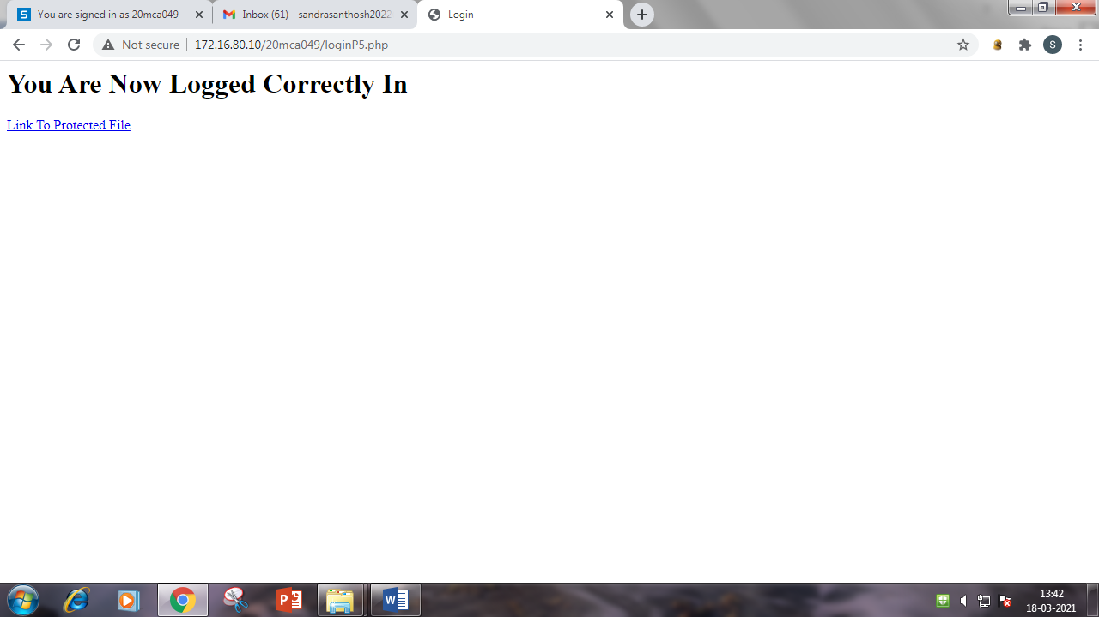

1. Write a program that keeps track of how many times a visitor has loaded the page.

<html>

<head>

<title>php counter</title>

</head>

<body>

<?php

session_start();

if(isset($_SESSION['counter']))

{

$_SESSION['counter'] += 1;

}

else

{

$_SESSION['counter'] = 1;

}

echo "You Have Visited This Page ".$_SESSION['counter']." time in this session ";

?>

</body>

</html>

**Output:**

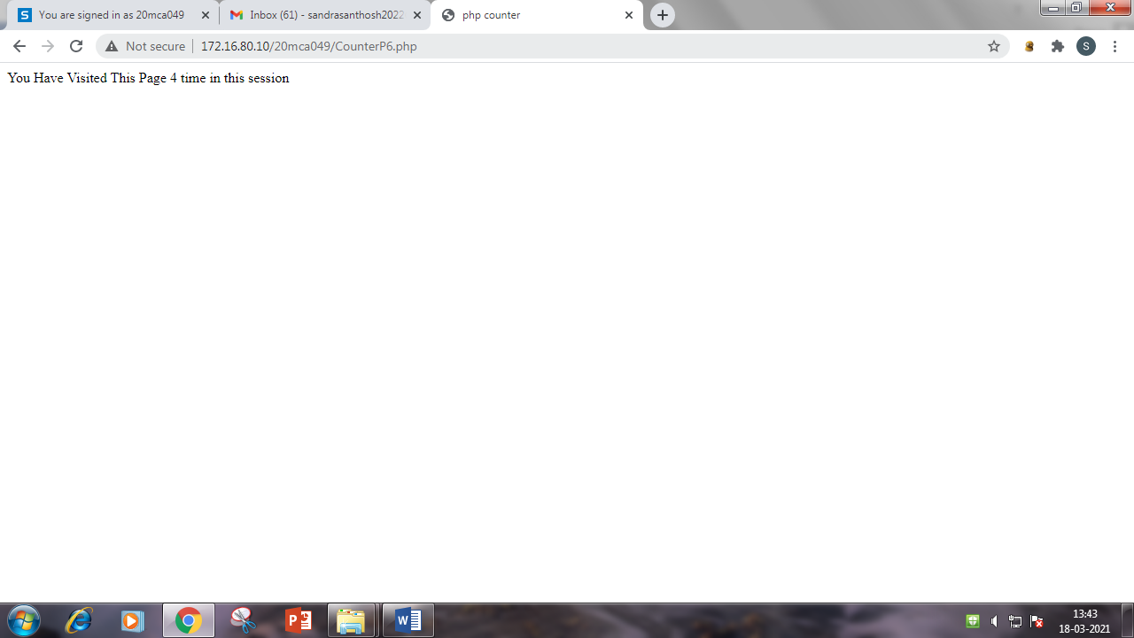

1. Write a PHP program to insert record into a table STUDENT(id,Name,branch,mark) using MySQL.

<html>

<head>

<title>Student Form</title>

</head>

<body>

<form method = "POST" action="">

Name :

<input type = "text" name = "txtname" />

<br><br>

Branch :

<input type = "text" name = "txtbranch">

<br><br>

Mark :

<input type ="text" name ="txtmark">

<br><br>

<input type = "submit" name = "insert" value = "Save">

<input type="submit" name="view" value="select">

<br><br>

</form>

<?php

if(isset($_POST['insert']))

{

$conn =mysqli_connect("localhost","20mca049","2737","20mca049");

if($conn)

{

echo "Mysql connection ok<br>";

$name =$_POST['txtname'];

$branch = $_POST['txtbranch'];

$mark =$_POST['txtmark'];

$sql="INSERT INTO STUDENT(name,branch,mark) VALUES ('$name','$branch','$mark')";

if(mysqli_query($conn, $sql))

{

echo "Data inserted successfully<br>";

}

$qry = "SELECT * FROM STUDENT";

$result = mysqli_query($conn, $qry);

echo "<table border='1'>

<tr>

<th>Id</th>

<th>Name</th>

<th>Branch</th>

<th>Mark</th>

<th>Update</th>

<th>Delete</th>

</tr>";

while ($row = mysqli_fetch_assoc($result))

{

echo "<tr>";

echo "<td>".$row['id']."</td>";

echo "<td>".$row['name']."</td>";

echo "<td>".$row['branch']."</td>";

echo "<td>".$row['mark']."</td>";

echo "<td bgcolor='green'><a href='StudData_update.php?id=$row[id]'><font color='white'>Update</a>";

echo "<td bgcolor='green'><a href='StudData_delete.php?id=$row[id]'><font color='white'>Delete</a>";

echo "</tr>";

}

echo "</table>";

mysqli_close($conn);

}

}

?>

</body>

</html>

**Output:**

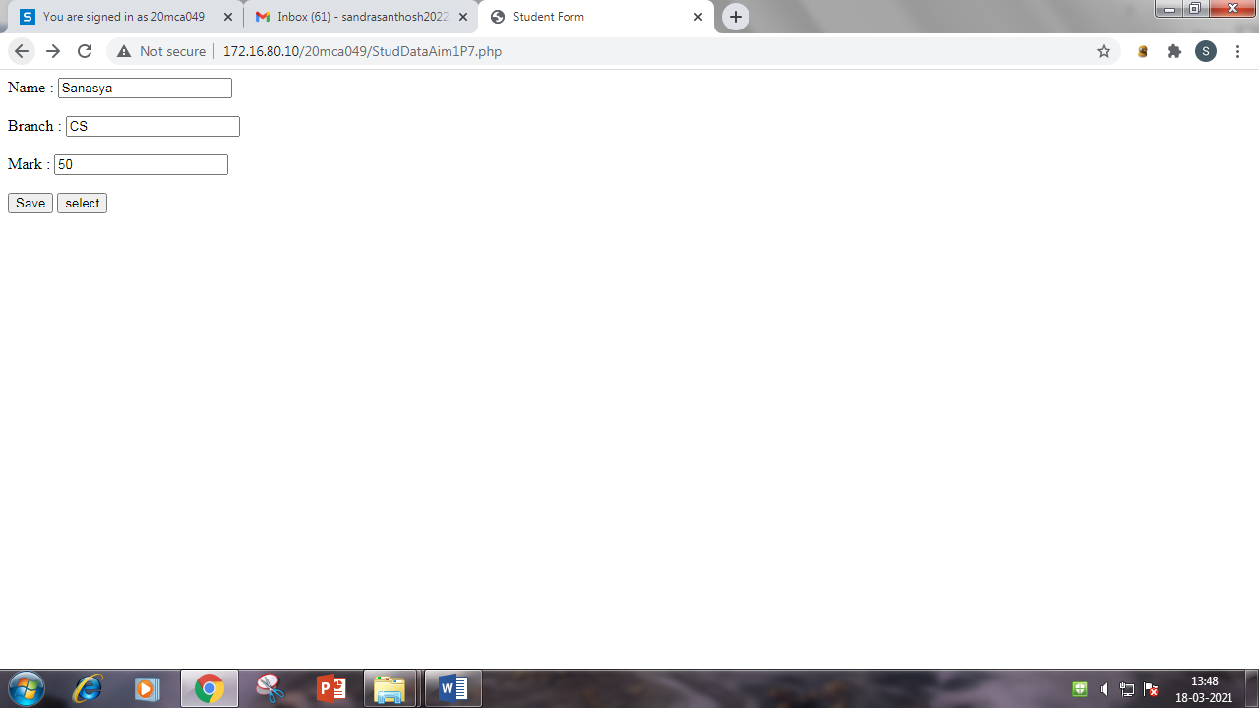

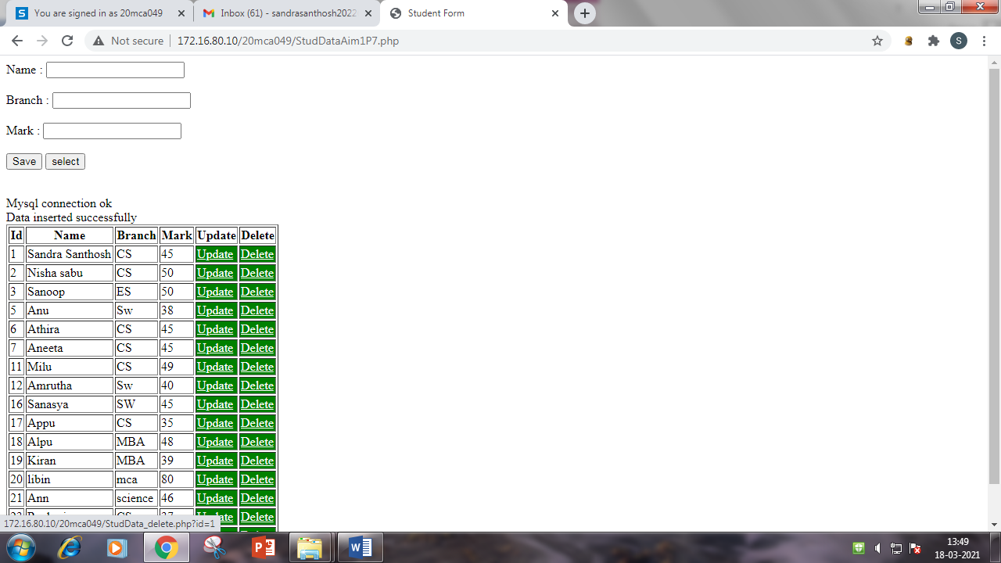

1. Write a program to update table.

<html>

<head>

<title>Update Form</title>

</head>

<body>

<?php

$id = $_GET['id'];

$conn =mysqli_connect("localhost","20mca049","2737","20mca049");

$sql = "SELECT * FROM STUDENT where id = '$id' ";

$res = mysqli_query($conn,$sql);

$r = mysqli_fetch_array($res);

?>

<form method = "post" action = "StudData_update.php">

<!--h1 style= "text-align:center"><u>UPDATE</u></h1-->

<input type ="hidden" name= "id" value="<?php echo $_GET['id'];?>">

<table align= "center">

<tr>

<td>Id</td>

<td>:</d>

<td>

<input type="text" name="sid" value="<?php echo $r['id'];?>">

</td>

</tr>

<tr>

<td>Name</td>

<td>:</d>

<td>

<input type="text" name="name" value="<?php echo $r['name'];?>">

</td>

</tr>

<tr>

<td>Branch</td>

<td>:</d>

<td>

<input type="text" name="branch" value="<?php echo $r['branch'];?>">

</td>

</tr>

<tr>

<td>Mark</td>

<td>:</d>

<td>

<input type="text" name="mark" value="<?php echo $r['mark'];?>">

</td>

</tr>

<tr>

<td colspan="2" style="text-align:right">

<td>

<input type="submit" name="update" value="UPDATE">

</td>

</tr>

</table>

</form>

<?php

if(isset($_POST["update"]))

{

$id=$_POST['id'];

$name=$_POST['name'];

$branch=$_POST['branch'];

$mark=$_POST['mark'];

$qry = "update STUDENT set name='$name', branch='$branch', mark='$mark'

where id='$id'";

if(mysqli_query($conn, $qry))

{

echo "Data Upadated Successfully<br>";

}

}

?>

</body>

</html>

**Output:**

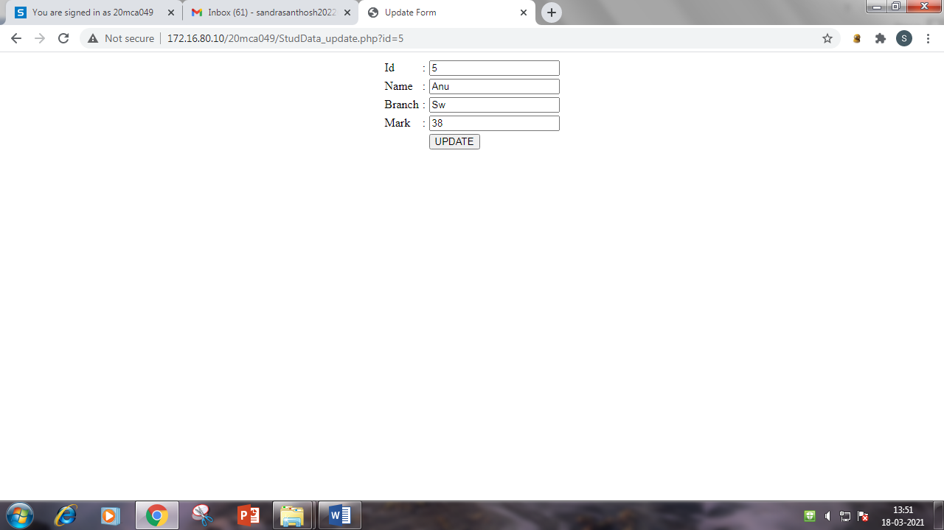

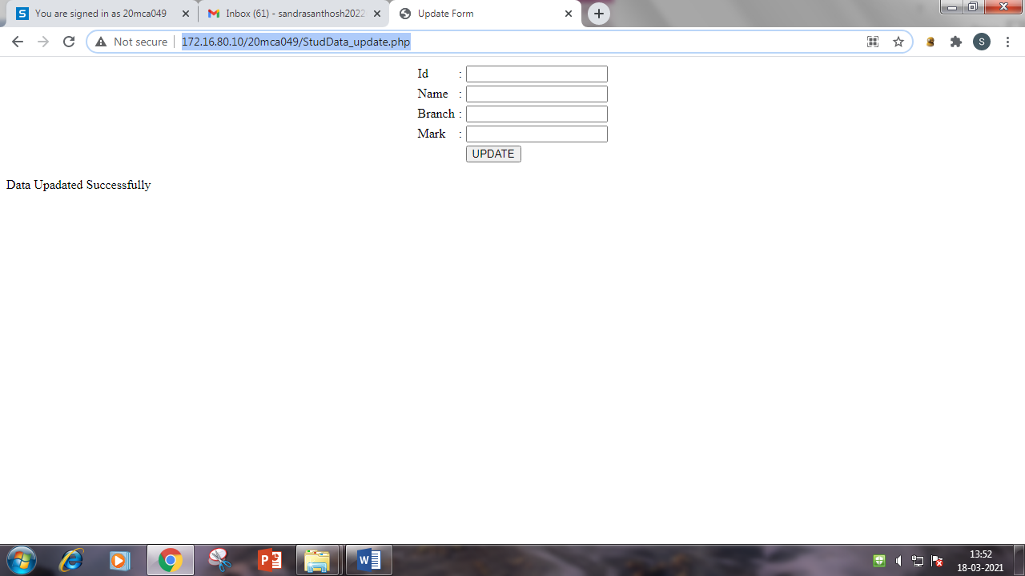

1. Write a PHP program to select data and show into table format..

<html>

<head>

<title>Display Table Format</title>

</head>

<body>

<?php

$conn =mysqli_connect("localhost","20mca049","2737","20mca049");

if($conn)

{

echo "Mysql connection ok<br>";

echo "<h1><u>STUDENT DATA</u></h1>";

$sql = "SELECT * FROM STUDENT";

$res = mysqli_query($conn, $sql);

echo "<table border='1'>

<tr>

<th>ID</th>

<th>Name</th>

<th>Branch</th>

<th>Mark</th>

</tr>";

while ($row = mysqli_fetch_assoc($res))

{

echo "<tr>";

echo "<td>".$row['id']."</td>";

echo "<td>".$row['name']."</td>";

echo "<td>".$row['branch']."</td>";

echo "<td>".$row['mark']."</td>";

echo "</tr>";

}

echo "</table>";

mysqli_close($conn);

}

?>

</body>

</html>

**Output:**

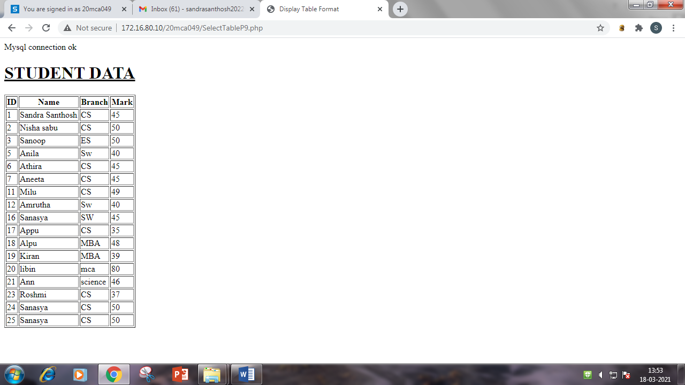

1. Create a student Registration in PHP and Save and Display the

student Records.

<html>

<head>

<title>General Form</title>

</head>

<body bgcolor="powderblue">

<?php

$conn =mysqli_connect("localhost","20mca049","2737","20mca049");

$sql = "SELECT * FROM STUDENT where id = '$id' ";

$res = mysqli_query($conn,$sql);

$r = mysqli_fetch_array($res);

?>

<form method = "POST" action="StudRegP10.php">

Name :

<input type = "text" name = "txtname"/>

<br><br>

Roll NO :

<input type = "text" name = "txtr_no">

<br><br>

Gender :

<input type ="text" name ="txtgen">

<br><br>

Address :

<textarea name = "txtadd" type = "textarea"></textarea>

<br><br>

<input type = "submit" name = "insert" value = "Save">

<!--input type = "submit" name = "view" value = "View"-->

</form>

<?php

if(isset($_POST['insert']))

{

$conn = mysqli_connect("localhost","20mca049","2737","20mca049");

if($conn)

{

echo "Mysql Connection Ok<br>";

$name =$_POST['txtname'];

$rollno =$_POST['txtr_no'];

$gender =$_POST['txtgen'];

$address =$_POST['txtadd'];

$sql = "INSERT INTO tbl_studreg(name,rollno,gender,address) VALUES ('$name','$rollno','$gender','$address')";

if(mysqli_query($conn, $sql))

{

echo "Data Inserted Successfully<br>";

}

$qry = "SELECT * FROM tbl_studreg";

$result = mysqli_query($conn, $qry);

echo "<table border='1'>

<tr>

<th>Id</th>

<th>Name</th>

<th>Roll NO</th>

<th>Gender</th>

<th>Address</th>

</tr>";

while ($row = mysqli_fetch_assoc($result))

{

echo "<tr>";

echo "<td>".$row['id']."</td>";

echo "<td>".$row['name']."</td>";

echo "<td>".$row['rollno']."</td>";

echo "<td>".$row['gender']."</td>";

echo "<td>".$row['address']."</td>";

echo "</tr>";

}

echo "</table>";

mysqli_close($conn);

}

}

?>

</body>

</html>

**Output:**

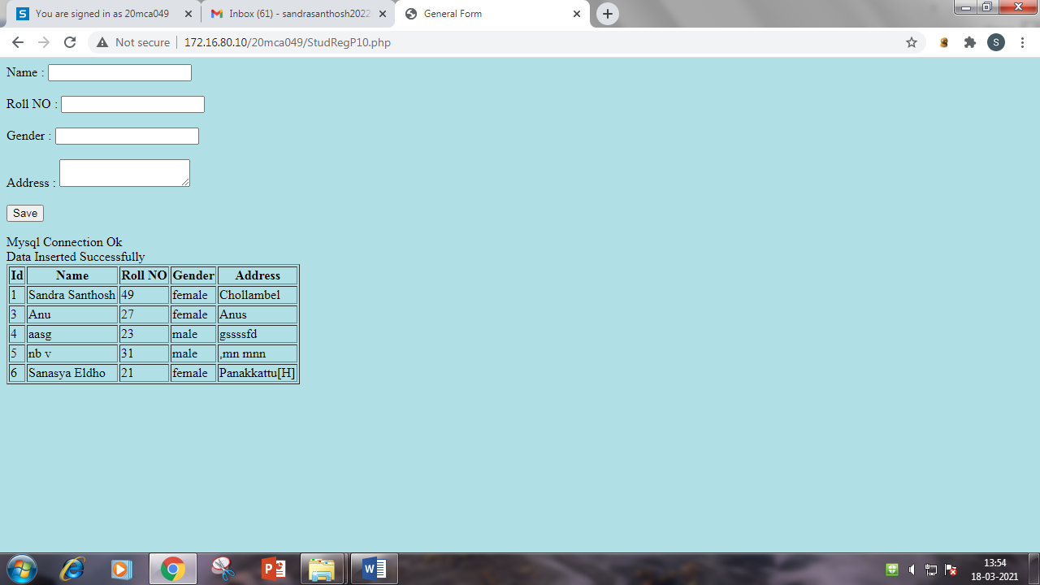

1. Write a program to read customer information like c_no, c_name,

item_purchased and mob_no from customer table and display all this

information in table format on output screen.

<html>

<head>

<title>Customer Form</title>

</head>

<body>

<div align="center">

<h1 style="text-align:center"><u>Insert Data</u></h1>

<form method="post" action="" >

Name :

<input type = "text" name = "txtname" />

<br><br>

Item Purchased :

<input type = "text" name = "txtitem">

<br><br>

Mobile No :

<input type ="text" name ="txtmobno">

<br><br>

<input type="submit" value="submit" name="insert">

<input type="submit" name="view" value="view">

</div>

<?php

$conn=mysqli_connect("localhost","20mca049","2737","20mca049");

if(isset($_POST["insert"]))

{

if($conn)

{

echo "Mysql connection ok<br>";

$name =$_POST['txtname'];

$item = $_POST['txtitem'];

$mobno =$_POST['txtmobno'];

$qry="INSERT INTO tbl_customer(c_name,item_purchased,mob_no) VALUES ('$name','$item','$mobno')";

if(mysqli_query($conn, $qry))

{

echo "Data inserted successfully<br>";

}}}

?>

<?php

if(isset($_POST["view"]))

{

$qry="select * from tbl_customer";

$result=mysqli_query($conn, $qry);

?>

<h1 style="text-align:center"><u>CUSTOMER DETAILS</u></h1>

<table align="center" border="1">

<tr>

<th>NO</th>

<th>Name</th>

<th>Item Purchased</th>

<th>Mobile No</th>

</tr>

<?php

while ($row = mysqli_fetch_assoc($result))

{

echo "<tr>";

echo "<td>".$row['c_no']."</td>";

echo "<td>".$row['c_name']."</td>";

echo "<td>".$row['item_purchased']."</td>";

echo "<td>".$row['mob_no']."</td>";

echo "</tr>";

}

echo "</table>";

mysqli_close($conn);

}

?>

</body>

</html>

**Output:**

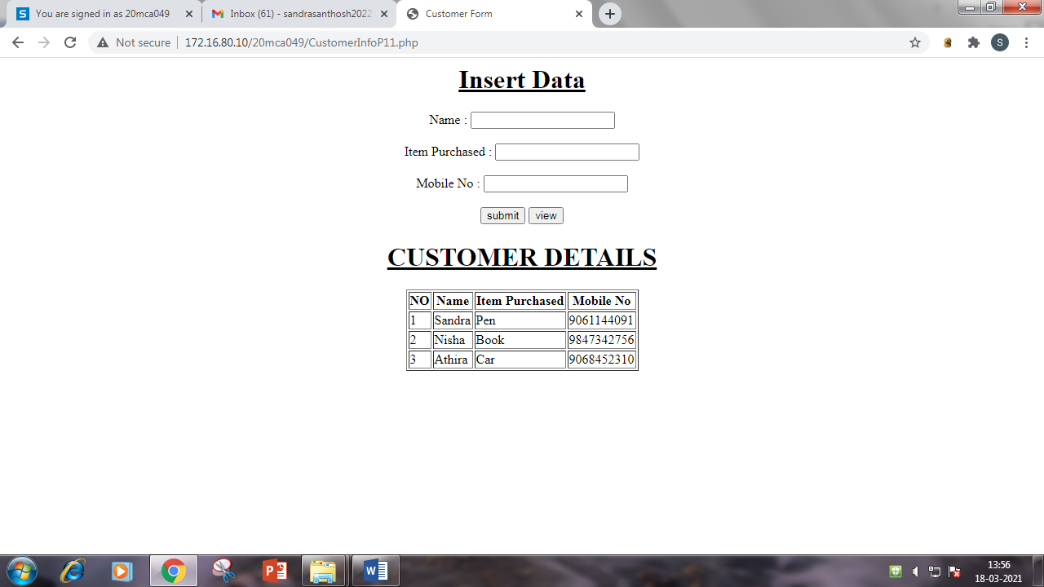

1. Outline a registration form using PHP and do necessary validations. (K4)

<html>

<head></head>

<title>Form Validation</title>

<body>

<style>

.error {color: #FF0000;}

</style>

<?php

$sid=$name=$branch=$mark="";

if(isset($_POST["submit"]))

{

if(empty($_POST["sid"]))

{

$iderror="Student id required";

}

elseif($_POST["sid"]>100)

{

$iderror1="Enter a value less than 100";

}

else

{

$sid=$_POST["sid"];

}

if(empty($_POST["name"]))

{

$nameerror="Student name required";

}

else

{

$name=$_POST["name"];

}

if(empty($_POST["branch"]))

{

$brancherror="Branch required";

}

else

{

$branch=$_POST["branch"];

}

if(empty($_POST["mark"]))

{

$markerror="Enter your mark";

}

elseif($_POST["mark"]>1200)

{

$markerror1="Enter a valid value";

}

else

{

$mark=$_POST["mark"];

}

}

?>

<form method="post" action="FormValidationP12.php" >

<h1 style="text-align:center"><u>STUDENT REGISTRATION FORM</u></h1>

<table align="center">

<tr>

<td>ID</td>

<td>:</td>

<td><input type="text" name="sid"><span class="error">*<?php echo $iderror; echo $iderror1;?></span></td></tr>

<tr>

<td>Name</td>

<td>:</td>

<td><input type="text" name="name"><span class="error">*<?php echo $nameerror; ?></span></td></tr>

<tr>

<td>Branch</td>

<td>:</td>

<td><input type="text" name="branch"><span class="error">*<?php echo $brancherror; ?></span></td></tr>

<tr>

<td>Mark</td>

<td>:</td>

<td><input type="text" name="mark"><span class="error">*<?php echo $markerror;echo $markerror1; ?></span></td></tr>

<tr>

<td>&nbsp;</td></tr>

<tr>

<td colspan="2" style="text-align:right"><input type="submit" value="submit" name="submit"></td></tr>

</table>

</form>

</body>

</html>

**Output:**

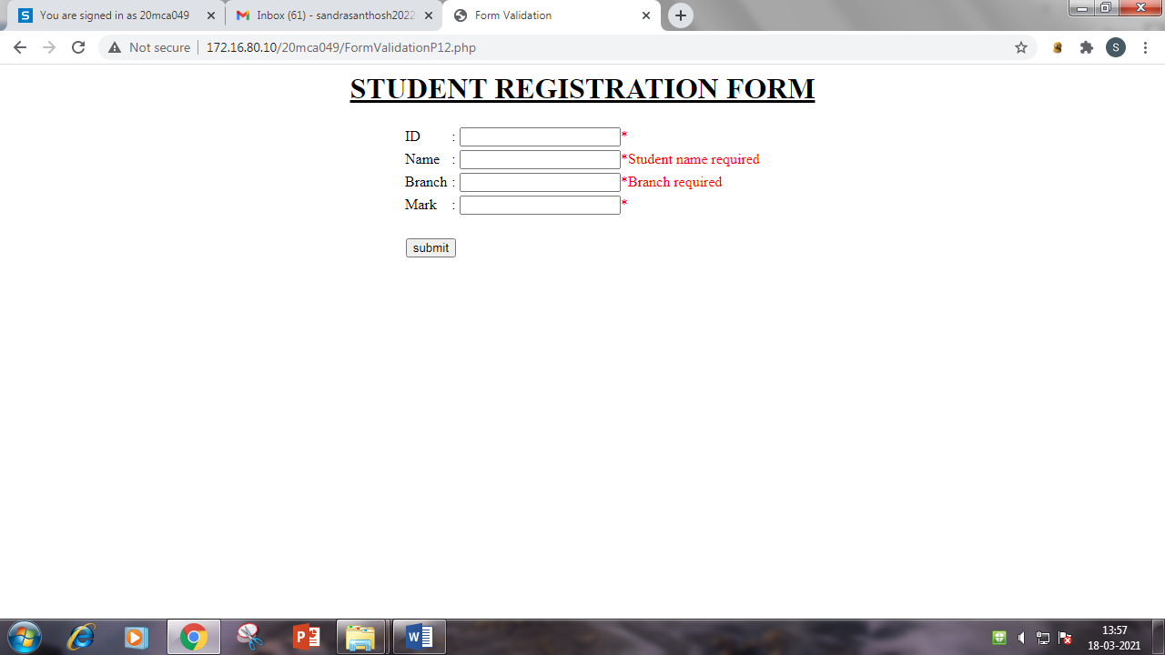

1. Compose Electricity bill from user input based on a given tariff using PHP. (K6)

<html>

<head></head>

<title>Electricity Bill</title>

<body>

<h1 style="text-align:center;color:blue"><u>ELECTRICITY BILL CALCULATOR</u></h1>

<br><br>

<form method="post" >

<div align="center">

<label>Total Unit Consumption:</label>

<input type="text" name="unit"><br><br><br>

<input type="submit" value="calculate" name="calculate" style="background-color:blue;color:white;">

</div>

</form>

<?php

if(isset($_POST["calculate"]))

{

$unit=$_POST["unit"];

if($unit<=300)

{

$price=$unit*5.80;}

elseif($unit>=301 && $unit<=350)

{

$price=$unit*6.60;}

elseif($unit>=351 && $unit<=400)

{

$price=$unit*6.90;

}

elseif($unit>=401 && $unit<=500)

{

$price=$unit*7.10;

}

else

{

$price=$unit*7.90;}

?>

<h1 style="text-align:center;color:green"><u>ELECTRICITY BILL</u></h1>

<table align="center" border="0">

<tr>

<th>Total unit Consuption</th>

<td>:</td>

<td><?php echo $unit; ?></td></tr>

<tr>

<th>Amount to be paid</th>

<td>:</td>

<td><?php echo $price; ?></td>

</tr>

</table>

<?php

}

?>

</body>

</html>

**Output:**

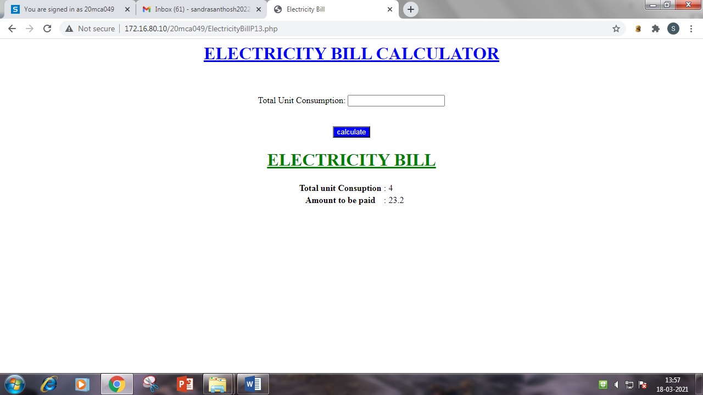

1. Build a PHP code to store name of students in an array and display it using print_r function. Sort and Display the same using asort & arsort functions. (K6)

<!DOCTYPE html>

<html>

<title>student array</title>

<body>

<?php

$name=array("Sandra","Sanasya","Sanoj");

$name1=array("Anu","Ammu","Appu");

echo "<h1>ARRAY IS</h1>";

print_r($name);

print_r($name1);

asort($name);

arsort($name1);

echo "<h1>Ascending Order</h1>";

foreach($name as $name_array)

{

echo $name_array;

echo "<br>";

}

echo "<h1>Descending Order</h1>";

foreach($name1 as $name1_array)

{

echo $name1_array;

echo "<br>";

}

?>

</body>

</html>

**Output:**

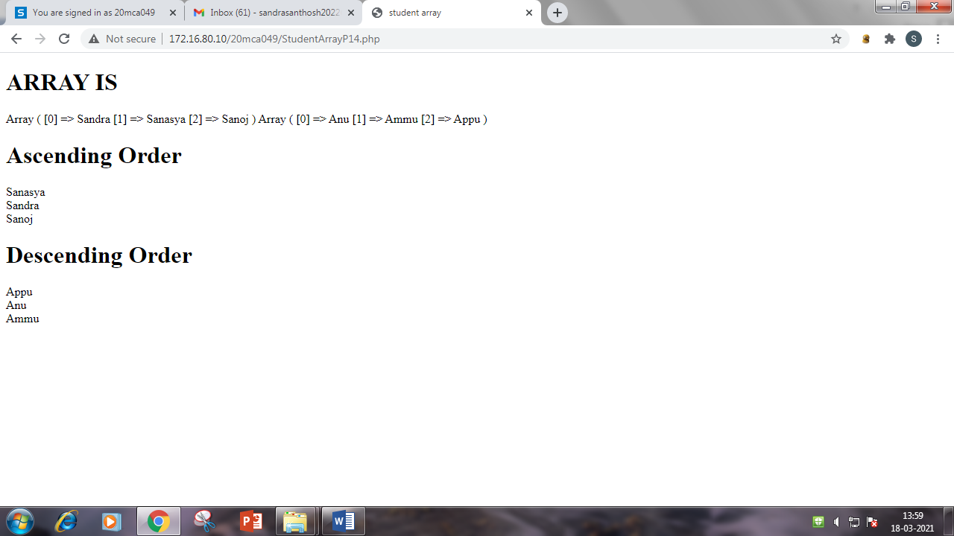

1. Build a PHP code to store name of Indian Cricket players in an array and display the same in HTML table. (K6)

<html>

<head></head>

<body>

<style>

body{

background-color:#f2e6ff;

}

table {

border-collapse: collapse;

width: 50%;

text-align: center

}

th,td{

padding: 10px;

}

th{

background-color:#b366ff;

}

tr:nth-child(even){background-color: #d9b3ff}

</style>

<?php

$my_array = array( "Virat Kohli", "Shikhar Dhawan", "M.S Dhoni","Suresh Raina","Rohit Sharma","Mohit Sharma","Vijay Shankar","Ravindra Jadeja","Irfan Pathan","Gautam Gambhir","Parthiv Pate","Virender Sehwag","Harbhajan Singh","Anil Kumble","Sachin Tendulkar","Rohit Sharma"," Gautam Gambhir");

?>

<h1 style="text-align:center"><u>Indian Cricket Players</u></h1>

<table border=”1” align="center">

<tr>

<th>Sl.No</th>

<th>Name of Players</th>

</tr>

<?php

$arraysize=sizeof($my_array);

for($i=0;$i<$arraysize;$i++)

{

?>

<tr>

<td><?php echo $i+1; ?></td>

<td><?php echo $my_array[$i];?></td>

</tr>

<?php

}

?>

</table>

</body>

</html>

**Output:**

