AI assistance methodology
Used a mix of Cdex and Claude code with VsCode IDE to generate codes and iterations. Claude code is very good and vague prompt to propose a plan and give you idea when not sure. Very good at making sure all files in the repo are up to date. However use lots of credits very fast. So I learn to get use of Codex more. And improve my prompt.
Claude code clearly excel at figuring things out and this is very helpful in exploration [hase. So I hav been using claude code mostly when I was trying to figure out things with sometimes missing cntext. While I was using cidex with most of the time clear instructions. Exemple of prompt for the Streamlit refactor below, done by codex. Codex you need to explicitly reference files in the prompt.
Also use claude to review the code, if hallucinations, errors, incoherences. And give improvement plans.

Screenshots needed
# What to capture Where in report How to get it
1 Ingest page — single PDF upload with extraction result, token usage summary, noise level §4.1 / §7.2 Upload one PDF, screenshot the result panel

2 Ingest page — bulk mode — progress bar, summary table (saved/skipped/failed) §7.2 step 15 Upload 3+ PDFs in bulk mode

3 Inbox page — title-first expandable cards, inline approve buttons, batch actions §4.1 Open Inbox with 5+ records
4 Record detail page — confidence detail breakdown, Quick Approve button §4.1 Open one record, expand confidence detail
5 Dashboard — Topic Momentum — Altair chart with Emerging/Fading labels §4.1 Open Dashboard with 10+ records
6 Dashboard — Priority Distribution — stacked bars + High-Ratio line §4.1 Same dashboard view
7 Weekly Brief — AI-generated — executive brief output with citations §4.1 Generate one AI brief
8 API quota sidebar — progress bars showing per-model usage §7.5.9 Open Ingest page with some calls used
9 Documents library — filtered view with evidence previews §4.1 Open Documents page with filters applied
Diagrams to create
# What to diagram Where in report Content
10 System architecture — end-to-end flow from PDF upload to executive brief §4.1 PDF → text extraction → clean/chunk → model routing → postprocess → validate → store → brief/dashboard
11 Spec-to-code evolution (Phase 1 → Phase 3) §6.1 ASCII placeholder already in report — convert to clean diagram. 5 spec files → 3 touchpoints
12 Extraction prompt before vs after §7.5.8 Side-by-side showing the added topic guidance + competitor context sections
13 Two-tier region architecture §6.1 or §7.2 DISPLAY_REGIONS (broad buckets) vs FOOTPRINT_REGIONS (country-level) with collapse map
Schema / content to fill in
# What Where Source
14 JSON schema excerpt §6.2 (line 302) Copy from record_response_schema() in src/model_router.py or use the clean version from spec/SKILL_final.md §9
15 Results data §9 (lines 675-685) Run 5-10 real ingests, record: total docs, schema pass rate, mean tokens, mean time, override rate, strengths/weaknesses
Test cases for evaluation (§8.3)
# What Status
16 Case A: Market note (region-heavy) — source snippet + JSON + brief Needs real ingest
17 Case B: Competitor/OEM program (priority-driven) — source snippet + JSON + brief Needs real ingest
18 Case C: Government/regulatory (actor type driven) — source snippet + JSON + brief Needs real ingest
Total: 9 screenshots + 4 diagrams + 1 schema fill + 1 results section + 3 test cases = 18 items.

Maintenance heavy risks
a small constant like that usually reduces maintenance, as long as you treat it like a configuration list and keep it stable.
What makes it complex (or not) depends on where it lives and how often it changes.
When it stays simple ✅
It’s low-maintenance if:
- It lives in one place (e.g., constants.py)
- It’s small and readable
- You add a short comment explaining the intent (priority escalation = “exec attention”)
- You add a tiny unit test / smoke test that proves escalation works
In that setup, updating it is literally editing a list.
When it becomes maintenance-heavy ⚠️
It can get annoying if:
- You start adding many special-case lists (“themes for region X”, “themes for OEM Y”, “themes for supplier vs OEM”)
- Priority logic becomes a maze of overlapping rules
- The theme names drift over time (renamed themes) and this set isn’t updated → silent misbehavior

Streamlit UI/UX improvements:

Do many pages, cognitive load. Need to refactore the streamlit interface to make the UI feels more a pipeine not a toolbox.
Ingest → Validate → Approve → Synthesize Weekly Brief
Stage 1 — Capture
Stage 2 — Validate
Stage 3 — Approve
Stage 4 — Weekly Brief
Stage 5 — Insights (optional analytics)
So I sent the stremalit pages to ChatGPTthat has my entire Cognitra context and ask to propose a plan to improve that Streamlit interface and once I agree with the plan, I ask him to right a prompt for codex (see below)
Before
Prompt:
You are Codex operating inside a Streamlit multipage repo (Cognitra). Your job: refactor the UI so the app reads like a single, clear workflow: Ingest → Review/Approve → Weekly Executive Brief → Insights, with Admin hidden under Advanced.

Constraints
- Do not change the core pipeline logic (ingest/extract/postprocess/validate/store) unless required by the UI refactor.
- Keep storage format and APIs the same (data/records.jsonl, src/storage.py functions).
- Preserve backward compatibility: old records may lack newer fields → always use .get() with defaults.
- Keep behavior deterministic except where it already uses LLM (weekly brief synthesis).
- Minimize risk: move code, don’t rewrite algorithms.

Repo context (current pages)
- pages/01_Ingest.py
- pages/02_Inbox.py
- pages/03_Record.py
- pages/04_Dashboard.py
- pages/05_Weekly_Brief.py
- pages/06_Review_Brief.py
- pages/07_Documents.py
- pages/08_Admin.py

Target navigation (4 main pages)
1) Ingest (keep as page 01)
2) Review & Approve (merge Inbox + Record; remove standalone Record page)
3) Weekly Executive Brief (merge Weekly_Brief + Review_Brief)
4) Insights (Dashboard)
Advanced (collapsed / hidden): Admin utilities

High-level refactor plan
A) Merge Inbox + Record
- Create a new page: pages/02_Review_Approve.py (or rename 02_Inbox.py to 02_Review_Approve.py).
- This page must contain:
1. The existing filter + list UI from Inbox (priority/status/source/search).
2. A record detail panel (right side) that shows and edits the selected record JSON (like Record page), including:
- Rendered Intelligence Brief preview
- Schema validation errors (validate_record)
- Save changes (overwrite_records)
- Quick Approve / Disapprove
- Reviewed By + Notes
- Exclude-from-brief toggle
- Selection UX:
- Use a table (st.dataframe with row selection if available in this Streamlit version) OR a selectbox fallback.
- Clicking “Open full record” should no longer switch pages; it should set st.session_state["selected_record_id"] and open details in the same page.
- Delete pages/03_Record.py after migration (or leave stub that redirects to 02_Review_Approve).

B) Merge Weekly_Brief + Review_Brief into one flagship page
- Create/rename to: pages/03_Weekly_Executive_Brief.py (or keep 05 but refactor and rename later).
- This page must include:
1. Candidate selection for a period (days back).
2. A clear “Approved-only” default selection (only Approved and not excluded).
3. AI brief generation (existing synthesize_weekly_brief_llm flow).
4. Save brief + download + open in email client (existing features).
5. “Review” features from Review_Brief:
- Load latest saved brief markdown
- Compare to previous brief diff (optional, collapsed)
- Show brief metadata (selected ids, week_range, usage)
- Show table of candidate/approved records for the brief period
- Flag approved records missing from selection
- Ability to toggle Approved / Exclude-from-brief for a selected record (inline controls)
- Remove pages/06_Review_Brief.py after migration (or leave a stub that redirects).

C) Remove/retire Documents page
- Delete pages/07_Documents.py (or leave a stub). Its functionality is redundant; review page already provides source links and browsing.

D) Insights page
- Keep pages/04_Dashboard.py but rename it to pages/04_Insights.py (or keep filename but change title to “Insights”).
- Ensure it is clearly “optional analytics” and not part of the core pipeline.

E) Admin
- Keep pages/08_Admin.py but:
- Rename title to “Advanced / Admin”
- Add a warning caption: “Developer/analyst utilities”
- Optionally hide destructive buttons (clear all records) behind an “I understand” checkbox.

UX cleanup requirements (must implement)
1) Every main page should show a small progress ribbon at the top:
“1 Ingest → 2 Review → 3 Weekly Brief → 4 Insights”
Highlight current step (simple markdown is fine).
2) Collapse advanced diagnostics on Ingest behind expanders:
- Quota details
- Overrides applied
- Chunking debug output
3) Reduce visual noise in Review page:
- Collapsed list view should show: Title, Source, Date, Priority/Confidence, Status
- Details show evidence + insights + metadata + JSON editor.
4) Preserve all existing functionality (approve/disapprove, notes, reviewed_by, exclude flags, saving records, rendering briefs).

Implementation steps
1) Scan the repo and identify shared helpers duplicated across pages (e.g., _norm_status, safe list parsing). Consolidate into src/ui_helpers.py (or similar) and import from pages.
2) Implement new merged pages first, leaving existing pages intact until new pages work.
3) Add a temporary redirect stub in old pages:
- 03_Record.py → message + st.switch_page to the new Review page
- 06_Review_Brief.py → redirect to Weekly Executive Brief
- 07_Documents.py → redirect to Review page (or display “removed”)
4) Update page numbering to match the new workflow ordering so sidebar reads correctly.

Acceptance criteria (definition of done)
- App sidebar shows only: Ingest, Review & Approve, Weekly Executive Brief, Insights, Advanced/Admin.
- User can:
- Ingest PDFs and generate records as before.
- Review and edit record JSON in the Review page without leaving the page.
- Approve/disapprove/exclude records.
- Generate AI weekly brief, review latest saved brief, compare diff, and save/export.
- No import-time errors; Streamlit app runs.
- Minimal code duplication (helpers extracted).
- Keep existing function calls to src.* modules intact; avoid changing business logic.

Deliverables
- Code changes across pages + any new helper module.
- Remove or redirect deprecated pages.
- Brief README update (optional): describe the new workflow navigation.

Now start by:
1) Listing the current page behaviors and any shared helpers you find.
2) Implement merge A (Review & Approve) with a working selection + detail split layout.
3) Then implement merge B (Weekly Executive Brief).
4) Finally cleanup pages (remove/redirect) and rename titles.

Proceed.

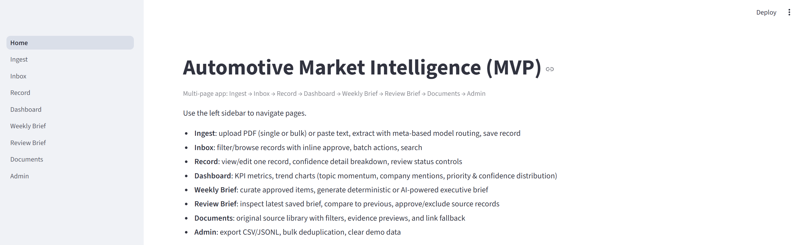

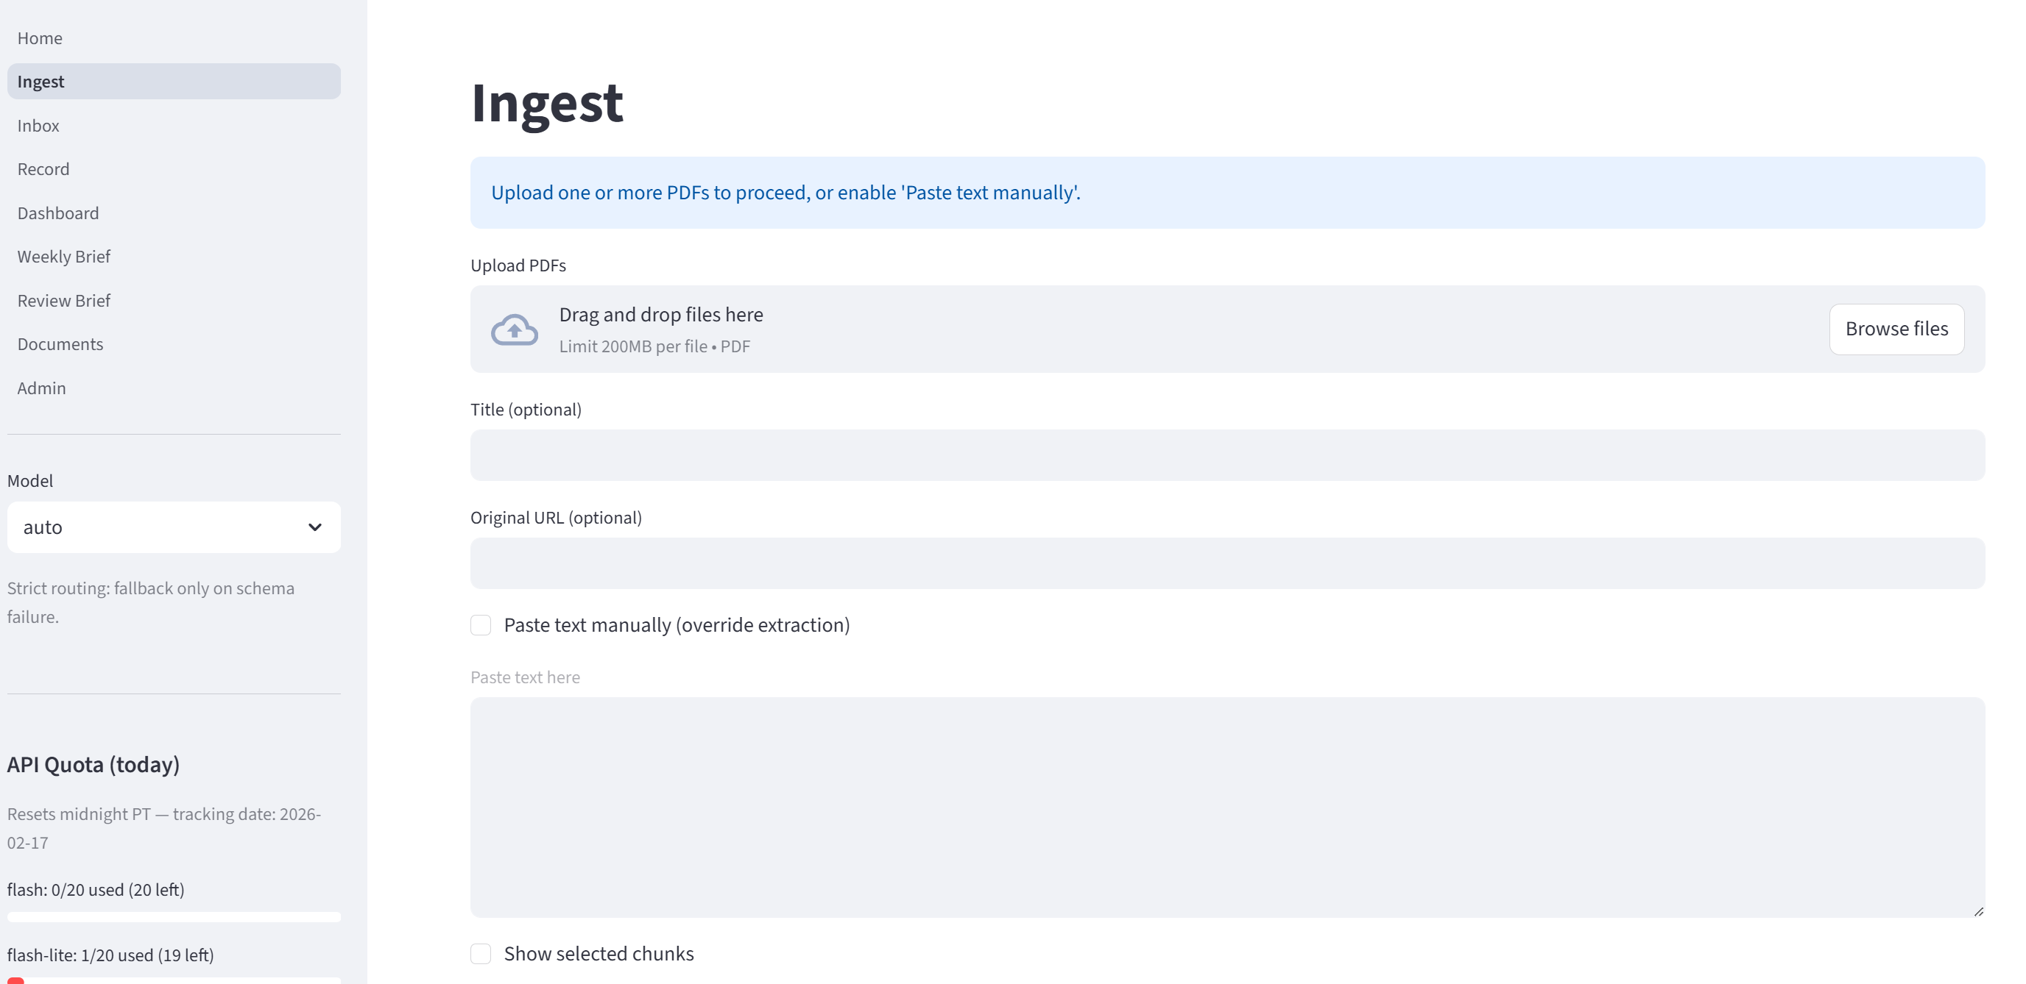

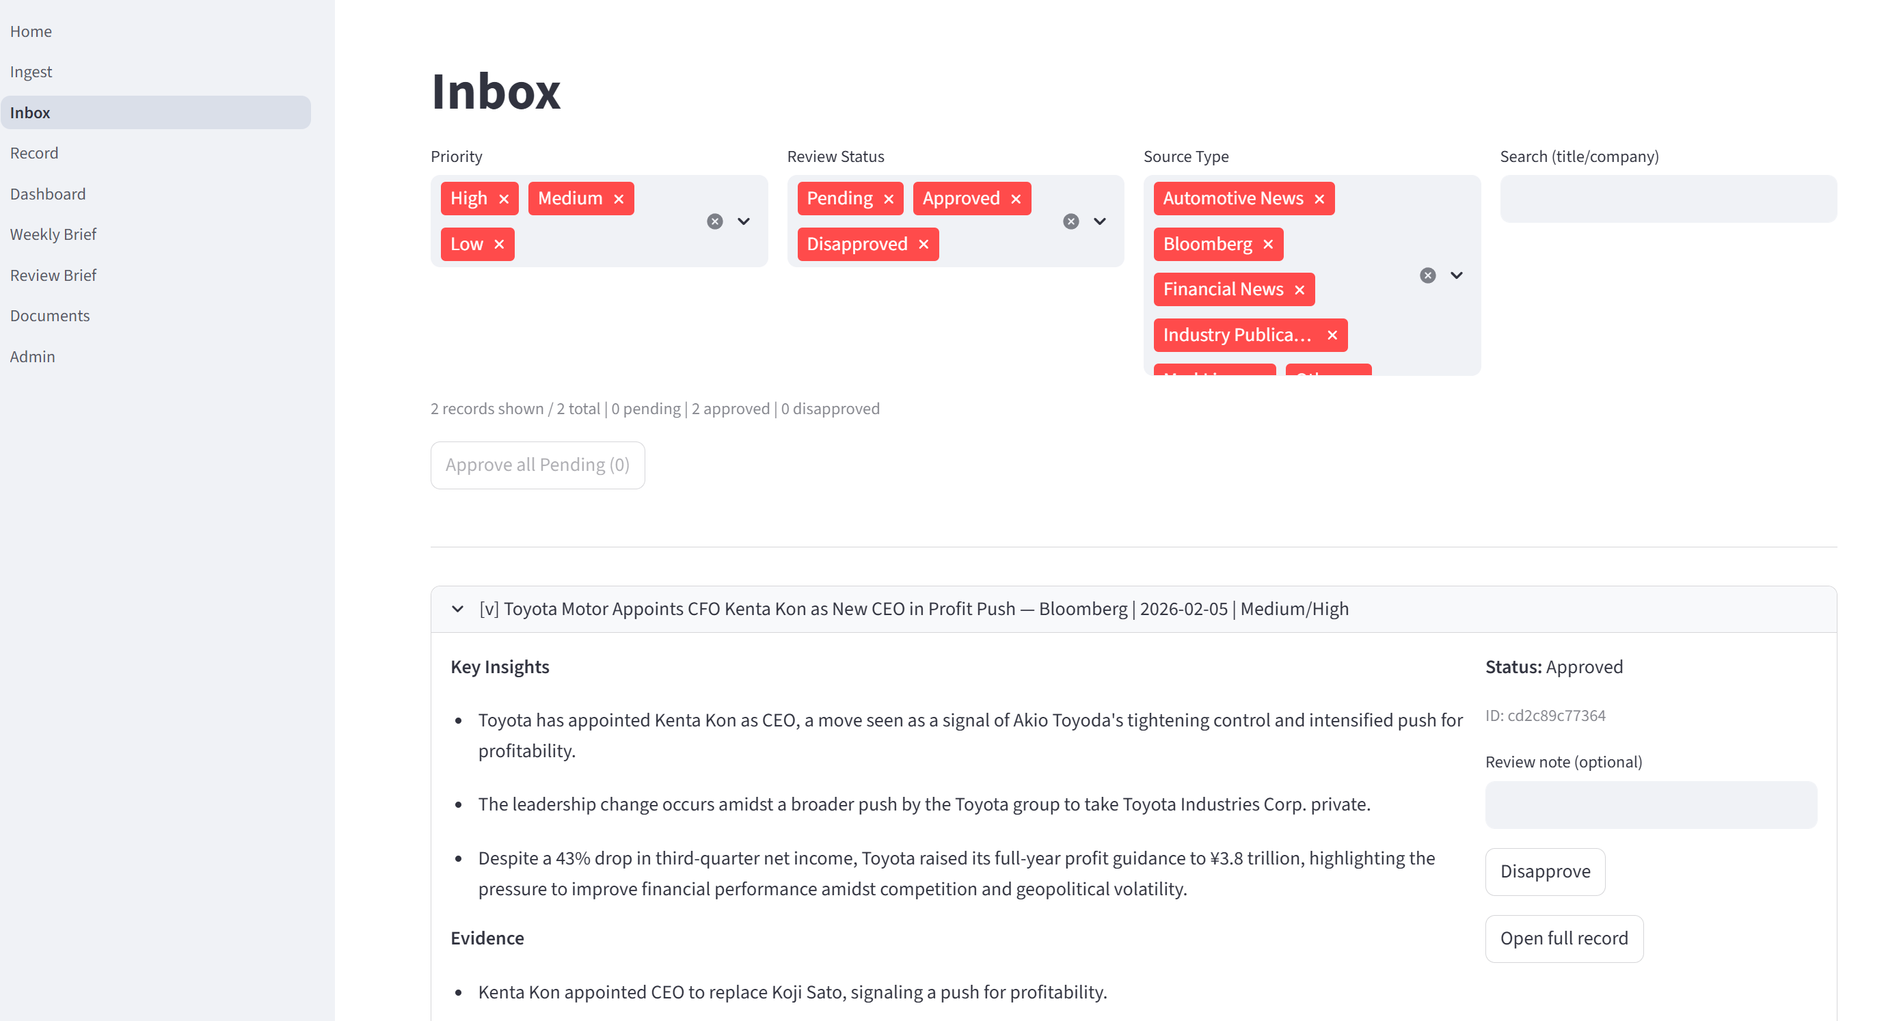

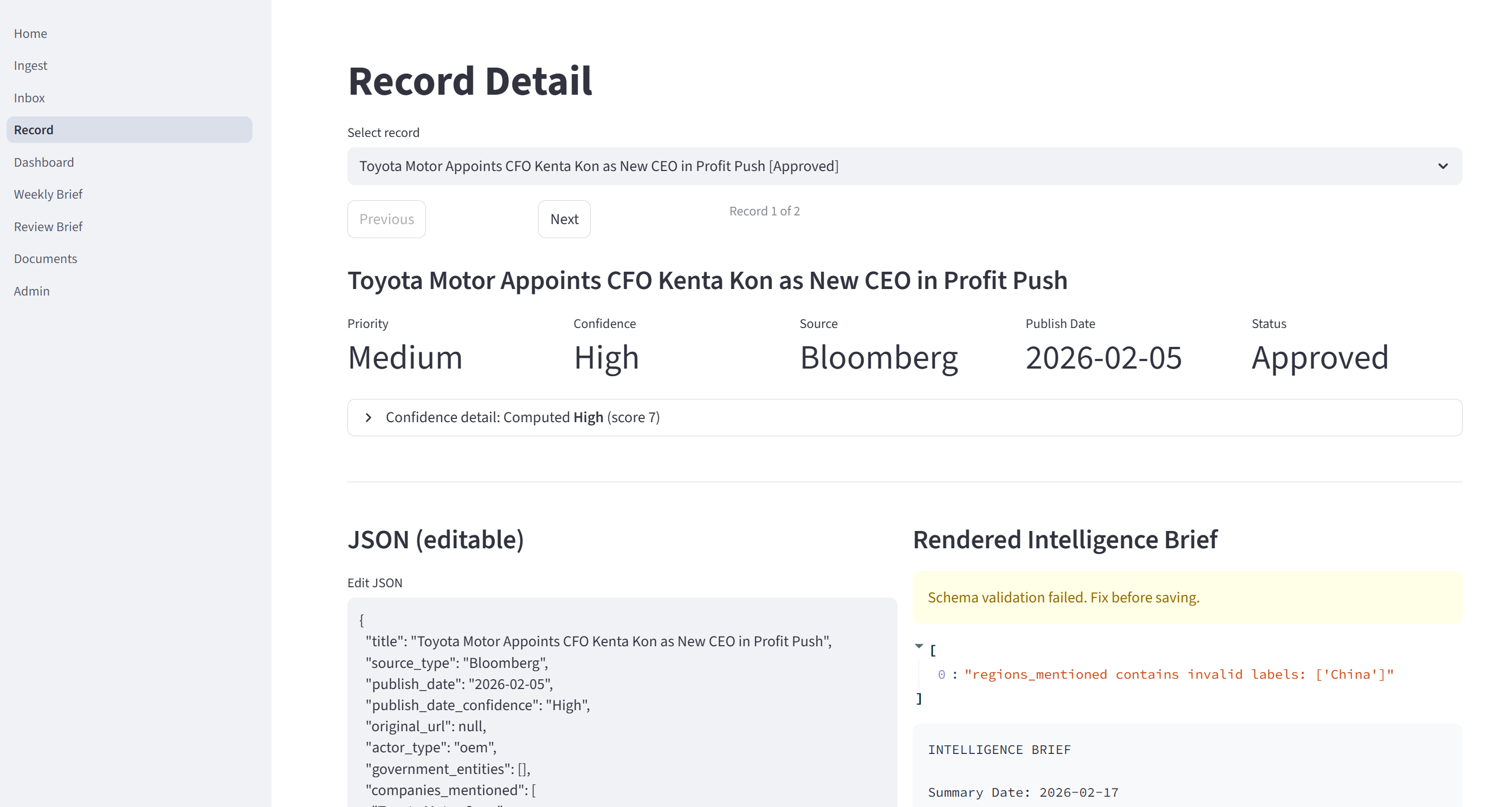

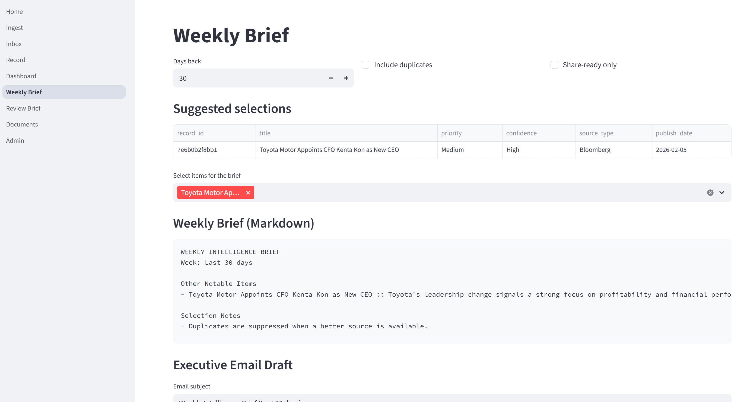

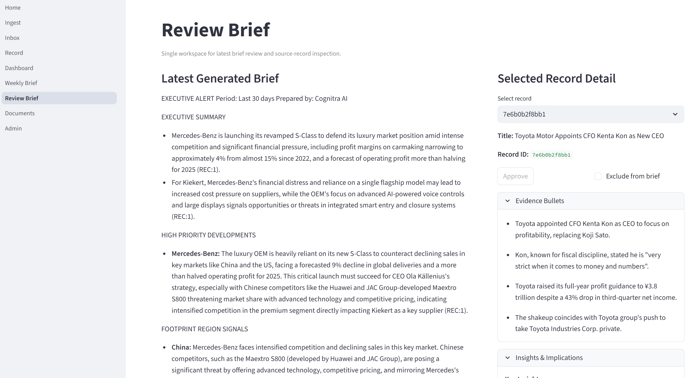

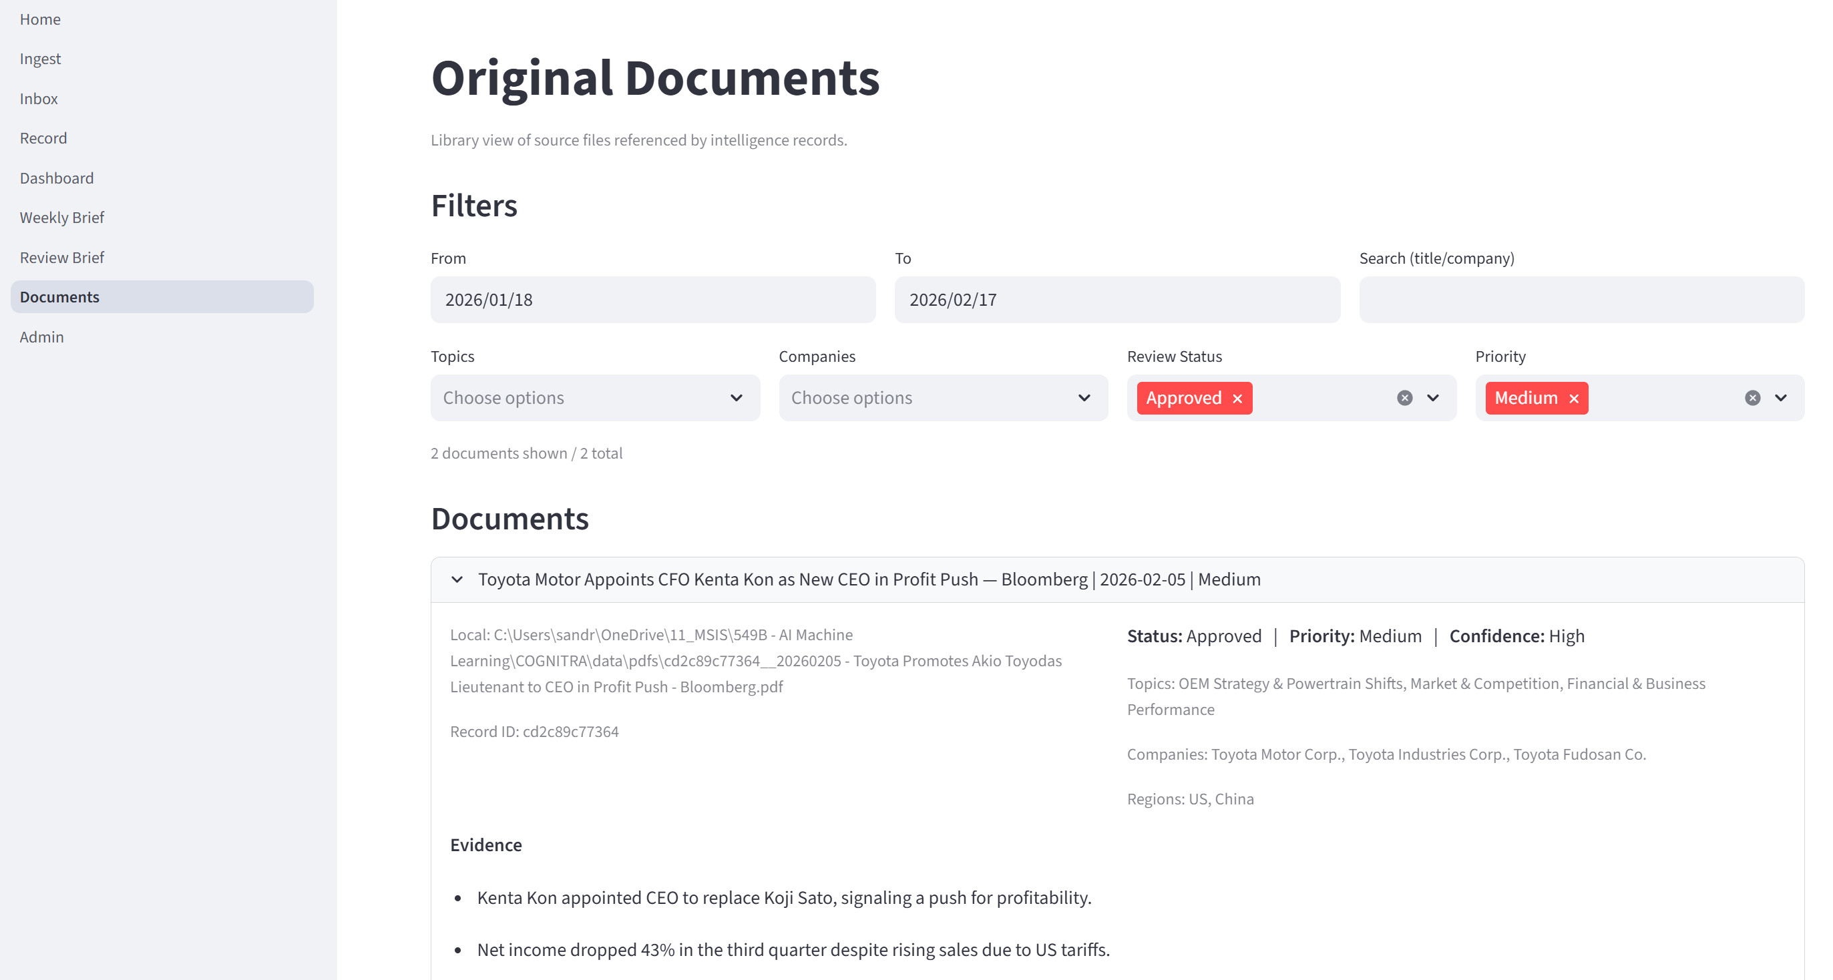

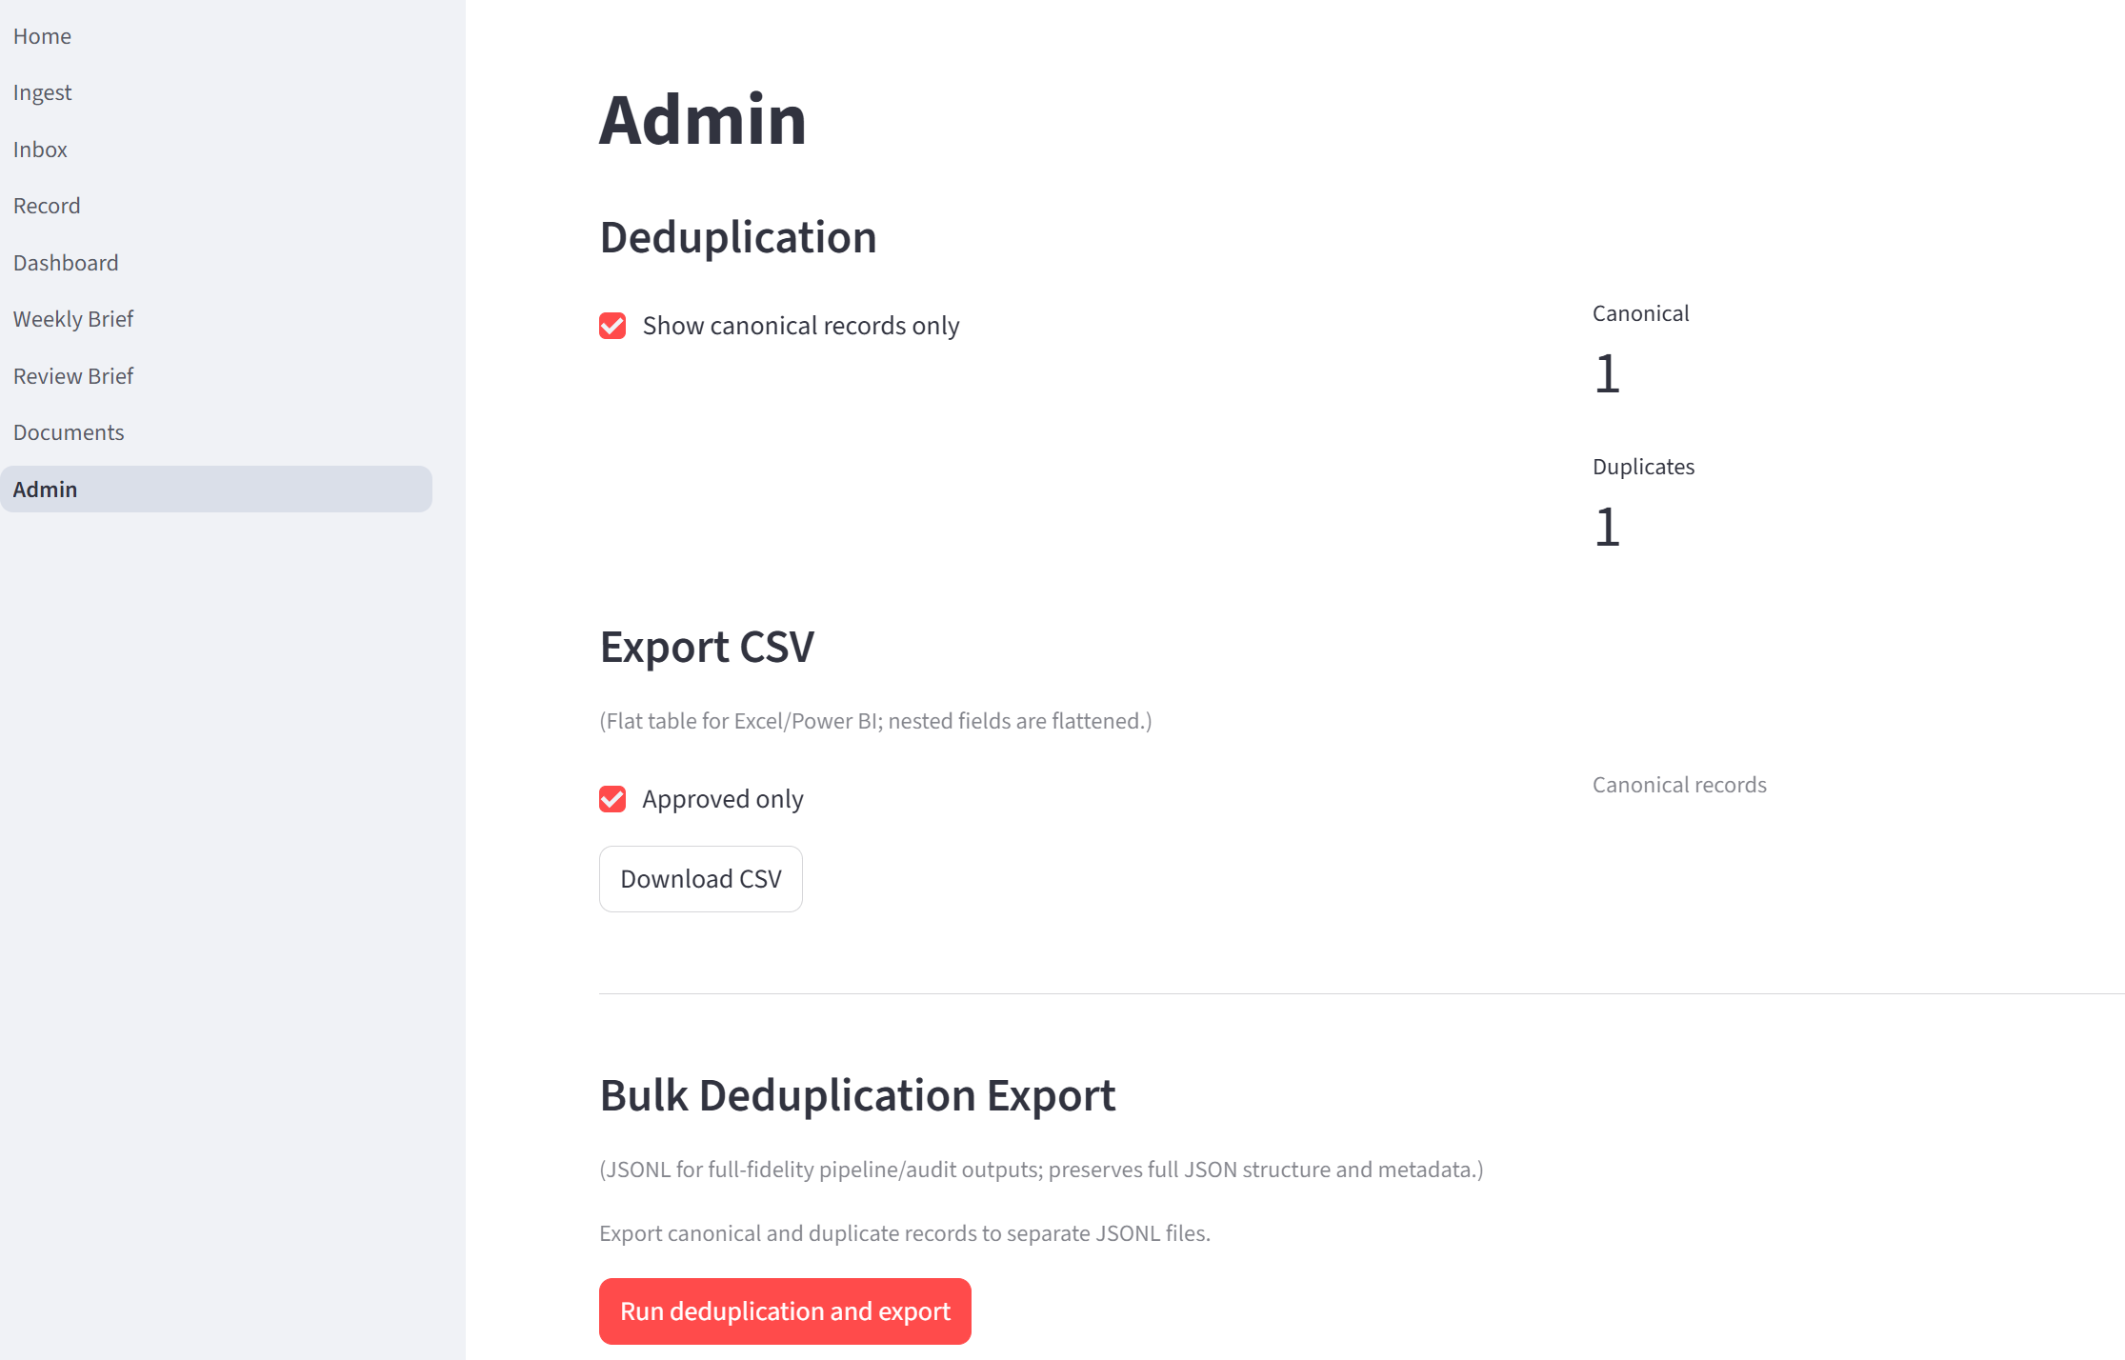

AFTER
CODEX work summary:
What I Found
- Current page split before refactor:
  - 01_Ingest.py: ingest pipeline + diagnostics.
  - 02_Inbox.py + 03_Record.py: review flow split across two pages.
  - 05_Weekly_Brief.py + 06_Review_Brief.py: brief generation/review split.
  - 07_Documents.py: overlapping browsing functionality.
  - 04_Dashboard.py: analytics page.
  - 08_Admin.py: utilities.
- Shared helper duplication:
  - _norm_status duplicated in 02_Inbox.py, 03_Record.py, 07_Documents.py.
  - _safe_list duplicated in 04_Dashboard.py, 07_Documents.py.
  - Repeated link fallback, list joining, and record update patterns across review pages.
Implemented
- Added shared helper module ui_helpers.py with:
  - normalize_review_status, safe_list, join_list, best_record_link, workflow_ribbon.
- Merge A complete:
  - New unified review page 02_Review_Approve.py.
  - Includes filter/list queue + selection + detail pane + JSON editor + validation + rendered brief preview + approve/disapprove + reviewed_by/notes + exclude toggle + save.
  - “Open full record” now keeps selection in-page via st.session_state["selected_record_id"].
- Merge B complete:
  - New unified flagship page 03_Weekly_Executive_Brief.py.
  - Includes candidate selection by period, approved-only default selection, deterministic + AI brief generation, save/download/email.
  - Includes latest saved brief load, metadata view, previous diff, candidate coverage table, missing-approved warnings, inline approve/exclude controls.
- Insights refactor:
  - Replaced dashboard page with 04_Insights.py (renamed title/position, analytics preserved).
- Ingest UX cleanup:
  - Added workflow ribbon in 01_Ingest.py.
  - Collapsed diagnostics into expanders:
    - “Quota details”
    - “Overrides Applied”
    - “Chunking debug output” (single/manual preview).
- Admin update:
  - Renamed to “Advanced / Admin” in 08_Admin.py.
  - Added warning caption and “I understand” checkbox gate for clear-all action.
- Navigation cleanup:
  - Removed deprecated pages from pages/ so sidebar now shows only:
    - 01_Ingest.py
    - 02_Review_Approve.py
    - 03_Weekly_Executive_Brief.py
    - 04_Insights.py
    - 08_Admin.py
- Home + docs:
  - Updated Home.py workflow copy.
  - Updated README.md with new workflow navigation.
Validation
- Compiled updated modules successfully:
  - ui_helpers.py
- Tests pass:
  - .\.venv\Scripts\python -m pytest -q (all passing).

And results

Biggest frustration
This happened so many times, in just 5 minutes!


