Calving Fronts summary

Dataset

- 681 samples.
- Locations: Antarctica, Greenland, Alaska (7 glaciers).
- Structure: SAR images, front labels, zones labels, bounding boxes.
- Time span: 1995 – 2020.
- SAR imagery sources: ERS-1/2, Envisat, RADARSAT-1, ALOS Phased Array L-band Synthetic, Aperture Radar (ALOS PALSAR), TerraSAR-X (TSX), TanDEM-X (TDX), and Sentinel-1.
- SAR data sources: German Aerospace Center (DLR), the European Space Agency (ESA), and the Alaska Satellite Facility (ASF).
- 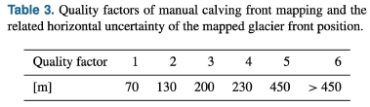

Front Segmentation Baseline Method
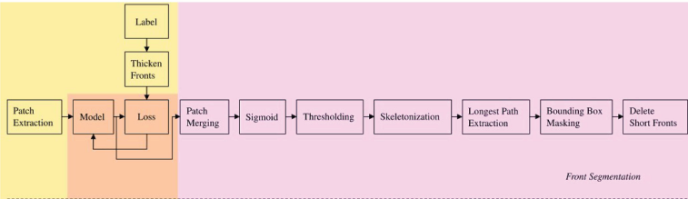
High level scheme:

Preprocessing for front segmentation:
- Input data and labels gathering.
- Class balancing with morphological dilation with 5x5 kernel to thicken the fronts and reduce unbalancing issues (since front line is underrepresented with too few pixels).
- Patch Extraction -> images are divided in 256x256 patches (in training stride with no overlap, in validation and test stride with overlap 128 pixels) and padding with zeros to handle edges.
- Data augmentation, with fixed probability, with rotations, flips, brightness variation, gaussian noise, wrap (only in training)
- Normalization with z-score on each patch using mean and standard deviation of training set.

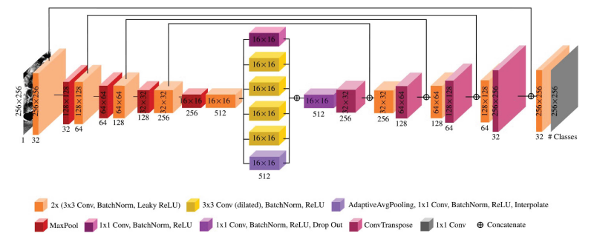
Model:

- Base architecture:
- Skip connection Encoder-decoder.
- Bottleneck enriched with ASPP (Atrous Spatial Pyramid Pooling) equipped with dilation rates 1,2,4,8 (useful since front may have very different scales).
- Activation: Leaky ReLU (slope 0.1).
- Padding: “same”.
- Initial features: 32.
- Output:
- Front segmentation: probability map (pixel →probability to be part of the front line)
- Training setup:
- Batch size: 16 (max fitting in GPU with 256×256 patch).
- Optimizer: Adam + cyclic learning rate (base/max LR = 1e-4/5e-4 per front).
- Gradient clipping norm = 1.0.
- Front Loss functions: adapted Improved Distance Map Loss (Davari 2021) → combining Dice with weights coming from front-line EDT.
- Early stopping with threshold patience 30 epochs.
- Training: 150 epochs × 5 runs → mean of results.
Postprocessing:
- Patch merging with Gaussian weighting.
- Sigmoid + threshold (0.12) → binarization.
- Skeletonization → 1-pixel lines.
- Longest path extraction: deletion of spurious branches.
- Bounding box masking + segment filter < 750 m.
Evaluation:
- Final metric (front delineation): Mean Distance Error (MDE) → symmetric mean distance between predicted lines and ground truth.

Results with a run of pretrained model

Epochs of pretrained model: 144
Validation:
Average Loss: 0.5756176710128784
Average Precision: 0.026997725059931248
Average Recall: 0.6769877295167577
Average F1 Score: 0.051666733482539196
Average IoU: 0.026549514893114853
####################################################################
# Results for all images
####################################################################
Number of images: 56
Number of images with no predicted front: 0
Mean distance error: 309.95518257905826

Test:
Average Loss: 0.6058998107910156
Average Precision: 0.029292776000305158
Average Recall: 0.5542650039930039
Average F1 Score: 0.052082547176828135
Average IoU: 0.027040528813207523
####################################################################
# Results for all images
####################################################################
Number of images: 122
Number of images with no predicted front: 7
Mean distance error: 768.3999955685621

