**Docker Set Up**

# CREATE CONTAINER

NOTE: Docker will not run from command line unless the docker.exe file location is in path

To set up docker image and container run from the command line:

docker run -e "ACCEPT_EULA=Y" -e "SA_PASSWORD=Pa55word" -p 1433:1433 --name data26 -d mcr.microsoft.com/mssql/server:2019-latest

To check if the container is setup correctly, enter into command line:

docker images

You should get:



Open Azure Data Studio and connect to localhost, 1433

Login details:

* Username: SA
* Password: Pa55word

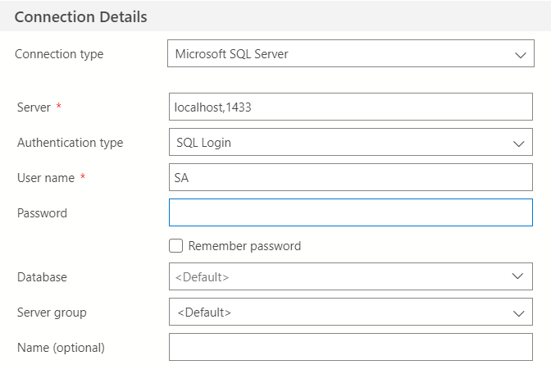

# CREATE DATABASE

A database called “spartaGlobal” should be created in Azure, by running command

CREATE DATABASE spartaGlobal

After connecting to data26 container, open a python script. From here everything can be handled using “pyodbc”, using

import pyodbc

server = 'localhost, 1433'

database = 'spartaGlobal'

username = 'SA'

password = 'Pa55word'

spartaGlobal = pyodbc.connect(('DRIVER={ODBC Driver 17 for SQL Server};SERVER='+server+';DATABASE='+database+';UID='+username+';PWD='+ password))

to connect & use SQL queries in Python