AJAX JSON viewer

Description:
Tool for getting static json from server and showing it in user friendly way.
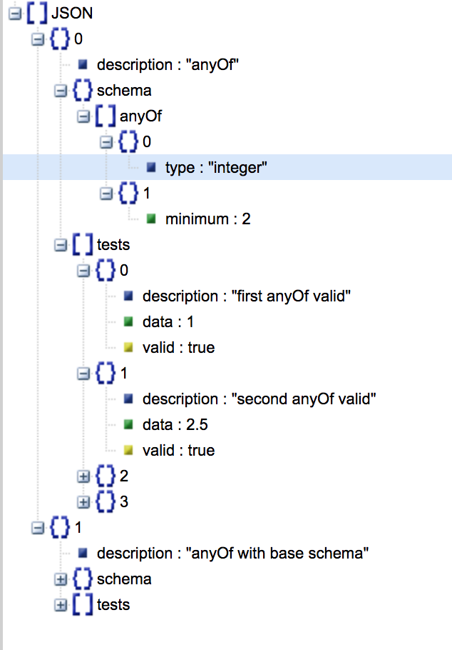

Requirements:
- No any predefined HTML used – entire tool should be created with native JavaScript (without any toolkit and frameworks).
- Tool created inside absolutely positioned DIV with dragging possibility
- User can input any http path and press “Get” button to acquire JSON using GET METHOD.
  - + request can be send using POST METHOD with “Post” button
- JSON acquired in asynchronous mode.
- On JSON receiving
  - Show JSON status – OK/INCORRECT DATA
  - Count of Errors (X)
  - Count of Warnings (X)
  - Size of JSON (in bytes)
- Clicking JSON/Errors/Warning expands informational panel (with border), which is hidden by default.
  - JSON tab – show formatted JSON data
    - + data can be colored
    - + data can be expandable (look http://jsonviewer.stack.hu/)
  - “Errors” and “Warning” tabs have list of encountered Errors and Warnings
- GUI must be easy configurable via external css.

Comments:
“Errors” and “Warnings” are not real errors and warnings produced by JSON parser, but special keys (for example “error”:{“text”:”Incorrect date”, “code”:1} & “warning”:{“text”:”Attention”}) which must be processed in special way after receiving JSON. Such tags shouldn’t be shown in JSON view, but data inside such tags should populate informational area under “Errors” and “Warning”.

+ tasks marked with “+” sign should be implemented in the last turn.

