CLASS ASSIGNMENT – 6
ID : 12341550
FIFO

STEP 1
FILE : proc.h

#define MAX_PAGES 20
…
under struct proc
…
int pages[MAX_PAGES];
int page_count;

STEP 2
FILE : vm.c

modified allocum() :

int allocuvm(pde_t *pgdir, uint oldsz, uint newsz)
{
char *mem;
uint a;
if (newsz >= KERNBASE)
return 0;
if (newsz < oldsz)
return oldsz;
a = PGROUNDUP(oldsz);
for (; a < newsz; a += PGSIZE)
{
mem = kalloc();
if (mem == 0)
{
cprintf("allocuvm out of memory\n");
deallocuvm(pgdir, newsz, oldsz);
return 0;
}
memset(mem, 0, PGSIZE);
if (mappages(pgdir, (char *)a, PGSIZE, V2P(mem), PTE_W | PTE_U) < 0)
{
kfree(mem);
deallocuvm(pgdir, newsz, oldsz);
return 0;
}
struct proc *cur = myproc();
if (cur->page_count < MAX_PAGES)
{
cur->pages[cur->page_count++] = (int)a;
cprintf("Allocated page %d at virtual address 0x%x\n", cur->page_count - 1, a);
}
else
{
int evict = cur->pages[0];
mem = (char *)P2V(PTE_ADDR(*walkpgdir(pgdir, (void *)evict, 0)));
kfree(mem);
for (int i = 1; i < MAX_PAGES; i++)
cur->pages[i - 1] = cur->pages[i];
cur->pages[MAX_PAGES - 1] = (int)a;
cprintf("Evicted page at 0x%x, allocated new page at 0x %x\n", evict,
a);
}
}
return newsz;
}

STEP 3
FILE : mytest.c

#include "types.h"
#include "user.h"
#define MAX_PAGES 5
// Number of physical pages available
#define TOTAL_ACCESSES 15 // Total virtual pages to access
int main(int argc, char *argv[])
{
int fifo[MAX_PAGES];
// Stores allocated virtual pages
int next_to_replace = 0; // FIFO pointer
int i, j;
int page;
int hit, miss;
// Initialize page table
for (i = 0; i < MAX_PAGES; i++)
fifo[i] = -1;
hit = 0;
miss = 0;
printf(1, "Starting FIFO page replacement simulation...\n");
// Simulated accesses
int accesses[TOTAL_ACCESSES] = {0, 1, 2, 3, 4, 1, 5, 0, 6, 1, 2, 7, 3, 8, 4};
for (i = 0; i < TOTAL_ACCESSES; i++)
{
page = accesses[i];
int found = 0;
// Check if page is already in memory (hit)
for (j = 0; j < MAX_PAGES; j++)
{
if (fifo[j] == page)
{
found = 1;
break;
}
}
if (found)
{
hit++;
printf(1, "Access page %d: HIT\n", page);
}
else
{
miss++;
printf(1, "Access page %d: MISS, replacing page %d\n", page,
fifo[next_to_replace]);
fifo[next_to_replace] = page;
next_to_replace = (next_to_replace + 1) % MAX_PAGES;
}
}
printf(1, "FIFO simulation completed.\n");
printf(1, "Total hits: %d\n", hit);
printf(1, "Total misses: %d\n", miss);
exit();
}

OUTPUT :

with size 3

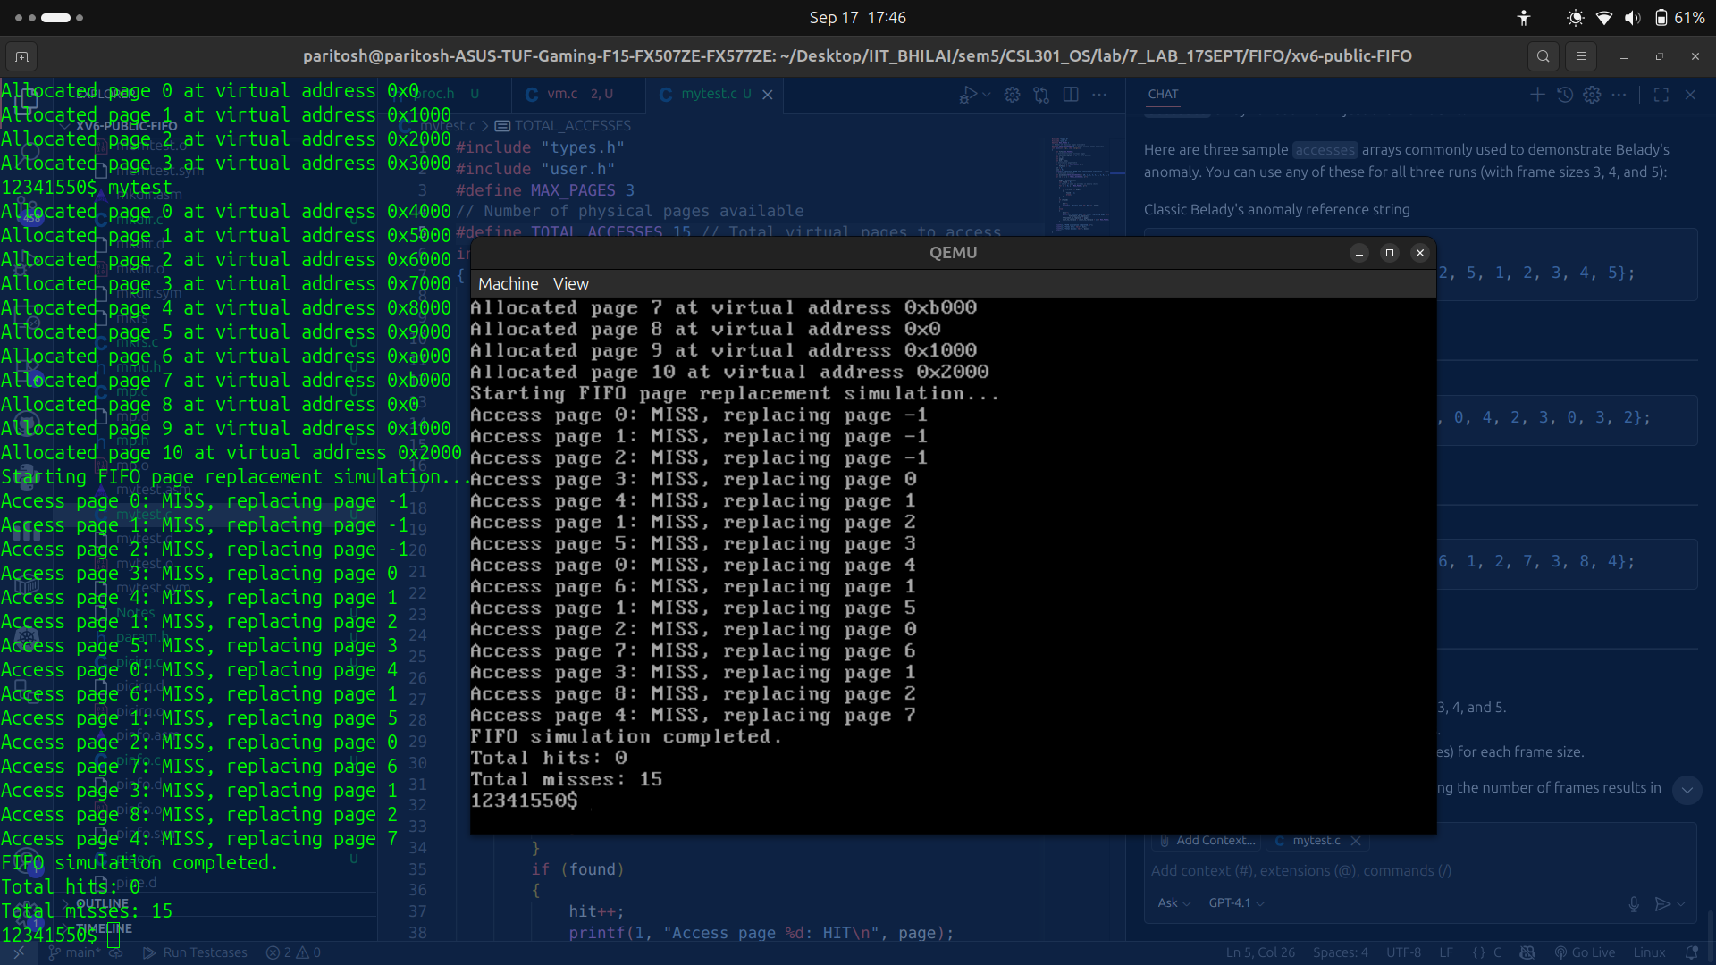
with size 4

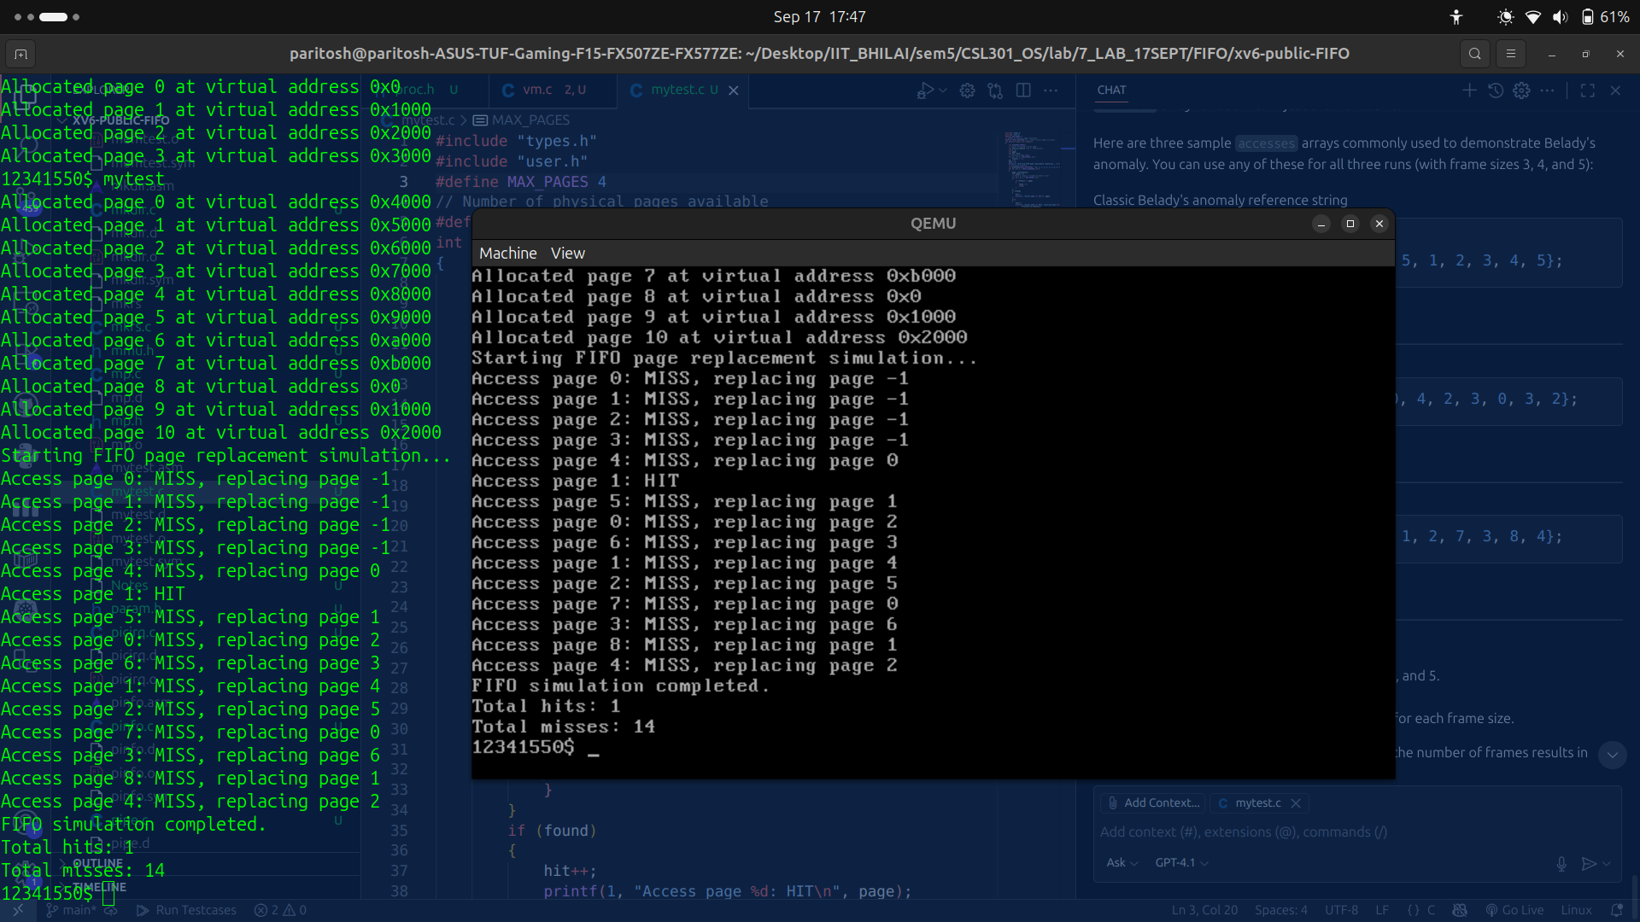
with size 5

