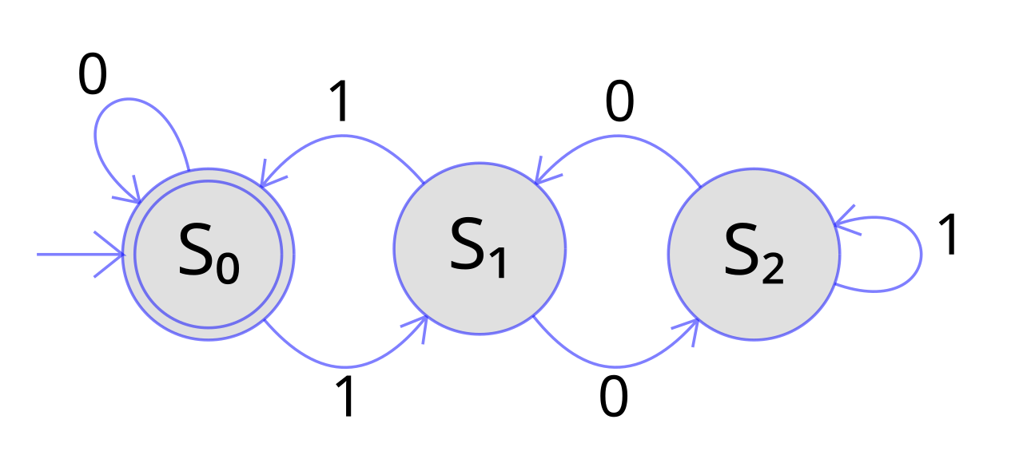
Consider the FSM above.

- Assume that So is the state where S\phiS is true.

- Detailed label checking for EX $\phi$

- Detailed label checking for AF $\phi$

- Symbolic model checking for EX $\phi$

- Symbolic model checking for AF $\phi$

Comparison of Traditional and Symbolic model checking

