HOME ASSIGNMENT 4
ID : 12341550
DATE : 18/10/25

Q1:
code :
#include<stdio.h>
#include<pthread.h>
#include<stdlib.h>
#define SEGMENT_SIZE 10
#define SIZE 100

typedef struct
{
int *arr;
int start;
}args;

void *partial_sum(void *arg)
{
args *a = (args *)arg;
int sum = 0;
for (int i = a->start; i<a -> start + SEGMENT_SIZE; ++i)
sum += a->arr[i];
int *result = malloc(sizeof(int));
*result = sum;
return result;
}

void *total_sum(void *arg){
int * partial_sums = (int *)arg;
int total = 0;
for(int i = 0; i < SEGMENT_SIZE; i++){
total += partial_sums[i];
}
int * result = malloc(sizeof(int));
*result = total;
return result;
}

int main(){
int arr[SIZE];
for(int i = 0; i < SIZE; i++) arr[i] = i + 1;

pthread_t thread[SEGMENT_SIZE];
args segment[SEGMENT_SIZE];
int segment_sum[SEGMENT_SIZE];

for(int i = 0; i < 10; i++){
segment[i].arr = arr;
segment[i].start = i * SEGMENT_SIZE;
pthread_create(&thread[i],NULL,partial_sum,&segment[i]);
}

for(int i = 0; i < SEGMENT_SIZE; i++){
void * result;
pthread_join(thread[i],&result);
segment_sum[i] = *((int *)result);
printf("Thread %d partial sum : %d\n",i + 1,*((int *)result));
free(result);
}

pthread_t master_sum;
void *total;

pthread_create(&master_sum,NULL,total_sum,segment_sum);
pthread_join(master_sum,&total);

printf("Total sum : %d\n",*((int *)total));
}
OUTPUT:
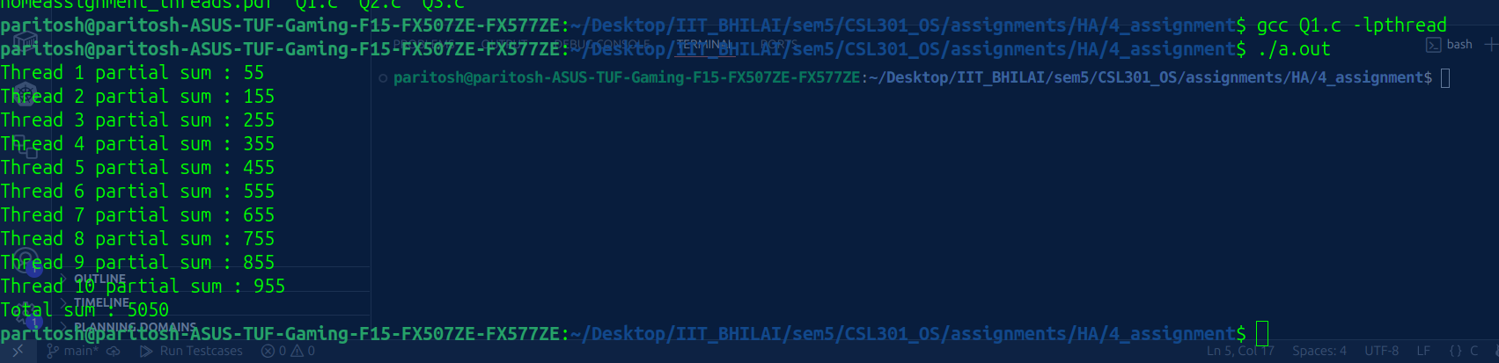

Q2:
code:
#include<stdio.h>
#include<pthread.h>
#include<stdlib.h>
#define SEGMENT_SIZE 10
#define SIZE 100

typedef struct
{
int *arr;
int start;
}args;

void *partial_sum(void *arg)
{
args *a = (args *)arg;
int sum = 0;
for (int i = a->start; i<a -> start + SEGMENT_SIZE; ++i)
sum += a->arr[i];
int *result = malloc(sizeof(int));
*result = sum;
return result;
}

void *total_sum(void *arg){
int * partial_sums = (int *)arg;
int total = 0;
for(int i = 0; i < SEGMENT_SIZE; i++){
total += partial_sums[i];
}
int * result = malloc(sizeof(int));
*result = total;
return result;
}

int main(){
int arr[SIZE];
for(int i = 0; i < SIZE; i++) arr[i] = i + 1;

pthread_t thread[SEGMENT_SIZE];
args segment[SEGMENT_SIZE];
int segment_sum[SEGMENT_SIZE];

for(int i = 0; i < 10; i++){
segment[i].arr = arr;
segment[i].start = i * SEGMENT_SIZE;
pthread_create(&thread[i],NULL,partial_sum,&segment[i]);
}

for(int i = 0; i < SEGMENT_SIZE; i++){
void * result;
pthread_join(thread[i],&result);
segment_sum[i] = *((int *)result);
printf("Thread %d partial sum : %d\n",i + 1,*((int *)result));
free(result);
}

pthread_t master_sum;
void *total;

pthread_create(&master_sum,NULL,total_sum,segment_sum);
pthread_join(master_sum,&total);

printf("Total sum : %d\n",*((int *)total));

double average = (double)*((int *)total) / SIZE;
printf("Average : %f\n",average);
}

OUPUT:

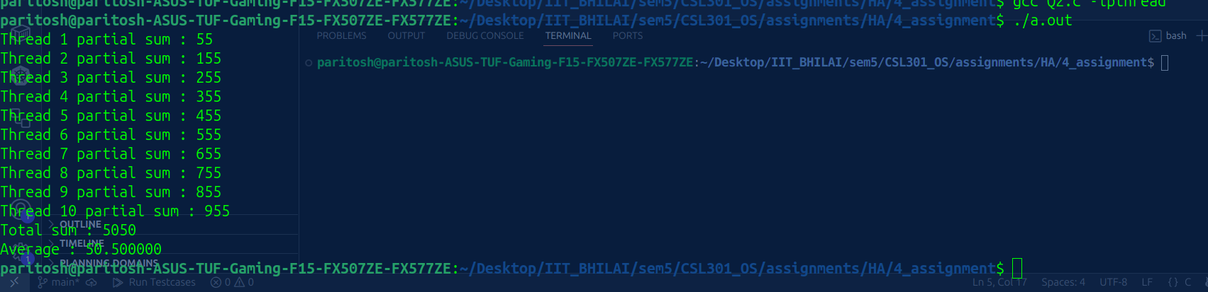

Q3:

code:
#include <stdio.h>
#include <pthread.h>
#include <stdlib.h>
#include <time.h>
#include <limits.h>

#define N 10
#define SEGMENT_SIZE 10
#define SIZE (N * SEGMENT_SIZE)

typedef struct
{
int *arr;
int start;
} args;

void *partial_max(void *arg)
{
args *a = (args *)arg;
int max_val = INT_MIN;

for (int i = a->start; i < a->start + SEGMENT_SIZE; ++i)
{
if (a->arr[i] > max_val)
{
max_val = a->arr[i];
}
}

int *result = malloc(sizeof(int));
*result = max_val;
return result;
}

void *overall_max(void *arg)
{
int *partial_maxima = (int *)arg;
int total_max = INT_MIN;

for (int i = 0; i < N; i++)
{
if (partial_maxima[i] > total_max)
{
total_max = partial_maxima[i];
}
}

int *result = malloc(sizeof(int));
*result = total_max;
return result;
}

int main()
{
srand(time(NULL));

int arr[SIZE];
printf("Array: [");
for (int i = 0; i < SIZE; i++)
{
arr[i] = rand() % 100;
printf("%d%s", arr[i], (i == SIZE - 1) ? "" : ", ");
}
printf("]\n\n");

pthread_t thread[N];
args segment[N];
int segment_max[N];

for (int i = 0; i < N; i++)
{
segment[i].arr = arr;
segment[i].start = i * SEGMENT_SIZE;
pthread_create(&thread[i], NULL, partial_max, &segment[i]);
}

for (int i = 0; i < N; i++)
{
void *result;
pthread_join(thread[i], &result);

segment_max[i] = *((int *)result);

printf("Thread %d max: %d\n", i + 1, *((int *)result));

free(result);
}

pthread_t master_max;
void *overall;

pthread_create(&master_max, NULL, overall_max, segment_max);
pthread_join(master_max, &overall);

printf("\nOverall max: %d\n", *((int *)overall));

free(overall);

return 0;
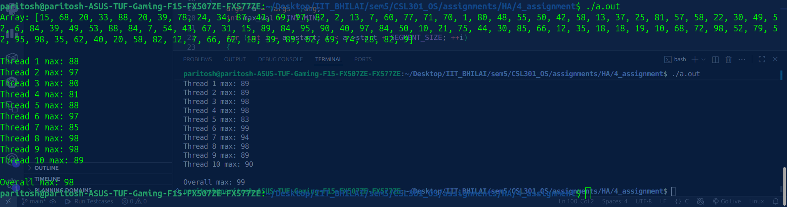
}
OUTPUT:

